National Source Tracking System (NSTS)

User’s Guide

Version 2.2

June 2012



Prepared by:

Lockheed Martin Corporation
30 W. Gude Drive, Suite 300
Rockville, MD 20850

Prepared for the:

United States Nuclear Regulatory Commission (NRC)
Office of Federal and State Materials and Environmental Management Programs (FSME)
Rockville, MD 20852

SafeSource Phase II
Contract No. GS-35F-4524G
Delivery Order DR-02-06-005

Revision History

Date | Version | Description | Author
October 27, 2006 | 1.0 | Initial Draft | Lockheed Martin
November 30, 2006 | 1.1 | Version 1.1 following NRC comments dated 11/15/06 | Lockheed Martin
February 12, 2007 | 1.2 | Version 1.2 following NRC comments dated 12/22/06 | Lockheed Martin
March 16, 2007 | 1.3 | Version 1.3 following NRC comments dated 3/7/07 | Lockheed Martin
April 9, 2007 | 1.4 | Version 1.4 following NRC comments dated 4/4/07 | Lockheed Martin
July 31, 2008 | 2.0 | Version 2.0 following updates to the NSTS application | Lockheed Martin
December 5, 2008 | 2.01 | Version 2.01 following NRC comments dated 11/10/08 | Lockheed Martin
February 23, 2009 | 2.02 | Version 2.02 following NRC comments dated 2/3/09 | Lockheed Martin
June 30, 2009 | 2.03 | Updated for NSTS Release 1.10:  - Updated screens in Section 6.4.1, 6.4.2, and NSTS Main Menu screens to show the Official Use Only – Security-Related Information (OUO-SRI) logo.  - Section 4.6: Added the following statement: ‘For more details on XML file content, refer to the NSTS File Upload Guide.’ | Lockheed Martin
November 30, 2009 | 2.04 | Updated for NSTS Release 1.2:  - Added Section 4.1.8: Annual Inventory Reconciliation.  - Added Section 4.1.9: View Annual Inventory Reconciliation Status – Agency User.  Updated section callouts 4.1.8 and 4.1.9 in Appendix B. | Lockheed Martin
October 28, 2010 | 2.05 | Updated for NSTS Release 1.3  Added the following sections:  - 4.1.11 Manufacture Bulk New8: Record Lost or Stolen Sources (CR 35878)  4.2.4 Inventory Report (CR 36274)  - 4.1.9: Annual Inventory Reconcilliation  - 4.1.10: View Annual Inventory Reconcilliation Status (Agency User)  - 4.1.11: Manufacture New Source - Bulk  Updated the following sections:  4.1.1 (CR 34374 – Model )  4.1.3 (CR 34374 – Model)  4.1.4 (CR 34374 Model; CR 35915 – Error Message/ADMN Multiple Roles  4.1.5 (CR 34374 Model)  4.1.6 (CR 34374 Model)  4.1.7 (CR 34374 Model)  4.4.1 (CR 34374 – Moded)  Moved the following section:  View Licensee ‘s Inventory from 4.2.1 to 4.1.24.7: Training  4.7.1: Computer-Based Training  4.7.2: Obtain Supporting Information  6.5: Roles and User Groups  Appendix B: NSTS Windows, Functions, Alternatives, and Scenarios  Appendix C: Data Field Descriptions | Lockheed Martin
December 2, 2010 | 2.07 | Updated for NSTS Release 1.3  Modified the following area and sections:  Retuned shading and borders from tables within the document.  Updated figure numbers to correlate with text in document.  4.1.5 – Update Source Information  4.1.11 – Manufacture New Sources – Bulk  4.2.4 – Inventory Report  Appendix C: Data Field Descriptions  Updated for NSTS Release 1.4  Change Request – 38283  Change Request – 39574; Enter Unrecorded Source from Unrecorded Transfer - Update Figure 4-117  Change Request – 38284 | Lockheed Martin
January 18, 2011 | 2.08 | Addressed the issues found by IV&V | Lockheed Martin
May 26, 2011 | 2.09 | Release 2.0.1 Updates and Additions:  Updated screen prints  Updated Sections - 3.0 (NSTS Main Menu), 4.1.2 (Create License), 4.2.2 (Update/Delete License), 4.2.3 (Record Licensee Transaction), and 4.3.3 (Export Source).  Added Sections - 2.4.2 (Common Action/Navigation Buttons), 4.1.8 (Specify Long Term Storage Sources), 4.1.13 (Record Lost or Stolen Sources), 4.1.14 (Record Irretrievable Sources), 4.1.15 (Review Source History), 4.1.16 (Record Found Sources), 4.1.17 (Review Lost and Stolen Sources), 4.1.18 (Review Long-Term Storage Sources), 4.1.19 (Query Sources), 4.2.5 (Query Licenses), 4.3.10 (Review Pending/Overdue Transfers), 4.3.11 (Record Import Notifications), 4.3.12 (Update Import Notifications), 4.3.13 (Record Export Notifications), 4.3.14 (Update Export Notifications), 4.3.15 (Review Import Notifications), 4.3.16 (Review Export Notifications), 4.3.7 (Review Transfer History), 4.3.8 (View Transfer Progress), 4.3.9 (Query Transfers and Receipts), 4.7 (Alert Management), 4.7.1 (Display Current Alerts), 4.7.2 (Update Alert Status), 4.7.3 (Review Alert History), 4.7.4 (Send Message to NSTS Mailbox), 4.7.5 (Update Message in NSTS Mailbox), 4.8 (Reporting), 4.8.1 (Manage Reports), 4.8.2 (Maintain Report Schedules), 4.8.3 (Upload Report), 6.2 (Obtain Supporting Information)  Renamed 6.0 to Training  Renumbered CBT Section to 6.1 (formerly 6.0)  Added 6.2 (Obtain Supporting Information). | Lockheed Martin
December 6, 2011 | 2.1 | Release 2.1 Updates  Updated the following sections  - Update/Cancel Source Transfer  - Verify Pending Transfers  4.3.3 Receive Sources (Domestic)  4.5.2 Verify Pending Make/Model  4.5.4 Verify Pending Locations  4.5.3 Verify Pending Licenses  4.3.7 Update/Cancel Source Export | Lockheed Martin
June 19, 2012 | 2.2 | Release 2.2 Updates  Updated the following sections  4.3.2 Receive Sources (Domestic)  4.4.2 Enter Unrecorded Transfer  4.1.20 Inventory Report – License User – NEW  4.2.4 Inventory Report – Agency User and NSTS Analyst (Title changed) | Lockheed Martin

Table of Contents

1 Introduction 1
1.1 Purpose 1
1.2 Scope 1
1.3 Assumptions 2
1.4 Applicable Documents 3
2 System Summary 4
2.1 System Interfaces 4
2.2 Standard Format 4
2.3 Sorting 5
2.3.1 Set Current Sort 6
2.4 Design 8
2.4.1 Widget Use Guidelines 9
2.4.2 Common Action/Navigation Buttons 10
2.4.3 Searching in the NSTS 10
2.4.4 Error Messages 11
2.5 NSTS Authentication 12
2.5.1 Failed Logon 13
2.5.2 Session Timeouts 13
2.5.3 Logging off the System 14
2.6 User Groups 15
2.6.1 Categories 15
2.6.2 Roles and Their Functions 15
2.6.2.1 Administration 15
2.6.2.2 Licensee 15
2.6.2.3 Licensing Agency 15
3 NSTS Main Menu 16
3.1 NSTS Main Menu – (Licensee – Generic Landing Page) 23
4 NSTS Modules 25
4.1 Source Management 25
4.1.1 View Own Inventory 25
4.1.2 View Licensee’s Inventory 30
4.1.3 Manufacture New Source 32
4.1.4 Regenerate Sources 41
4.1.5 Update Source Information 46
4.1.6 Record Destroyed Sources – Manufacturer 52
4.1.7 Record Destroyed Sources – NRC Staff 56
4.1.8 Specify Long-Term Storage Sources 61
4.1.9 Dispose Source 65
4.1.10 Annual Inventory Reconciliation 69
4.1.10.1 Verify Annual Inventory Reconciliation Report 69
4.1.10.2 Print an Inventory Report 70
4.1.10.3 Export Options 70
4.1.10.4 Pre-Existing Inventory Reconciliation Record 71
4.1.11 View Annual Inventory Reconciliation Status (Agency User) 71
4.1.12 Manufacture New Sources - Bulk 72
4.1.13 Record Lost or Stolen Source 76
4.1.14 Record Irretrievable Source 81
4.1.15 Review Source History 85
4.1.16 Record Found Sources 88
4.1.17 Review Lost and Stolen Sources 91
4.1.18 Review Long-Term Storage Sources 93
4.1.19 Query Sources 95
4.1.20 Inventory Report - License User 97
4.2 License Management 102
4.2.1 Create License 102
4.2.2 Update/Delete License Information 109
4.2.3 Record Licensee Transactions 119
4.2.3.1 Search Criteria for Recording Licensee Transactions 121
4.2.4 Inventory Report – Agency User and NSTS Analyst 123
4.2.5 Query Licenses 128
4.3 Transfer Management 131
4.3.1 Transfer Sources (Domestic) 131
4.3.2 Receive Sources (Domestic) 138
4.3.3 Export Sources 143
4.3.4 Receive Imports 149
4.3.5 Update/Cancel Source Transfer 154
4.3.6 Update/Cancel Source Export 166
4.3.7 Review Transfer History 171
4.3.8 View Transfer Progress 176
4.3.9 Query Transfers/Receipts 180
4.3.10 Review Pending/Overdue Transfers 183
4.3.11 Record Import Notifications 186
4.3.12 Update Import Notifications 195
4.3.13 Record Export Notifications 199
4.3.14 Update Export Notifications 206
4.3.15 Review Import Notifications 211
4.3.16 Review Export Notifications 213
4.4 Unrecorded Information 216
4.4.1 Enter Unrecorded Source 216
4.4.2 Enter Unrecorded Transfer 219
4.4.3 Enter Unrecorded Location – Licensee – Manufacturer Landing Page 232
4.4.4 Enter Unrecorded Location – Licensing Agency – NRC Landing page 234
4.4.5 Enter Unrecorded Make/Model 235
4.4.6 Enter Unrecorded Licensee 238
4.5 Verifications 240
4.5.1 Verify Pending Transfers 240
4.5.2 Verify Pending Make/Model 242
4.5.3 Verify Pending Licenses 246
4.5.4 Verify Pending Locations 251
4.6 Upload/Download Information 254
4.6.1 File Upload 254
4.7 Alert Management 256
4.7.1 Current Alerts 256
4.7.2 Update Alert Status 260
4.7.3 Review Alert History 267
4.7.4 Send Message to NSTS Mailbox 271
4.7.5 Update Message in NSTS Mailbox 273
4.8 Reporting 275
4.8.1 Manage Reports 276
4.8.2 Maintain Report Schedules 289
4.8.3 Upload Report 299
5 NSTS Security-Related Requirements 302
5.1 Classification 302
5.1.1 Sensitivity of Information 302
5.1.2 Security Controls 302
5.1.3 Digital Certification 302
5.1.4 Role Driven Permissions 302
5.1.5 Single Sign-on (SSO) 302
5.1.5.1 Receive Security Credentials 302
5.1.5.2 Send Security Credentials 303
5.1.5.3 Security Auditing 303
5.1.5.4 Encryption 303
5.1.6 External Data Transmission 303
5.1.7 Encryption Algorithms 303
5.2 Smart Card 303
5.2.1 Using the Smart Card 303
5.2.2 Safeguarding your Smart Card 303
5.3 NSTS User Responsibilities 304
5.3.1 Protection Controls 304
5.3.2 Workstation Security Controls 304
5.3.3 Handling Sensitive Information 304
6 Training 305
6.1 Computer Based Training 305
6.1.1 Purpose 305
6.1.2 Scope 305
6.1.3 Interface and Navigation 305
6.1.4 Accessing the NSTS Computer Based Training Menu 306
6.1.4.1 NSTS Rules of Behavior 308
6.1.4.2 NSTS Security Awareness Training 313
6.1.5 Roles and User Groups 326
6.1.5.1 Licensee 326
6.1.5.2 Licensing Agencies 329
6.1.5.3 NSTS Analyst 332
6.2 Obtain Supporting Information 334
Appendix A: Abbreviations and Acronyms 1
Appendix B: NSTS Windows, Functions, Alternatives, and Scenarios 1
Appendix C: Data Field Descriptions 1

List of Figures
Figure 2-1: Design (NRC Logo & NSTS Graphics/Banners) 8
Figure 2-2: Design (Required Fields) 8
Figure 2-3: Design (Buttons) 9
Figure 2-4: Widget Use (Radio Button) 9
Figure 2-5: Widget Use (Check Box) 9
Figure 2-6: Widget Use (Standalone Check Box) 10
Figure 2-7: Widget Use (Standard Visual Representations) 10
Figure 2-8: Error Messages (NSTS Recoverable Error 1) 11
Figure 2-9: Error Messages (NSTS Recoverable Error 2) 11
Figure 2-10: NSTS Authentication (Enter PIN) 12
Figure 2-11: NSTS Authentication (System Terms and Conditions) 13
Figure 2-12: Logging Off (Logout Button)) 14
Figure 2-13: Logging Off (Logoff Confirmation) 14
Figure 3-1: NSTS Main Menu (Licensee – Manufacturer Landing Page) 17
Figure 3-2: NSTS Main Menu (Licensee – Source User Landing Page) 18
Figure 3-3: NSTS Main Menu (Licensee – Disposer Landing Page) 19
Figure 3-4: NSTS Main Menu (Licensee – Distributor Landing Page) 20
Figure 3-5: NSTS Main Menu (Licensee – Waste Broker Landing Page) 21
Figure 3-6: NSTS Main Menu (DOE Site User – Landing Page) 22
Figure 3-7: NSTS Main Menu (Licensee – Generic Landing Page) 23
Figure 3-8: NSTS Main Menu (showing selected license number) 24
Figure 4-1: View Own Inventory (NSTS Main Menu) 26
Figure 4-2: View Own Inventory (Search Criteria) 27
Figure 4-3: View Own Inventory (License Inventory) 29
Figure 4-4: View Licensees’s Inventory (Search and Choose License 30
Figure 4-5: View Licensees’s Inventory (Choose License Search Results) 31
Figure 4-6: View Licensees’s Inventory (Review Licensee’s Inventory) 32
Figure 4-7: Manufacture New Source (Source Description) 33
Figure 4-8: Manufacture New Source (Isotope Table) 35
Figure 4-9: Manufacture New Source (Review New Sources) 37
Figure 4-10: Manufacture New Source (Edit Source) 38
Figure 4-11: Manufacture New Source (Additional Sources) 39
Figure 4-12: Manufacture New Source (Review New Sources) 40
Figure 4-13: Manufacture New Source (Confirmation) 41
Figure 4-14: Regenerate Sources (Search Sources for Regeneration) 42
Figure 4-15: Regenerate Sources (No Source Found) 43
Figure 4-16: Regenerate Sources (Search Results) 44
Figure 4-17: Regenerate Sources (Regenerate Source 44
Figure 4-18: Regenerate Source (Confirmation) 46
Figure 4-19: Update Source Information (Search Sources for Update) 47
Figure 4-20: Update Source Information (Search Results) 48
Figure 4-21: Update Source Information (Update Screen) 49
Figure 4-22: Update Source Information (Confirmation) 51
Figure 4-23: Record Destroyed Sources – Manufacturer (Search Criteria) 52
Figure 4-24: Record Destroyed Sources – Manufacturer (Search Results) 54
Figure 4-25: Record Destroyed Sources – Manufacturer (Destroyed Date/Details) 55
Figure 4-26: Record Destroyed Sources – Manufacturer (Confirmation) 56
Figure 4-27: Record Destroyed Sources – NRC Staff (Search Criteria( 58
Figure 4-28: Record Destroyed Sources – NRC Staff (Search Results) 59
Figure 4-29: Record Destroyed Sources – NRC Staff (Destroyed Date/Details) 60
Figure 4-30: Record Destroyed Sources – NRC Staff (Confirmation) 61
Figure 4-31: Specify Long-Term Storage (Search Criteria) 62
Figure 4-32: Specify Long-Term Storage (Search Results) 63
Figure 4-33: Specify Long-Term Storage (Storage Information) 64
Figure 4-34: Specify Long-Term Storage Source (Confirmation) 65
Figure 4-35: Search Sources for Dispose 66
Figure 4-36: Search Sources for Dispose (Search Results) 67
Figure 4-37: Dispose Source 68
Figure 4-38: Dispose Source Confirmation 69
Figure 4-39: Manufacture a New Source 72
Figure 4-40: Manufacture Bulk New Sources Review 75
Figure 4-41: Manufacture Bulk New Sources Confirmation 76
Figure 4-42: Record Lost or Stolen Source (Search for License) 77
Figure 4-43: Record Lost or Stolen Source (Search Results – Licenses) 78
Figure 4-44: Record Lost or Stolen Source (Search for Sources) 78
Figure 4-45: Record Lost or Stolen Source (Search Results – Sources) 79
Figure 4-46: Record Lost or Stolen Source (Source Information) 80
Figure 4-47: Record Lost or Stolen Source (Confirmation of Report) 81
Figure 4-48: Record Irretrievable Source (Search Criteria – Licenses) 82
Figure 4-49: Record Irretrievable Source (Search Results – Licenses) 83
Figure 4-50: Record Irretrievable Source (Search Criteria – Sources) 83
Figure 4-51: Record Irretrievable Source (Search Results – Sources) 84
Figure 4-52: Record Irretrievable Source (Source Information) 84
Figure 4-53: Record Irretrievable Source (Confirmation of Report) 85
Figure 4-54: Review Source History (Search Criteria) 86
Figure 4-55: Review Source History (Search Results) 87
Figure 4-56: Review Source History – Source Detail 87
Figure 4-57: Record Found Sources (Search Criteria) 88
Figure 4-58: Record Found Sources (Search Results – Lost/Stolen Sources) 89
Figure 4-59: Record Found Source (Source Discovery Information) 90
Figure 4-60: Record Found Source (Source Discovery Information) 91
Figure 4-61: Search Source for Lost and Stolen Sources (Search Criteria) 92
Figure 4-62: Search Source for Lost and Stolen Sources (Search Results) 93
Figure 4-63: Search Source for Long-Term Storage Sources (Search Criteria) 94
Figure 4-64: Search Source for Long-Term Storage Sources (Search Results) 95
Figure 4-65: Query Sources (Search Criteria) 96
Figure 4-66: Query Sources (Search Results) 97
Figure 4-67: Main Menu – Inventory Report 98
Figure 4-68: Inventory Report - Licensee 100
Figure 4-69: Inventory Report in Excel Format 100
Figure 4-70: Inventory Report in PDF Format 101
Figure 4-71: Print Dialog 101
Figure 4-72: Create License 103
Figure 4-73: Create License (Location Address Information) 106
Figure 4-74: Enter License Location Address Information 107
Figure 4-75, Enter License Contact Information 108
Figure 4-76: Additional License Information 110
Figure 4-77: Update / Delete License 111
Figure 4-78: Update / Delete License (Add Locations) 112
Figure 4-79: Update / Delete License (Add Contacts) 113
Figure 4-80: Update / Delete License – Delete the License 116
Figure 4-81: Update / Delete License – Add Location Address 116
Figure 4-82: Update / Delete License – Remove Location Address 117
Figure 4-83: Enter License Location Address Information 117
Figure 4-84: Update / Delete License – Add Contacts 118
Figure 4-85: Update / Delete License – Remove Contacts 118
Figure 4-86: Enter License Contact Information 119
Figure 4-87: NSTS Main Menu (NSTS Analyst acting as Licensee Surrogate) 121
Figure 4-88: Inventory Report 124
Figure 4-89: Inventory Report – Excel Export 125
Figure 4-90: Inventory Report – PDF Export 126
Figure 4-91: Inventory Report – Print Inventory Report 127
Figure 4-92: Query Licenses (Search Criteria) 128
Figure 4-93: Query Licenses (Search Results) 129
Figure 4-94: Query Licenses (Straight List) 130
Figure 4-95: Query Licenses (Mailing Labels) 130
Figure 4-96: Search and Choose Sources for Transfer (Domestic) 131
Figure 4-97: Search and Choose Receiving Licensee 133
Figure 4-98: Additional License Information 134
Figure 4-99: Select Receiving Licensee 135
Figure 4-100: Enter Transfer Information (Domestic) 136
Figure 4-101: Transfer Source (Domestic) Confirmation 138
Figure 4-103: Search and Choose Shipments (Domestic) - Search Results 140
Figure 4-104: Enter Receipt Shipment/Transfer Information (Domestic) 141
Figure 4-105: Enter Receipt Shipment/Transfer Information (Domestic)(extended table view) 141
Figure 4-106: Confirmation of Receive All to mark all Transfers as “Received” 142
Figure 4-107: Enter Export Information 144
Figure 4-108: Search and Choose Sources for Export 146
Figure 4-109: Search and Choose Sources for Export (Search Results) 147
Figure 4-110: Export Sources Review 148
Figure 4-111: Enter Receipt Information (Foreign) 149
Figure 4-112: Enter Receipt Sources Information (Foreign) 151
Figure 4-113: Enter Receipt Sources Information (Foreign)(Isotope Table) 152
Figure 4-114: Receive Imports Review 153
Figure 4-115: Search and Choose Open Domestic Shipments 155
Figure 4-116: Update / Cancel Domestic Shipment 156
Figure 4-117: Search and Choose Sources for Transfer (Domestic) 157
Figure 4-118: Update / Cancel Domestic Shipment (Add and Update) 159
Figure 4-119: Additional License Information 160
Figure 4-120: Search and Choose Receiving Licensee 160
Figure 4-121: View and Choose Open Domestic Shipments (Search Results) 162
Figure 4-122: Update/Cancel Domestic Shipment 163
Figure 4-123: Update / Cancel Domestic Shipment (Add and Update) 164
Figure 4-124: Update / Cancel Domestic Shipment (Remove) 165
Figure 4-125: Update / Cancel Domestic Shipment (Cancel Shipment) 166
Figure 4-126: Search and Choose Open Export Shipments 167
Figure 4-127: Update / Cancel Export Shipment 168
Figure 4-128: Search and Choose Sources for Export 169
Figure 4-129: Update / Cancel Export Shipment with Added Source 170
Figure 4-130: Review Transfer History (Shipment List of Licensee NYC 914-220-473) 172
Figure 4-131: Review Transfer History (Search Criteria) 173
Figure 4-132: Review Transfer History (Search Results) 174
Figure 4-133: Review Transfer History (Shipment List) 174
Figure 4-134: Review Transfer History (Export Notification) 175
Figure 4-135: Review Transfer History (Source Details) 175
Figure 4-136: View Transfer Progress (Open Shipments for NYC 914-220-473) 176
Figure 4-137: View Transfer Progress (Search criteria) 177
Figure 4-138: View Transfer Progress (Search Results) 179
Figure 4-139: View Transfer Progress (Transfer Details) 179
Figure 4-140: View Transfer Progress (Additional License Information) 180
Figure 4-141: Query Transfers and Receipts (Search Criteria) 181
Figure 4-142: Query Transfers and Receipts (Search Results) 182
Figure 4-143: Query Transfers and Receipts (Search Results- Right Columns) 182
Figure 4-144: Query Transfers and Receipts (Source Detail) 183
Figure 4-145: Review Pending/Overdue Transfers (Search Criteria) 184
Figure 4-146: Review Pending/Overdue Transfers (Search Results) 185
Figure 4-147: Review Pending/Overdue Transfers (Search Results- Right Columns) 185
Figure 4-148: Query Transfers and Receipts (Source Detail) 186
Figure 4-149: Record Import Notifications (Import Notification Form) 187
Figure 4-150: Record Import Notifications (Number of End-Use Locations) 189
Figure 4-151: Record Import Notifications (End-Use Locations Address Form) 189
Figure 4-152: Record Import Notifications (Aggregated Isotopes-1) 190
Figure 4-153: Record Import Notifications (Aggregated Isotopes-2) 190
Figure 4-154: Record Import Notifications (Aggregated Isotopes-3) 191
Figure 4-155: Record Import Notifications (Source Details- Blank) 192
Figure 4-156: Record Import Notifications (Source Details – Isotope/Activity) 193
Figure 4-157: Record Import Notifications (Import Notification Form – Isotopes/Sources) 194
Figure 4-158: Record Import Notifications (Import Notification Confirmation) 195
Figure 4-159: Update Import Notifications (Search Criteria) 196
Figure 4-160: Update Import Notifications (Search Results) 197
Figure 4-161: Update Import Notifications (Edit Screen) 198
Figure 4-162: Record Export Notification (Export Notification Form) 200
Figure 4-163: Record Export Notifications (Number of End-Use Locations) 202
Figure 4-164: Record Export Notifications (End-Use Locations Address Form) 202
Figure 4-165: Record Export Notifications (Number of Aggregated Isotopes) 203
Figure 4-166: Record Export Notifications (Aggregated Isotopes Activity Form) 203
Figure 4-167: Record Export Notifications (Aggregated Sources / # of Sources) 204
Figure 4-168: Record Export Notifications (Source Details) 204
Figure 4-169: Record Export Notifications (Source Details – Isotope/Activity) 205
Figure 4-170: Record Export Notifications (Export Notification Form - Sources) 205
Figure 4-171: Record Export Notifications (Export Notification Confirmation) 206
Figure 4-172: Update Export Notifications (Search Criteria) 207
Figure 4-173: Update Export Notifications (Search Results) 208
Figure 4-174: Update Export Notifications (Edit Screen) 209
Figure 4-175: Update Export Notifications (Confirmation) 210
Figure 4-176: Review Import Notifications (Search Criteria) 211
Figure 4-177: Review Import Notifications (Search Results) 212
Figure 4-178: Review Import Notifications (Detail) 213
Figure 4-179: Review Export Notifications (Search Criteria) 214
Figure 4-180: Review Export Notifications (Search Results) 215
Figure 4-181: Review Export Notifications (Detail) 215
Figure 4-182: Enter Unrecorded Source 216
Figure 4-183: Search and Choose Open Shipments (Domestic) 219
Figure 4-184: Search and Choose Open Shipments (Domestic) 220
Figure 4-185: Search and Choose Open Shipments (Domestic) (No Open Shipment/Transfers) 221
Figure 4-187: Search and Choose Sending Licensee 223
Figure 4-188: Search and Choose Sending Licensee (Search Results) 224
Figure 4-189: Additional License Information 225
Figure 4-190: Enter Unrecorded Shipment/Transfers 226
Figure 4-191: Enter Unrecorded Shipment/Transfers (Transfer Details) 227
Figure 4-192: Review Unrecorded Shipment/Transfers 228
Figure 4-193: View and Choose Open Shipments (Domestic) 229
Figure 4-194: Enter Receipt Shipment/Transfers Information (Domestic) 230
Figure 4-195: Enter Receipt Shipment/Transfers Information (Domestic)(Right-hand columns) 230
Figure 4-196: Receive Sources Confirmation 231
Figure 4-198: Enter an Unrecorded Location 233
Figure 4-199: Enter an Unrecorded Location 235
Figure 4-200: Enter an Unrecorded Make/Model 236
Figure 4-201: Enter Isotope Information 237
Figure 4-202: Enter an Unrecorded Licensee 238
Figure 4-203: Search and Choose Pending Shipment/Transfers 240
Figure 4-204: Search and Choose Pending Shipment/Transfers 241
Figure 4-205: Verify Pending Shipment/Transfers 241
Figure 4-207: Verify Pending Make/Model Information 244
Figure 4-208: View and Choose Pending Licensee 246
Figure 4-209: Verify and Complete Pending License Information 247
Figure 4-210: Enter Pending License Information 248
Figure 4-211: Enter Pending License Information (continued) 249
Figure 4-212: Verify and Choose Pending Locations 251
Figure 4-213: View Pending Location Information 252
Figure 4-214: File Upload 254
Figure 4-215: Choose File 255
Figure 4-216: Select File 255
Figure 4-217: Display Current Alerts (Notice of New Alerts) 256
Figure 4-218: Display Current Alerts (Current Alerts) 257
Figure 4-219: Display Current Alerts (Current Alerts – Right-hand columns) 257
Figure 4-220: Display Current Alerts (Recipient Details) 257
Figure 4-221: Display Current Alerts (Update Alert Status) 258
Figure 4-222: Display Current Alerts (Change Primary Recipient) 259
Figure 4-223: Display Current Alerts (Update Alert Status) 259
Figure 4-224: Display Current Alerts (Update Alert Status Confirmation) 260
Figure 4-225: Update Alert Status (Search Criteria) 261
Figure 4-226: Update Alert Status (Search Results) 262
Figure 4-227: Update Alert Status (Search Results – Right-hand columns) 263
Figure 4-228: Update Alert Status (Recipient Details) 263
Figure 4-229: Update Alert Status (Licensee Details) 263
Figure 4-230: Update Alert Status (Source Details) 264
Figure 4-231: Update Alert Status (Comments) 264
Figure 4-232: Update Alert Status (Update Screen) 265
Figure 4-233: Update Alert Status (Change Primary Recipient) 266
Figure 4-234: Update Alert Status (Update Confirmation) 267
Figure 4-235: Review Alert History (Search Criteria) 268
Figure 4-236: Review Alert History (Search Results) 269
Figure 4-237: Review Alert History (Search Results – Right-hand columns) 269
Figure 4-238: Review Alert History (Recipient Details) 270
Figure 4-239: Review Alert History (Comments) 270
Figure 4-240: Review Alert History (Sources) 271
Figure 4-241: Review Alert History (Alert Status) 271
Figure 4-242: Send Message to NSTS Mailbox (Message Form) 272
Figure 4-243: Send Message to NSTS Mailbox (Confirmation) 273
Figure 4-244: Update Message in NSTS Mailbox (Open Message List) 273
Figure 4-245: Update Message in NSTS Mailbox (Message Details) 274
Figure 4-246: Update Message in NSTS Mailbox (Update Message Status window) 274
Figure 4-247: Update Message in NSTS Mailbox (Confirmation) 275
Figure 4-248: Manage Reports (Report Search Criteria) 276
Figure 4-249: Manage Reports (Report Search Results) 277
Figure 4-250: Manage Reports (View Report Parameters) 278
Figure 4-251: Manage Reports (View Report) 279
Figure 4-252: Manage Reports (Download Report Parameters) 280
Figure 4-253: Manage Reports (Download Report File Format) 280
Figure 4-254: Manage Reports (Download Report - PDF) 281
Figure 4-255: Manage Reports (Run/Schedule Parameters) 282
Figure 4-256: Manage Reports (Report Instance Values) 282
Figure 4-257: Manage Reports (Report Schedule Settings) 283
Figure 4-258: Manage Reports (Report Schedule Settings – Weekly) 283
Figure 4-259: Manage Reports (Report Schedule Confirmation) 284
Figure 4-260: Manage Reports (Report Notification Email) 285
Figure 4-261: Manage Reports (Report Search – Retrieve Report Instance - 1) 285
Figure 4-262: Manage Reports (Report History - 1) 286
Figure 4-263: Manage Reports (Report Instance – Success Link) 286
Figure 4-264: Manage Reports (Report Instance – Recurring Link) 287
Figure 4-265: Manage Reports (Report History - 2) 287
Figure 4-266: Manage Reports (Download of Recurring Report Instance) 288
Figure 4-267: Manage Reports (Report Properties) 288
Figure 4-268: Manage Reports (Update Report Properties Confirmation) 289
Figure 4-269: Maintain Report Schedules (Report Instance Search Criteria) 290
Figure 4-270: Maintain Report Schedules (Report Instance Search Results - 1) 291
Figure 4-271: Maintain Report Schedules (Report Instance – Success Link) 291
Figure 4-272: Maintain Report Schedules (Report Instance – Recurring Link) 292
Figure 4-273: Maintain Report Schedules (Report Instance Search Results - 2) 292
Figure 4-274: Maintain Report Schedules (View Report) 293
Figure 4-275: Maintain Report Schedules (Run/Schedule Parameters) 294
Figure 4-276: Maintain Report Schedules (Report Instance Values) 295
Figure 4-277: Maintain Report Schedules (Report Schedule Settings) 295
Figure 4-278: Maintain Report Schedules (Report Schedule Settings – Weekly) 296
Figure 4-279: Maintain Report Schedules (Report Schedule Confirmation) 297
Figure 4-280: Maintain Report Schedules (Download Report File Format) 298
Figure 4-281: Maintain Report Schedules (Download Report - PDF) 298
Figure 4-282: Maintain Report Schedules (Download of Recurring Report Instance) 299
Figure 4-283: Upload Report (Publish Report - 1) 300
Figure 4-284: Upload Report (Publish Report - 2) 301
Figure 4-285: Upload Report (Publish Report Confirmation) 301
Figure 6-1: NSTS Main Menu – Computer Based Training 306
Figure 6-2: NSTS CBT Menu – Licensee 307
Figure 6-3: NSTS CBT Menu – Licensee (continued) 308
Figure 6-4: NSTS Security Policy Compliance 309
Figure 6-5: NSTS Rules of Behavior 310
Figure 6-6: NSTS Rules of Behavior (continued) 311
Figure 6-7: NSTS Rules of Behavior (end) 312
Figure 6-8: NSTS Rules of Behavior (Do Not Accept confirmation) 312
Figure 6-9: NSTS Rules of Behavior (Do Not Accept second confirmation) 313
Figure 6-10: NSTS Security Awareness Training (Introduction and Contents) 314
Figure 6-11: NSTS Security Awareness Training (Attitudes and Fallacies) 315
Figure 6-12: NSTS Security Awareness Training (IT Security Threats) 316
Figure 6-13: NSTS Security Awareness Training (IT Security Measures) 317
Figure 6-14: NSTS Security Awareness Training (IT Security Measures)(continued) 318
Figure 6-15: NSTS Security Awareness Training (Information Security) 319
Figure 6-16: NSTS Security Awareness Training (System Use Notification Message) 320
Figure 6-17: NSTS Security Awareness Training (Rules of Behavior) 321
Figure 6-18: NSTS Security Awareness Training (Rules of Behavior)(continued) 322
Figure 6-19: NSTS Security Awareness Training (Rules of Behavior)(end) 323
Figure 6-20: NSTS Security Awareness Training (Best Practices) 324
Figure 6-21: NSTS Security Awareness Training (Best Practices)(continued) 325
Figure 6-22: NSTS CBT Menu – Licensee 327
Figure 6-23: NSTS CBT Menu – Licensee (continued) 328
Figure 6-24: NSTS CBT Menu – Licensing Agency 330
Figure 6-25: NSTS CBT Menu – Licensing Agency (continued) 331
Figure 6-26: NSTS CBT Menu – NSTS Analyst 332
Figure 6-27: NSTS CBT Menu – NSTS Analyst (Continued) 333
Figure 6-28: NSTS Supporting Information 334

Introduction
The NSTS is a national, centralized database that allows the Nuclear Regulatory Commission (NRC) to know, in near real-time, the primary location of a particular source and who is responsible for the source. The NSTS tracks Category 1 and Category 2 nuclear sources. The system is designed to:
- Be primarily web-based;
- Include nuclear sources of highest concern from NRC licensees, Agreement States licensees, and Department of Energy (DOE) facilities;
- Require licensees and facilities to report the manufacture, transfer, receipt, and disposition of sources; and
- Minimize impact on licensees to the extent practical.

In addition, the NSTS will help the NRC and other agencies to:
- Monitor the primary location, use, and disposal of radioactive sources of concern throughout the United States;
- Improve accountability and give better information to decision makers;
- Detect and act on discrepancies;
- Conduct inspections and investigations;
- Communicate radioactive source information among government agencies;
- Respond in the event of an emergency; and
- Verify legitimate import, export, ownership, and use of radioactive sources.

Purpose
This User Guide provides the NSTS user with the information necessary to understand and use the NSTS. This manual provides the NSTS user with information to enter, maintain, retrieve, and report data within the system. Each of the NSTS functions is documented in detail, including examples of system windows (Figures) and explanatory notes.

Scope
This NSTS User Guide is designed to be used by the following user groups:
- Licensee – Represents the company or person authorized to use radioactive materials under a license issued by the NRC or an Agreement State. Six types of licensees will be able to report the manufacture, transfer, receipt, and disposition of sources:
  - Manufacturer: authorized to manufacture sources
  - Disposer: authorized to dispose of sources (e.g., by burial)
  - Distributor: authorized to distribute sources
  - Source User: authorized to use sources
  - Waste Broker: authorized to temporarily store sources prior to transferring to a disposer
  - DOE Site: RIS (Reporting Identification Symbol) identifier for DOE sites. This user represents a DOE site that has radioactive sources of concern. For the purposes of the NSTS, the DOE Site user is treated as a ‘pseudo-licensee’ in that a DOE Site is responsible for keeping track of individual sources that have been associated to that site. Similarly, the RIS used for identifying DOE Sites is treated as a ‘pseudo-license number’ in the NSTS. DOE sites may manufacture or process nuclear materials.
- Licensing Agency – Represents an agency that has the authority to license and inspect byproduct, source, or special nuclear materials used or possessed within its jurisdiction. This includes the NRC, Agreement State Agencies, and DOE under whose regulations DOE Sites may manufacture or possess nuclear materials.
- Other Federal Agencies – Represents other federal agencies that may need NSTS information. These are indirect users that will not have direct access to the system, but may obtain information through NSTS reports and/or downloads initiated by the NRC. Examples of these users include:
- Department of Homeland Security (DHS)
- Customs and Border Patrol (CBP)
- Department of Transportation (DOT)
- Environmental Protection Agency (EPA)
- Department of Defense (DOD)
- Department of Commerce (DOC)
- NSTS Analyst – Represents someone that has a holistic view of the NSTS information and can therefore see and enter all information regardless of Licensing Agency jurisdiction.
- NSTS Administrator – Represents someone that has the ability to access and modify all NSTS information and is responsible for resolving data discrepancies and maintaining NSTS-specific configuration information (e.g., maintaining user accounts, business rules, lookup values, etc.). For more information on this user role, see the NSTS Administrator Guide.

Assumptions
This User Guide is directed toward individuals who have had some instruction and hands-on training with the NSTS and Microsoft Windows. It is not intended for the first-time computer user.
It is assumed that users will have the following minimum skills and knowledge to use the NSTS:
- Familiar with web-based browsers, e.g., Internet Explorer or Netscape Navigator, versions 5.0 or higher.
- Familiar with Microsoft Windows (or other operating system).
- Familiar with Source terminology.
- Familiar with NRC business processes for handling Category 1 and 2 Sources.
- Familiar with Sensitive Unclassified Non-Safeguards Information (SUNSI) guidelines for protection of the information in the NSTS as specified in NRC COMSECY-05-0061, dated December 13, 2005, revised January 11, 2006.

Applicable Documents
508 Compliance Standards: 1194.1 – 5, Subpart A (General); 1194.21 – 26, Subpart B (Technical Standards); 1194-31 – Subpart C (Functional Performance Criteria); 1194.41 – Subpart D (Information, Documentation, and Support), dated December 21, 2000.

Federal Information Processing Standard (FIPS) Publication 140-2, Security Requirements for Cryptographic Modules, dated December 3, 2002.

National Institute of Standards and Technology (NIST) Special Publications (SP) 800-53, Recommended Security Controls for Federal Information Systems, Revision 1, dated December 2006.

NIST SP 800-60, Guide for Mapping Types of Information and Information Systems to Security Categories, Volumes I and II, Version 2.0, dated June 2004.

NIST SP 800-63, Electronic Authentication Guidelines: Recommendations of the NIST, Version 1.0.2, dated April 2006.

NSTS Guide for Formatting and Submission of Electronic Data Files, v1.6, dated September 14, 2008

SafeSource Phase II Statement of Work (SOW), Appendix B, Requirements Analysis for SafeSource Phase II: National Source Tracking System, version 1.4, dated September 2005.

System Summary
The NSTS will track Category 1 and Category 2 nuclear sources, provide near real-time source tracking, and allow the NRC to locate a particular source and the source owner. The system will also provide monitoring and control, inventory tracking, transfer and import/export, reporting, system administration, and alerts and notifications (available in Release 2). In addition, the NSTS will provide recording activities for licensee functions; tracking, monitoring, and control for licensing agency functions; and administration, reporting, time-triggered processing, and external interfaces for system administration and reporting functions.

System Interfaces
The NSTS may interface with numerous existing systems, including:
- DOE Radiological Source Registry and Tracking system (RSRT) for site and source tracking information
- NRC’s Web-Based Licensing/Licensing Tracking System (WBL/LTS) for license information
- NRC’s National Sealed Source and Device Registry (NSS&DR) for device information
- Agreement State Agency licensing systems
- Licensee systems for source tracking information
These interfaces are not direct links from one system to another. The interface is through a data file, which is uploaded through a secure Hypertext Transfer Protocol (HTTP) upload (HTTPS) to the NSTS in Extensible Markup Language (XML) format. For more information on the upload/download function in the NSTS, see Section 4.6. In addition, for information on formatting and submitting electronic data files, see the NSTS Guide for Formatting and Submission of Electronic Data Files, v1.6, dated September 14, 2008.

Standard Format
The NSTS was developed as a three-tiered web application. Many features in this application are common to any web application and are easy to learn and use. The NSTS uses these common features: a logon screen, a main menu or landing page, sidebar links, and online help.

Sorting
Columns can be sorted. Select columns to sort ascending or descending. Click once to sort ascending; click twice to sort descending. Within the same sort, it is possible to have some columns sorted ascending and descending in the same set.

Note: Not all columns can be sorted, only those which have a blue header and are underlined. Columns with a black header and are not underlined cannot be sorted.

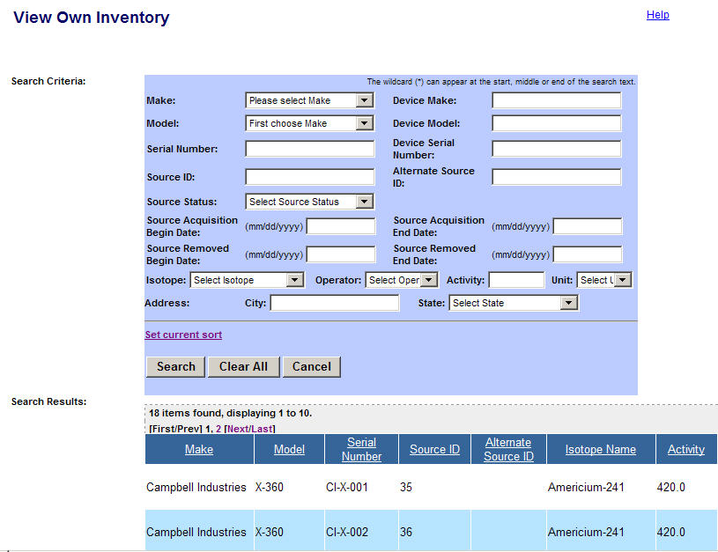

Non-Sortable

Sortable

Set Current Sort
Setting the current sort order lets you select the order in which items will be sorted.

To set the current sort order, click Set current sort.

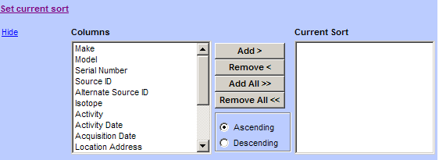

Select an item to sort In the left Columns pane, and then click Add >. The item will appear in the Current Sort pane on the right.

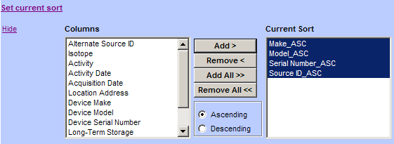

To select more than one item, hold down the Ctrl key on your keyboard. To select a range of items, select the first item, hold down the Shift key on your keyboard, and then select the last item in the range (all items will be highlighted).

To sort all items, select the items, and then click Add All >>.

To remove an item from the Current Sort pane, select the items, and then click Remove <. The item will appear in the Columns pane.

To remove all items from the Current Sort pane, click Remove <<.

To sort the selected inventory in A to Z order, select Ascending, and then select the items into the Current Sort box (see the following example.)

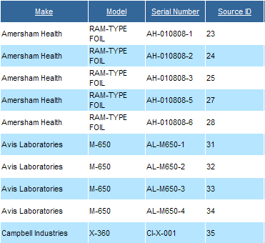

To sort the selected inventory in Z to A order, select Descending, and then select the items into the Current Sort box (see the following example.)

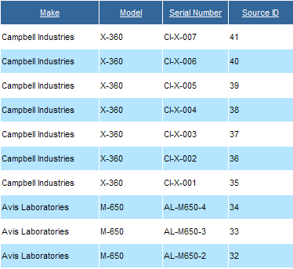

To hide the Set Current Sort option, click the link.

Design
- The NRC Logo and associated graphical images are present on the header section of all Web pages, as depicted in Figure 2-1. Links labeled “Print,” “Logout,” “NRC Home,” and “FSME Home” are present in the header section of all Web pages. “Help” links are present on all pages with Help topics.
NSTS information is designated as Official Use Only – Security-Related Information (OUO–SRI), a category of Sensitive Unclassified Non-Safeguards Information (SUNSI). The ‘Official User Only – Security-Related Information’designation appears on all of the NSTS windows.
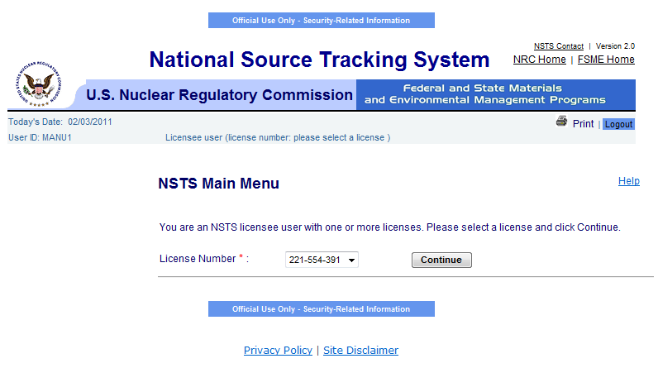
Figure 2-1: Design (NRC Logo & NSTS Graphics/Banners)

- Required fields have a red asterisk ( * ) beside them and a line of text that reads, “Indicates required field.”
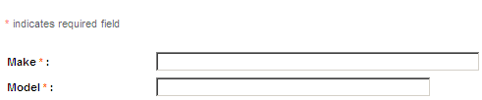

Figure 2-2: Design (Required Fields)

  - Buttons (to submit a page) appear at the bottom of the page and are left-justified, as shown in Figure 2-3 example: ‘Export Sources’ and ‘Enter Unrecorded Source.’
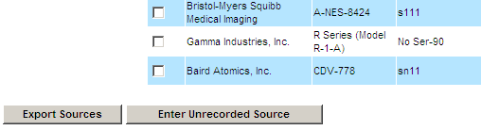
Figure 2-3: Design (Buttons)

- Long lists have scroll bars.
- All Section 508 of the Rehabilitation Act compliance standards have been applied.
  - All labels are left-aligned.
  - All tables have column headers.
  - Text displayed in a table is left-justified; numeric values in a table are right-justified.

Widget Use Guidelines
- Radio buttons are used when there is a list of two or more options that are mutually exclusive, and the user must select exactly one choice. There is a default selection.

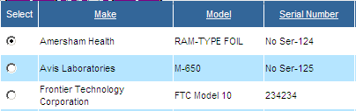
Figure 2-4: Widget Use (Radio Button)

- Check boxes are used when there are lists of options, and the user may select any number of choices, including zero, one, or several.

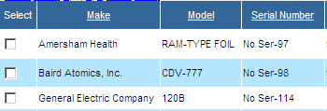
Figure 2-5: Widget Use (Check Box)

- A stand-alone check box is used for a single option that the user can either select or clear.

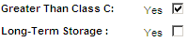
Figure 2-6: Widget Use (Standalone Check Box)

- Standard visual representations: A check box is a small square that is populated with a check mark when selected. A radio button is a small circle that contains a solid circle inside it when selected.

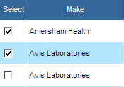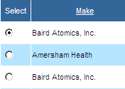
Figure 2-7: Widget Use (Standard Visual Representations)

Common Action/Navigation Buttons
Many screens in the NSTS share navigation and actions buttons that have the same function on each screen where they are available:
Search
– After entry of the desired search parameters, click Search to display a list of items meeting the specified criteria. Clicking Search without defining any search parameters will usually return all items in the set to be searched. Search results will include only items which the user has permission to view.
Clear All
– To return the fields in a search form to the default parameters, click Clear All.
Previous
– When using a function that employs a series of screens, click Previous to go back to the preceding screen.
Continue
– When using a function that employs a series of screens, click Continue to go to the next screen.
Back to Menu
– Following completion of a task, click Back to Menu to terminate the function and return to the Main Menu.
Cancel
– Prior to completion of a task, click Cancel to terminate a function (without saving any changes) and return to the Main Menu.
Reset
– On an edit screen, click Reset to return the field entries to the saved data (as displayed when the screen was opened).
Save
– On an edit screen, click Save to record a new item with the properties described or to update the properties of an existing item.

Searching in the NSTS
Using search criteria will help to narrow and filter search results. The more search criteria entered in a search, the more refined the search results will be. When multiple search criteria are entered, the results are “and” searches. This means that the results will be only items that contain all of the entered search criteria. For example, Make X, Model Y, and Device ABC, will return results that contain all three values. Values that contain only one of the search criteria will not be displayed. If no results are found on a particular query, eliminating some of the entered search criteria may help.

In addition to standard searching, wildcard searches are permitted in text entry fields. A wildcard is a character that may be used in a search term to represent one or more characters. An asterisk * may be used to specify zero or more alphanumeric characters. For example, searching for the term “h*s” would yield results that contain such words as “his,” “homes,” “houses,” “horses,” “horticulturalists,” and “herbaceous.”

Error Messages
There are two types of error messages that can occur in the NSTS: recoverable and unrecoverable.

A recoverable error occurs when there is a problem with a file being uploaded (see Figure 2-8).
If there is a problem with the file, an error message will be displayed, and the file will be rejected. In the example error in Figure 2-8, you would click Back to update entries to return to the form that caused the error, change the data, and then resubmit the form.
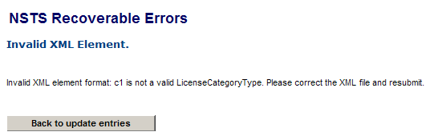
Figure 2-8: Error Messages (NSTS Recoverable Error 1)

Another example of an error message is when data is missing (as shown in Figure 2-9). In this example, you would click OK to return to the form that caused the data, enter the missing data, and then resubmit the form.

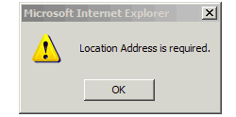
Figure 2-9: Error Messages (NSTS Recoverable Error 2)

Note: Unrecoverable errors can occur due to programming or system data issues. If these errors occur, call the NSTS Help Desk at 1-877-671-6787 (NSTS).

NSTS Authentication
To log on to the NSTS application, enter your Smart Card in your card reader, and connect to the application’s Uniform Resource Locator (URL) through your web browser.

Enter your Personal Identification Number (PIN) at the prompt, and the OK button will be enabled. Click OK.

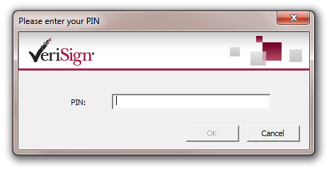
Figure 2-10: NSTS Authentication (Enter PIN)

The Terms and Conditions window will appear with a message about computer usage and consent to monitoring (see Figure 2-11).

If you agree to the terms and conditions of the system usage, click I Accept.

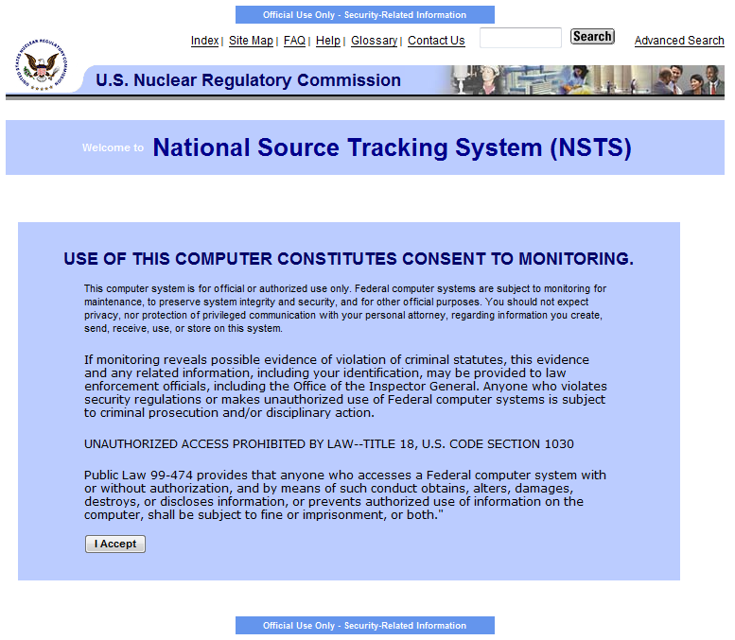
Figure 2-11: NSTS Authentication (System Terms and Conditions)

Failed Logon
The system allows you to log on six (6) times before a failed logon occurs. If you fail to log on after six attempts, you will be locked out of the system. To unlock your account, contact the NSTS Help Desk at 1-877-671-6787 (NSTS).

Session Timeouts
If your NSTS session is inactive for 15 minutes, the system will lock you out. Also, if you click
the Close button [] in the upper-right corner on your browser window, the system will lock you out for 15 minutes.

You can have only one active session open at a time. If you close your browser window without logging off, you will have to wait 15 minutes to log on again.

Logging off the System
To log off the system, click (located on the upper-right portion of the NSTS window).

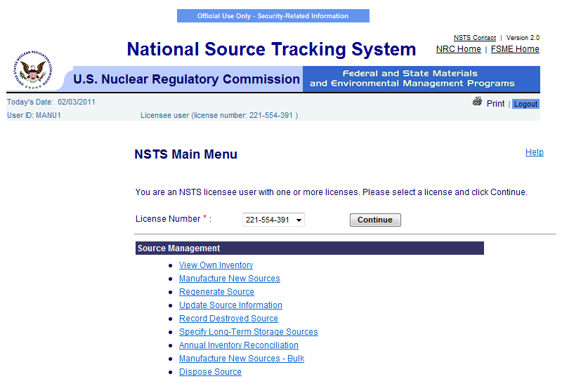
Figure 2-12: Logging Off (Logout Button))

A confirmation message will appear asking if you want to log out of the NSTS. Click OK.
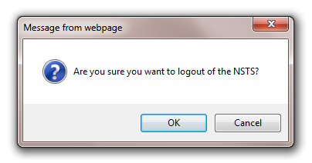
Figure 2-13: Logging Off (Logoff Confirmation)

To close the confirmation box and return to the previous window, click Cancel.

Note: You may see an additional dialog box asking if you would like to close your browser window. To close the browser, click Yes.

User Groups

Categories
The following two categories of user groups are authorized to use the NSTS:
- Users – Licensees (recording activities) and Licensing Agencies (tracking, monitoring, and control).
- Administrator – NSTS Analyst and NSTS Administrator (system administration, reporting, time-triggered processing, and external interfaces). For more information about the NSTS Administrator role, see the NSTS Administrator Guide.

Roles and Their Functions

Administration
The Administration role accesses and modifies all NSTS information. This role is responsible for resolving data discrepancies and for maintaining NSTS-specific configuration information (e.g., maintaining user accounts, business rules, lookup values, etc.). The Administration module allows you to perform the following functions:
- Administrator – User Account Management, Licensing Agency and Code Table Management, and Auditing Management
- NSTS Analyst – License and Source Management, Enter Unrecorded Information, and Verifications

Licensee
The Licensee represents the company or person authorized to use radioactive materials under a license issued by the NRC or an Agreement State (A/S). Types of Licensees include Source Manufacturer, Source Distributor, Source User, Waste Broker, Source Disposer, and DOE Site. In the Licensee module, you can perform:
- Source Management
- Transfer Management
- Enter Unrecorded Information
- Verifications

Licensing Agency
The Licensing Agency represents an agency that has the authority to license and inspect byproduct, source, or special nuclear materials used or possessed within its jurisdiction. This includes NRC, Agreement State agencies, and DOE (under whose regulations DOE Sites may manufacture or possess nuclear materials). In the Licensing Agency module, you can perform:
- License Management
- Source Management
- Enter Unrecorded Information
- Verifications

NSTS Main Menu
Starting from the NSTS Main Menu, the user can perform many NSTS functions, including:
- Source Management – View, record, regenerate, and update source information.
- Transfer Management – Transfer sources from one licensee to another, receive imports and export sources, update/cancel transfers, and record licensee transactions as a surrogate for a licensee.
- Unrecorded Information Management – Enter source information that has not previously been recorded in the NSTS.
- Verifications – Licensees and Licensing Agency staff can verify pending information.
- Upload/Download Information – Allowing the user to upload information.
- Training – Users can access Computer Based Training Modules and obtain supporting information, such as: Frequently Asked Questions, NRC Rules on NSTS, as well as external websites (e.g., IAEA, DOE, NRC) and more.
- Alert Management – Users can view NSTS alerts and send messages to the NSTS Mailbox.
- License Management – Create, update, and record license information.
- Administration – System administration, reporting, processing, and external interfaces.

Depending on the user role, different menu items will appear after you log on to the NSTS. For example, a manufacturer licensee will have different menu items available on their main menu than a disposer licensee. The Main Menu for the Manufacturer menu items is shown in Figure 3-1.

Landing pages for other types of licensee users are shown in the graphical exhibits that follow as:
- Figure 3-2: Source User
- Figure 3-3: Disposer
- Figure 3-4: Distributor
- Figure 3-5: Waste Broker
- Figure 3-6: Department of Energy (DOE) Site user

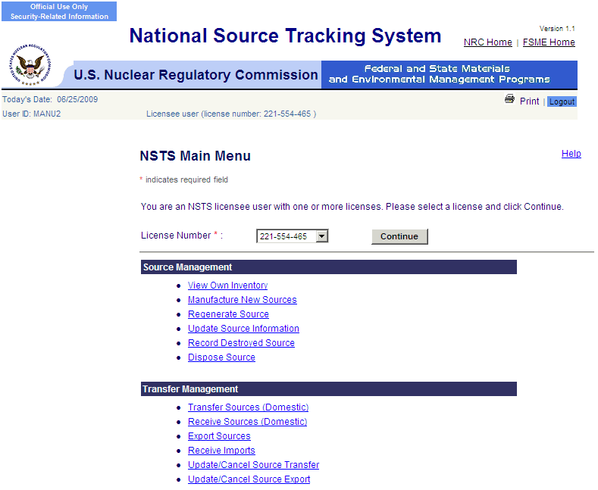
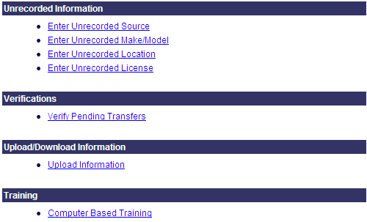
Figure 3-1: NSTS Main Menu (Licensee – Manufacturer Landing Page)
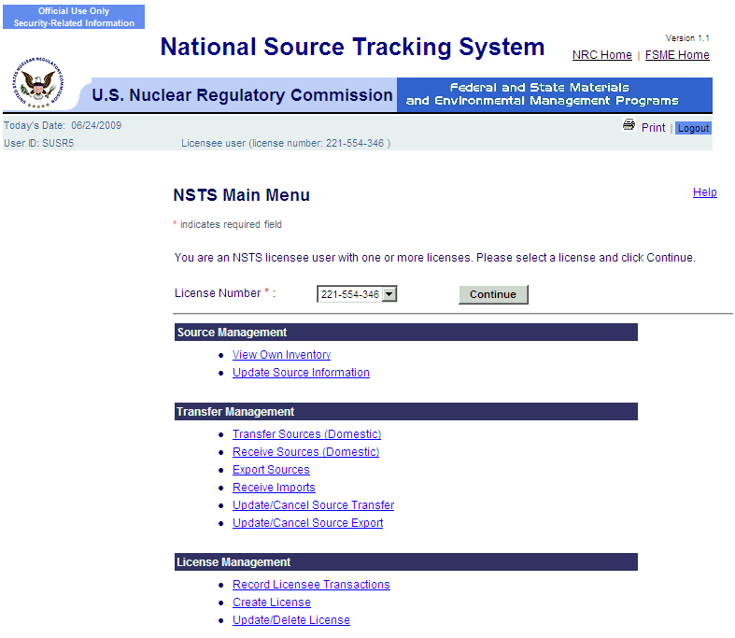
Figure 3-2: NSTS Main Menu (Licensee – Source User Landing Page)
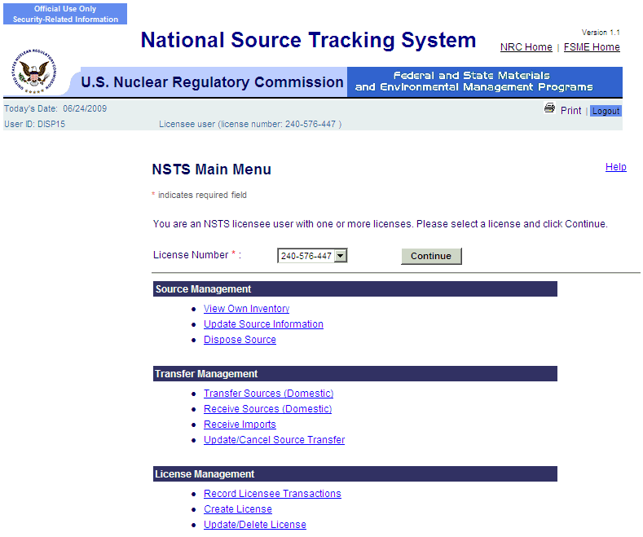
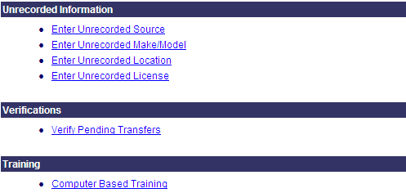
Figure 3-3: NSTS Main Menu (Licensee – Disposer Landing Page)
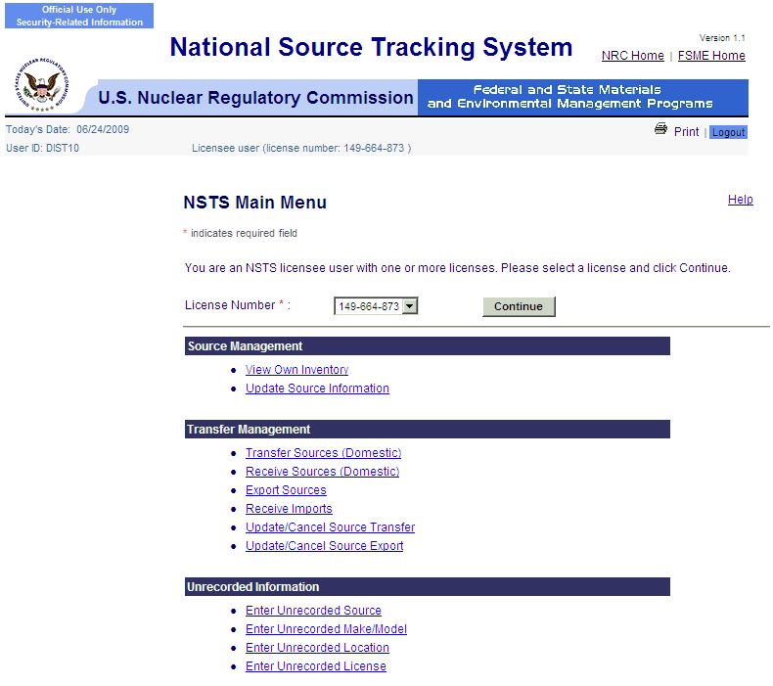
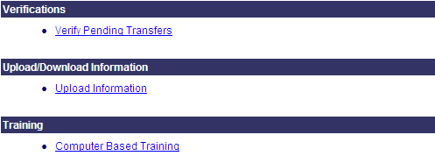
Figure 3-4: NSTS Main Menu (Licensee – Distributor Landing Page)
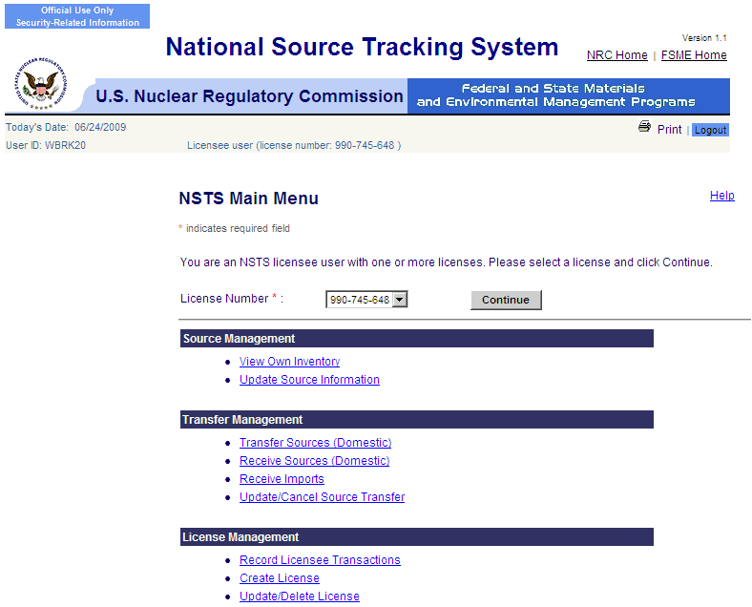

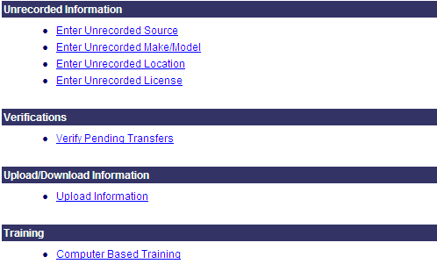
Figure 3-5: NSTS Main Menu (Licensee – Waste Broker Landing Page)

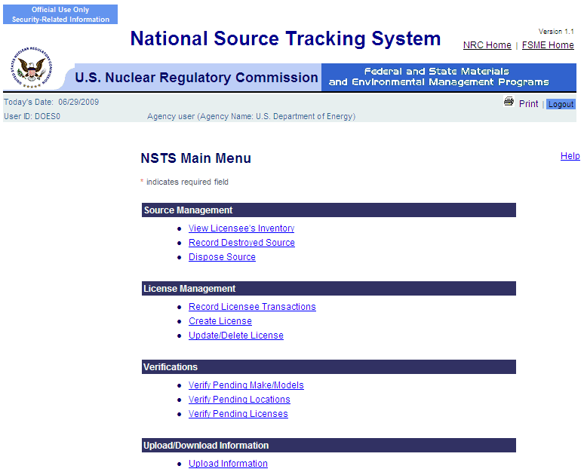

Figure 3-6: NSTS Main Menu (DOE Site User – Landing Page)

NSTS Main Menu – (Licensee – Generic Landing Page)
When a user logs on to the system, the NSTS Main Menu window appears. The user will be presented with a license number drop-down selection listing preconfigured with the license numbers associated with the user. The user will select a license number from the drop-down listing and click Continue. Once the license number is selected, the links on the Main Menu will be displayed. The links displayed on the Main Menu are based on the role and access privileges for the user logged in.

To change the license number under which the user wants to perform the functions in NSTS, select the license number in the License Number drop-down list, and then click Continue. The menu items in the lower portion of the window will be refreshed.

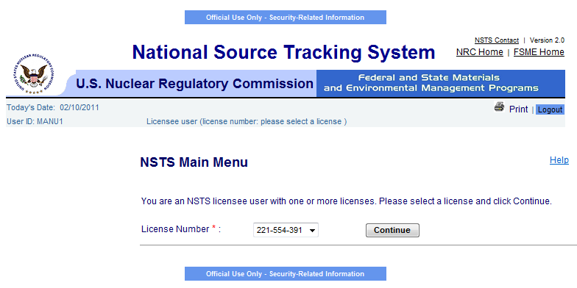
Figure 3-7: NSTS Main Menu (Licensee – Generic Landing Page)

The license number on the upper banner of the window will change to reflect the user’s current choice. In the example in Figure 3-8, the selected license number appears as: ‘Licensee user (license number 221-554-465).’

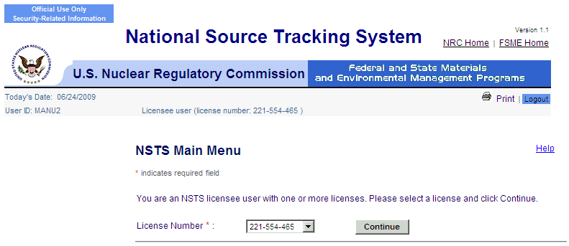

License number appears in banner.

Figure 3-8: NSTS Main Menu (showing selected license number)

NSTS Modules

Source Management

View Own Inventory
User – Source Users, Manufacturer Licensee, Distributor, Disposer, Waste Broker, Agreement State Staff, NRC Staff, and NSTS Analyst as Surrogates.

Use – View a list of Sources that the Licensee possesses by currently selected license number. Cross-check own inventory against what NSTS recorded.

1. From the NSTS Main Menu, click View Own Inventory.
Figure 4-1: View Own Inventory (NSTS Main Menu)
- The View Own Inventory window appears.

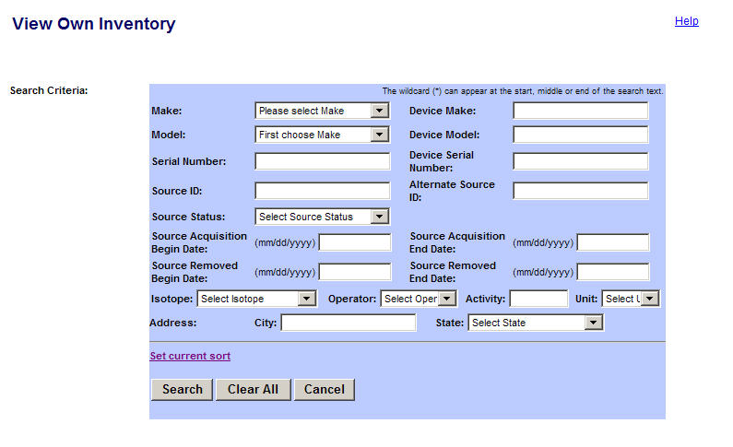Figure 4-2: View Own Inventory (Search Criteria)

The following fields are available to enter search criteria:

Field Name | Req. Value | Description/Comments | Acceptable Values | Example Value
Make |  | Represents the manufacturer. Each Make will have one or more models associated with it. | Drop-down | 800 Delta
Model |  | Item that is manufactured. Represents a Model associated with a Make. | Drop-down | A424-19
Serial Number |  | Identification number assigned to a Source by the manufacturer. | Alphanumeric | TK12345
Source ID |  | A unique system-generated identifier for each manufactured source. | Numeric value | 23456234567
Source Status |  | Status of trackable Sources. | Drop-down list | Disposed
Device Make |  | Make of the device containing a trackable nuclear Source. | Alphanumeric | Acme
Device Model |  | Model of the device containing a trackable nuclear Source. | Alphanumeric | Acme123
Device Serial Number |  | Device serial number assigned by the manufacturer. | Alphanumeric | L98X777
Alternate Source ID |  | Additional Source ID that is designated by the Licensee. | Alphanumeric | 456781B
Source Acquisition Begin Date |  | The beginning date a Source is added to a Licensee’s inventory. | mm/dd/yyyy | 03/02/2006
Source Acquisition End Date |  | The ending date a Source is added to a Licensee’s inventory. | mm/dd/yyyy | 05/05/2007
Source Removed Begin Date |  | The beginning date a Source was removed from a Licensee’s inventory. | mm/dd/yyyy | 09/24/2005
Source Removed End Date |  | The ending date a Source was removed from a Licensee’s inventory. | mm/dd/yyyy | 09/30/2005
Isotope Name |  | Identification of the isotope in a Source. | Entry from a Code Table; populated based on Make and Model. | Cobalt-60
Isotope: Enter Activity |  | Activity level for isotope. | Numeric value | 223
Isotope: Select Operator |  | A filter for search criteria. | Drop-down list | = (equal)
Isotope: Select Unit |  | Unit in which the activity level of the Source is measured. | Drop-down list | Ci
Address City |  | Name of the U.S. City to be searched. | Free-form text | Dallas
Address State |  | Name of the U.S. State to be searched. | Drop-down list | TX

- To initiate a request to view a list of your own inventory, enter search criteria in the fields and then click Search. By default, the search results will return sources that have not reached an end point unless Source Status is specified in the search criteria.

Note: To see all inventory, leave search criteria fields blank, then click Search.

- Search results appear below the search criteria.

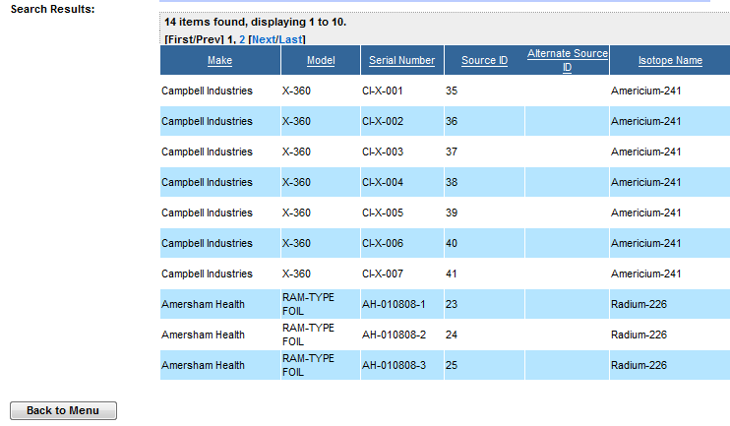
Figure 4-3: View Own Inventory (License Inventory)

Note: Navigation Options

The [First/Prev] 1, 2 [Next/Last] options on the top of the Search Results window allow you to navigate through items in the search results. The number of items found in each search result is displayed below the navigation options. Ten (10) items are displayed at a time. The following options are available:

Click First to go to the first page of search results. Click Prev to go to the previous page.

The numbers (1, 2, etc.) indicate each set of results that are displayed. For example, clicking 1 will display items 1-10, clicking 2 will display items 11-20, etc.

Click Next to go to the next page. Click Prev to go to the last page of the search results.

- When you are done viewing the inventory, click the Back to Menu button to return to the NSTS Main Menu.

Note: Lookup –The Model drop-down selection will be populated from the chosen Make.

Filtering – The system will only include a list of Sources that are currently possessed by this Licensee.

Default Sort – The system will automatically sort the Sources by Location, Isotope, Make, Model, and Serial Number.

View Licensee’s Inventory
User – Licensing Agency, Other Federal Agencies (indirect users), and NSTS Analyst.

Use – Agency Staff retrieves a list of Sources a Licensee possesses.

- From the NSTS Main Menu, under Source Management, click View Licensee’s Inventory.
- The Search and Choose Licensee window appears with fields you can select to search for a Licensee.
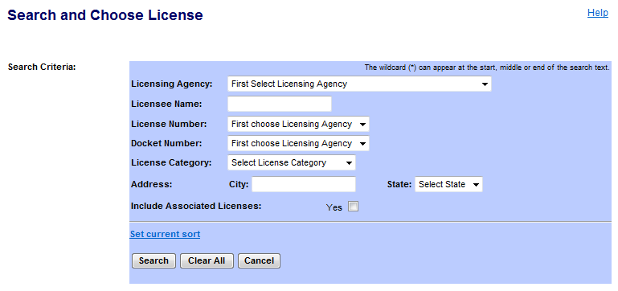
Figure 4-4: View Licensees’s Inventory (Search and Choose License

The following fields are available to define the search:
Field Name | Req. Value | Description/Comments | Acceptable Values | Example Value
Licensing Agency |  | Agency that has regulatory authority over the Licensees. Defaults to the user’s Agency. Only an NRC user or the NSTS Analyst can change the value of the Licensing Agency. | Drop-down list | NRC
Licensee Name |  | Name of the organization or individual to whom the license is issued. | Free-form text | ABC Company
License Number |  | Number assigned when a license is issued. | Drop-down list | 945AL733WP9
License Category |  | Category assigned by a Licensing Agency. | Drop-down list | Gamma Knifes
Docket Number |  | License identifier used by NRC. Required for NRC Licensees only. Optional for search criteria. | Drop-down list | 05000313
City |  | Name of the U. S. City. | Free-form text | Hanover
State |  | Name of the U. S. State. | Drop-down list | PA
Include Associated Licenses |  | Click the yes checkbox to include associated licenses in the search results. | Checkbox
- Enter search criteria to view a Licensee’s inventory, and then click Search. To view all available Licensees, leave the search criteria fields blank, and then click Search. The search results display at the bottom of the window.

Note: To see other fields in the search results window, use the horizontal scroll bar to scroll to the right.

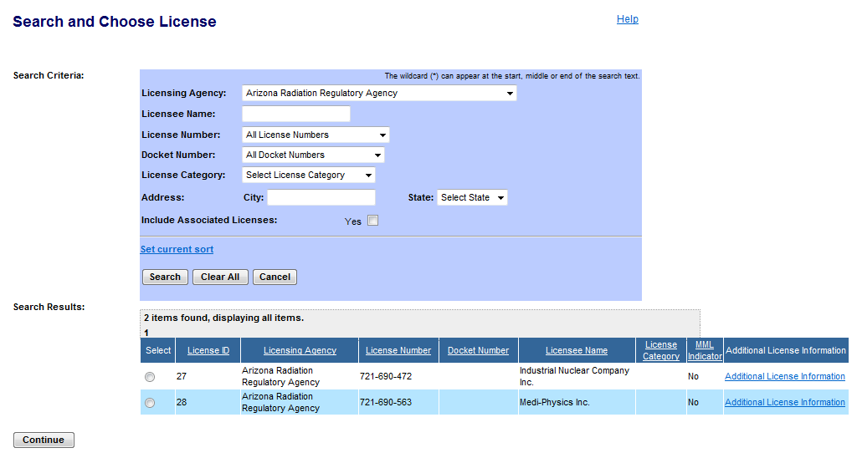
Figure 4-5: View Licensees’s Inventory (Choose License Search Results)

- Select a licensee by clicking the Select radio button ().

- Click Continue. The Review Licensee’s Inventory window appears.
- Review a list of Sources that a particular Licensee possesses.
Note: To see other fields in the window, use the horizontal scroll bar to scroll to the right.

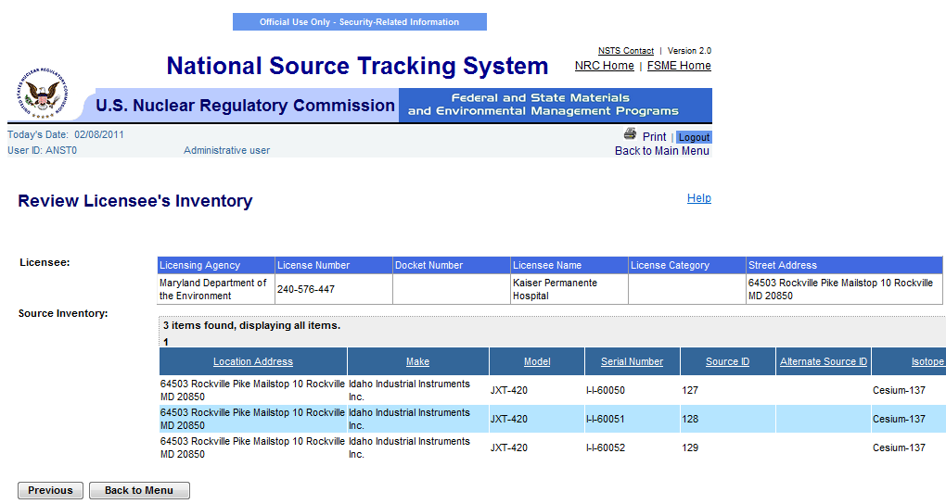
Figure 4-6: View Licensees’s Inventory (Review Licensee’s Inventory)

Note: Click the Previous button to return to the Search and Choose License (Search Results) window, if this is not the item to be updated.

- When you are done viewing the Sources, click Back to Menu to return to the Main Menu.

Note: The NRC will be able to see its own Licensees and the Agreement State Licensees; the Agreement State Agency will be able to see its own Licensees; DOE will be able to see all DOE Sites; and the NSTS Analyst can see all Licensees and DOE Sites.

Manufacture New Source
User – Manufacturer Licensee, Agreement State Staff, NRC Staff, and NSTS Analyst as Surrogate.

Use – Record new NSTS trackable Sources that are manufactured, including Sources manufactured from bulk materials and from re-manufactured Sources.

  - From the NSTS Main Menu, under Source Management, click Manufacture New Sources.

- The Manufacture New Sources window appears:
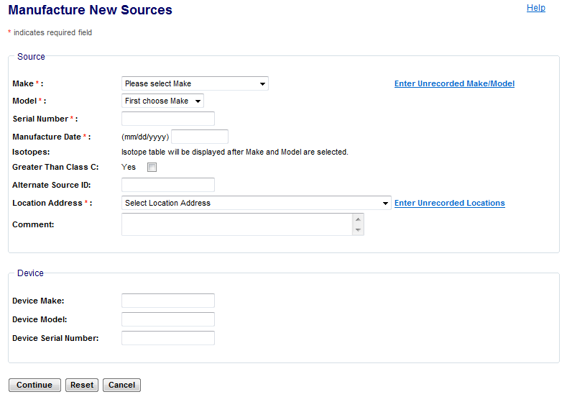
Figure 4-7: Manufacture New Source (Source Description)

The following fields are available to enter Source information:

Field Name | Req. Value | Description/Comments | Acceptable Values | Example Value
Make | Y | Make/manufacturer of the Source. Each Make will have one or more Models associated with it. | Drop-down list | 800 Delta
Model | Y | Item that is manufactured. Represents a Model associated with a Make. | Drop-down list | A424-19
Serial Number | Y | Identification number assigned to a Source by the manufacturer. | Alphanumeric | TK12345
Manufacture Date | Y | Date the Source is manufactured. | mm/dd/yyyy | 02/05/2003
Isotope Name | Y | Identification of the isotope in a Source. This field will not appear until the Make and Model are selected. | Entry from a Code Table; populated based on Make and Model. | Cobalt-60
Isotope Activity | Y | Activity level of the Source. This field will not appear until the Make and Model are selected. | Numeric value | 223
Isotope Activity Unit | Y | Unit in which the activity level of the Source is measured. This field will not appear until the Make and Model are selected. | Drop-down list | Ci
Isotope Activity Date | Y | Date the activity level of the Source is measured. Defaults to the entered Manufacture Date. This field will not appear until the Make and Model are selected. | mm/dd/yyyy | 01/02/2006
Greater-Than-Class-C |  | Indicates a Source’s radioactivity exceeds the concentration limits established for Class C.  If the checkbox is not checked, the source will be recorded as Not GTCC. | Check mark
Alternate Source ID |  | Additional Source ID that is designated by the Licensee. | Alphanumeric | 456781B
Location Address:  Line 1  Line 2  City, State, Zip | Y | Physical location of the Source. A location cannot exist without an address. | Line 1 - free-form text  Line 2 – free-form text  City – free-form text  State – drop-down list  ZIP – 5 or 9 digit ZipCode | 415 Oak Road  Suite 101  Town, LA 70360-0000
Comment |  | Notes regarding the Source. | Free-form text (up to 2,000 characters) | This Source is manufactured from bulk materials.
Device Make |  | Make of the device containing a trackable nuclear source. | Alphanumeric | Acme
Device Model |  | Model of the device to which the source is attached. | Alphanumeric | Acme123
Device Serial Number |  | Serial number of the device to which the source is attached. | Alphanumeric | L98X777

- Select a Make and Model from the drop-down list. The Isotope table will display, populated with the isotopes associated with the selected Make and Model. If the Make or Model is not available in the drop-down list, click the Enter Unrecorded Make/Model link.

Note: Figure 4-8 depicts the Isotope table after the Make and Model are selected.

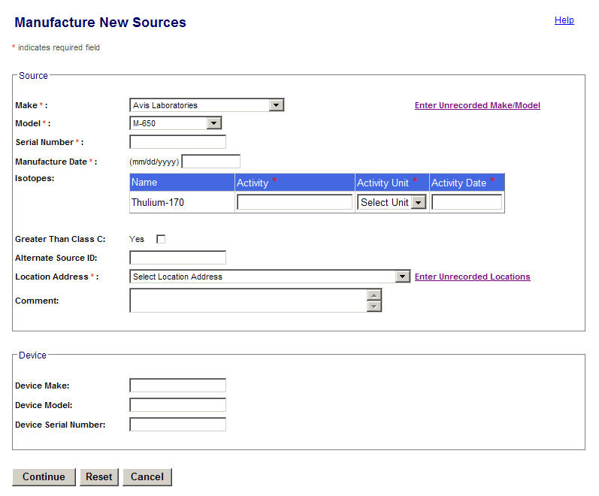
Figure 4-8: Manufacture New Source (Isotope Table)

- Enter the Source Serial Number designated by the manufacturer.
- Enter the Manufacture Date that the Source is manufactured.

Note: If another Source exists in the system with the same Make, Model, and Serial Number, the system will display an error message and prohibit the entry.

- Enter Isotope information (Activity, Activity Unit, and Activity Date) in the Isotopes table. The displayed isotopes are those Isotopes already associated with the entered Make/Model. The user does not have to enter values for each isotope row. If no value is entered on a row, that isotope is not saved with the source.

Note: Greater Than – If the Activity entered is greater than the Maximum Activity of the Source’s Make/Model, the system will display a WARNING to the user. This is a warning, but not a restriction; the system will still accept the entered Activity if the user chooses to ignore the warning.

- If the source manufactured is Greater Than Class C, check the GTCC check box. If the GTCC check box is not selected, the system will set the GTCC to NO.
Note: This field is optional.
- If applicable, enter an Alternate Source ID.
- Select a Location Address from the drop-down list, which is populated with all locations on file for the particular Licensee. If the drop-down list does not contain the appropriate Location Address, click the Enter Unrecorded Location link to enter the desired location.
- Any applicable comments may be entered in the Comment field. Up to 2000 characters may be entered.
- Enter Device Make, Model, and Serial Number, if applicable.
- If all entered information is correct, click Continue to proceed to the Review New Sources window. To discard all changes and exit the Manufacture a New Source window (returning to the NSTS Main Menu), click Cancel. To clear all entered data on the screen, click Reset and new data can be entered.
- In the Review New Sources window, review the information for each Source in the list.
- To remove a source, select the Remove check box located to the right of the Source information box, and then click Save.
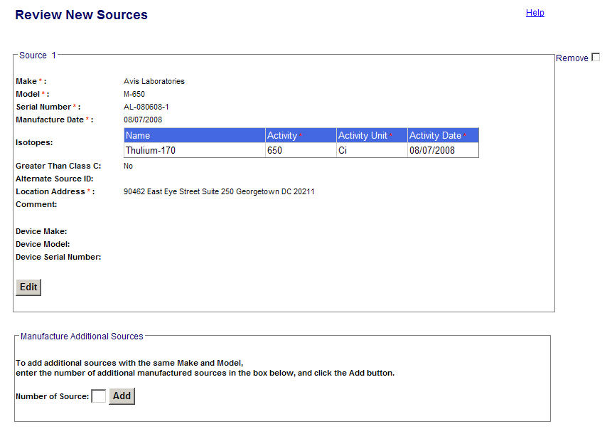
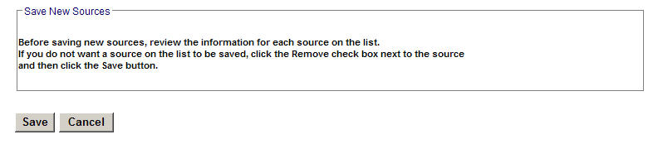
Figure 4-9: Manufacture New Source (Review New Sources)

- To edit the information in the Review window, click Edit to open the Edit Source window.

- In the Edit Source window, you can change information regarding an existing Source. The following fields must be populated: Serial Number, Manufacture Date, Isotope Activity, Isotope Activity Unit, Isotope Activity Date, and Location Address.

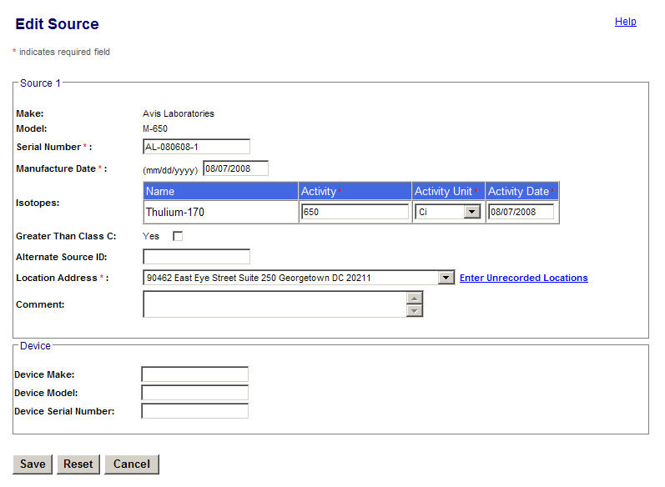
Figure 4-10: Manufacture New Source (Edit Source)

- To exit the Edit Source window without saving the information, click Cancel.

- To clear the entered information, click Reset.

- Once all changes have been entered, click Save to return to the Review New Sources window.

- To enter additional sources with the same Make and Model, enter the number of sources in the Number of Sources field, and then click Add.
- In the Manufacture Additional Sources window, fields that are required for entry include Serial Number, Manufacture Date, Isotope Activity, Isotope Activity Unit, and Isotope Activity Date. Manufacture Date and Activity Date must be less than or equal to the current date. Optionally, you can enter the Alternate Source ID.
- Before saving new Sources, review the information for each Source on the list, and then click Save.
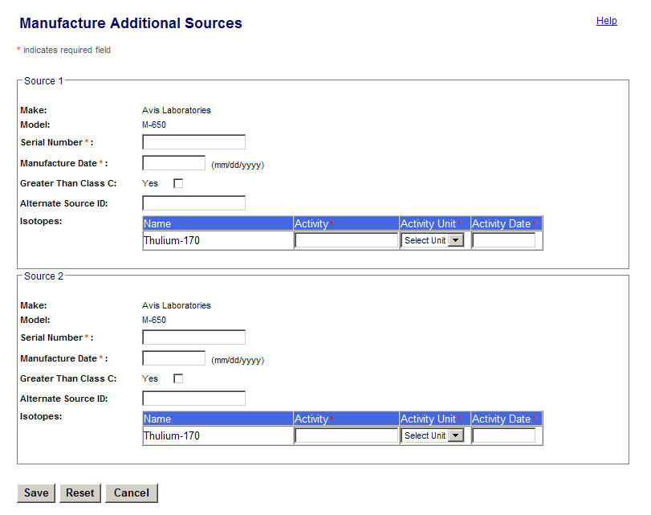
Figure 4-11: Manufacture New Source (Additional Sources)
- In the Review New Sources window, review the displayed data for accuracy.
- To save all new Sources and any other changes or updates to Sources, scroll down and then click Save.
- If you do not want a Source in the Review listing to be saved, select the Remove check box for the source, scroll down, and then click Save.

Figure 4-12: Manufacture New Source (Review New Sources)
- The Manufacturer New Sources Confirmation window will appear:

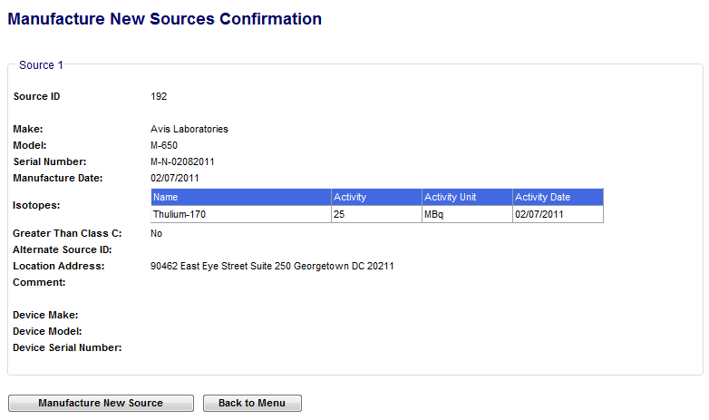
Figure 4-13: Manufacture New Source (Confirmation)

Note: You cannot edit in this window. To correct an error, from the NSTS Main Menu, click the Update Source Information link.

- Click the Back to Menu button to return to the NSTS Main Menu. Note: To enter a new source, click the Manufacture New Source button.

- When all new sources have been saved, several updates automatically occur, including:

  - Source ID, a unique system-generated number, is assigned to each source.
  - Source Status is set to Above Threshold.
  - Status Date and Entry Date are set to the current date.
  - Source Category will automatically be updated by comparing the calculated Activity to the category threshold (e.g., 1, 2, or blank).
  - Source will automatically be added to the Licensee’s inventory.

Regenerate Sources
User – Manufacturer Licensee, and Agreement State Staff, NRC Staff, and NSTS Analyst acting as a surrogate.

Use – Record when a Source is regenerated and has a new Activity amount.

- From the NSTS Main Menu, under Source Management, click Regenerate Source (see Figure 4-1).

- In the Search Sources for Regeneration window, enter search criteria, and then click Search. Note: To view all sources available for regeneration, leave search criteria fields blank, then click Search.

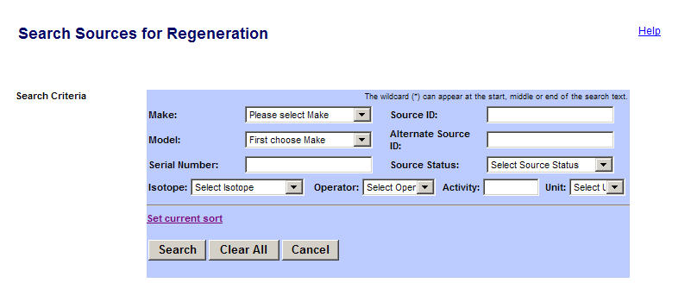
Figure 4-14: Regenerate Sources (Search Sources for Regeneration)

The following fields are available to enter search criteria for Source information:

Field Name | Req. Value | Description/Comments | Acceptable Values | Example Value
Make |  | Represents the manufacturer. Each Make will have one or more models associated with it. | Drop-down list | 800 Delta
Model |  | Item that is manufactured. Represents a Model associated with a Make. | Drop-down list | A424-19
Serial Number |  | Identification number assigned to a Source by the manufacturer. | Alphanumeric | TK12345
Source ID |  | A unique system-generated identifier for each manufactured source. | Numeric value | 23456234567
Alternate Source ID |  | Additional Source ID that is designated by the Licensee. | Alphanumeric | 456781B
Source Status |  | Status of trackable Sources | Drop-down list | Above Threshold
Isotope Name |  | Identification of the isotope in a Source. | Drop-down list | Cobalt-60
Isotope: Select Operator |  | A filter for search criteria. | Drop-down list | = (equal)
Isotope: Enter Activity |  | Activity level for isotope. | Numeric value | 223
Isotope: Select Unit |  | Unit in which the activity level of the Source is measured. | Drop-down list | Ci

Note: If no sources are found, the Search Results box will display “Your search yielded no results. Please try again.”

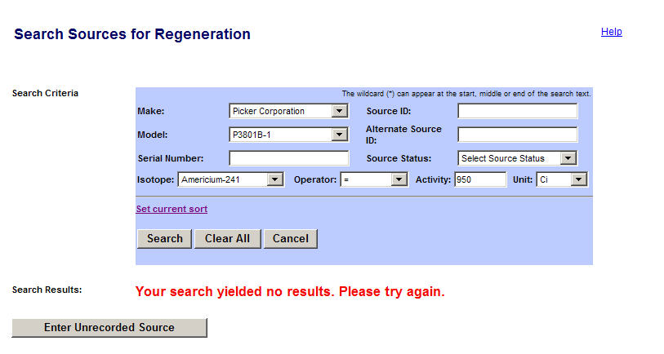
Figure 4-15: Regenerate Sources (No Source Found)

Note: If the source for regeneration is not found in the system, click Enter Unrecorded Source to enter it.

- In the Search Results box, select a source by clicking the Select radio button ().

Note: To see other fields in the Search Results window, use the horizontal scroll bar to scroll to the right.

- Click Regenerate Source.

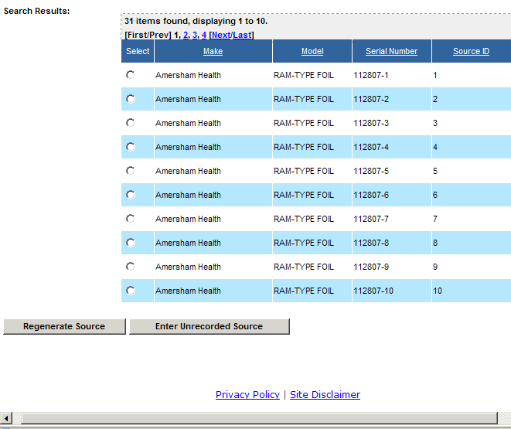
Figure 4-16: Regenerate Sources (Search Results)

- The Regenerate Source window appears.

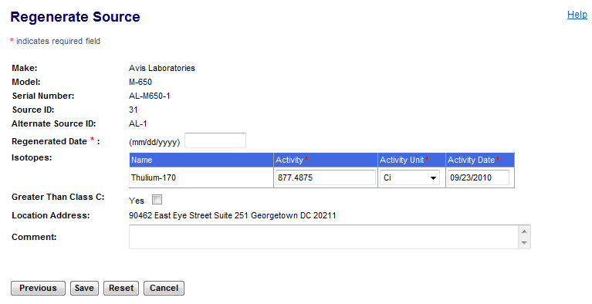
Figure 4-17: Regenerate Sources (Regenerate Source

Note: Click the Previous button to return to the Search Sources for Regeneration (Search Results) window, if this is not the item to be updated.

The following fields are available in the Regenerate Source window to enter Source information:

Field Name | Req. Value | Description/Comments | Acceptable Values | Example Value
Regenerated Date | Y | Date the Source is regenerated. | mm/dd/yyyy | 11/21/2006
Greater-Than-Class-C |  | Indicates a Source’s radioactivity exceeds the concentration limits established for Class C.  If the checkbox is not checked, the source will be recorded as Not GTCC. | Check mark
Isotope: Activity | Y | Activity level for isotope. | Numeric value | 223
Isotope: Activity Unit | Y | Unit in which the activity level of the Source is measured. | Drop-down list | Ci
Isotope: Activity Date | Y | Date the activity level of the Source is measured. Defaults to the entered Regenerated Date. | mm/dd/yyyy | 12/21/2006
Comment |  | Details entered as free-form text by the user. | Free-form text (up to 2000 characters). | The Source is active.

- Enter the Regenerated Date.
- For each Source Isotope, enter the Activity amount, Activity Unit, and Activity Date. Enter Comments, if any.

Note: All isotope values do not have to be populated. Isotopes without values in the activity fields will not be saved.
- Click Save. The Regenerate Source Confirmation window appears. Click Regenerate Sources to return to the Search Sources for Regeneration window to search for another source to regenerate. To return to the NSTS Main Menu, click Back to Menu.

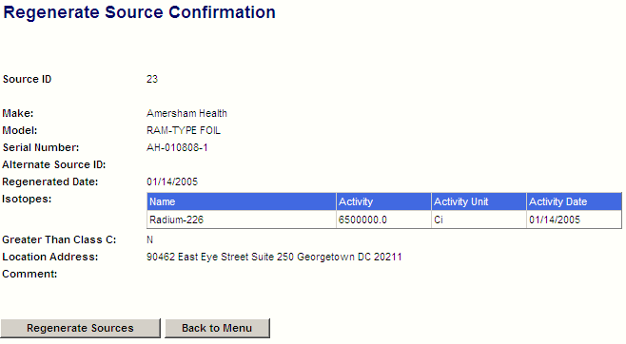
Figure 4-18: Regenerate Source (Confirmation)
- When all regenerated sources have been processed, several updates automatically occur, including:

  - Source Status is set to Above Threshold.
  - Source Originator is set to Licensee if the Source is regenerated by a Licensee (e.g., License ID) or to DOE if the Source is regenerated by a DOE Site.
  - For each isotope, the entered Activity and Activity Unit values will be used to calculate and internally store a Standard Activity value using a Standard Unit (e.g., Curies). This common unit simplifies system calculations and comparisons.
  - Source Category will automatically be updated by comparing the calculated Activity to the category threshold (e.g., 1, 2, or blank).

Update Source Information
User – Licensee, Licensing Agency, and NSTS Analyst and NRC Staff (acting as Licensee surrogate).

Use – Provide detailed information or correct erroneous information about Sources.

- From the NSTS Main Menu, under Source Management, click Update Source Information.

- The Search Sources for Update window appears.

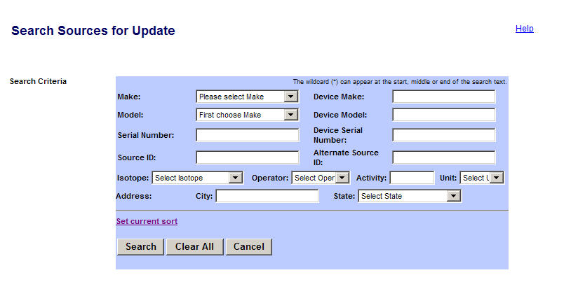
Figure 4-19: Update Source Information (Search Sources for Update)

The following fields are available to search Sources for update:

Field Name | Req. Value | Description/Comments | Acceptable Values | Example Value
Make |  | Represents the manufacturer. Each Make will have one or more models associated with it. | Drop-down list | 800 Delta
Model |  | Item that is manufactured. Represents a Model associated with a Make. | Drop-down list | A424-19
Serial Number |  | Identification number assigned to a Source by the manufacturer. | Alphanumeric | TK12345
Source ID |  | A unique system-generated identifier for each manufactured source. | Numeric value | 23456234567
Isotope Name |  | Identification of the isotope in a Source. | Entry from a Code Table | Cobalt-60
Isotope: Select Operator |  | A filter for search criteria. | Drop-down list | = (equal)
Isotope: Enter Activity |  | Activity level for isotope. | Numeric value | 223
Isotope: Select Unit |  | Unit in which the activity level of the Source is measured. | Drop-down list | Ci
Address City |  | Physical location of the U. S. City where the Source is located. A location cannot exist without an address. | Free-form text | Houston
Address State |  | Physical location of the U. S. State where the Source is located. A location cannot exist without an address. | Drop-down list | TX
Device Make |  | Make of the device containing a trackable nuclear source. | Alphanumeric | Acme
Device Model |  | Model of the device containing a trackable nuclear Source. | Alphanumeric | Acme xx
Device Serial Number |  | Device serial number assigned by the manufacturer. | Alphanumeric | L98X777
Alternate Source ID |  | Additional Source ID that is designated by the Licensee. | Alphanumeric | 456781B

- Enter search criteria, and then click Search. The results appear in the Search Results boxes at the bottom of the window.

Note: To view all Sources available for update, leave search criteria fields blank, then click Search.

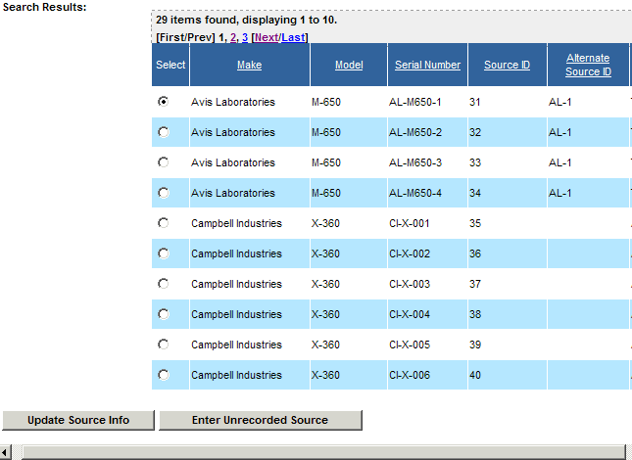
Figure 4-20: Update Source Information (Search Results)

- Select the source by clicking the Select radio button(). Note: To see other fields in the Search Results window, use the horizontal scroll bar to scroll to the right.

- Click Update Source Info. Note: If you cannot find the Sources in the system, click Enter Unrecorded Source.

- The Update Source Information window appears.
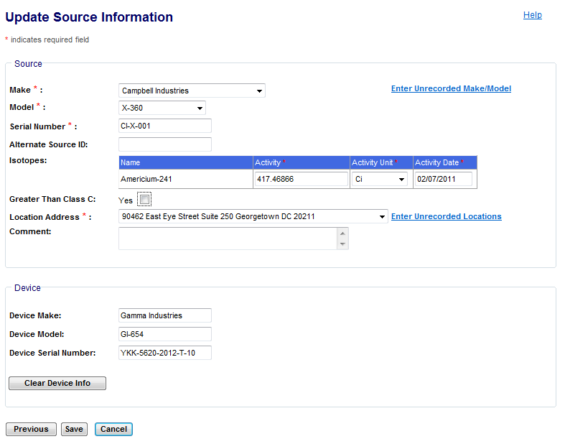
Figure 4-21: Update Source Information (Update Screen)

Note: Click the Previous button to return to the Search Sources for Update (Search Results) window, if this is not the item to be updated.

The following fields are available to update Source information:

Field Name | Req. Value | Description/Comments | Acceptable Values | Example Value
Make | Y | Represents the manufacturer. Each Make will have one or more models associated with it. | Drop-down list | 800 Delta
Model | Y | Item that is manufactured. Represents a Model associated with a Make. | Drop-down list | A424-19
Serial Number | Y | Identification number assigned to a Source by the manufacturer. | Alphanumeric | TK12345
Greater-Than-Class-C |  | Indicates a Source’s radioactivity exceeds the concentration limits established for Class C.  If the checkbox is not checked, the source will be recorded as Not GTCC. | Check mark
Isotope Name | Y | Identification of the isotope in a Source. | Entry from a Code Table; populated based on Make and Model. | Cobalt-60
Isotope: Activity | Y | Activity level for isotope. | Numeric value | 223
Isotope: Activity Unit | Y | Unit in which the activity level of the Source is measured. | Drop-down list | Ci
Isotope: Activity Date | Y | Date the activity level of the Source was measured. | mm/dd/yyyy | 12/21/2006
Location Address | Y | Physical location of the Source. A location cannot exist without an address. | Drop-down list | City: Houston State: TX
Device Make |  | Make of the device containing a trackable nuclear source. | Alphanumeric | Acme
Device Model |  | Model of the device containing a trackable nuclear Source. | Alphanumeric | Acme xx
Device Serial Number |  | Device serial number assigned by the manufacturer. | Alphanumeric | L98X777
Alternate Source ID |  | Additional Source ID that is designated by the Licensee. | Alphanumeric | 456781B
Comment |  | Details entered as free-form text by the user. | Free-form text (up to 2000 characters). | The Source is active.

- To update source information, enter updates in the available fields: Make, Model, Serial Number, Alternate Source ID, Isotopes information, Long-term Storage information, Location Address, and Comments, if any.
- If the Make or Model is not available on the Make drop-down list, click the Enter Unrecorded Make/Model link to enter it.
- If the Location address is not available on the Location Address drop-down list, click the Enter Unrecorded Location link to enter it.
- To clear information about the Device, scroll down and then click Clear Device Info.
- When all updates are complete, click Save. The Update Source Confirmation window appears.
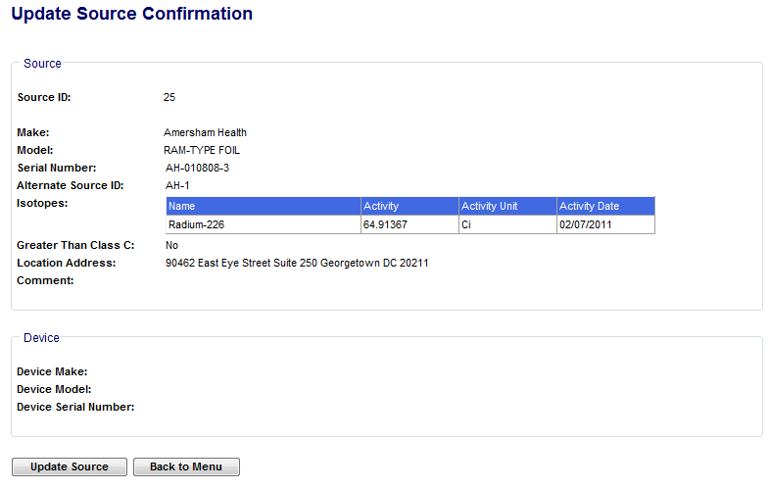
Figure 4-22: Update Source Information (Confirmation)

- Click Update Source to return to the Search Sources for Update window to update another source. To return to the NSTS Main Menu, click Back to Menu.
- When all Sources have been updated, the following will automatically occur:

  - For each isotope, the entered Activity and Activity Unit values will be used to calculate and internally store a Standard Activity value using a Standard Unit (e.g., Curies). This common unit simplifies system calculations and comparisons.
  - Source Category will automatically be updated by comparing the calculated Activity to the category threshold (e.g., 1, 2, or blank).
  - The Current Alternate Source ID will be copied to the Alternate Source ID in the Licensee’s Inventory record to preserve the Alternate Source ID history.

Note: The system will allow a Source to be deleted only if a Manufacturer has entered a Source but has never transferred it. In all other cases, a Source cannot be deleted. The system will mark the Source record as deleted, but not physically delete it. The Source is not seen by a non-NSTS Administrator. The record will remain online and retrievable only by an NSTS Administrator.
The Licensee cannot normally change the Make, Model, Serial Number, and Isotope information. This can only be changed if the Licensee is the Originator of the source and if the source has never been transferred to someone else. If someone other than the originator tries to update the source they will receive the following error message: “Only the originator of the source is able to modify the make, model, serial number and isotope information if the source has not been transferred.” It can also be changed by the Agency that is acting as a surrogate for the Licensee when updating source information. A NSTS Administrator shall be able to change any element of a Source except the system generated Source ID.

Record Destroyed Sources – Manufacturer
User – Manufacturer Licensee, Licensing Agency, and NSTS Analyst and NRC Staff (acting as a Licensee surrogate).

Use – Record in NSTS when a Source is destroyed.

Note: Once a source has been destroyed, it will not be possible to readily undo the action. Care should be taken when utilizing this functionality. If a Source is recorded as Destroyed in error, please contact the NSTS Help Desk at 1-877-671-NSTS (6787) to correct it.

- From the NSTS Main Menu, under Source Management, click Record Destroyed Source.

- The Search Sources for Recording Destroyed window appears.
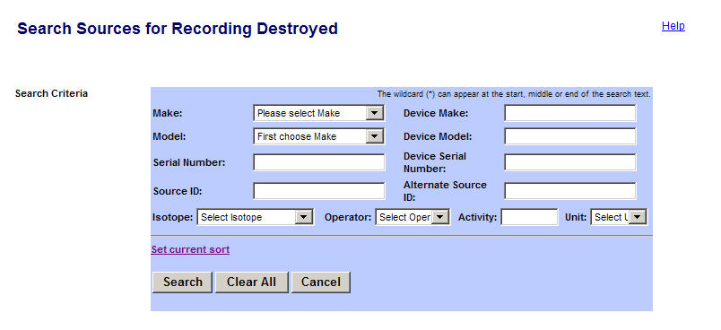
Figure 4-23: Record Destroyed Sources – Manufacturer (Search Criteria)

The following fields are available to enter Source search criteria:

Field Name | Req. Value | Description/Comments | Acceptable Values | Example Value
Make |  | Represents the manufacturer. Each Make will have one or more models associated with it. | Drop-down list | 800 Delta
Model |  | Item that is manufactured. Represents a Model associated with a Make. | Drop-down list | A424-19
Serial Number |  | Identification number assigned to a Source by the manufacturer. | Alphanumeric | TK12345
Source ID |  | A unique system-generated identifier for each manufactured source. | Numeric value | 23456234567
Isotope Name |  | Identification of the isotope in a Source. | Drop-down list | Cobalt-60
Isotope: Select Operator |  | A filter for search criteria. | Drop-down list | = (equal)
Isotope: Enter Activity |  | Activity level for isotope. | Numeric value | 223
Isotope: Select Unit |  | Unit in which the activity level of the Source is measured. | Drop-down list | Ci
Device Make |  | Make of the device containing a trackable nuclear source. | Alphanumeric | Acme
Device Model |  | Model of the device containing a trackable nuclear Source. | Alphanumeric | Acme xx
Device Serial Number |  | Device serial number assigned by the manufacturer. | Alphanumeric | L98X777
Alternate Source ID |  | Additional Source ID that is designated by the Licensee. | Alphanumeric | 456781B

- In the Search Sources window, enter search criteria and then click Search. The system presents a list of Sources that meet the criteria.

Note: To view all Sources to be marked as Record Destroyed, leave search criteria fields blank, and then click Search.

- Select a source by clicking the Select radio button (). Note: To see other fields in the Search Results window, use the horizontal scroll bar to scroll to the right.
- Click the Record Destroyed Source button.
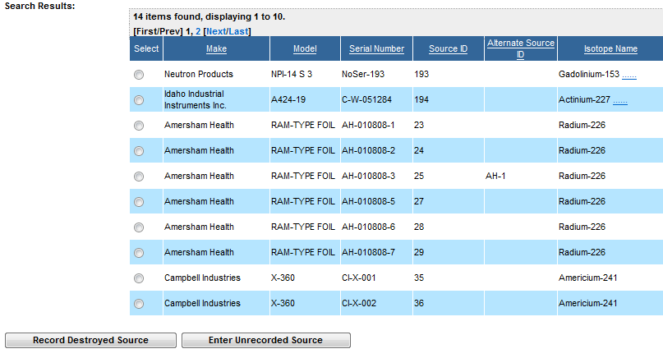
Figure 4-24: Record Destroyed Sources – Manufacturer (Search Results)

- The Record Destroyed Source window appears with the Make, Model, Serial Number, Source ID, Alternate Source ID (if applicable), Isotope information, Location Address, and Destroyed Date fields populated.

Note: The Destroyed Date defaults to the current date.

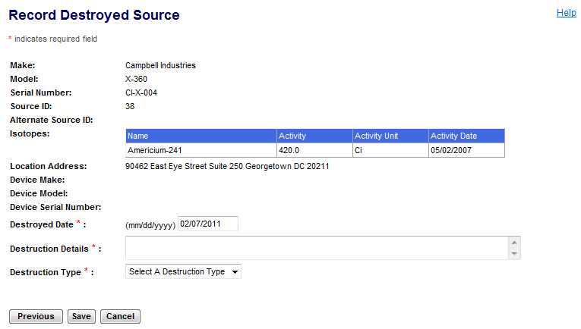
Figure 4-25: Record Destroyed Sources – Manufacturer (Destroyed Date/Details)

Note: Click the Previous button to return to the Record Destroyed Source (Search Results) window, if this is not the item to be updated.

The following fields are available in the Record Destroyed Source window to enter destruction information:

Field Name | Req. Value | Description/Comments | Acceptable Values | Example Value
Destroyed Date | Y | Date the Source was destroyed, i.e., no longer physically intact. (Must be on or before current date. Default is the current date.) | mm/dd/yyyy | 02/05/2002
Destruction Details | Y | Comment field. | Free-form text. | Destroyed for remanufacturing
Destruction Type | Y | Type of destruction that occurred. | Drop-down list | Accidental
- Enter the date the Source was destroyed in the Destroyed Date box. The system defaults to the current date.

- Enter a reason why the source was destroyed in the Destruction Details box.

- Select the type of destruction in the Destruction Type box.

- Click Save.

- When the confirmation window appears, click Record Destroyed Sources to return to the Search Sources for Recording Destroyed window to record the destruction of another source. To return to the NSTS Main Menu, click Back to Menu.

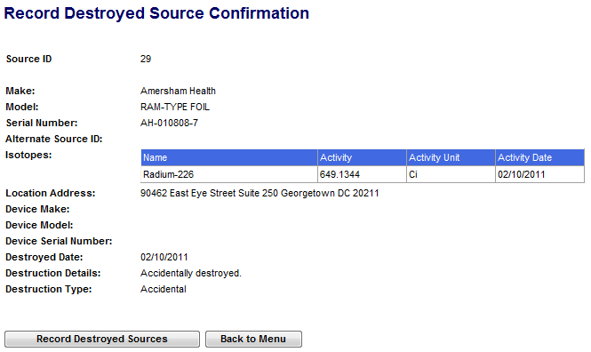
Figure 4-26: Record Destroyed Sources – Manufacturer (Confirmation)

- When all Sources have been updated, the Source status for the chosen Sources is set to Destroyed and the Device Make, Device Model, and Device Serial Number are blanked out.

Record Destroyed Sources – NRC Staff
User – NRC Staff, Licensing Agency, and NSTS Analyst (as a surrogate).

Use – Record in NSTS when a Source is destroyed.

Note: Once a source has been destroyed, it will not be possible to readily undo the action. Care should be taken when utilizing this functionality. If a Source is recorded as Destroyed in error, please contact the NSTS Help Desk at 1-877-671-NSTS (6787) to correct it.

- From the NSTS Main Menu, under Source Management, click the Record Destroyed Sources link. The Search and Choose Licensee window appears:

The following fields are available to search for a Licensee:

Field Name | Req. Value | Description/Comments | Acceptable Values | Example Value
Licensing Agency |  | Agency that has regulatory authority over the Licensees. Defaults to the user’s Agency. Only NRC staff or the NSTS Analyst can change the value of the Licensing Agency. | Drop-down list | NRC
Licensee Name |  | Name of the organization or individual to whom the license is issued. | Free-form text | ABC Company
License Number |  | Number assigned when a license is issued. | Drop-down list | 945AL733WP9990
Docket Number |  | License identifier used by NRC. Required for NRC Licensees only. Optional for search criteria. | Drop-down list | 05000313
License Category |  | The category of the License. | Drop-down list | Manufacturer
Location Address City |  | Name of the U. S. City to be searched. | Free-form text | Dallas
Location Address State |  | Name of the U. S. State to be searched. | Drop-down list | TX
Include Associated Licenses |  | Click the yes checkbox to include associated licenses in the search results | Checkbox
- Enter search criteria, and then click Search. The search results, a list of Licensees that meet the criteria, is displayed. Note: To see all Licensees, leave search criteria fields blank, then click Search.
- In the search results, select a Licensee by clicking the Select radio button (), and then click Continue.
- The Search Sources for Recording Destroyed window appears.
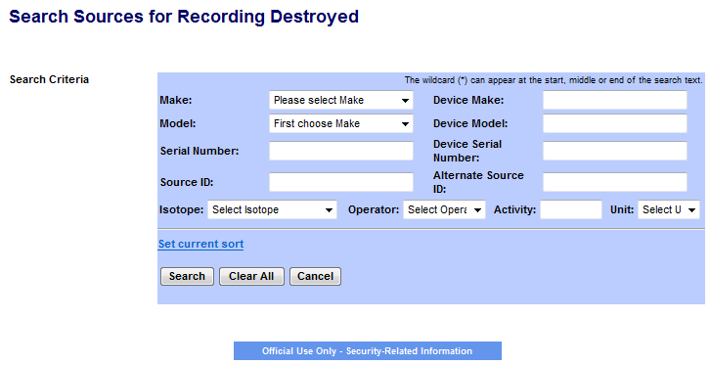
Figure 4-27: Record Destroyed Sources – NRC Staff (Search Criteria(

The following fields are available to specify the criteria to search for Sources:

Field Name | Req. Value | Description/Comments | Acceptable Values | Example Value
Make |  | Represents the manufacturer. Each Make will have one or more models associated with it. | Drop-down list | 800 Delta
Model |  | Item that is manufactured. Represents a Model associated with a Make. | Drop-down list | A424-19
Serial Number |  | Identification number assigned to a Source by the manufacturer. | Alphanumeric | TK12345
Source ID |  | A unique system-generated identifier for each manufactured source. | Numeric value | 23456234567
Isotope: Name |  | Identification of the isotope in a Source | Drop-down list | Cobalt-60
Isotope: Select Operator |  | A filter for search criteria. | Drop-down list | = (equal)
Isotope: Enter Activity |  | Activity level for isotope. | Numeric value | 223
Isotope: Select Unit |  | Unit in which the activity level of the Source is measured. | Drop-down list | Ci
Device Make |  | Make of the device containing a trackable nuclear source. | Free-form text | Acme
Device Model |  | Model of the device containing a trackable nuclear Source. | Free-form text | Acme xx
Device Serial Number |  | Device serial number assigned by the manufacturer. | Free-form text | L98X777
Alternate Source ID |  | Additional Source ID that is designated by the Licensee. | Free-form text | 456781B
- Enter search criteria, and then click Search. The system presents a list of sources that meet the criteria.

Note: To view all sources available for recording as destroyed, do not enter any search criteria, and click Search.

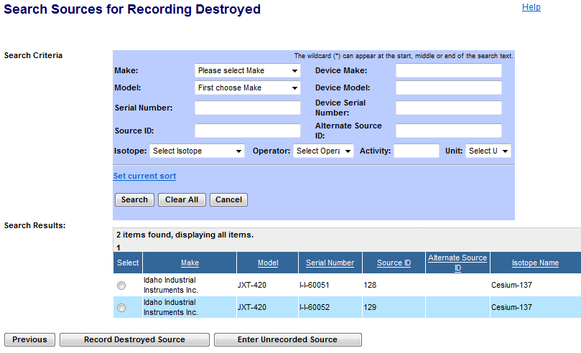
Figure 4-28: Record Destroyed Sources – NRC Staff (Search Results)

Note: Click the Previous button to return to the Search Sources for Recording Destroyed window.

- Review and select a Source by clicking the Select radio button (), and then click Record Destroyed Sources. Note: You can only select one source at a time.

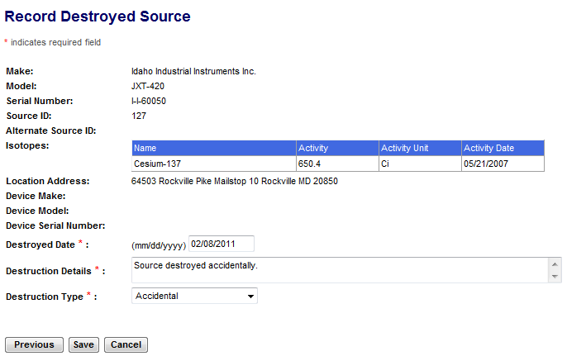
Figure 4-29: Record Destroyed Sources – NRC Staff (Destroyed Date/Details)

Note: Click the Previous button to return to the Search Sources for Recording Destroyed (Search Results) window, if this is not the item to be updated.

  - The Record Destroyed Source window appears with the Make, Model, Serial Number, Source ID, Alternate Source ID (if applicable), Isotope information, Location Address, and Destroyed Date fields populated.

The following fields are available to enter Destruction information:

Field Name | Req. Value | Description/Comments | Acceptable Values | Example Value
Destroyed Date | Y | Date the Source was destroyed, i.e., no longer physically intact. (Must be on or before current date. Default is the current date.) | mm/dd/yyyy | 02/05/2002
Destruction Details | Y | Comment field | Free-form text | Destroyed for remanufacturing
Destruction Type | Y | Indicates how Source was destroyed, i.e., type of destruction that occurred. | Drop-down list | Accidental

- Enter the date the source was destroyed in the Destroyed Date box. System defaults to the current date.

- Enter a reason why the source was destroyed in the Destruction Details box.

- Select the type of destruction in the Destruction Type box.

- Click Save.

- When the confirmation window appears, click Record Destroyed Sources to return to the Search Sources for Recording Destroyed window to record the destruction of another source. To return to the NSTS Main Menu, click Back to Menu.

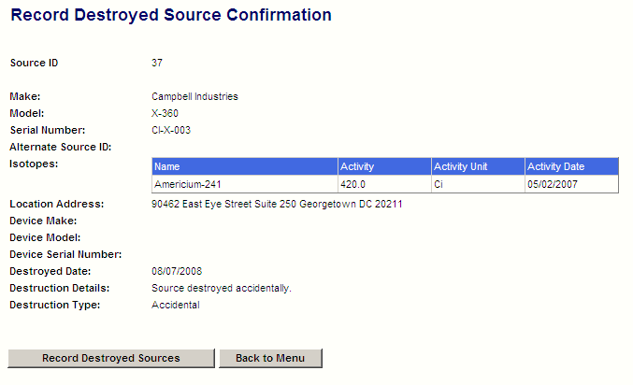
Figure 4-30: Record Destroyed Sources – NRC Staff (Confirmation)
- When the record is saved, the Source status for the chosen Sources is set to Destroyed and the Device Make, Device Model, and Device Serial Number are blanked out.

Specify Long-Term Storage Sources
User – Licensees, and (acting as a licensee surrogate) Agreement State Staff, NRC Staff, DOE Staff, and NSTS Analysts.

Use – A Licensee that has sources which are no longer in use, yet which cannot be disposed of (e.g., Greater Than Class C) may use NSTS to indicate that the source is in long-term storage.

- From the NSTS Main Menu, under Source Management, click the Specify Long-Term Storage Sources link. The Search Sources for Specify Long-Term Storage window will be displayed.

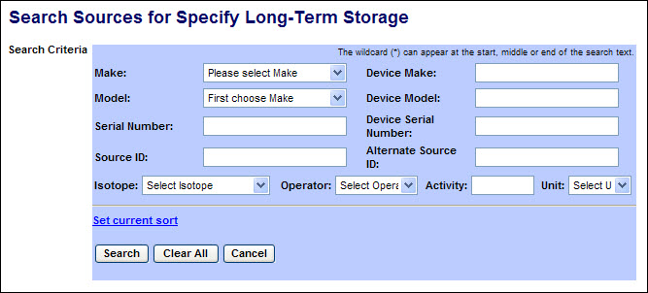
Figure 4-31: Specify Long-Term Storage (Search Criteria)

The following fields are available to specify the criteria to search for Sources:

Field Name | Description/Comments | Acceptable Values | Example Value
Make | Represents the manufacturer. Each Make will have one or more models associated with it. | Drop-down list | Delta
Model | Item that is manufactured. Represents a Model associated with a Make. | Drop-down list | A424-19
Serial Number | Identification number assigned to a Source by the manufacturer. | Alphanumeric | TK12345
Source ID | A unique system-generated identifier for each manufactured source. | Numeric value | 23456
Isotope: | Identification of the isotope in a Source | Drop-down list | Cobalt-60
Operator | A filter for searching by the level (greater than, less than, etc.) of the current activity. | Drop-down list | = (equal)
Activity | Current activity level for isotope. | Numeric value | 223
Unit | Unit in which the activity level of the Source is measured. | Drop-down list | Ci
Device Make | Make of the device containing a trackable nuclear Source. | Alphanumeric | Acme
Device Model | Model of the device containing a trackable nuclear Source. | Alphanumeric | Acme123
Device Serial Number | Device serial number assigned by the manufacturer. | Free-form text | L98X777
Alternate Source ID | Additional Source ID designated by the Licensee. | Alphanumeric | 456781B

- Enter search criteria and click the Search button.
A list of sources meeting the search criteria will be displayed. (If no criteria are entered, all trackable sources in the licensee’s inventory will be listed.)

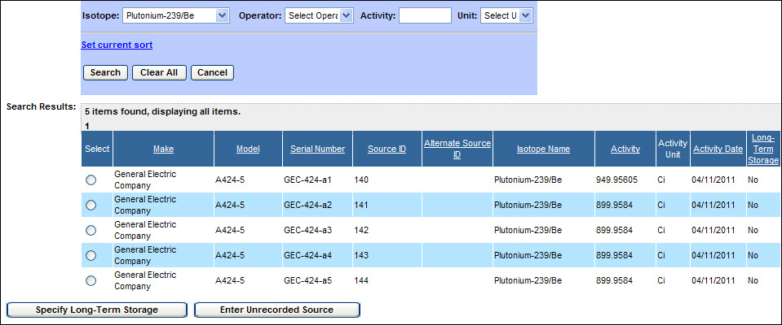
Figure 4-32: Specify Long-Term Storage (Search Results)

- From the search results displayed, select the radio button () for the desired source. Then click the Specify Long-Term Storage button.

Note: If the Source cannot be found, the Licensee must first enter the Source by selecting the Enter Unrecorded Sources button (Refer to User Guide Section 4.4.1).

- The Specify Long-Term Storage Source window will be displayed.

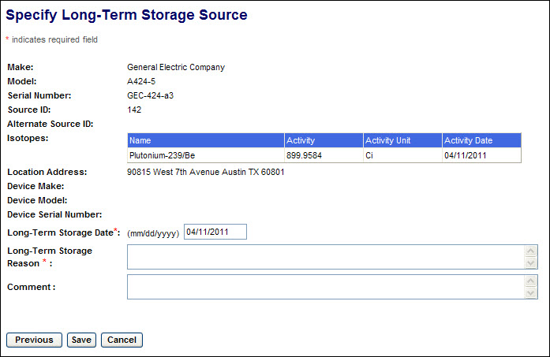
Figure 4-33: Specify Long-Term Storage (Storage Information)

- Enter source storage information in the following fields:

- Long-Term Storage Date (Required) – Enter the date the source will be or was placed in long-term storage.
- Long-Term Storage Reason (Required) – Enter the reason the source was placed in long-term storage, (e.g., Available for reuse).
- Comment (Optional) – Although this field is not required, you may enter comments that would be applicable.

- After populating the form, click the Save button. The Specify Long-Term Storage Source Confirmation window will be displayed.

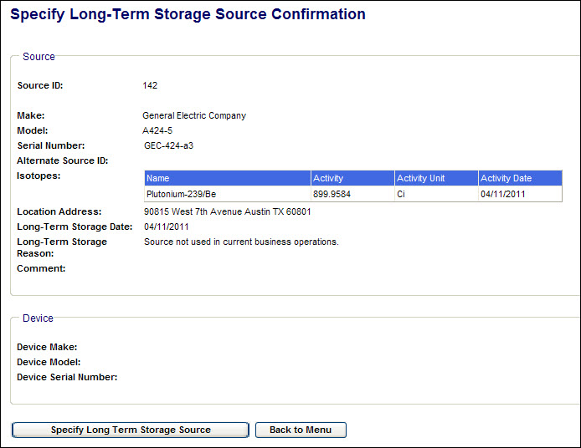
Figure 4-34: Specify Long-Term Storage Source (Confirmation)

- Click the Specify Long Term Storage Source button to select another source for long-term storage, or click the Back to Menu button to return to the NSTS Main Menu.

Dispose Source
User – Disposer Licensee, Licensing Agency, and NSTS Analyst and NRC Staff (acting as Licensee surrogate).

Use – Disposer Licensee records in NSTS when a Source is disposed.

- From the NSTS Main Menu, under Source Mangaement click the Dispose Source link.

- The Search Sources for Dispose window appears.

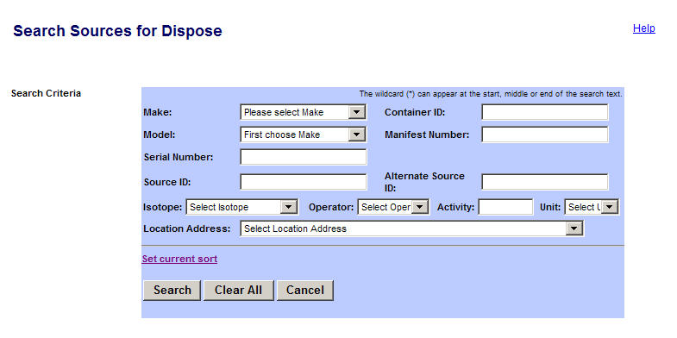
Figure 4-35: Search Sources for Dispose

The following fields are available to search Sources for disposal:

Field Name | Description/Comments | Acceptable Values | Example Value
Make | Represents the manufacturer. Each Make will have one or more models associated with it. | Drop-down list | 800 Delta
Model | Item that is manufactured. Represents a Model associated with a Make. | Drop-down list | A424-19
Serial Number | Identification number assigned to a Source by the manufacturer. | Alphanumeric | TK12345
Source ID | A unique system-generated identifier for each manufactured source. | Numeric value | 23456234567
Isotope Name | Identification of the isotope in a Source. | Drop-down list | Cobalt-60
Isotope: Select Operator | A filter for search criteria. | Drop-down list | = (equal)
Isotope: Enter Activity | Activity level for isotope | Numeric value | 223
Isotope: Select Unit | Unit in which the activity level of the Source is measured. | Drop-down list | Ci
Container ID | ID of the container to be disposed. | Numeric value | 02349294
Manifest Number | Number used in a shipping record. | Alphanumeric | 555229999
Alternate Source ID | Additional Source ID that is designated by the Licensee. | Alphanumeric | 456781B
Address City | Name of the U. S. City. | Free-form text | Dallas
Address State | Name of the U. S. State. | Drop-down list | TX

- In the Search Sources for Dispose window, select the criteria to record disposal of Sources, and then click Search.

Note: To see all sources available for disposal, leave search criteria fields blank, and then click Search.

- In the Search Results window, click the Select radio button to select a Source to be disposed.

Note: To see other fields in the Search Results window, use the horizontal scroll bar to scroll to the right. Click Dispose Source.

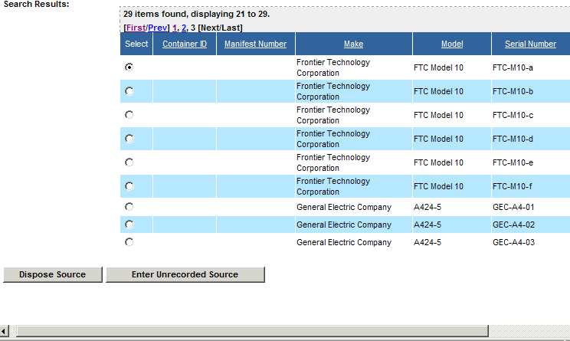
Figure 4-36: Search Sources for Dispose (Search Results)

- The Dispose Source window appears.

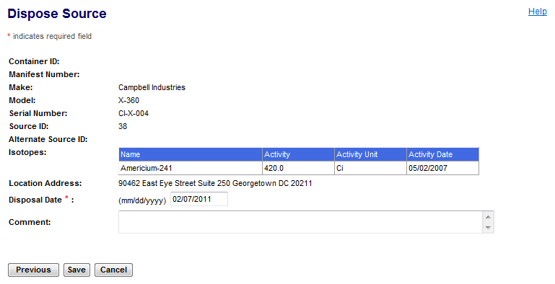
Figure 4-37: Dispose Source

Note: Click the Previous button to return to the Search Sources for Dispose (Search Results) window, if this is not the item to be updated.

The following fields are available to enter information:

Field Name | Req. Value | Description/Comments | Acceptable Values | Example Value
Disposal Date | Y | Date a Source was disposed. Defaults to the current date. | Numeric value | 12/31/2006
Comment |  | Details about the disposal of the Source. | Free-form text (up to 2000 characters). | The container was buried in Area 3.

- Enter the Disposal Date. The system will default the disposal date to the current date.
- Enter comments, if any, in the Comment box.

- Click Save.

- When the Dispose Source Confirmation window appears, click Dispose Sources to return to the Search Sources for Dispose window. To return to the NSTS Main Menu, click Back to Menu.

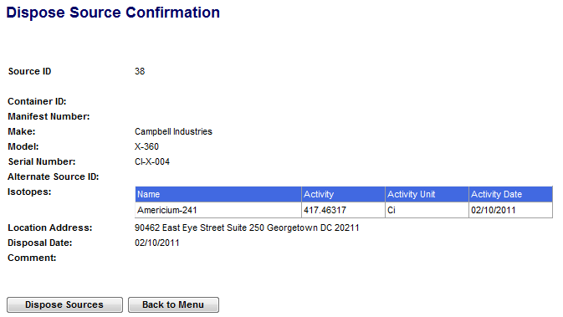
Figure 4-38: Dispose Source Confirmation

- If the chosen source that was disposed of is part of a container, then all other sources in that container are also automatically disposed.

Annual Inventory Reconciliation
The NRC requires the Licensee to review and confirm their inventory annually in the NSTS. Failure to do so is cause for the Licensee’s license to be revoked by the NRC. This regulation applies to all licensees who use the NSTS.
To support NRC requirements for annual licensee inventory reconciliation each January, a specially formatted inventory report has been created to enable the Licensee to confirm their inventory and ensure the inventory record in the NSTS is correct.

Verify Annual Inventory Reconciliation Report
User – Licensees or Agency Users (Agreement States [A/S], NRC, or Department of Energy [DOE] acting as surrogates for Licensees.

Use – Verify and print annual inventory reconciliation reports. Export inventory reconciliation files to a Microsoft Excel spreadsheet or a portable document format (PDF) file..

For a detailed description of the Annual Inventory Reconciliation function (with windows), refer to the NSTS Annual Inventory Reconciliation User Guide, version 0.3, dated November 2009.

- From the NSTS Main Menu, click Annual Inventory Reconciliation. The Annual Inventory Reconciliation Report window opens.

- To verify an annual inventory reconciliation (after successful verification of a licensee’s existing inventory against the inventory records in the NSTS), scroll to the bottom of the screen and click Verify Annual Inventory. The Annual Inventory Reconciliation window opens.

- Read the statements confirming that the data in the system is correct for your license as of the date populated in the Reconciliation Date.

- Enter your name in the Name of Signer field.

- Enter the date the activity occurred in the Reconciliation Date field.

Note: The reconciliation date must be a date in the current year and must be a date before today’s date. The reconciliation date defaults to today’s date. The Reconciliation Year field is non-editable and defaults to the current year.

- Click Save (the reconciliation confirmation window appears), or click Cancel to return to the NSTS Main Menu without confirming the data.

- In the confirmation window, review the information, and then click Back to Menu to return to the NSTS Main Menu.

Print an Inventory Report
- From the Annual Inventory Reconciliation Report window, click Print Inventory Report. A Print dialog box appears. Note: Set your printer orientation to Landscape.

- Click Print. To close the box without printing a report, click Cancel.

Export Options
You can export reconcialiation inventory data to a Microsoft Excel file or to a Portable Document Format (PDF) file. Both file formats can be saved to a location of your choice.

Microsoft Excel file
- From the Annual Inventory Reconciliation Report window, click the Excel link.
- A File Download dialog box appears, asking if you want to open or save the file.
- Click Open to view the file, or to save the file to a location of your choice, click Save. To cancel the download, click Cancel.

PDF
- From the Annual Inventory Reconciliation Report window, click the PDF link.
- A File Download box appears, asking if you want to open or save the file.
- Click Open to view the file, or to save the file to a location of your choice, click Save. To cancel the download, click Cancel.

Pre-Existing Inventory Reconciliation Record
User – Licensee or Agency user acting as a surrogate for the Licensee.

Use – Licensee acting as a surrogate attempts to perform an annual inventory reconciliation that has already been confirmed by the system. For more detailed information on this function (with windows), refer to the NSTS Annual Inventory Reconciliation User Guide, version 0.3, dated November 2009.
- From the NSTS Main Menu, the Licensee surrogate clicks Annual Inventory Reconciliation. The Annual Inventory Reconciliation Report window appears.
- If an inventory reconciliation record already exists in the system, a message highlighted in red will display: ‘The current year licensee’s annual inventory reconciliation record exists in the system,’ indicating that the reconciliation has been completed. The Verify Annual Inventory button will be grayed out.
- To print a copy of the report, click Print Inventory Report. The Print dialog box appears.
Note: Set your printer orientation to Landscape.
- Click Print, or click Cancel to return to the Reconciliation Report window. Click Cancel again to return to the NSTS Main Menu.

View Annual Inventory Reconciliation Status (Agency User)
The Agency User can view the status of the annual inventory, or click the Licensee Details link to view detailed information for each Licensee. For a detailed description of the Annual Inventory Reconciliation function (with windows), refer to the NSTS Annual Inventory Reconciliation User Guide, version 0.3, dated November 2009.

User –Agency Users (Agreement States, NRC, or DOE) or NSTS Analyst.

Use – View the status of the annual inventory reconciliation.
- From the NSTS Main Menu, click View Annual Inventory Reconciliation Status. The View Annual Inventory Reconciliation Status window appears.
- To view the reconciliation status for a particular year, select the year in the Reconciliation Year drop-down list. Click Continue. The View Annual Inventory Reconciliation Status–Agency window appears.
- The reconciliation status information is grouped at the agency level. An Agreement States staff user only sees their agency’s status, NRC staff sees the NRC’s own status, DOE staff sees its status inventory, and the NSTS Analyst sees the status of all the agencies.
- To view detailed information for each Licensee in the agency, click the Licensee Details link. The View Annual Inventory Reconciliation Status–Licensee window appears.
- The Agency user can view completion status and date information for each licensee. The licensee’s contact information (Name and Phone) is included in the table to assist the Agency user or NSTS analyst in contacting licensees.
- To return to the NSTS Main Menu, click Close.

Manufacture New Sources - Bulk
User – Manufacturer Licensee, DOE, Agreement State Staff, NRC Staff, and NSTS Analyst as Surrogate.

Use – To record a large volume of source manufacturing data.

- From the NSTS Main Menu, under Source Management click Manufacture New Sources - Bulk.

- The Manufacture Bulk New Sources window appears..

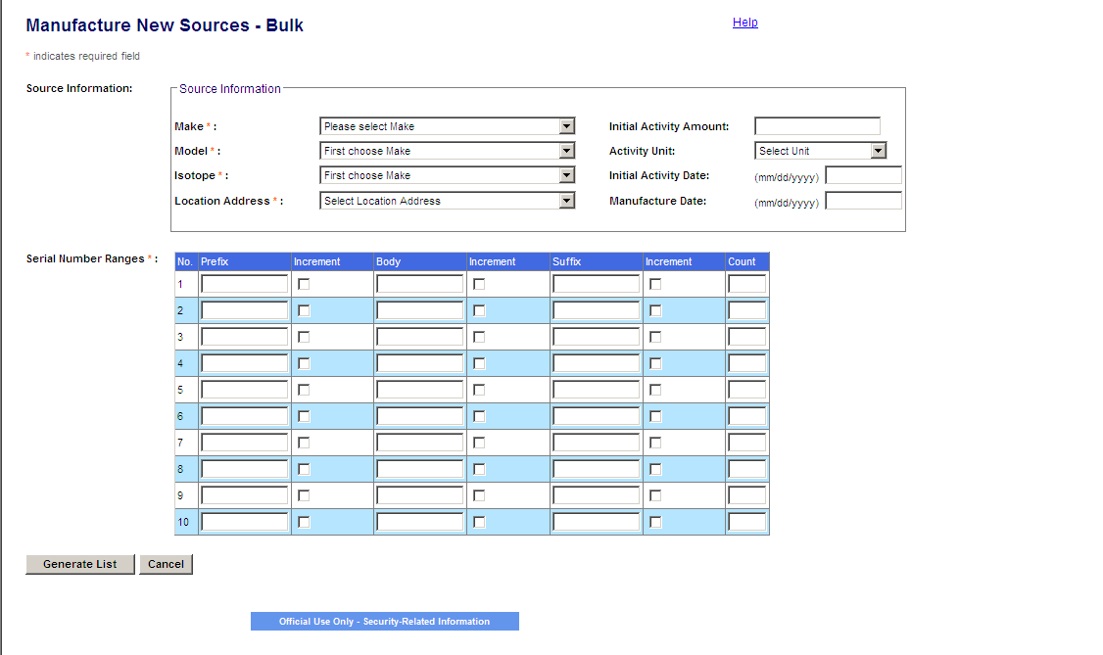
Figure 4-39: Manufacture a New Source

The following fields are available to enter Source information:

Field Name | Req. Value | Description/Comments | Acceptable Values | Example Value
Make | Y | Make/manufacturer of the Source. Each Make will have one or more Models associated with it. | Drop-down list | 800 Delta
Model | Y | Item that is manufactured. Represents a Model associated with a Make. | Drop-down list | A424-19
Isotope | Y | Identification of the isotope in a Source. This field will not appear until the Make and Model are selected. | Entry from a Code Table; populated based on Make and Model. | Cobalt-60
Initial Activity Amount | N | Activity level of the Source. This field will not appear until the Make and Model are selected. | Numeric value | 223
Activity Unit | N | Unit in which the activity level of the Source is measured. | Drop-down list | Ci
Initial Activity Date | N | Date the activity level of the Source is measured. | mm/dd/yyyy | 01/02/2006
Manufacture Date | N | Date the Source is manufactured. | mm/dd/yyyy | 02/05/2003
Location Address: | Y | Physical location of the Source. A location cannot exist without an address. | Drop-down list | 415 Oak Road  Suite 101  Town, LA 70360-0000
Serial Number Ranges |  | The validation rules for a row in the Serial Number Range table are:  - Values for ‘Prefix’, ‘Body’, and ‘Suffix’ can be a string of alphanumeric characters (including empty string).  - For any given row, one and only one checkbox under the column labeled ‘Increment’ may be checked.  - The value for the column labeled ‘Count’ can only be numeric. If values are specified for prefix, body or suffix and the count field is empty, an error message will be shown.  The rules for serial number generation are as follows:  - The data entered for the ‘Prefix’, ‘Body’, and ‘Suffix’ portion of the Serial Number will be treated as fixed string. And one of these values will be used as the base during Serial Number generation.  - The checkbox labeled ‘Increment’ to the right of one of ‘Prefix’, ‘Body’, or ‘Suffix’ determines the respective portion of the serial number that gets incremented (during Serial Number generation).  The discrete value for increment will start with the value specified in field corresponding to the checked increment field. | Prefix = AA  Body = BB  Suffix = CC

- Select a Make, Model, and Isotope from the drop-down list.

- Select a Location Address from the drop-down list, which is populated with all locations on file for the particular Licensee. If the drop-down list does not contain the appropriate Location Address, click the Enter Unrecorded Location link to enter the desired location.

- The Initial Activity, Activity Date, and Manufacture Date should be entered if it is the same for all sources, but are all optional fields.

- Enter a range of unique Serial Numbers up to 10 in 3 parts (prefix, body, and suffix).

- If all entered information is correct, click Generate List to generate a tabular list of the generated source records where the user will be required to enter any missing data, such as variable initial activity levels or manufacture dates.

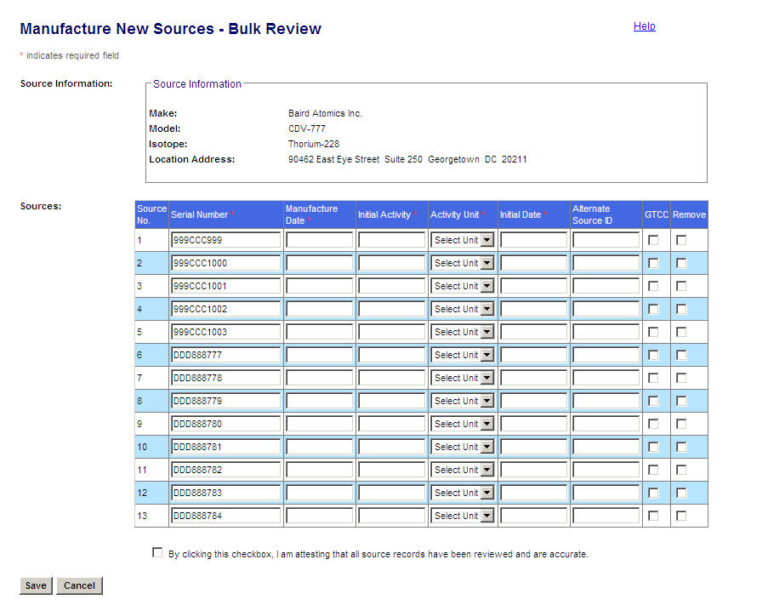
Figure 4-40: Manufacture Bulk New Sources Review

- In the Manufacture Bulk New Sources Review window review the information for each Source in the list.

- The user now has the ability to enter an alternate id, click the GTCC check box, or remove the source.

- All the fields are editable except the row number.

- Before saving new Sources, review the information for each Source on the list, and then click Save.

- In the Review New Sources window, review the displayed data for accuracy.

- Click the “By clicking this checkbox, I am attesting that all source records have been reviewed and are accurate” check box.

- To save all new Sources and any other changes or updates to Sources, scroll down and then click Save.
Note: If another Source exists in the system with the same Make, Model, and Serial Number, the system will display an error message and prohibit the entry and the entire transaction will be rolled back.

- If you do not want a Source in the Review listing to be saved, select the Remove check box for the source, scroll down, and then click Save.

Note: Greater Than – If the Activity entered is greater than the Maximum Activity of the Source’s Make/Model, the system will display a WARNING to the user. This is a warning, but not a restriction; the system will still accept the entered Activity if the user chooses to ignore the warning.
- The Manufacture Bulk New Sources Confirmation window will appear.

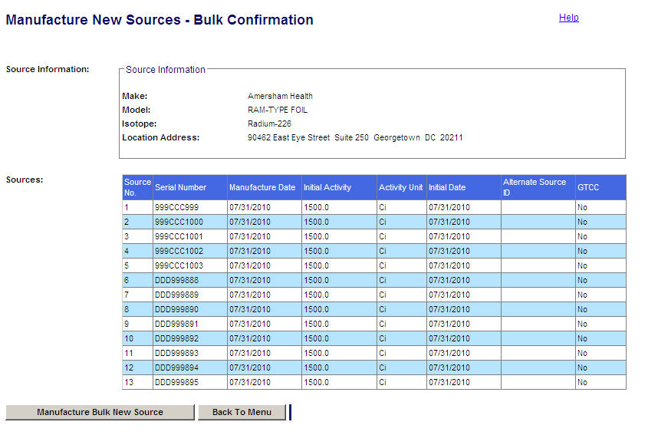
Figure 4-41: Manufacture Bulk New Sources Confirmation

Record Lost or Stolen Source

User – NRC Staff, State Agency Staff, DOE Staff, and NSTS Analysts.

Use – A Licensee must report to its respective agency (the NRC, Agreement States, or DOE) when Sources are lost or stolen. The recording of a lost/stolen source in the NSTS is typically done by the NRC Operations Center or the Agreement State / DOE equivalents.

      - From the NSTS Main Menu, under Source Management, click the Record Lost or Stolen Sources link. The Search and Choose License window will be displayed.

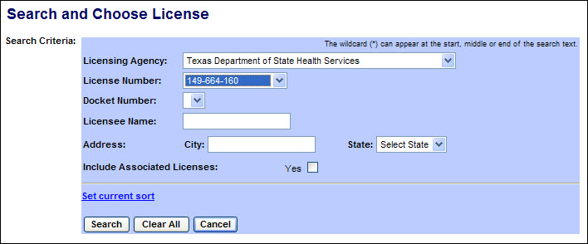
Figure 4-42: Record Lost or Stolen Source (Search for License)

The following fields are available to define the search:
Field Name | Description/Comments | Acceptable Values | Example Value
Licensing Agency | The Agency that has regulatory authority over the Licensee. An NRC user or NSTS Analyst can select a Licensing Agency. A DOE user or State Agency user can select only their agency. | Drop-down list | Ohio Department of Health
License Number | Number assigned when a license is issued. | Drop-down list | 45-27764-01
Docket Number | License identifier used by NRC. NRC Licensees only. | Alphanumeric | 05000313
Licensee Name | Name of the organization to which the license was issued. | Free-form text | ABC Company
Address: City | City in which the license address is located. | Free-form text | Hanover
Address: State | State in which the license address is located. | Drop-down list | OH
Include Associated Licenses: Yes | If a search returns a license that has licenses associated with it, the associated licenses will be included in the search results. | Check mark

- Enter the search criteria to display a list of Licenses, and then click Search. A list of licenses meeting the search criteria will be displayed. (If no criteria are entered, all licenses accessible to the user will be listed.)
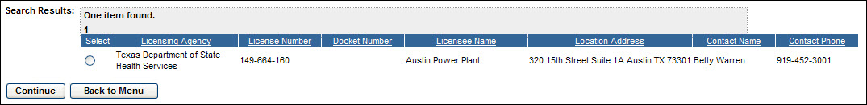
Figure 4-43: Record Lost or Stolen Source (Search Results – Licenses)
3. Click the radio button () for the applicable Licensee, then click the Continue button. The Search Sources for Record Lost or Stolen search criteria window will be displayed.

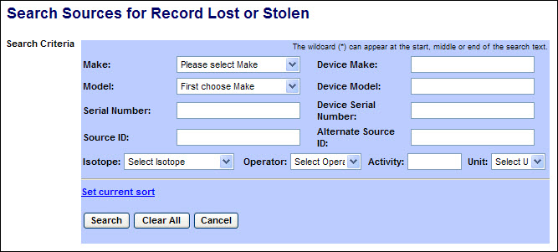
Figure 4-44: Record Lost or Stolen Source (Search for Sources)

The following fields are available to enter search criteria:

Field Name | Description/Comments | Acceptable Values | Example Value
Make | Represents the manufacturer. Each Make has one or more models associated with it. | Drop-down | Delta
Model | Item that is manufactured. Represents a Model associated with a Make. | Drop-down | A424-19
Serial Number | Identification number assigned to a Source by the manufacturer. | Alphanumeric | TK12345
Source ID | A unique system-generated identifier for each manufactured source. | Numeric value | 23456
Device Make | Make of the device containing a trackable nuclear Source. | Alphanumeric | Acme
Device Model | Model of the device containing a trackable nuclear Source. | Alphanumeric | Acme123
Device Serial Number | Device serial number assigned by the manufacturer. | Alphanumeric | L98X777
Alternate Source ID | Additional Source ID that is designated by the Licensee. | Alphanumeric | 456781B
Isotope | Identification of the isotope in a Source | Drop-down list | Cobalt-60
Operator | A filter for searching by the level (greater than, less than, etc.) of the current activity. | Drop-down list | = (equal)
Activity | Current activity level for isotope. | Numeric value | 223
Unit | Unit in which the activity level of the Source is measured. | Drop-down list | Ci

- Enter the search criteria, and then click Search. A list of sources in the selected licensee’s inventory which meet the search criteria will be displayed. (If no criteria are entered, all sources in the licensee’s inventory will be listed.)

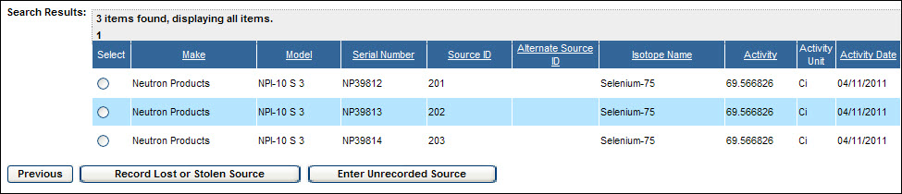
Figure 4-45: Record Lost or Stolen Source (Search Results – Sources)

Note: If the Source cannot be found, the Licensee must first enter the Source by selecting the Enter Unrecorded Sources button (Refer to User Guide Section 4.4.1).

- Click the radio button () for the lost/stolen source, and then click the Record Lost or Stolen Source button. The Record Lost or Stolen Source window appears:

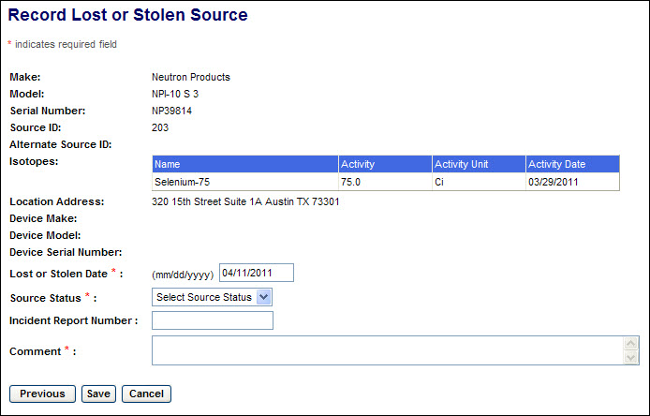
Figure 4-46: Record Lost or Stolen Source (Source Information)

Note: Click the Previous button to return to the search results window.

- Review the information presented.

- Enter the applicable information in the following fields:

Field Name | Req. Value | Description/Comments | Acceptable Values | Example Value
Lost or Stolen Date | Y | Enter date of lost or stolen item. | mm/dd/yyyy | 02/09/2011
Source Status | Y | Use the drop-down arrow to select the appropriate status. | Drop-down | Lost
Incident Report Number | N | Enter the Incident Report Number. | Free-form text | 2011TX035
Comment | Y | Enter comments regarding situation involving the Lost or Stolen Source. | Free-form text

- Select the Save button. A confirmation of the report will be displayed.

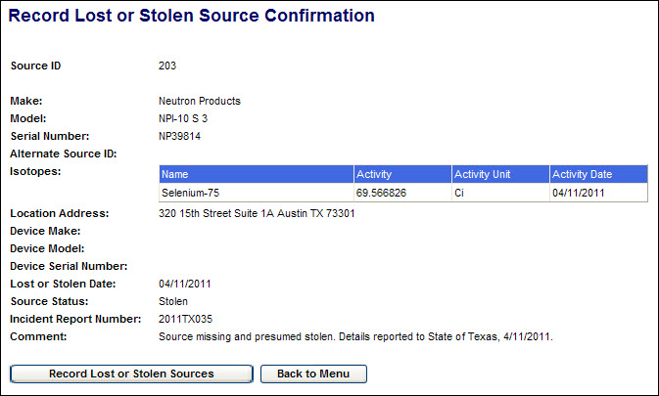
Figure 4-47: Record Lost or Stolen Source (Confirmation of Report)

On the confirmation screen, click the Back to Menu button to return to the NSTS Main Menu or click the Record Lost or Stolen Sources button to record another lost or stolen source.

Record Irretrievable Source
User – NRC Staff, State Agency Staff, DOE Staff, and NSTS Analysts

Use – A Licensee must report to its licensing agency (the NRC, Agreement State, or DOE) when a Source is irretrievable. The recording of an irretrievable source in the NSTS is typically done by the NRC Operations Center or the Agreement State / DOE equivalents.

- From the NSTS Main Menu, under Source Management, click the Record Irretrievable Source link. The Search and Choose License window will be displayed.

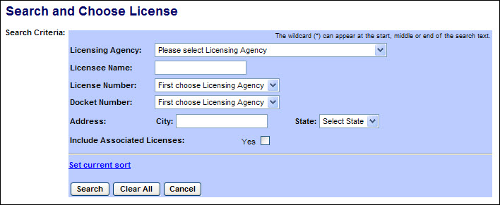
Figure 4-48: Record Irretrievable Source (Search Criteria – Licenses)

The following fields are available to define the search:

Field Name | Description/Comments | Acceptable Values | Example Value
Licensing Agency | The Agency that has regulatory authority over the Licensee. An NRC user or NSTS Analyst can select a Licensing Agency. A DOE user or State Agency user can select only their agency. | Drop-down list | Ohio Department of Health
Licensee Name | Name of the organization to which the license was issued. | Free-form text | ABC Company
License Number | Number assigned when a license is issued. | Drop-down list | 45-27764-01
Docket Number | License identifier used by NRC. NRC Licensees only. | Alphanumeric | 05000313
Address: City | City in which the license address is located. | Free-form text | Hanover
Address: State | State in which the license address is located. | Drop-down list | OH
Include Associated Licenses: Yes | If a search returns a license that has licenses associated with it, the associated licenses will be included in the search results. | Check mark

- Enter the search criteria to display a list of Licenses, and then click Search. A list of licenses meeting the search criteria will be displayed. (If no criteria are entered, all licenses accessible to the user will be listed.)

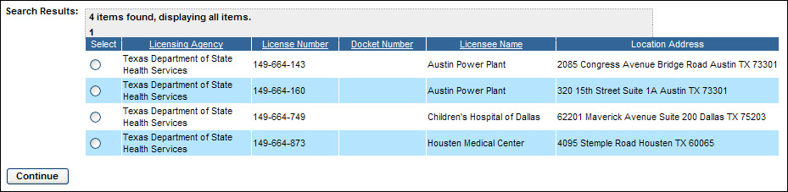
Figure 4-49: Record Irretrievable Source (Search Results – Licenses)

3. Click the radio button () for the applicable Licensee, then click the Continue button.

4. The Search Sources for Record Irretrievable Source window appears:

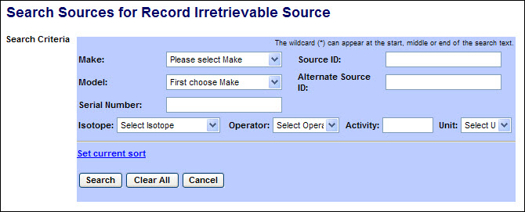
Figure 4-50: Record Irretrievable Source (Search Criteria – Sources)

The following fields are available to enter search criteria:

Field Name | Description/Comments | Acceptable Values | Example Value
Make | Represents the manufacturer. Each Make has one or more models associated with it. | Drop-down | Delta
Model | Item that is manufactured. Represents a Model associated with a Make. | Drop-down | A424-19
Serial Number | Identification number assigned to a Source by the manufacturer. | Alphanumeric | TK12345
Source ID | A unique system-generated identifier for each manufactured source. | Numeric value | 23456
Alternate Source ID | Additional Source ID that is designated by the Licensee. | Alphanumeric | 456781B
Isotope | Identification of the isotope in a Source | Drop-down list | Cobalt-60
Operator | A filter for searching by the level (greater than, less than, etc.) of the current activity. | Drop-down list | = (equal)
Activity | Current activity level for isotope. | Numeric value | 223
Unit | Unit in which the activity level of the Source is measured. | Drop-down list | Ci

- Enter the search criteria, and then click Search. A list of sources in the selected licensee’s inventory which meet the search criteria will be displayed. (If no criteria are entered, all sources in the licensee’s inventory will be listed.)

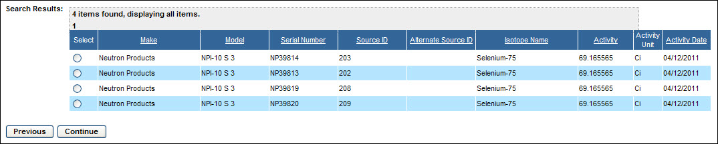
Figure 4-51: Record Irretrievable Source (Search Results – Sources)

- Click the radio button () for the irretrievable source, then click the Continue button. The Record Irretrievable Source window will be displayed.

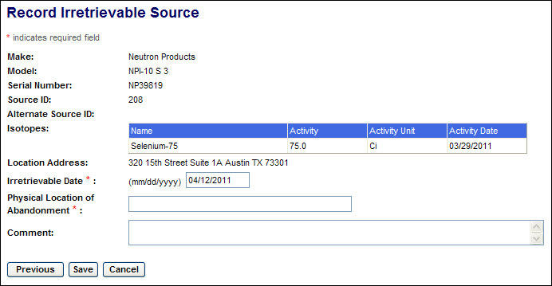
Figure 4-52: Record Irretrievable Source (Source Information)

Note: Click the Previous button to return to the search results window.

- Enter the applicable information in the following fields:

Field Name | Req. Value | Description/Comments | Acceptable Values | Example Value
Irretrievable Date | Y | Enter date source became irretrievable.. | mm/dd/yyyy | 02/09/2011
Physical Location of Abandonment | Y | Enter a description of the location of the irretrievable source. | Free-form text
Comment | N | Enter comments regarding abandonment of the source. | Free-form text

- Select the Save button. A confirmation of the report will be displayed.

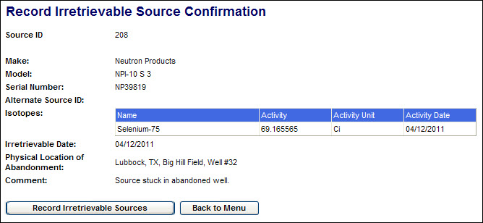
Figure 4-53: Record Irretrievable Source (Confirmation of Report)

- On the confirmation screen, click the Back to Menu button to return to the NSTS Main Menu or click the Record Irretrievable Sources button to record another irretrievable source.

Review Source History
User – NRC Staff, Agreement State Staff, DOE Staff, and NSTS Analyst

Use – View full history of transfers and status changes of a selected source. This essentially provides a full life-cycle view of a Source from cradle-to-grave.

1. From the NSTS Main Menu, under Source Management, click on the Review Source History link. The Review Source History search criteria window appears:

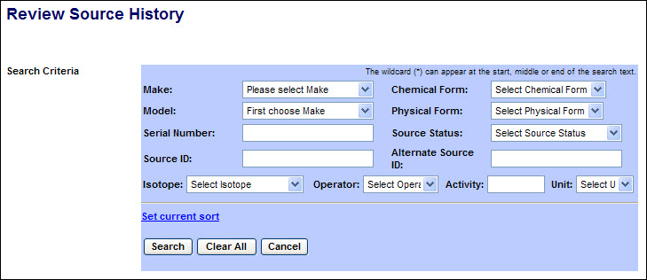
Figure 4-54: Review Source History (Search Criteria)

The following fields are available to define the search:

Field Name | Description/Comments | Acceptable Values | Example Value
Make | Represents the manufacturer. Each Make will have one or more models associated with it. | Drop-down | Delta
Model | Item that is manufactured. Represents a Model associated with a Make. | Drop-down | A424-19
Serial Number | Identification number assigned to a Source by the manufacturer. | Alphanumeric | TK12345
Source ID | A unique system-generated identifier for each manufactured source. | Numeric value | 23456
Chemical Form | The Chemical Form of the Source | Drop-down | THO2
Physical Form | The Physical Form of the Source | Drop-down | Solid
Source Status | Status of trackable Sources | Drop-down | Above Threshold
Alternate Source ID | Additional Source ID that is designated by the Licensee. | Alphanumeric | 456781B
Isotope | Identification of the isotope in a Source | Drop-down list | Cobalt-60
Operator | A filter for searching by the level (greater than, less than, etc.) of the current activity. | Drop-down list | = (equal)
Activity | Current activity level for isotope. | Numeric value | 223
Unit | Unit in which the activity level of the Source is measured. | Drop-down list | Ci

2. After entering the search criteria, select the Search button. (If no criteria are selected, all sources which the user is authorized to view will be displayed.) The search results display at the bottom of the window:

Scroll to the right to display additional source information.

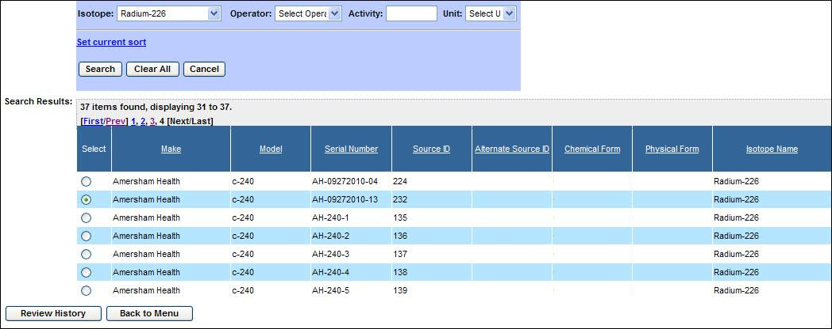
Figure 4-55: Review Source History (Search Results)

3. Click the radio button () to select a source, and then click the Review History button.

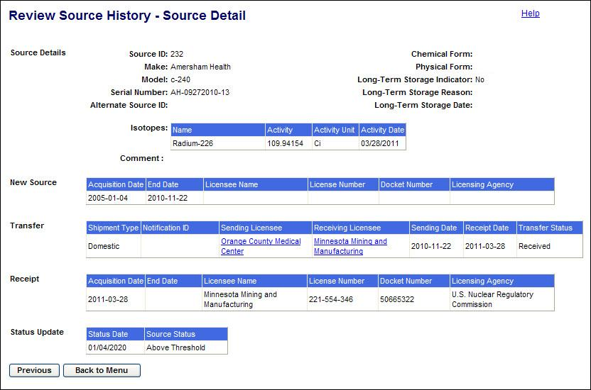
Figure 4-56: Review Source History – Source Detail

4. After reviewing the information provided, click the Back to Menu button to return to the NSTS Main Menu.

Note: To select a different source, click the Previous button to return to the Review Source History (Search Results) window.

Record Found Sources
User – NRC Staff, Agreement State Staff, DOE Staff, and NSTS Analysts

Use – A licensee or member of the public may report finding a source to the NRC, an Agreement State agency, or to the DOE. A report of a found source is typically entered in the NSTS by the NRC operations call center or Agreement State/DOE equivalents.

1. From the NSTS Main Menu, under Source Management, click on the Record Found Sources link. The Search for Record Found Sources search criteria window will be displayed.

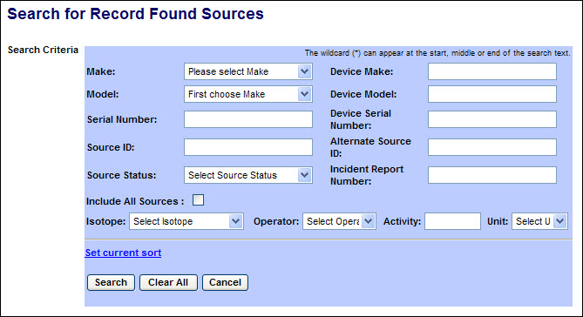
Figure 4-57: Record Found Sources (Search Criteria)

The following fields are available to define the search:
Field Name | Description/Comments | Acceptable Values | Example Value
Make | Represents the manufacturer. Each Make has one or more models associated with it. | Drop-down | Delta
Model | Item that is manufactured. Represents a Model associated with a Make. | Drop-down | A424-19
Serial Number | Identification number assigned to a Source by the manufacturer. | Alphanumeric | TK12345
Source ID | A unique system-generated identifier for each manufactured source. | Numeric value | 23456
Device Make | Make of the device containing a trackable nuclear Source. | Alphanumeric | Acme
Device Model | Model of the device containing a trackable nuclear Source. | Alphanumeric | Acme123
Device Serial Number | Device serial number assigned by the manufacturer. | Alphanumeric | L98X777
Alternate Source ID | Additional Source ID that is designated by the Licensee. | Alphanumeric | 456781B
Incident Report Number | Incident report number if the found source had been reported lost or stolen. | Alphanumeric | 2011TX035
Include All Sources | Include in search results all sources meeting the search criteria rather than just those sources reported as lost or stolen. | Check mark
Isotope | Identification of the isotope in a Source | Drop-down list | Cobalt-60
Operator | A filter for searching by the level (greater than, less than, etc.) of the current activity. | Drop-down list | = (equal)
Activity | Current activity level for isotope. | Numeric value | 223
Unit | Unit in which the activity level of the Source is measured. | Drop-down list | Ci

- Enter the search criteria, and then click Search. A list of sources meeting the search criteria will be displayed.
By default, only those sources matching the search criteria and that have been reported lost or stolen will be included in the search results. If the search results should include sources not reported as lost or stolen, select the Include All Sources checkbox. (If no criteria are entered, all sources accessible to the user will be listed.)
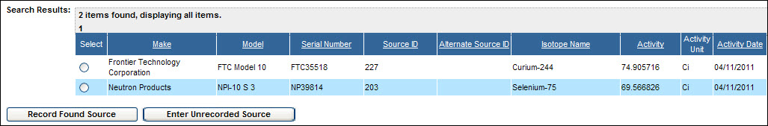
Figure 4-58: Record Found Sources (Search Results – Lost/Stolen Sources)
- If the found source is included in the search results, click the radio button () for the source and click the Record Found Source button. The Record Found Source window will be displayed.
(If the found source is not included in the search results, click the Enter Unrecorded Source link to record the source. (Refer to User Guide section 4.4.1) After recording the source, repeat the search for found sources with a checkmark in Include All Sources.)

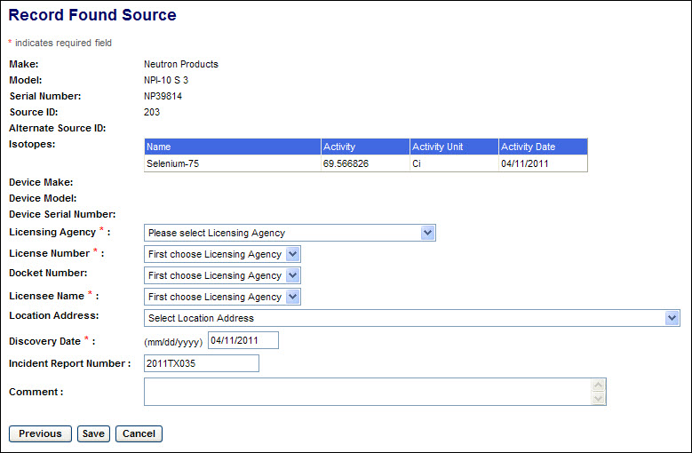
Figure 4-59: Record Found Source (Source Discovery Information)

The following fields are available to enter Found Source information:
Field Name | Req. Value | Description/Comments | Acceptable Values | Example Value
Licensing Agency | Y | Agency that has authority to license and inspect source materials used or possessed within their jurisdiction. | Drop-down list | Ohio Department of Health
License Number | Y | Number assigned when a license is issued. | Drop-down list | 45-27764-01
Docket Number |  | License identifier used by NRC. NRC Licensees only. | Drop-down list | 5000313
Licensee Name | Y | Name of the organization to which the license was issued. | Free-form text | ABC Company
Location Address |  | Physical location of the Source | Street, City, State, Zip | 415 Oak Road  Oldham, LA  70360-0000
Discovery Date | Y | Date the Source was found . Defaults to the current date. Should be on or before the current date. | mm/dd/yyyy | 03/11/2010
Incident Report Number |  | Associated incident report number, if any. | Alphanumeric | ADWE123456
Comment |  | Details entered as free-form text by the user. | Free-form text (up to 2000 characters). | Source found in unused storage facility
- Complete the entry of information describing the date of source discovery and the current custodian licensee of the source. Click the Save button, and the Record Found Source Confirmation screen will be displayed.

Note: Click the Previous button to return to the search results screen.
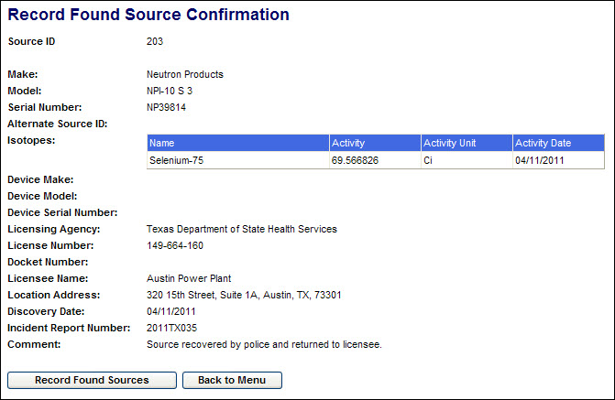
Figure 4-60: Record Found Source (Source Discovery Information)

If the source had not been reported as lost or stolen, an Alert will be generated and sent to designated NRC staff.

On the confirmation screen, click the Back to Menu button to return to the NSTS Main Menu or click the Record Found Source button to record another found source.

Review Lost and Stolen Sources
User – NRC Staff, Agreement State Staff, DOE Staff, Customs Staff, and NSTS Analyst

Use – To retrieve a list of all Sources that have been reported as lost or stolen.

- From the NSTS Main Menu, under Source Management, click on the Review Lost/Stolen Sources link. The Search for Lost and Stolen Sources search criteria window appears:

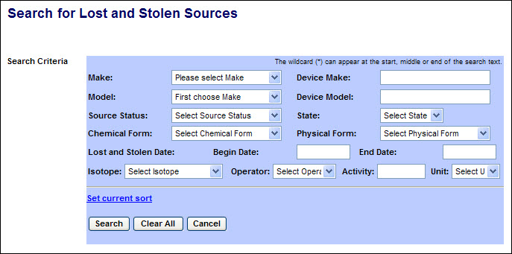
Figure 4-61: Search Source for Lost and Stolen Sources (Search Criteria)

The following fields are available to enter search criteria:

Field Name | Description/Comments | Acceptable Values | Example Value
Make | Represents the manufacturer. Each Make has one or more models associated with it. | Drop-down | Delta
Model | Item that is manufactured. Represents a Model associated with a Make. | Drop-down | A424-19
Source Status | The status of the Source. | Drop-down | Stolen
Chemical Form | The chemical form of the Source. | Drop-down | THO2
Device Make | Make of the device containing a trackable nuclear Source. | Alphanumeric | Acme
Device Model | Model of the device containing a trackable nuclear Source. | Alphanumeric | Acme123
State | Where the Source was lost or stolen | Drop-down | MD
Physical Form | The physical form of the Source | Drop-down list | Gas
Lost and Stolen: Begin Date | Begin date of reported lost/stolen date range | mm/dd/yyyy | 02/07/2011
Lost and Stolen: End Date | End date of reported lost/stolen date range | mm/dd/yyyy | 02/10/2011
Isotope | Identification of the isotope in a Source | Drop-down list | Cobalt-60
Operator | A filter for searching by the level (greater than, less than, etc.) of the current activity. | Drop-down list | = (equal)
Activity | Current activity level for isotope. | Numeric value | 223
Unit | Unit in which the activity level of the Source is measured. | Drop-down list | Ci

- After entering the search criteria, select the Search button. (If no criteria are selected, all sources which the user is authorized to view will be displayed.)

Scroll to the right to display additional source information.

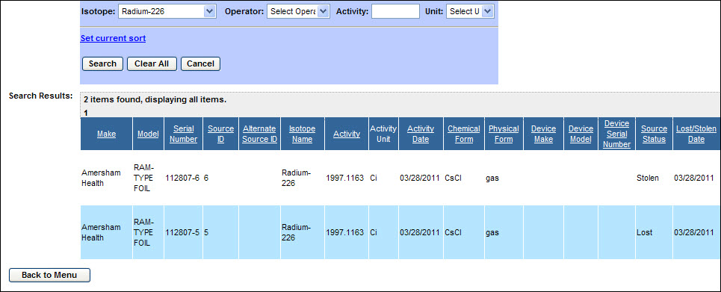
Figure 4-62: Search Source for Lost and Stolen Sources (Search Results)

3. After reviewing the information provided, click the Back to Menu button to return to the NSTS Main Menu.

Review Long-Term Storage Sources
User – NRC Staff, Agreement State Staff, DOE Staff, and NSTS Analyst

Use – To retrieve a list of NSTS trackable sources which are in long-term storage. Only those sources which the user is authorized to view will be displayed.

- From the NSTS Main Menu, under Source Management, select the Review Long-Term Storage Sources link. The Search Source for Long-Term Storage Sources window appears.

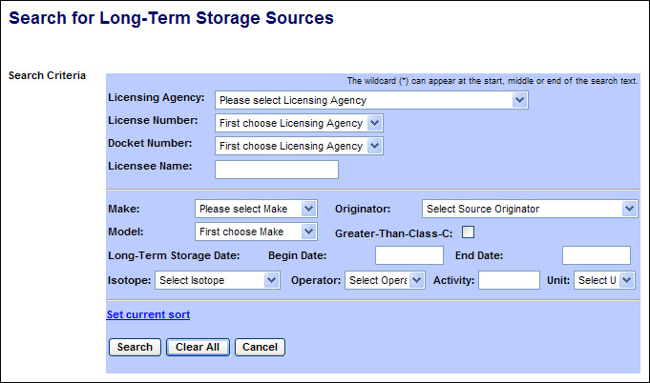
Figure 4-63: Search Source for Long-Term Storage Sources (Search Criteria)

The following fields are available to specify the criteria to search for Sources:

Field Name | Description/Comments | Acceptable Values | Example Value
Licensing Agency | Agency that has authority to license and inspect source materials used or possessed within their jurisdiction. | Drop-down list | Ohio Department of Health
License Number | Number assigned when a license is issued. | Drop-down list | 45-27764-01
Docket Number | License identifier used by NRC. NRC Licensees only. | Alphanumeric | 05000313
Licensee Name | Name of the organization to which the license was issued. | Free-form text | ABC Company
Make | Represents the manufacturer. Each Make will have one or more models associated with it. | Drop-down list | Delta
Model | Item that is manufactured. Represents a Model associated with a Make. | Drop-down list | A424-19
Originator | The entity that manufactured or regenerated a Source. This can be a Licensee or DOE. | Free-form text | Neutron Products
Greater-Than-Class-C | Indicates a Source’s radioactivity exceeds the concentration limits established for Class C. | Check mark
Long-Term Storage Date: Begin Date | Beginning date range when the Source was placed in Long-Term Storage (Status Date). | Numeric (mm/dd/yyyy) | 02/12/2010
Long-Term Storage Date: End Date | Ending date range when the Source was placed in Long-Term Storage (Status Date). | Numeric (mm/dd/yyyy) | 02/19/2010
Isotope | Identification of the isotope in a Source | Drop-down list | Cobalt-60
Operator | A filter for search criteria. | Drop-down list | = (equal)
Activity | Activity level for isotope. | Numeric value | 223
Unit | Unit in which the activity level of the Source is measured. | Drop-down list | Ci

- After entering the search criteria, select the Search button. (If no criteria are selected, all sources in long-term storage which the user is authorized to view will be displayed.)

Scroll to the right to display additional source information.

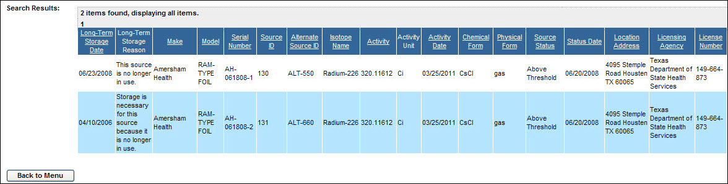
Figure 4-64: Search Source for Long-Term Storage Sources (Search Results)

3. After reviewing the information provided, click the Back to Menu button to return to the NSTS Main Menu.

Query Sources
User – NRC Staff, Agreement State Staff, DOE Staff, Customs Staff, and NSTS Analyst

Use – To retrieve a list and summary view of tracked sources based on selection of specific criteria. Only those sources which the user is authorized to view will be displayed.

1. From the NSTS Main Menu, under Source Management, select the Query Sources link. The Query Sources search criteria window appears:

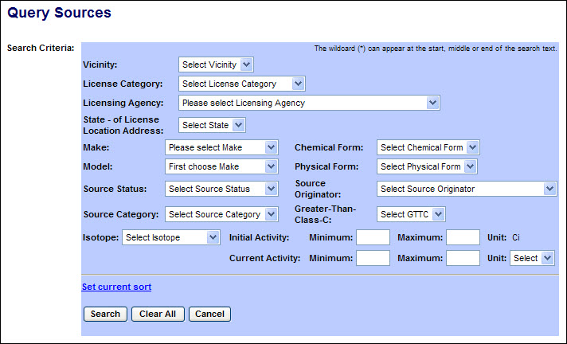
Figure 4-65: Query Sources (Search Criteria)

The following fields are available to specify the criteria to search for Sources:

Field Name | Description/Comments | Acceptable Values | Example Value
Vicinity | Geographic regions defined by a set of zip codes of source location addresses | Drop-down list | Baltimore
License Category | Category of the License | Drop-down list | Power Reactor
Licensing Agency | Agency that has authority to license and inspect source materials used or possessed within their jurisdiction. | Drop-down list | Ohio Department of Health
State – of License Location Address | State in which the license address is located. | Drop-down list | OH
Make | Represents the manufacturer. Each Make has one or more models associated with it. | Drop-down list | Delta
Model | Item that is manufactured. Represents a Model associated with a Make. | Drop-down list | A424-19
Source Status | Status of trackable Sources. | Drop-down list | Above Threshold
Source Category | Category of the Source | Drop-down list | 2
Chemical Form | The chemical form of the Source | Drop-down list | THO2
Physical Form | The physical form of the Source | Drop-down list | Gas
Source Originator | The entity that manufactured or regenerated a source. | Drop-down list | Neutron Products
Greater-Than-Class-C | Indicates a Source’s radioactivity exceeds the concentration limits established for Class C. | Drop-down list | No
Isotope | Identification of the isotope in a Source | Drop-down list | Cobalt-60
Initial Activity: Minimum | Lower limit of initial source activity search criteria | Free-Text field | 25
Initial Activity: Maximum | Upper limit of initial source activity search criteria | Free-Text field | 300
Current Activity: Minimum | Lower limit of current source activity search criteria | Free-Text field | 25
Current Activity: Maximum | Upper limit of current source activity search criteria | Free-Text field | 300
Current Activity: Unit | Unit in which the current activity level of the Source is measured. | Drop-down list | Ci

2. After entering the search criteria, select the Search button. (If no criteria are selected, all sources which the user is authorized to view will be displayed.)

Scroll to the right to display additional source information.

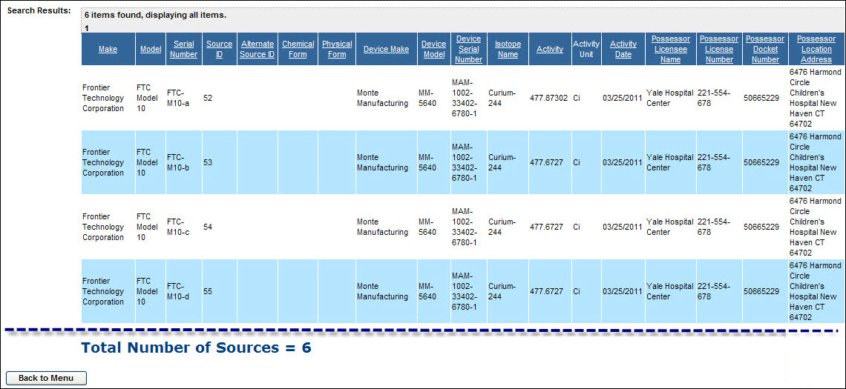
Figure 4-66: Query Sources (Search Results)

3. After reviewing the information provided, click the Back to Menu button to return to the NSTS Main Menu.

Inventory Report - License User
User – Licensees

- From the NSTS Main Menu, under Source Management, click the Inventory Report link.

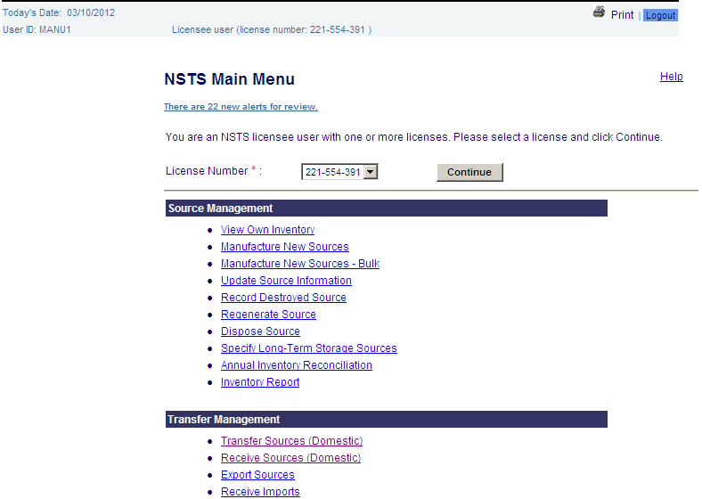
Figure 4-67: Main Menu – Inventory Report

2. The Inventory Report appears.

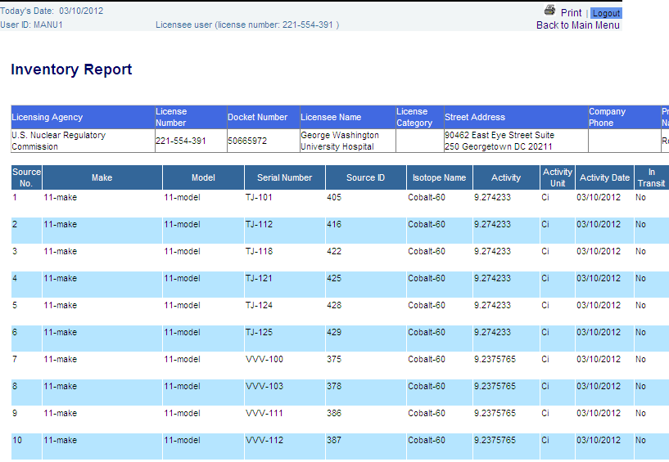

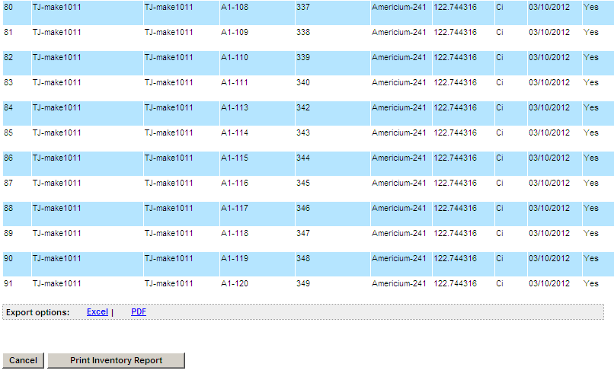
Figure 4-68: Inventory Report - Licensee
- The user has the ability to export and save the report in Excel or PDF format by clicking on the Excel link or the PDF link located above Cancel and Print Inventory Report buttons.

3.1 Export source inventory report in Excel format.

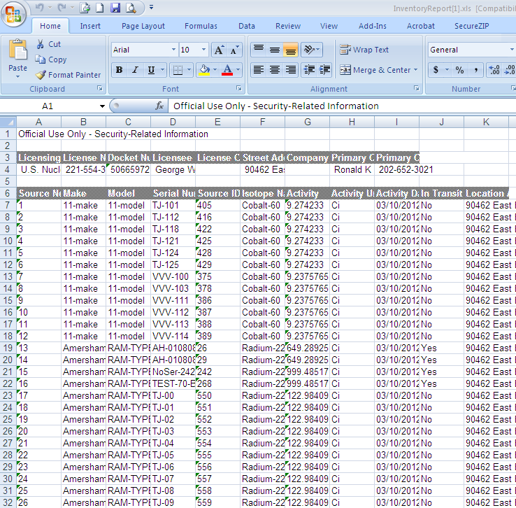
Figure 4-69: Inventory Report in Excel Format

3.2 Export source inventory report in PDF format.

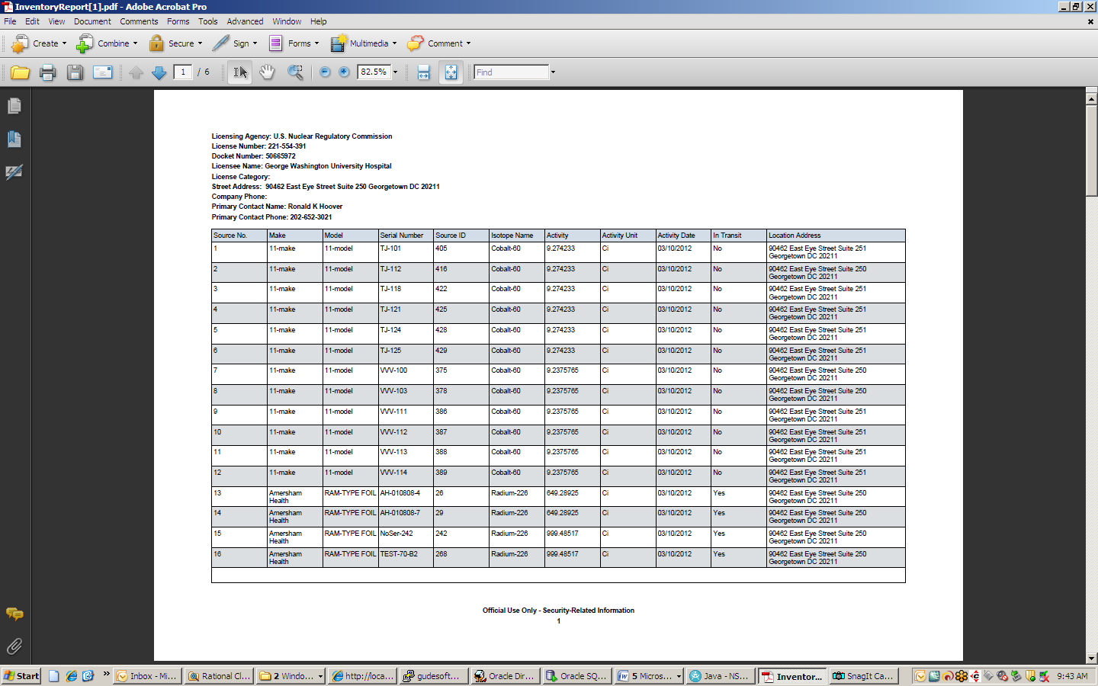
Figure 4-70: Inventory Report in PDF Format

- The user has the ability to print the Inventory Report by clicking on the Print Inventory Report button.

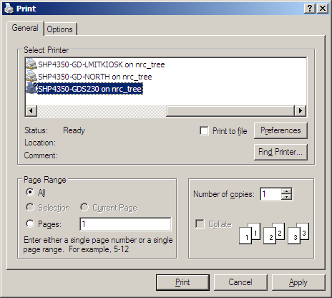

Figure 4-71: Print Dialog

- To return to the NSTS Main Menu page, click the Cancel button or the Back to Main Menu link.

License Management

Create License
User – NRC Staff, Licensing Agencies, NSTS Analyst, and Master Materials License (MML) Licensees.

Use – Agency Staff creates a new License record in the NSTS. A MML user creates a new permittee.
- From the NSTS Main Menu, under License Management, click Create License. The Create License window appears.
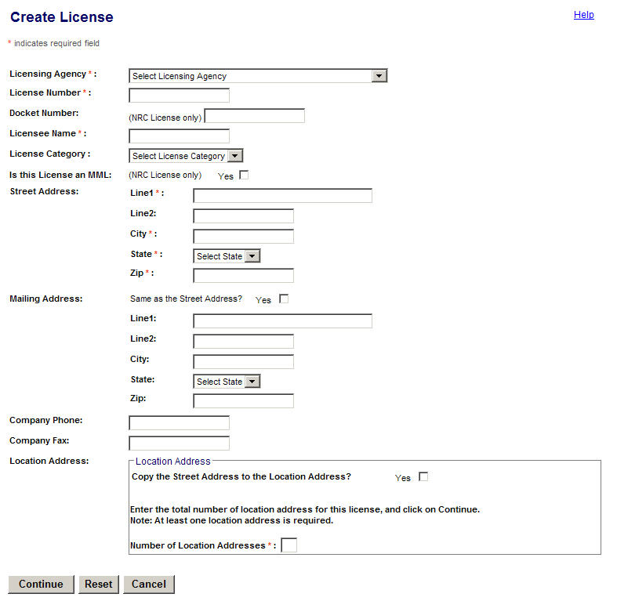
Figure 4-72: Create License

The following fields are available to enter License information:
Field Name | Req. Value | Description/Comments | Acceptable Values | Example Value
Licensing Agency | Y | Agency that has regulatory authority over the Licensees. Defaults to the user’s Agency. Only the NSTS Analyst can change the value of the Licensing Agency. | Drop-down list | NRC
License Number | Y | Number assigned when a license is issued.  When a MML licensee creates a permittee license, the system automatically prepends the MML parent’s license number. To the number. | Alphanumeric | 945AL733WP9990
Docket Number | Y | License identifier used by NRC. Required for NRC Licensees only. | Alphanumeric | 05000313
Licensee Name | Y | Name of the organization or individual to whom the license is issued. | Free-form text | ABC Company
License Category |  | Category assigned by a Licensing Agency. | Drop-down list | Gamma Knifes
Is this License an MML |  | Indicates if the Licensee is a Master Material License. The MML Indicator can only be set by the NRC Staff and the NSTS Analyst. | True or false (check box).
Street Address: Line 1 | Y | Physical street address. | Alphanumeric | 415 Oak Drive
Street Address: Line 2 |  | Additional address information. | Alphanumeric | Suite 101
Street Address: City | Y | Name of the U. S. City. | Free-form text | Hanover
Street Address: State | Y | Name of the U. S. State. | Drop-down list | PA
Street Address: Zip | Y | Zip Code for the street address. | 5 or 9 digit ZipCode | 19191-0000
Mailing Address: Same as the Street Address? |  | If different from street address, enter mailing address Line 1, Line 2 (if needed), City, State, and Zip. | ‘Check mark
Mailing Address: Line 1 |  | Location at which mail is received. | Alphanumeric | 233 Post Road
Mailing Address: Line 2 |  | Additional location information for the mailing address. | Alphanumeric | Box 100
Mailing Address: City |  | Name of the U. S. City for the mailing address. | Free-form text | Phoenix
Mailing Address: State |  | Name of the U. S. State for the mailing address. | Drop-down list | AZ
Mailing Address: Zip |  | Zip Code for the mailing address | 5 or 9 digit ZipCode | 85034-0100
Company Phone Number |  | Phone number of the Licensee. | xxx xxx-xxxx | 555 333-2222
Company Fax Number |  | Fax number of the Licensee. | xxx xxx-xxxx | 555 333-2111
Copy Street Address to Location Address |  | Allows the user to select the address used previously | Check mark
Number of Location Addresses |  | Total number of location addresses associated with a particular license. | Numeric value | 3
- In the Create License window, enter the required data to create a new License record: Licensing Agency, License Number, Docket Number (NRC Licenses only), and Licensee Name.

- Select a License Category in the drop-down list.

- If the License is an MML, select Yes.

Note: This check box will only be enabled for the NRC Staff and NSTS Analyst.

- Enter the Street Address. If the Mailing Address is the same as the Street Address, select the check box. If not, enter the Mailing Address.

- Enter the Company Phone and Company Fax numbers.

- If you want to copy the street address to the Location Address, select the Yes check box.

- Enter the number of locations in the Number of Location Addresses box, and then click Continue.

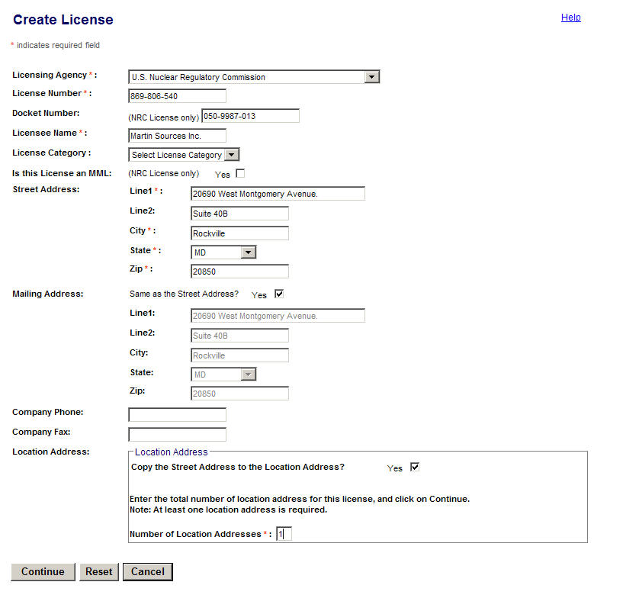
Figure 4-73: Create License (Location Address Information)

- In the Enter License Location Address Information window, enter the Location Address, City, State, and Zip.

- Enter the number of contacts in the Number of Contacts field and click Continue. Note: To clear the data in the fields, click Reset. To cancel the create license function, click Cancel.

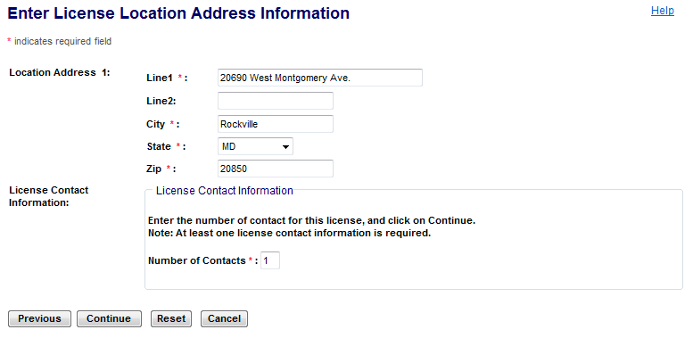
Figure 4-74: Enter License Location Address Information

Note: Click the Previous button to return to the Create License window, if this is not the item to be updated.

The following fields are available to enter information:

Field Name | Req. Value | Description/Comments | Acceptable Values | Example Value
Address Line 1 | Y | Physical street address. | Alphanumeric | 415 Oak Drive
Address Line 2 |  | Additional address information. | Alphanumeric | Suite 101
City | Y | Name of the U. S. City. | Free-form text | Hanover
State | Y | Name of the U. S. State. | Drop-down list | PA
Zip | Y | Zip Code | 5 or 9 digit ZipCode | 19191-0000
Number of Contacts | Y | Total number of contacts for this license. (At least one contact is required.) | Numeric value | 1

- The Enter License Contact Information window will be displayed.

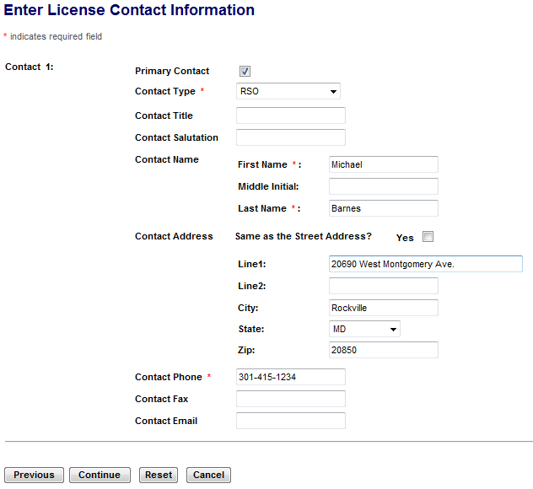
Figure 4-75, Enter License Contact Information

Note: Click the Previous button to return to the Enter License Location Address Information window, if this is not the item to be updated.

- Enter the Contact Type, Title, Salutation, Name, Address, Phone, Fax, and E-mail information.

- If the Contact Address is the same as the Street Address, select the Yes check box.

- Click Continue.

Note: To clear the data in the fields, click Reset. To cancel the create license transaction, click Cancel.

- The Create License window will appear, with all information populated.

- Verify the information, and then scroll down and click Save. To exit the window without saving the data, click Cancel. To reset all entered data, click Reset.

- At the Create License confirmation window, click Back to Menu to return to the NSTS Main Menu.

Note: A unique identifier will be generated for the new license. This identifier will not be altered at any time.

If a License is entered by a MML Licensee, the system will associate the new License with the MML as the MML’s permittee Licensee. The permittee’s license number becomes the concatenation of (linked to) the MML license number and the license number assigned by the licensee creating the license. For example, MML Licensee with license number ABCD creates a permittee with license number 1234; the full license number becomes ABCD: 1234.

Update/Delete License Information
User – MML Licensees, Licensing Agencies, and NSTS Analyst.

Use – Agency Staff updates or deletes a License record.

- From the NSTS Main Menu, under License Management, click the Update/Delete License link.

- The Search and Choose License window appears.
The following fields are available to search for a License:

Field Name | Req. Value | Description/Comments | Acceptable Values | Example Value
Licensing Agency |  | Agency that has regulatory authority over the Licensees. Defaults to the user’s Agency. Only the NSTS Analyst can change the value of the Licensing Agency. | Drop-down list | NRC
License Number |  | Number assigned when a license is issued. | Drop-down list | 945AL733WP9990
Docket Number |  | License identifier used by NRC (optional search criteria). Required for NRC Licensees only. | Drop-down list | 05000313
Licensee Name |  | Name of the organization or individual to whom the license is issued. | Free-form text | ABC Company
License Category |  | Category assigned by a Licensing Agency. | Drop-down list | Gamma Knifes
Address: City |  | Name of the U. S. City. | Free-form text | Hanover
Address: State |  | Name of the U. S. State. | Drop-down list | PA

- In the Search and Choose License window, enter search criteria (Licensing Agency, Licensee Name, License Number, Docket Number, License Category, Address), and then click Search.
- The search results display at the bottom of the Search and Choose License window.
- Select the Licensee by clicking the Select radio button (), and then click Continue. The Update / Delete License window appears.

Note: To view the License Street Address, Mailing Address, Company Phone Number, and Company Fax Number, click the Additional License Information link in the search results for a license. The Additional License Information window appears. To close the window and return to the Search and Choose License window, click Close.

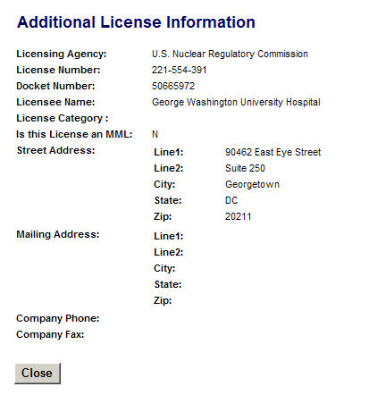
Figure 4-76: Additional License Information
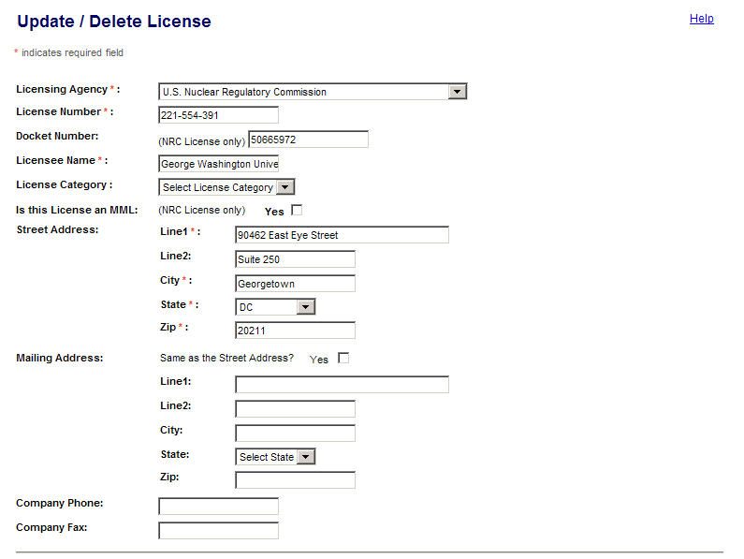
Figure 4-77: Update / Delete License

Note: At the bottom of the Update / Delete License window, click the Previous button to return to the Search and Choose License (Search Results) window, if this is not the item to be updated.

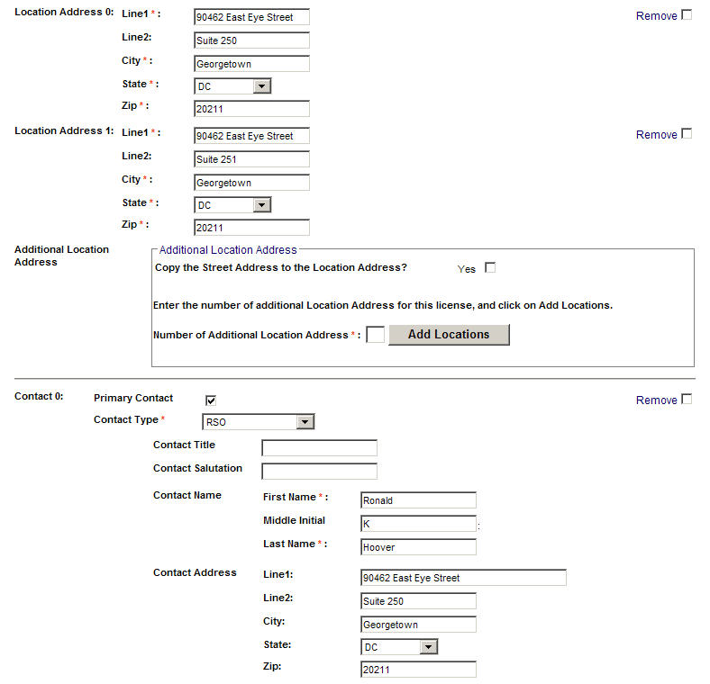
Figure 4-78: Update / Delete License (Add Locations)

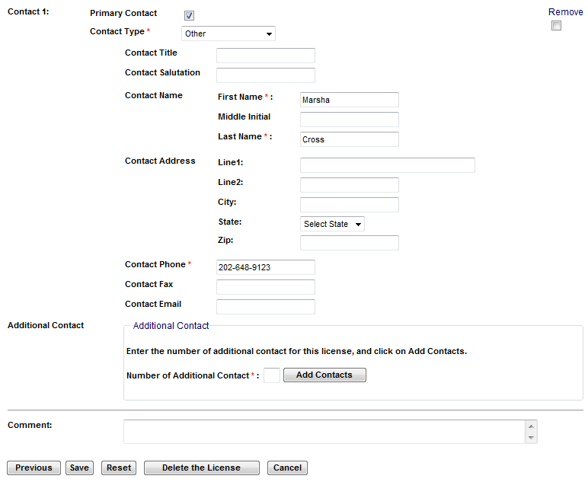
Figure 4-79: Update / Delete License (Add Contacts)

The following fields are available to update license information:

Field Name | Req. Value | Description/Comments | Acceptable Values | Example Value
Licensing Agency | Y | Agency that has regulatory authority over the Licensees. Defaults to the user’s Agency. Only the NSTS Analyst can change the value of the Licensing Agency. | Drop-down list | U.S. Nuclear Regulatory Commission
License Number | Y | Number assigned when a license is issued. | Alphanumeric | 945AL733WP9
Docket Number | Y | License identifier used by NRC. Required for NRC Licensees only. | Alphanumeric | 05000313
Licensee Name | Y | Name of the organization or individual to whom the license is issued. | Free-form text | ABC Company
License Category |  | Category assigned by a Licensing Agency. | Drop-down list | Gamma Knifes
Is this License an MML |  | Indicates if the Licensee is a Master Material License Licensee. The MML Indicator can only be set by the NRC Staff and the NSTS Analyst. | True or false (check box).
Street Address: Line 1  Line 2  City  State  Zip | Y | Physical location of the Licensee. | Line 1 - free-form text  Line 2 – free-form text  City – free-form text  State – drop-down list  Zip – 5 or 9 digit ZipCode | 30 W. Gude Dr.  Suite 35A  Dallas  TX  75212-0000
Mailing Address: Same as the Street Address? |  | If different from street address, enter mailing address Line 1, Line 2 (if needed), City, State, and Zip. | Check mark
Mailing Address: Line 1 |  | Location at which mail is received. | Alphanumeric | 233 Post Road
Mailing Address: Line 2 |  | Additional location information for the mailing address. | Alphanumeric | Box 100
Mailing Address: City |  | Name of the U. S. City for the mailing address. | Free-form text | Phoenix
Mailing Address: State |  | Name of the U. S. State for the mailing address. | Drop-down list | AZ
Mailing Address: Zip |  | Zip Code for the mailing address | 5 or 9 digit ZipCode | 85034-0100
Location Address: Line 1  Line 2  City  State  Zip |  | Physical address where the Source was received. If the Receiving Licensee only has one Location associated with it, the Location Address defaults to that location. | Line 1 - free-form text  Line 2 – free-form text  City – free-form text  State – drop-down list  Zip – 5 or 9 digit ZipCode | 415 Oak Drive  Suite 101  Hanover  PA  19191-0000
Company Phone Number |  | Phone number of the Licensee company. | xxx xxx-xxxx | 555 333-2222
Company Fax Number |  | Fax number of the Licensee company. | xxx xxx-xxxx | 555 333-2111
Primary Contact Indicator | Y | At least one contact must be Primary for a License. | True or false (check box)
Contact Type | Y | Type of contact. | Drop-down list | RSO, Other
Contact Title |  | Title of the contact person. | Free-form text | Vice President, Director
Contact Salutation |  | Greeting for a contact. | Free-form text | Mr., Mrs., Dr., Ms.
Contact First Name | Y | First name of the contact person. | Free-form text | Mary
Contact Middle Initial |  | Middle initial of the contact person. | Free-form text | J
Contact Last Name | Y | Last name of the contact person. | Free-form text | Smith
Contact: Address Line 1 |  | Physical street address of the contact person. | Alphanumeric | 415 Oak Drive
Contact: Address Line 2 |  | U. S. optional mailing address of the contact. | Alphanumeric | Suite 101
Contact: City |  | Name of the U. S. City. | Free-form text | Hanover
Contact: State |  | Name of the U. S. State. | Drop-down list | PA
Contact: Zip |  | Zip Code | 5 or 9 digit ZipCode | 19191-0000
Contact Phone | Y | Telephone number of the contact. | xxx xxx-xxxx | 555 333-2222
Contact Fax |  | Fax number of the contact. | xxx xxx-xxxx | 555 333-2111
Contact  Email |  | E-mail address of the contact. | Valid e-mail format | xax@nrc.gov
Additional License Contacts |  | The number of additional contacts the user wants to associate with a particular license. | Numeric value | 5
Number of Contacts | Y | The number of additional contacts the user wants to add to the license. | Numeric value | 2

- To delete the license, click Delete the License.

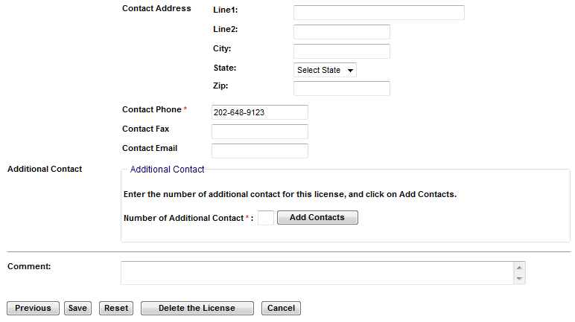
Figure 4-80: Update / Delete License – Delete the License

Note: A license cannot be deleted if there are any open shipments/transfers for the license and/or the Licensee possesses any Sources that have not reached an end-point.

When processing the delete, the system will prompt the user to confirm the deletion. Once confirmed, the system will mark the record as deleted, but not physically delete it. The record will remain online and retrievable by an NSTS Administrator.

- To add additional location addresses, enter the number of addresses in the Number of Location Address box, and then click Add Location Address.

Note: To remove a location address, select the Remove this Location check box.

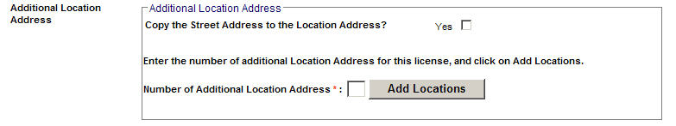
Figure 4-81: Update / Delete License – Add Location Address

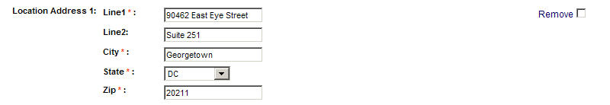
Figure 4-82: Update / Delete License – Remove Location Address

- In the Enter License Location Address Information window, enter Location Address Line 1, Line 2, City, State, and Zip for each location, and then click Save.

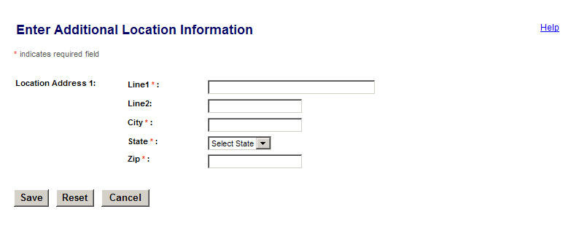
Figure 4-83: Enter License Location Address Information

Note: Click Cancel to close the Enter License Location Address Information page and return to the Update / Delete License window..

Click Reset to clear data in the Enter License Location Address Information window
- To add additional contact information, enter the number of contacts in the Number of Contact box, and then click Add. Note: To remove a Contact, select the Remove this Contact check box.

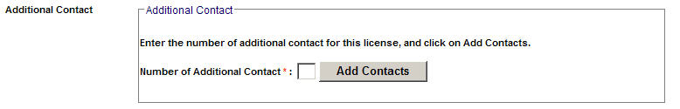
Figure 4-84: Update / Delete License – Add Contacts

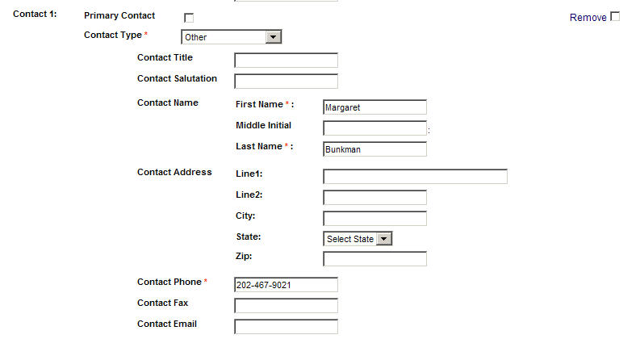
Figure 4-85: Update / Delete License – Remove Contacts

- If the contact persion is the primary contact, select the Primary Contact check box. Note: At least one contact must be Primary for a License.
- Enter license contact information: Contact Type, Title, Salutation, Name, Address, Phone, Fax, and Email. Click Save.
- If the Licensee’ s contact address is the same as the street address, select Yes in the Contact Address check box.

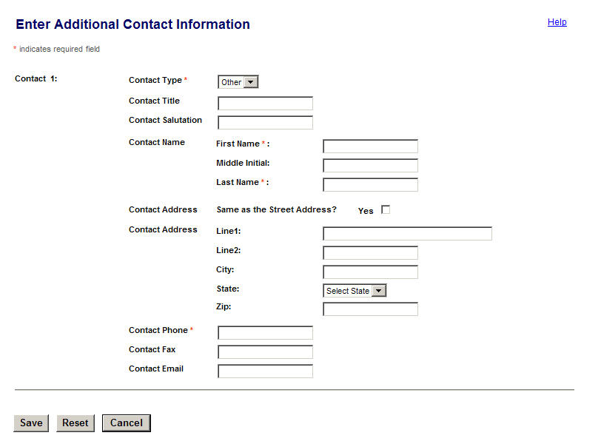
Figure 4-86: Enter License Contact Information

Note: Click Cancel to close the Enter License Contact Information window and return to the Update / Delete License window. Click Reset to clear the data in the Enter License Contact Information window

- Review the updated information, and then click Save to commit the changes.

- When the confirmation window appears, click Back to Menu.

Note: The NRC Staff will be able to see all NRC and Agreement State Licensees. The Agreement State Staff will only see its Licensees. The MML staff will only see its permittee Licensees. The NSTS Analyst can see all information regardless of Licensing Agency jurisdiction.

Record Licensee Transactions
User – Licensing Agency and NSTS Analyst.

Use – Agency Staff or Parent Licensee enters information as a surrogate for a Licensee.

      - From the NSTS Main Menu – NSTS Analyst Landing Page, under License Management, select Record Licensee Transactions.

2. The Search and Choose Licensee window appears.

The following fields are available to search Licensees:

Field Name | Req. Value | Description/Comments | Acceptable Values | Example Value
Licensing Agency |  | Agency that has regulatory authority over the Licensees. Defaults to the user’s Agency. | Drop-down list | NRC
Licensee Name |  | Name of the organization or individual to whom the license is issued. | Free-form text | ABC Company
License Number |  | Number assigned when a license is issued. | Drop-down list | 945AL733WP9990
Docket Number |  | License identifier used by NRC. Required for NRC Licensees only. | Drop-down list | 05000313
City |  | U. S. City | Free-form text | Houston
State |  | U. S. State | Drop-down list | TX

- Enter search criteria, and then click Search.

Note: To retrieve all Licenses, leave search criteria fields blank, and then click Search.

4. When the search results appear, click the Select radio button of the licensee on whose behalf you want to record transactions.

5. Click Continue.

6. A Note will appear on the NSTS Main Menu stating the user now acts as a surrogate for the selected Licensee’s transactions.

7. The Analyst can then carry out any system function on behalf of the Licensee by clicking on the appropriate links on the Main Menu.

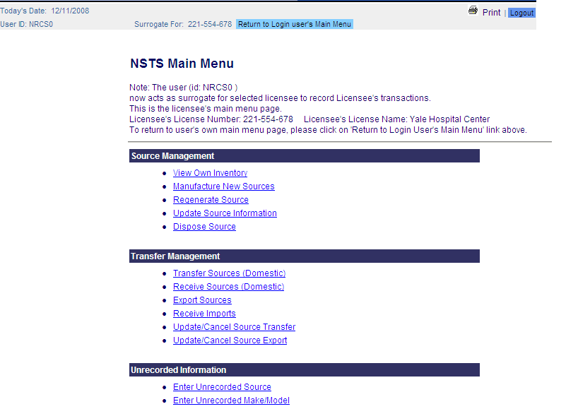
Figure 4-87: NSTS Main Menu (NSTS Analyst acting as Licensee Surrogate)

- To return to the agency staff Main Menu, at the top of the screen, click Return to Login User’s Main Menu.

Search Criteria for Recording Licensee Transactions
The search capability applies to Agency Staff and Parent Licensee users only. The Licensee user with multiple associated licenses will not have search capabilities, but will instead be shown a list of licenses to choose from based on the ‘Built-In Filtering’ requirements below.

- Licensee Lookup Restrictions – The system restricts the list of Licensees based on user role as follows:

User Role | Can View
NRC | NRC Licensees and Agreement State Licensees
Agreement State Agency | Agreement State Licensees
DOE | DOE Sites
NSTS Analyst | All Licensees and DOE Sites
Parent Licensee | Parent Licensee-associated Licenses/Licensees

- Built-in Filtering – The system restricts the list of Licensees based on user role as follows:

User Role | Can View
NRC Staff | NRC Licensees and Agreement State Licensees
Agreement State Agency | Agreement State Licensees
DOE | DOE Sites
NSTS Analyst | Holistic view of the NSTS information and can therefore record all information regardless of Licensing Agency jurisdiction.
Parent Licensee | Parent Licensee-associated Licenses/Licensees
Licensee user | Own Licensee-associated licenses.

The system stores multiple code tables, which are typically used throughout the system as lookup values during data entry. An entered value must match one of the values in the associated lookup code table unless otherwise specified. As a minimum, the code tables include the following:

Data Element | Description
Activity Unit | Units in which the radioactive material activities are measured.
Alert Status (Release 2) | Possible statuses of an alert.

Inventory Report – Agency User and NSTS Analyst
User – NSTS Analyst, NRC Staff, and State AgencyStaff.

1. From the NSTS Main Menu, under :License Management, select the Inventory Report link.

2. The Search and Choose Licensee window appears.

The following fields are available to search Licensees:

Field Name | Req. Value | Description/Comments | Acceptable Values | Example Value
Licensing Agency |  | Agency that has regulatory authority over the Licensees. Defaults to the user’s Agency. | Drop-down list | NRC
Licensee Name |  | Name of the organization or individual to whom the license is issued. | Free-form text | ABC Company
License Number |  | Number assigned when a license is issued. | Drop-down list | 945AL733WP9990
Docket Number |  | License identifier used by NRC. Required for NRC Licensees only. | Drop-down list | 05000313
City |  | U. S. City | Free-form text | Houston
State |  | U. S. State | Drop-down list | TX

- Enter search criteria, and then click Search.

Note: To retrieve all Licenses, leave search criteria fields blank, and then click Search.

4. When the search results appear, click the Select radio button of the licensee’s Inventory Report you would like to view.

5. Click Continue.

6. The Inventory Report for the selected licensee appears:

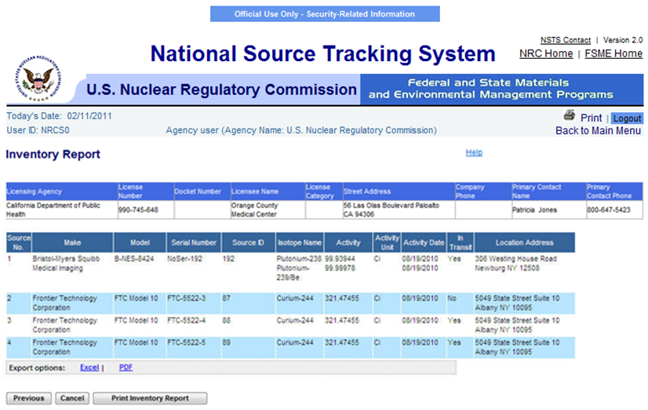
Figure 4-88: Inventory Report

Note: Click the Previous button to return to the Search and Choose Licensee (Search Results) window.

7. The user has the ability to export and save the report in excel or pdf format by clicking on the Excel link or the PDF link (located above the Previous, Cancel and Print Inventory buttons.

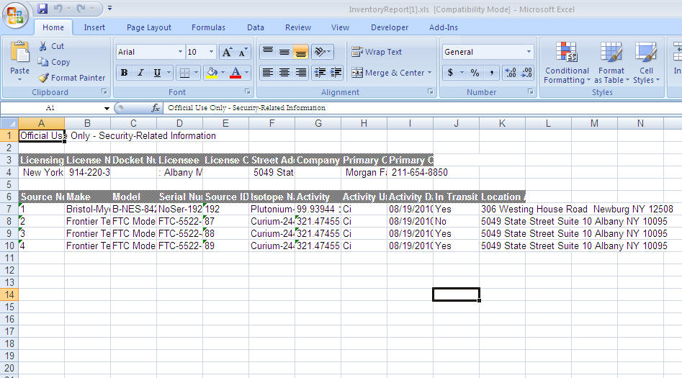

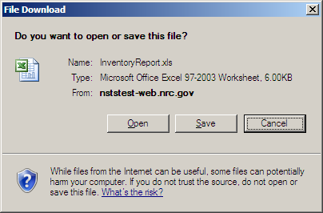

Figure 4-89: Inventory Report – Excel Export

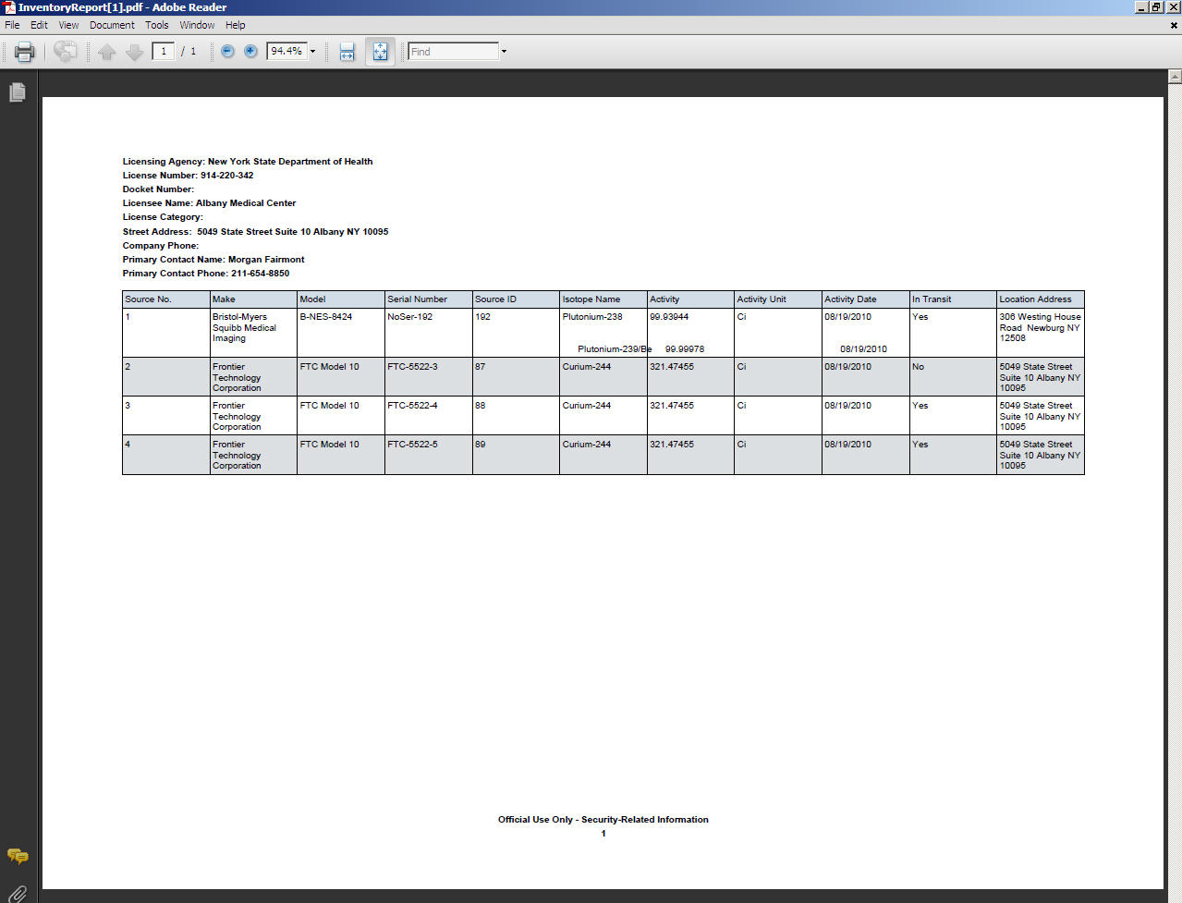
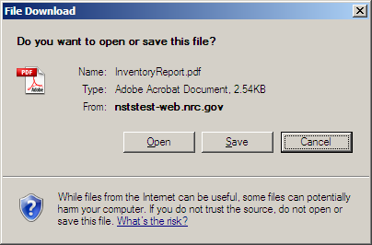

Figure 4-90: Inventory Report – PDF Export

- The user has the ability to print the Inventory Report by clicking on the Print Inventory Report button.

Figure 4-91: Inventory Report – Print Inventory Report

- To return to the NSTS Main Menu page, click the Cancel button or the Back to Main Menu link.

Query Licenses
User – NRC Staff, Agreement State Staff, DOE Staff, and NSTS Analyst

Use – To retrieve a list of licenses based on selection of specific criteria. The list can be viewed and saved as either a straight list or formatted as mailing labels. The list of licenses displayed will be limited by user role.

1. From the NSTS Main Menu, under License Management, select the Query Licenses link. The Query Licenses search criteria window appears:

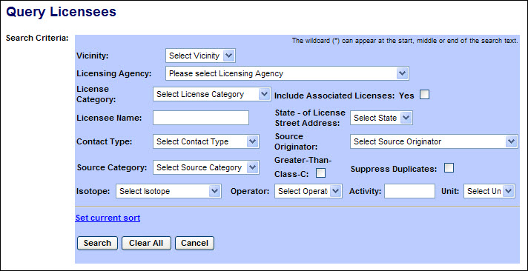
Figure 4-92: Query Licenses (Search Criteria)

The following fields are available to specify the criteria to search for Sources:

Field Name | Description/Comments | Acceptable Values | Example Value
Vicinity | Geographic regions defined by a set of zip codes of source location addresses | Drop-down list | Baltimore
Licensing Agency | Agency that has authority to license and inspect source materials used or possessed within their jurisdiction. | Drop-down list | Ohio Department of Health
License Category | Category of the License | Drop-down list | Power Reactor
Include Associated Licenses: Yes | If a search returns a license that has licenses associated with it, the associated licenses will be included in the search results. | Check mark
Licensee Name | Name of the organization to which the license was issued. | Free-form text | ABC Company
State – of License Street Address | State in which the license street address is located. | Drop-down list | OH
Contact Type | Type of contact. | Drop-down list | RSO
Source Originator | The entity that manufactured or regenerated a source. | Drop-down list | Neutron Products
Source Category | Category of the Source | Drop-down list | 2
Greater-Than-Class-C | Indicates a Source’s radioactivity exceeds the concentration limits established for Class C. | Check mark
Suppress Duplicates | Include licenses only once in the search results. | Check mark
Isotope | Identification of the isotope in a Source | Drop-down list | Cobalt-60
Operator | A filter for searching by the level (greater than, less than, etc.) of the current activity. | Drop-down list | = (equal)
Activity | Current activity level for isotope. | Numeric value | 223
Unit | Unit in which the activity level of the Source is measured. | Drop-down list | Ci

2. After entering the search criteria, select the Search button. (If no criteria are selected, all licenses which the user is authorized to view will be displayed.)

Scroll to the right to display additional license information.

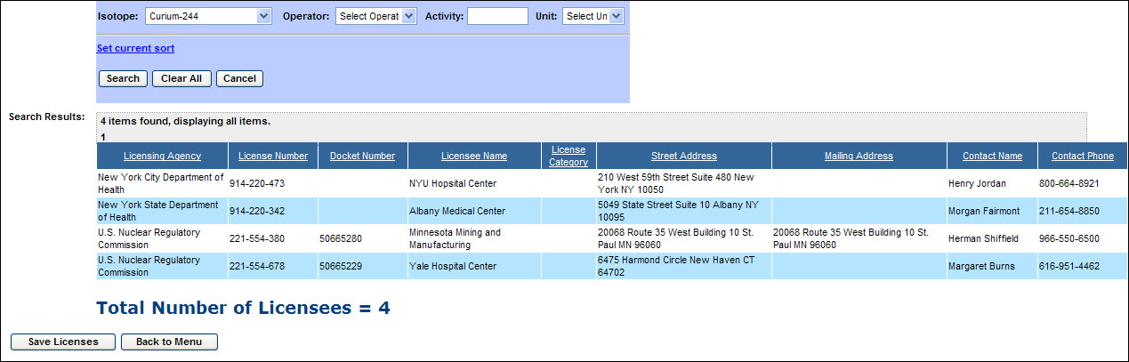
Figure 4-93: Query Licenses (Search Results)

3. To view and save the search results as either a straight list or formatted as mailing labels, click the Save Licenses link. The default view is the Straight List.

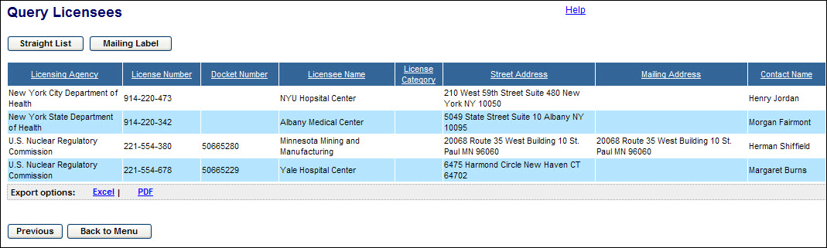
Figure 4-94: Query Licenses (Straight List)

The Straight List may be saved either as an Excel worksheet or as a PDF file by clicking the links at the bottom of the list.

Note: Click the Previous button to return to the Query Licenses search screen.

4. To view and save the search results formatted as mailing labels, click the Mailing Labels link.

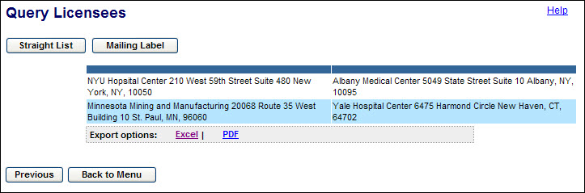
Figure 4-95: Query Licenses (Mailing Labels)

The Mailing Labels may be saved either as an Excel worksheet or as a PDF file by clicking the links at the bottom of the list.

5. After reviewing the information provided, click the Back to Menu button to return to the NSTS Main Menu.

Transfer Management

Transfer Sources (Domestic)
User – Licensees, Licensing Agencies and NSTS Analyst (acting as a Licensee surrogate).

Use – Record the transfer of Sources from one Licensee to another in NSTS.

- From the NSTS Main Menu, under Transfer Management, click Transfer Sources (Domestic).

- The Search and Choose Sources for Transfer (Domestic) window appears.

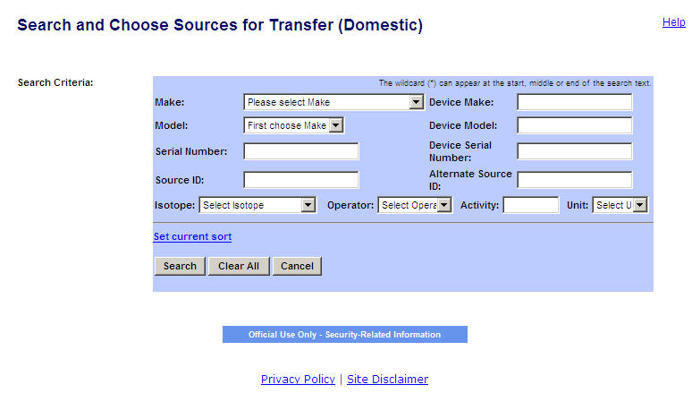
Figure 4-96: Search and Choose Sources for Transfer (Domestic)

The following fields are available to search for Sources:
Field Name | Req. Value | Description/Comments | Acceptable Values | Example Value
Make |  | Represents the manufacturer. Each Make will have one or more models associated with it. | Drop-down list | 800 Delta
Model |  | Item that is manufactured. Represents a Model associated with a Make. | Drop-down list | A424-19
Serial Number |  | Identification number assigned to a Source by the manufacturer. | Alphanumeric | TK12345
Source ID |  | A unique system-generated identifier for each manufactured source. | Numeric value | 23456234567
Isotope Name |  | Identification of the isotope in a Source. | Drop-down list | Cobalt-60
Isotope: Operator |  | A filter for search criteria. | Drop-down list | = (equal)
Isotope: Activity |  | Activity level for isotope. | Numeric value | 223
Isotope: Unit |  | Unit in which the activity level of the Source is measured. | Drop-down list | Ci
Include Sources Below Threshold |  | Indicates whether to include sources that are below threshold. | Check mark
Device Make |  | Make of the device containing a trackable nuclear source. | Alphanumeric | Acme
Device Model |  | Model of the device containing a trackable nuclear Source. | Alphanumeric | Acme xx
Device Serial Number |  | Device serial number assigned by the manufacturer. | Alphanumeric | L98X777
Alternate Source ID |  | Additional Source ID that is designated by the Licensee. | Alphanumeric | 456781B

- Select the search criteria (Make, Model, Serial Number, Source ID, Device Make, Device Model, Device Serial Number, Alternate Source ID, and Isotope information).

- Click Search.

Note: To see all sources available for transfer (other than those Below Threshold), leave search criteria fields blank, then click Search.

- Select the source(s) for Transfer by clicking the Select check box.

- Click Continue.

Note: If the Licensee cannot find the Sources to be transferred, the Licensee must first enter the Sources by clicking Enter Unrecorded Source.

- The Search and Choose Receiving Licensee window appears.

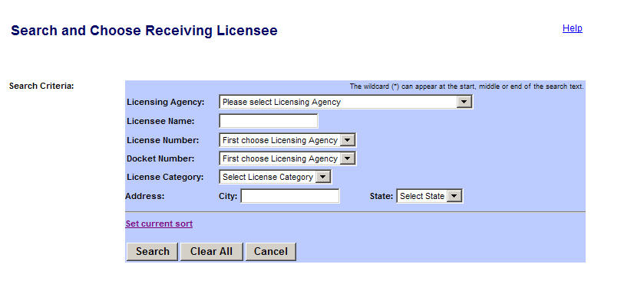
Figure 4-97: Search and Choose Receiving Licensee

The following fields are available to enter licensee search criteria information:

Field Name | Req. Value | Description/Comments | Acceptable Values | Example Value
Licensing Agency | l | Agency that has regulatory authority over the Licensees. Defaults to the user’s Agency. Only the NSTS Analyst can change the value of the Licensing Agency. | Drop-down list | NRC
License Number |  | Number assigned when a license is issued. | Alphanumeric | 945AL733WP9990
Docket Number |  | License identifier used by NRC. Required for NRC Licensees only. Optional search criteria. | Drop-down list | 05000313
Licensee Name |  | Name of the organization or individual to whom the license is issued. | Free-form text | ABC Company
License Category |  | Category assigned by a Licensing Agency. | Drop-down list | Gamma Knifes
Address: City |  | Name of the U. S. City. | Free-form text | Hanover
Address: State |  | Name of the U. S. State. | Drop-down list | PA

- In the Search and Choose License window, enter search criteria, and then click Search.

- To view the License Street Address, Mailing Address, Company Phone Number, and Company Fax Number, click the Additional License Information link for the license. The Additional License Information window appears (see example below). To close the window and return to the Search and Choose License window, click Close.
Figure 4-98: Additional License Information
- When the Licensee search results are displayed in the Search and Choose License window, select the Receiving Licensee by clicking the Select radio button, and then click Continue.

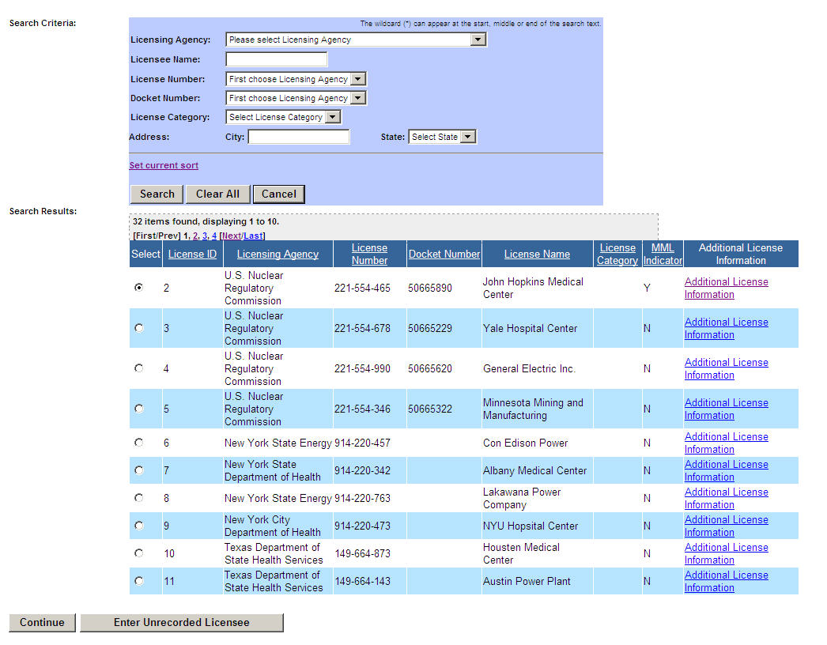
Figure 4-99: Select Receiving Licensee
- The Enter Transfer Information (Domestic) window appears. The Sources to Transfer are listed at the top of the form.
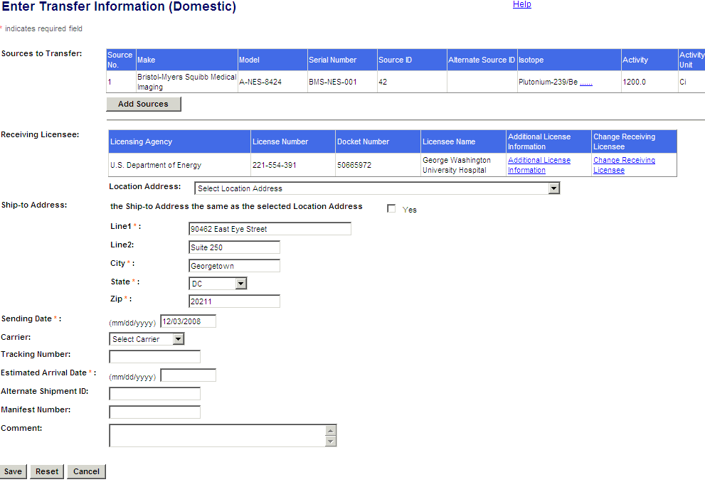
Figure 4-100: Enter Transfer Information (Domestic)
- To add additional sources to the transfer, click Add Sources.
- To change the Receiving Licensee, click the Change Receiving Licensee link.
- To view the Receiving Licensee address information, click the Additional License Information link.

- Select a location address from the Location Address drop-down list.
- If the Ship-to-Address is the same as the selected Location Address, select Yes.

The following fields are available to enter transfer source information:
Field Name | Req. Value | Description/Comments | Acceptable Values | Example Value
Location Address |  | Physical location of the Source. | Drop-down list | Houston,TX
Ship-To-Address: Line 1 | Y | Address where the transfer is being shipped. This address does not have to be a Licensee Location; it can be a job site. | Free-form text | 919 Elm Street
Line 2 |  | Additional address location information for the Licensee, e.g., Room, Building, Suite, etc. | Free-form text | Suite 3C
City | Y | City | Free-form text | Chicago
State | Y | State | Drop-down list | IL
Zip | Y | Zip code | 5 or 9 digit ZipCode | 30315-0000
Sending Date | Y | Shipping date for transfers. (Defaults to the current date.) | mm/dd/yyyy | 11/30/2006
Carrier |  | Sending company that delivers the shipment. | Drop-down list | FedEx
Tracking Number |  | Number provided by the Shipping or Sending company. | Alphanumeric | 444M32JS411
Estimated Arrival Date | Y | Date when the transfer is estimated to be received by the Receiving Licensee. | mm/dd/yyyy  (Must be on or after the sending date.) | 05/23/2006
Alternate Shipment ID |  | Shipment ID generated in another system such as the DOE RSRT or a Sending Licensee’s system. | Numeric value | 22233344455
Manifest Number |  | Number used in a shipping record. | Alphanumeric | 4094420
Comment |  | Details entered as free-form text by the user. | Free-form text (up to 2000 characters). | A shipment contains one or more transfers.

- Enter the shipping information (Address Line 1, Line 2 [optional], City, State, and Zip).

- Enter the Sending Date (the date the Sources are shipped); defaults to the current date.

- Select a Carrier from the drop-down list.

- Enter the Tracking Number, Estimated Arrival Date, Alternate Shipment ID, and Manifest Number.

- Enter additional Comments, if any, and then click Save. To clear the data entered on the screen, click Reset. To return to the Main Menu without saving the data, click Cancel.

- The Transfer Source Confirmation window appears. Click Transfer Sources to return to the Search and Choose Sources for Transfer (Domestic) window. To return to the NSTS Main Menu, click Back to Menu.

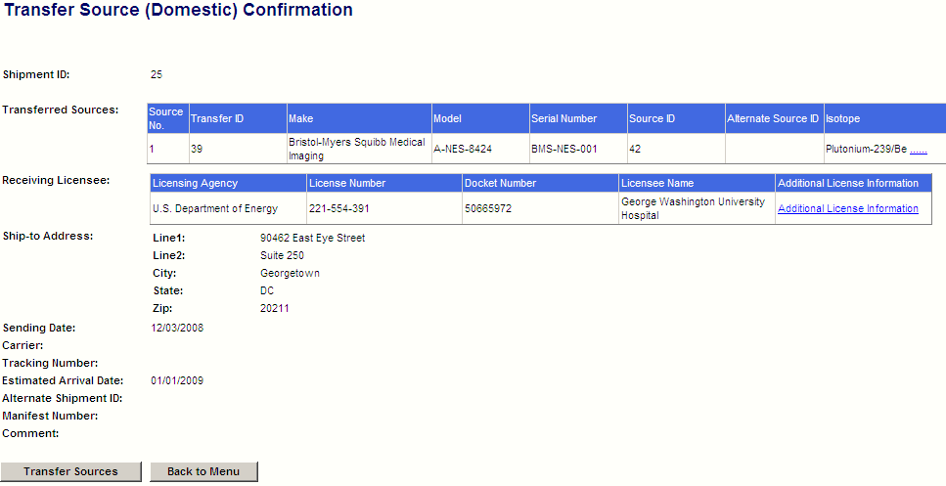
Figure 4-101: Transfer Source (Domestic) Confirmation

- When the system processes the transfer of Sources, several updates automatically occur, including:
- Shipment’s Status is set to Shipped and the Shipment Type is set to Domestic.
- Transfer Status for each chosen Source is set to Shipped.

Receive Sources (Domestic)
User – Licensees, and Licensing Agencies and NSTS Analyst (acting as a Licensee surrogate).

Use – Record the receipt (domestic) of Sources in NSTS if the material is an NSTS trackable Source.

- From the NSTS Main Menu, click Receive Sources (Domestic). The Search and Choose Open Shipments (Domestic) window appears.
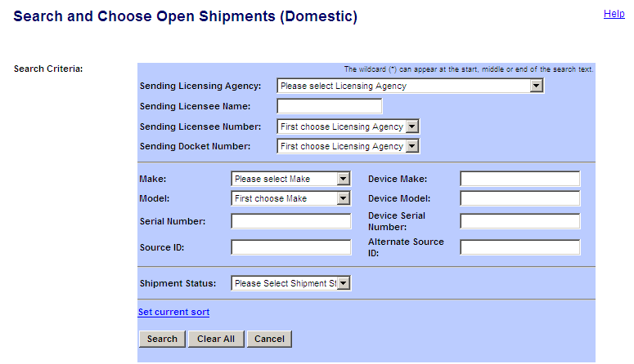
Figure 4-102: Search and Choose Open Shipments (Domestic)

- In the Search and Choose Open Shipments window, you can input individual criteria to search shipments that you are ready to receive. You can search shipments based on the shipment status “Pending” or “Shipped”. The system will default shipment status to “Shipped”. A shipment with status of “Pending” indicates that the shipment record was created by the receiving licensee and the shipment has not been verified by the sending licensee. When receiving a pending shipment, only the receiving license’s location can be updated.

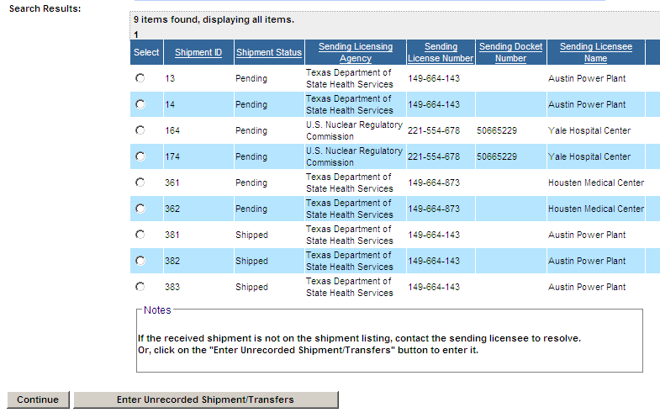
Figure 4-103: Search and Choose Shipments (Domestic) - Search Results

- Select a shipment (with Shipment Status – Shipped) by clicking the corresponding Select radio button.

Note: To see other fields in the Search Results window, scroll to the right.

- Click Continue. To exit the window without saving the changes, click Cancel.

- If the shipment is not found in the list (e.g., the Sending Licensee failed to report the shipment/transfer to the system), click Enter Unrecorded Shipment/Transfers.

- In the Enter Receipt Shipment/Transfers Information (Domestic) window, verify the transfer information for the shipment.

Note: To see other fields in the Search Results window, use the horizontal scroll bar to scroll to the right.
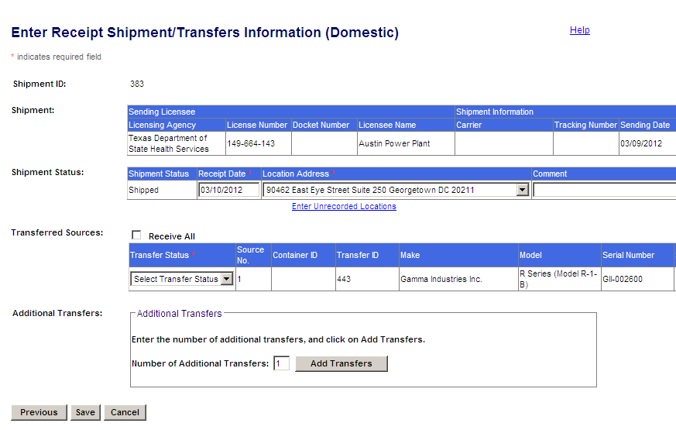
Figure 4-104: Enter Receipt Shipment/Transfer Information (Domestic)

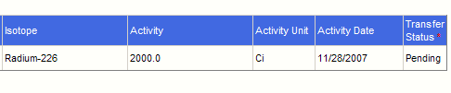
Figure 4-105: Enter Receipt Shipment/Transfer Information (Domestic)(extended table view)

The following fields are available for entry:
Field Name | Req. Value | Description/Comments | Acceptable Values | Example Value
Receipt Date | Y | Date a Source is received. Defaults to the current date. | mm/dd/yyyy | 12/21/2006
Location Address:  Line 1  Line 2  City  State  Zip | Y | Primary location for the source. If the Receiving Licensee only has one Location associated with it, then the Location Address defaults to that location. | Drop-down list. | 415 Oak Drive  Suite 101  Hanover, PA 19191-0000
Comment |  | Details entered as free-form text by the user. Required when a shipment is incomplete. | Free-form text (up to 2000 characters). | This shipment is incomplete.
Alternate Source ID |  | Additional Source ID that is designated by the Licensee. | Alphanumeric | 456781B
Transfer Status |  | Status of the transfer:  - Received – Source has been received by the Receiving Licensee.  - Not Received – Source is missing from the received Shipment.  - Unknown – Source may be missing from the received Shipment, but is unclear since the serial number of the missing Source has not been ascertained. | Check Box  Drop-down list | Receive All  Received
- In the Transferred Sources, select the Receive All box to mark all transfers as Received and move all the sources to the receiving Licensee’s inventory when the record is saved
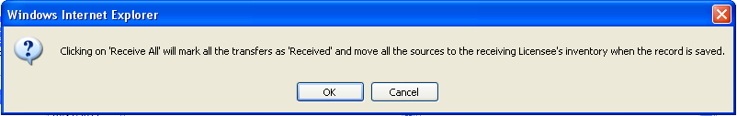
Figure 4-106: Confirmation of Receive All to mark all Transfers as “Received”
- In the Transfer Status drop-down list, select either Received, Not Received, or Unknown, for each source in the shipment.
Note: Select ‘Unknown’ when the Source is missing from the received Shipment, but it is unclear, since the serial number of the missing Source has not been determined.
- Click Save.

- When the confirmation window appears, click Back to Menu to return to the Main Menu.

Note: The Transfer Status cannot be changed by the user if the Transfer is Pending – the Transfer Status remains Pending.

If any Source that has a Container ID is chosen as Received, the system will require all sources in the same Container to be Received. This only applies for sources being sent for disposal.

For each received pending Source, the system will add the received Source to the Receiving Licensee’s inventory, set the Receiving Licensee’s Inventory status to Pending, and set the Sending Licensee’s Inventory status to Review.

If the Transfer Status is Received, the system will remove the Source from the Sending Licensee’s inventory and add the Source to the Receiving Licensee’s inventory. The Source’s Current Alternate Source ID will be carried to the Receiving Licensee’s Inventory record.

If all items in a shipment are Received, the system will set the Shipment Status to Received.

If any item in a shipment is not Received, and the Shipment Status prior to the receipt is Shipped, the system will set the status to Incomplete. (Overdue, Incomplete, and Pending shipments will maintain their original Shipment Status.)

If the received shipment/transfer is not listed, the system will prompt the user to contact the Sending Licensee to resolve the problem or to enter the unrecorded Shipment/Transfers directly (see ‘Enter Unrecorded Transfer,’ Section 4.4.2).

Export Sources
User – Licensees with an Export License, and Licensing Agency and NSTS Analyst (acting as a Licensee surrogate).

Use – Record the export of Sources to a foreign entity.

- From the NSTS Main Menu, under Transfer Management, click Export Sources. The Search and Choose Sources for Export window appears.
- The Enter Export Information window appears:
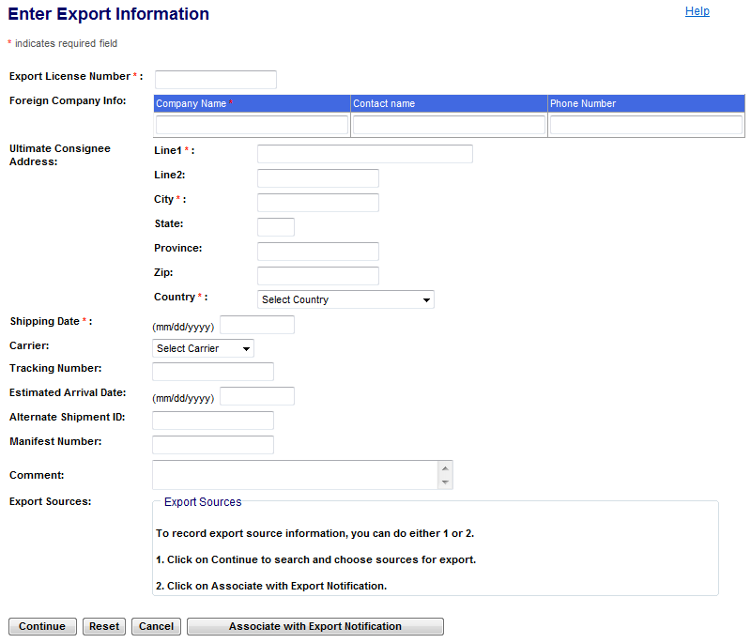
Figure 4-107: Enter Export Information

The following fields are available to enter export information:

Field Name | Req. Value | Description/Comments | Acceptable Values | Example Value
Export License Number | Y | License number assigned by the NRC, not the license number authorizing possession and use of the material. | Alphanumeric | 0398392110
Foreign Company Info: Company Name | Y | Name of the foreign recipient. | Free-form text | Cadbury Company
Foreign Company Info: Contact Name |  | Name of the contact person at the foreign company. | Free-form text | John Bright
Foreign Company Info: Phone Number |  | Telephone number at the foreign company | Numeric value | 011-2323-3000
Ultimate Consignee Address (foreign)  Line 1  Line 2  City, State  Province  Zip  Country | Y | Receiving Licensee’s foreign address. Line 1, City, and Country are required fields. | Free-form text  Drop-down list (Country) | 123 Lamp Road  29th Floor  Toronto, Ontario  D15 4EK  Canada
Shipping Date | Y | Date the Sources are shipped for export. | mm/dd/yyyy | 10/21/2006
Carrier |  | Sending company that delivers the shipment. | Drop-down list | FedEx
Tracking Number |  | Number provided by the Shipping or Sending company. | Alphanumeric | 666M32JS532
Estimated Arrival Date |  | Date when the transfer is estimated to be received by the Receiving Licensee. | mm/dd/yyyy  (Must be on or after the sending date.) | 11/22/2006
Alternate Shipment ID |  | Shipment ID generated in another system such as the DOE RSRT or a Sending Licensee’s system. | Numeric value | 22233344455
Manifest Number |  | for Sources packaged for disposal | Free-form text
Comment |  | Information regarding the export; entered as free-form text by the user. | Free-form text (up to 2000 characters). | This shipment is incomplete.

3. Enter the Export License Number, Foreign Company Information, Ultimate Consignee Address, Shipping Date, Carrier, Tracking Number, Estimated Arrival Date, Alternate Shipment ID, Manifest Number, and Comments, if any.

4. Click the Continue button to search and choose sources for export or click on Associate with Export Notifications button . To clear the data entered on the screen, click Reset. To return to the Main Menu without saving, click Cancel.

5. After selecting Continue, the Search and Choose Sources for Export window appears.
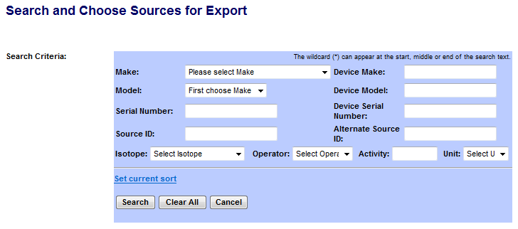
Figure 4-108: Search and Choose Sources for Export

The following fields are available to enter search criteria:

Field Name | Description/Comments | Acceptable Values | Example Value
Make | Represents the manufacturer. Each Make will have one or more models associated with it. | Drop-down | 800 Delta
Model | Item that is manufactured. Represents a Model associated with a Make. | Drop-down | A424-19
Serial Number | Identification number assigned to a Source by the manufacturer. | Alphanumeric | TK12345
Source ID | A unique system-generated identifier for each manufactured source. | Numeric value | 234562345
Device Make | Make of the device containing a trackable nuclear Source. | Alphanumeric | Acme
Device Model | Model of the device containing a trackable nuclear Source. | Alphanumeric | Acme123
Device Serial Number | Device serial number assigned by the manufacturer. | Alphanumeric | L98X777
Alternate Source ID | Additional Source ID that is designated by the Licensee. | Alphanumeric | 456781B
Isotope Name | Identification of the isotope in a Source. | Entry from a Code Table; populated based on Make and Model. | Cobalt-60
Isotope: Enter Activity | Activity level for isotope. | Numeric value | 223
Isotope: Select Operator | A filter for search criteria. | Drop-down list | = (equal)
Isotope: Select Unit | Unit in which the activity level of the Source is measured. | Drop-down list | Ci

6. Enter search criteria in the fields and then click Search. The search results will display:

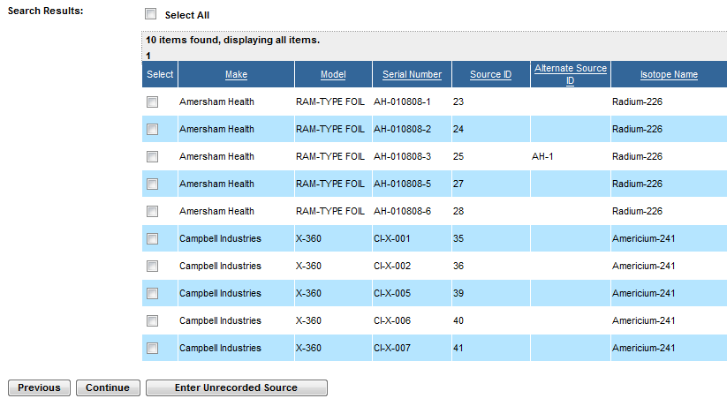
Figure 4-109: Search and Choose Sources for Export (Search Results)

Note: Click the Previous button to return to the Search and Choose Sources for Export window.

7. Select the checkbox () for the appropriate make/model, then click the Continue button. The Export Sources Review window will appear:

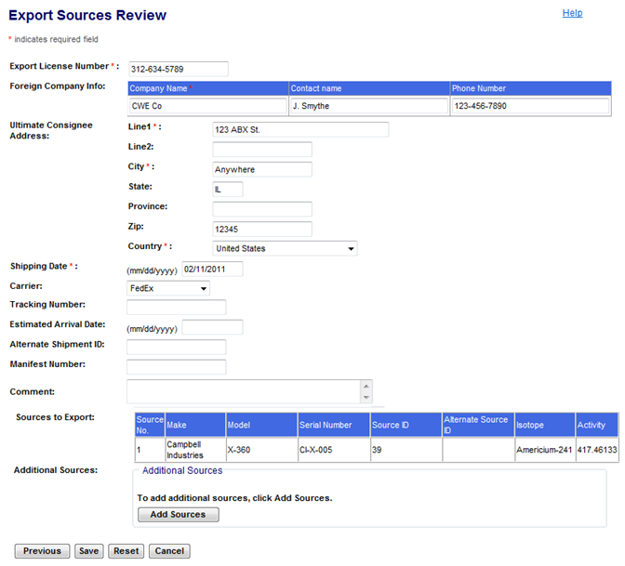
Figure 4-110: Export Sources Review

Note: Click the Previous button to return to the Search and Choose Sources for Export (Search Results) window.

8. Review the information and edit any field which requires updating.

9. Add additional sources by clicking on the Add Sources button.

10. After making edits, click the Save button.

11. At the confirmation screen, click the Back to Menu button to return to the NSTS Main Menu.

When the system processes the export of Sources, several updates automatically occur including:

  - Shipment type is set to Export.
  - Sending Licensee is set to the Licensee that is entering the information.
  - Shipment status is set to Shipped.
  - Transfer status is set to Exported.
  - Status Date is set to the Export Date.
  - Each of the exported Sources is removed from the Licensee’s inventory.

Receive Imports
User – Licensees, and Licensing Agencies and NSTS Analyst (acting as a Licensee surrogate).

Use – Record the receipt (foreign) of Sources in NSTS.

- From the NSTS Main Menu, under Transfer Management, click Receive Imports. The Enter Receipt Information (Foreign) window appears.

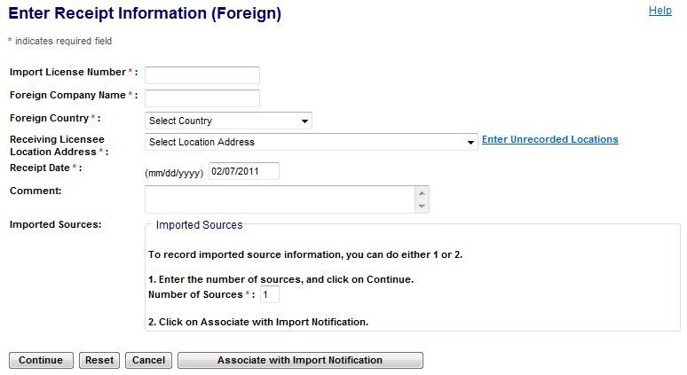
Figure 4-111: Enter Receipt Information (Foreign)

The following fields are available to enter Source Import information:
Field Name | Req. Value | Description/Comments | Acceptable Values | Example Value
Import License Number | Y | License number that authorizes import of the material. Assigned by NRC. | Alphanumeric | 03946211
Foreign Company Name | Y | Name of the foreign supplier or recipient | Free-form text | ABB Company
Foreign Country | Y | Where the Licensee is importing from or being exported. | Drop-down list | France
Receiving Licensee Location Address | Y | Physical address of the receiving licensee. Address Line 1, City, State, and Zip are required. If the Receiving Licensee only has one Location associated with it, then the Location Address defaults to that location. | Free-form text.  ‘State’ field is a drop-down list. | 30 Rockville Pike  Rockville, MD 20850
Receipt Date | Y | Date a Source is received. | mm/dd/yyyy | 01/02/2007
Comment |  | Information regarding the export; entered as free-form text by the user. | Free-form text (up to 2000 characters). | This shipment is incomplete.
Number of Sources | Y | Number of Sources in an import. | Numeric value | 4

- Enter the Import License Number, Foreign Company Name, Receipt Date, and Comments, if any.

- Select the Foreign Country and the Receiving Licensee Location Address. If the address of the receiving Location cannot be found in the system, click the Enter Unrecorded Location link.

- Enter the Number of Sources in the import, and then click Continue.

- The Enter Receipt Sources Information (Foreign) window is displayed.

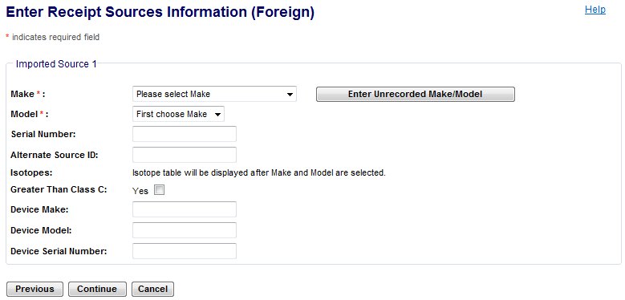
Figure 4-112: Enter Receipt Sources Information (Foreign)

Note: Click the Previous button to return to the Enter Receipt Information (Foreign) window.

The following fields are available to enter receipt sources (foreign) information:

Field Name | Req. Value | Description/Comments | Acceptable Values | Example Value
Make | Y | Represents the manufacturer. Each Make will have one or more models associated with it. | Drop-down list | 800 Delta
Model | Y | Item that is manufactured. Represents a Model associated with a Make. | Drop-down list | A424-19
Serial Number | Y | Identification number assigned to a Source by the manufacturer. | Alphanumeric | TK12345
Alternate Source ID |  | Additional Source ID that is designated by the Licensee. | Alphanumeric | 456781B
Device Make |  | Make of the device containing a trackable nuclear source. | Alphanumeric | Acme
Device Model |  | Model of the device containing a trackable nuclear Source. | Alphanumeric | Acme xx
Device Serial Number |  | Device serial number assigned by the manufacturer. | Alphanumeric | L98X777
Isotope: Name |  | Identification of the isotope in a Source. Isotope table displays, based on the selected Make and Model. (See Figure 4-113.) | Alphanumeric | Cobalt-60
Isotope: Activity |  | Activity level for isotope. (See Figure 4-112.) | Numeric value | 223
Isotope: Activity Date |  | Date the activity level of the Source is measured. (See Figure 4-112) | Mm/dd/yyyy | 01/02/2006
Isotope: Activity Unit |  | Unit in which the activity level of the Source is measured. (See Figure 4-112.) | Drop-down list | Ci
Greater Than Class C |  | Indicates a Source’s radioactivity exceeds the concentration limits established for Class C. | Check mark

- Select the Make and Model for each received Source.

Note: If the received Make/Model cannot be found in the system, click the Enter Unrecorded Make/Model link to enter it.

- The Isotope table will display, populated with the isotopes associated with the selected Make and Model.

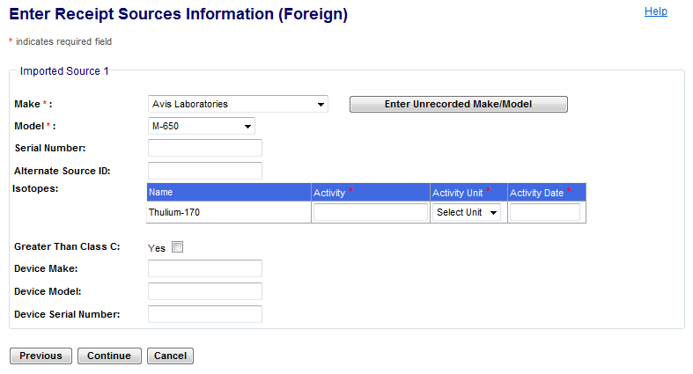
Figure 4-113: Enter Receipt Sources Information (Foreign)(Isotope Table)

Note: Click the Previous button to return to the Enter Receipt Sources Information (Foreign) window.

- Enter the Source Serial Number.

Note: If the Serial Number is not available, the system will generate a serial number in the form of NoSer-XXXX where XXXX is the system-generated Source ID.
- Enter isotope information (Activity, Activity Unit, and Activity Date). The displayed isotopes are those isotopes already associated with the entered Make/Model. You do not have to enter values for each isotope row. If no value is entered on a row, that isotope is not saved with the Source.

- If the Source’s activity level is Greater Than Class C, select the GTCC check box. If the GTCC check box is not checked, the system will set the GTCC indicator to NO.
Note: Maximum Activity – If the activity entered is greater than the Maximum Activity of the Source’s Make/Model, the system will display a WARNING to the user. This is a warning, not a restriction. The system will still accept the entered Activity if the user chooses to ignore the warning.

- Enter the Alternate Source ID, Device Make, Device Model, and Device Serial Number of the received Source. Note: If the Serial Number is not available, the system will generate a serial number in the form of NoSer-XXXX where XXXX is the system-generated Source ID

- Click the Continue button. The Receive Imports Review window appears:
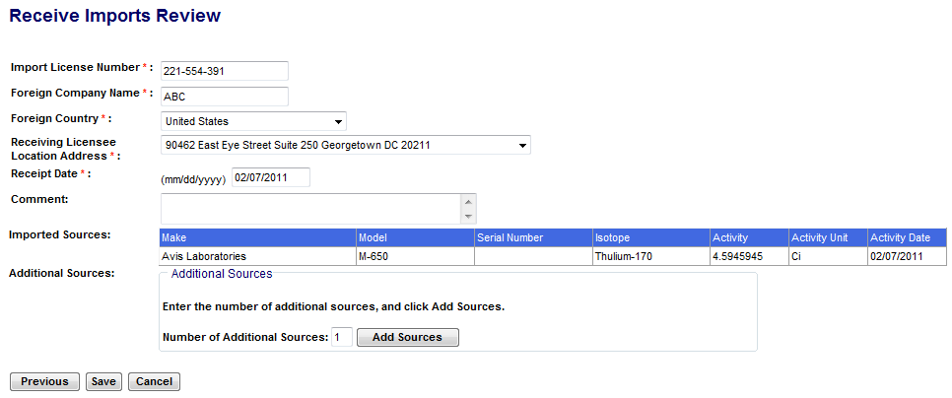
Figure 4-114: Receive Imports Review

Note: Click the Previous button to return to the Enter Receipt Sources Information (Foreign) window.
- From the Receive Imports Review window, review the information provided. Click the Save button.
Note: If there are additional sources, enter the number of Additional Sources, then click the Add Sources button (the Enter Additional Sources Information (Foreign) window will appear).
- When the confirmation window appears, to return to the NSTS Main Menu, click Back to Menu.
- When the system processes the receipt of foreign Sources, several updates automatically occur including:
  - Shipment type is set to Import.
  - Receiving Licensee’s Name, License, and Licensing Agency is set to the Licensee that is entering the import.
  - Ship-to-Address is set to the entered Location address.
  - Shipment Status is set to Received.
  - Transfer Status is set to Received.
  - Status Date is set to Receipt Date.
  - Source Status is set to Active.
  - The system adds each of the received Sources to the Licensee’s inventory, sets the Location to the entered Location Address, sets the Acquisition Date to the Receipt Date, and sets the Alternate Source ID to the Source’s Current Alternate Source ID.

Update/Cancel Source Transfer
User – Licensees, and Licensing Agencies and NSTS Analyst (acting as a Licensee surrogate).

Use – Sending Licensee updates existing transfer information or cancels a transfer.

- From the NSTS Main Menu, under Transfer Management, click Update/Cancel Source Transfer.

- The Search and Choose Open Domestic Shipments window appears. Enter appropriate search criteria or click the search button to retrieve all open domestic shipments and transfers where the Licensee is the Sending Licensee.

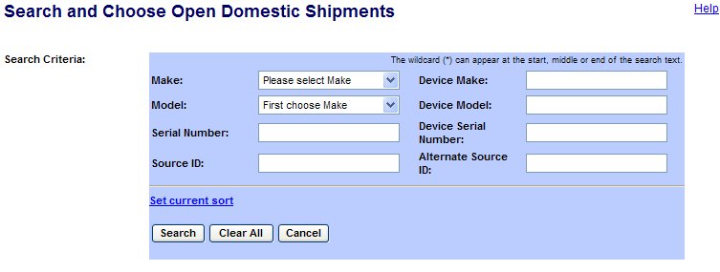

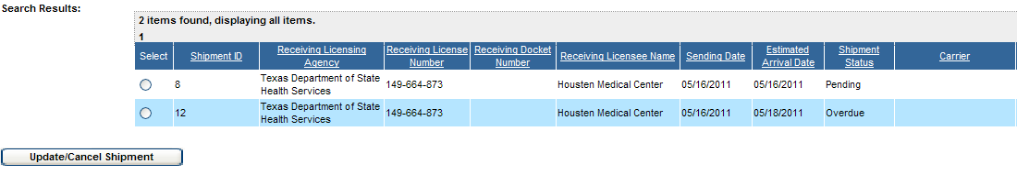
Figure 4-115: Search and Choose Open Domestic Shipments

Note: If there are multiple open Shipment/Transfers you can use the sort capability by clicking the column headings for ascending and descending sorts.

- Click the Select radio button to select a shipment to update.

- Click Update/Cancel Shipment.

- The Update/Cancel Domestic Shipment window appears.
- To add sources to the shipment, click Add Sources.
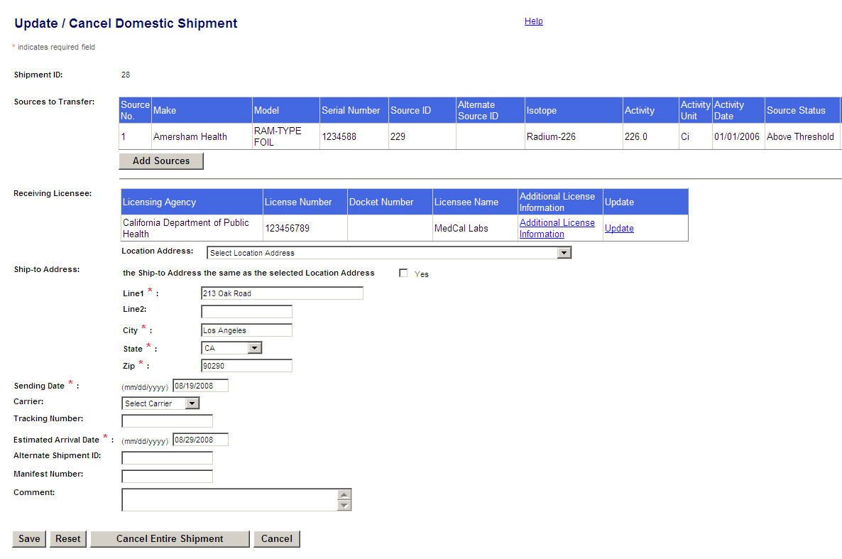
Figure 4-116: Update / Cancel Domestic Shipment

- The Search and Choose Sources for Transfer (Domestic) window appears.

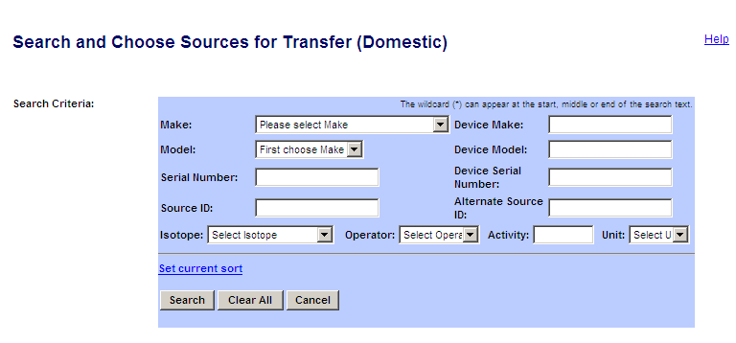
Figure 4-117: Search and Choose Sources for Transfer (Domestic)

The following fields are available to search for Sources:

Field Name | Req. Value | Description/Comments | Acceptable Values | Example Value
Make |  | Represents the manufacturer. Each Make will have one or more models associated with it. | Drop-down list | 800 Delta
Model |  | Item that is manufactured. Represents a Model associated with a Make. | Drop-down list | A424-19
Serial Number |  | The serial number assigned by the manufacturer. | Alphanumeric | TK12345
Source ID |  | A unique system-generated identifier for each manufactured source. | Numeric value | 23456234567
Isotope Name |  | Identification of the isotope in a Source. | Drop-down list | Cobalt-60
Isotope: Select Operator |  | A filter for search criteria. | Drop-down list | = (equal)
Isotope: Enter Activity |  | Activity level for isotope. | Numeric value | 223
Isotope: Select Unit |  | Unit in which the activity level of the Source is measured. | Drop-down list | Ci
Device Make |  | Make of the device containing a trackable nuclear source. | Alphanumeric | Acme
Device Model |  | Model of the device containing a trackable nuclear Source. | Alphanumeric | Acme xx
Device Serial Number |  | Device serial number assigned by the manufacturer. | Alphanumeric | L98X777
Alternate Source ID |  | Additional Source ID that is designated by the Licensee. | Alphanumeric | 456781B

- Select the search criteria (Make, Model, Isotope information, Serial Number, Source ID, Device Make, Device Model, Device Serial Number, and Alternate ID).
- Click Search.

- The Search Results will be displayed. Select the source(s) to add to the transfer by clicking the Select check box.

- Click Add Sources.
- If the Source is not available in the list, click Enter Unrecorded Source to enter the Source.

- To return to the Update/Cancel Source Transfer window, click Cancel.

- The Update/Cancel Domestic Shipment window appears with the newly added sources.

Note: To see other fields in the window, use the horizontal scroll bar to scroll to the right.

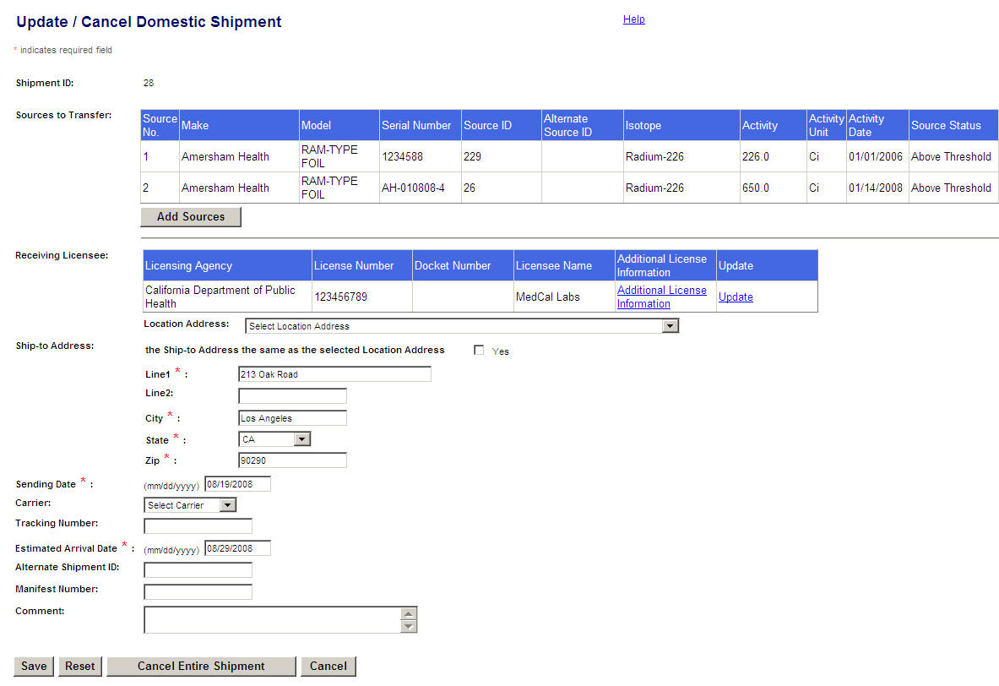
Figure 4-118: Update / Cancel Domestic Shipment (Add and Update)

- To view additional license information click the Additional License Information link.

- The Additional License Information window appears. To close the window and return to the Update/Cancel Domestic Shipment window, click Close.

Figure 4-119: Additional License Information

- To change the Receiving Licensee, scroll down and click the Update link in the Receiving Licensee section of the Update/Cancel Domestic Shipment window. The Search and Choose Receiving Licensee window appears.

Figure 4-120: Search and Choose Receiving Licensee

The following fields are available to search Licensee information:

Field Name | Req. Value | Description/Comments | Acceptable Values | Example Value
Licensing Agency |  | Agency that has regulatory authority over the Licensees. Defaults to the user’s Agency. Only an NRC user or the NSTS Analyst can change the value of the Licensing Agency. | Drop-down list | NRC
Licensee  Name |  | Name of the licensee. | Free-form text | ABC Company
License Number |  | Number assigned when a license is issued. | Drop-down list | 945AL733WP9
Docket Number |  | License identifier used by NRC. Required for NRC Licensees only. Optional search criteria. | Drop-down list | 05000313
License Category |  | The category of the License | Drop-down list | Manufacturer
Address: City |  | Receiving Licensee’s City. | Free-form text | Rockville
Address: State |  | Receiving Licensee’s State. | Drop-down list | Maryland

- Enter Licensee search criteria and then click Search. To see all Licensees available for selection, do not enter search criteria.
- The search results display. Select a receiving licensee by clicking the Select radio button, and then click Continue.

Figure 4-121: View and Choose Open Domestic Shipments (Search Results)

- The Update/Cancel Domestic Shipment window appears with the updated Licensee in the Receiving Licensee box.

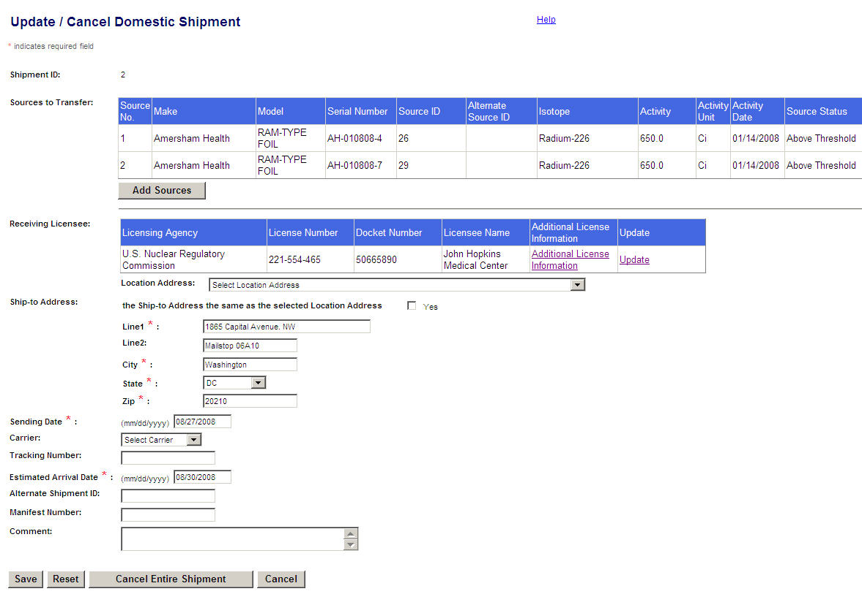
Figure 4-122: Update/Cancel Domestic Shipment
The following fields are available to update shipment information:
Field Name | Req. Value | Description/Comments | Acceptable Values | Example Value
Location Address |  | Physical location of the Source. A location cannot exist without an address. | Drop-down list | Houston, TX
Ship-To-Address: Line 1 | Y | Receiving Licensee’s United States (U.S.) address. Defaults to the entered Receiving Licensee’s street address. | Free-form text | 919 Elm Street
Line 2 |  | Additional address location information for the Licensee, e.g., Room, Building, Suite, etc. | Free-form text | Suite 3C
City | Y | City of the receiving licensee. | Free-form text | Chicago
State | Y | State of the receiving licensee. | Drop-down list | IL
Zip | Y | Zip code of the receiving licensee. | 5 or 9 digit ZipCode | 30315-0000
Sending Date | Y | Shipping date for transfers. (Defaults to the current date.) | mm/dd/yyyy | 11/30/2006
Carrier |  | Sending company that delivers the shipment. | Drop-down list | FedEx
Tracking Number |  | Number provided by the Shipping or Sending company. | Alphanumeric | 444M32JS411
Estimated Arrival Date | Y | Date when the transfer is estimated to be received by the Receiving Licensee. | mm/dd/yyyy  (Must be on or after the sending date.) | 05/23/2006
Alternate Shipment ID |  | Shipment ID generated in another system such as the DOE RSRT or a Sending Licensee’s system. | Numeric value | 22233344455
Manifest Number |  | Number used in a shipping record. | Alphanumeric | 4094420
Comment |  | Details entered as free-form text by the user. | Free-form text (up to 2000 characters). | This is a shipment.

- To edit shipment/transfer information, make changes in the Update/Cancel Shipment Information window.
Figure 4-123: Update / Cancel Domestic Shipment (Add and Update)

- To cancel a source transfer in the shipment, select the Cancel check box for that source. To remove a newly added source from the shipment, click the Remove link for the source.

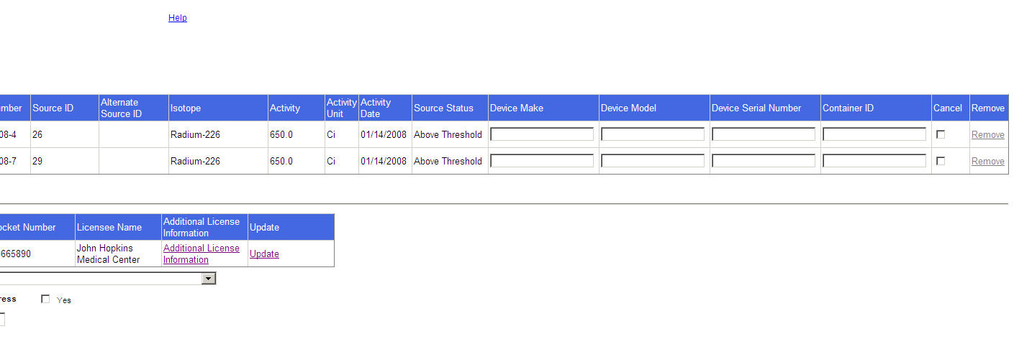
Figure 4-124: Update / Cancel Domestic Shipment (Remove)
- When all updates are complete, click Save.
- To cancel the entire shipment, click Cancel Entire Shipment. To exit the window without saving the changes, click Cancel.
Figure 4-125: Update / Cancel Domestic Shipment (Cancel Shipment)

- When the confirmation window appears, click Back to Menu to return to the NSTS Main Menu
- The system will process the cancelled shipment or transfers as follows:

  - Cancel Entire Shipment – If the entire shipment is cancelled, the system sets the Shipment Status and all Transfer Statuses to Cancelled, and sets the Shipment Status Date and all Transfer Status Dates to the current date.

  - Cancel Selected Transfers – If only one or some Transfers are cancelled, the system sets the appropriate Transfer Status to Cancelled and the Transfer Status Date to the current date.

Update/Cancel Source Export
User – Licensees, and Licensing Agencies and NSTS Analyst (acting as a Licensee surrogate).

Use – Sending Licensee updates existing transfer information or cancels a transfer.

- From the NSTS Main Menu, under Transfer Management, click Update/Cancel Source Export. The Search and Choose Open Export Shipments window appears
- Enter search criteria and click Search button. A list of open export shipments displays.

- Click the Select radio button to select a shipment.

- Click the Update/Cancel Shipment button.

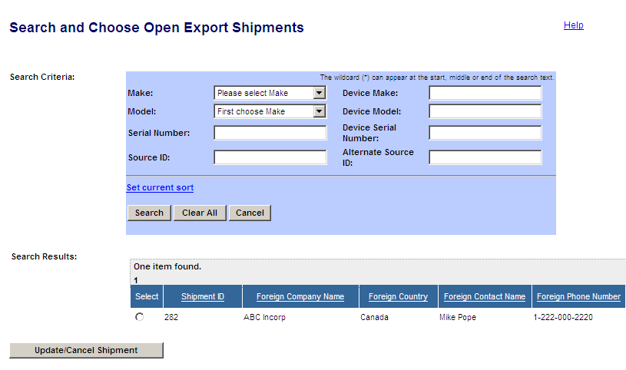
Figure 4-126: Search and Choose Open Export Shipments

- The Update/Cancel Export Shipment window appears. To add sources to the shipment, click the Add Sources button within the Sources to Export section.
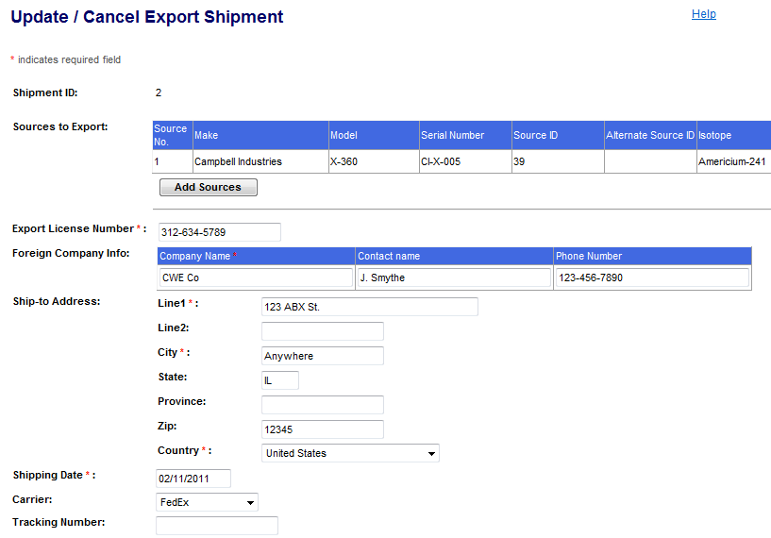
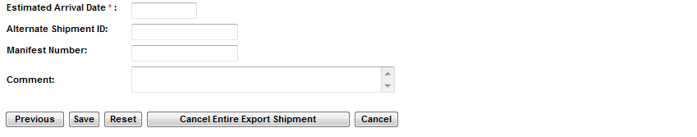
Figure 4-127: Update / Cancel Export Shipment

Note: Click the Previous button to return to the Search and Choose Open Export Shipments window.

- The Search and Choose Sources for Export window appears.

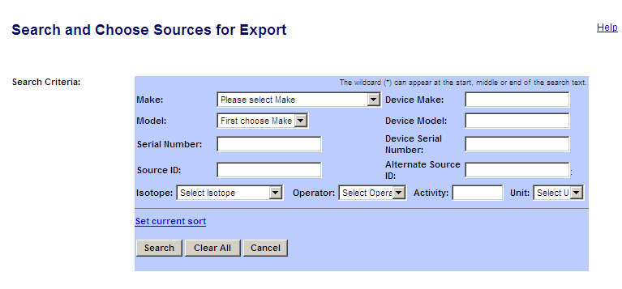
Figure 4-128: Search and Choose Sources for Export

The following fields are available in the Search and Choose Sources for Export window to enter Source information:
Field Name | Req. Value | Description/Comments | Acceptable Values | Example Value
Make |  | Represents the manufacturer. Each Make will have one or more models associated with it. | Drop-down list | 800 Delta
Model |  | Item that is manufactured. Represents a Model associated with a Make. | Drop-down list | A424-19
Serial Number |  | Identification number assigned to a Source by the manufacturer. | Alphanumeric | TK12345
Device Make |  | Make of the device containing a trackable nuclear source. | Alphanumeric | Acme
Device Model |  | Model of the device containing a trackable nuclear Source. | Alphanumeric | Acme xx
Device Serial Number |  | Device serial number assigned by the manufacturer. | Alphanumeric | L98X777
Alternate Source ID |  | Additional Source ID that is designated by the Licensee. | Alphanumeric | 456781B
Isotope Name |  | Identification of the isotope in a Source. | Drop-down list | Cobalt-60
Isotope: Select Operator |  | A filter for search criteria. | Drop-down list | = (equal)
Isotope: Select Unit |  | Unit in which the activity level of the Source is measured. | Drop-down list | Ci
- Select the search criteria (Make, Model, and Isotope information). Enter the Serial Number, Source ID, Device Make, Device Model, Device Serial Number, and Alternate Source ID.
- Click Search. To return to the Update/Cancel Source Transfer window, click Cancel.

  - In the search results, select the Source(s) to add to the transfer by clicking the Select check box. Click the Add Sources button. Note: If the Source is not available on the list, click Enter Unrecorded Source.

9. The Update/Cancel Export Shipment window appears with the newly added sources in the Sources to Export box.

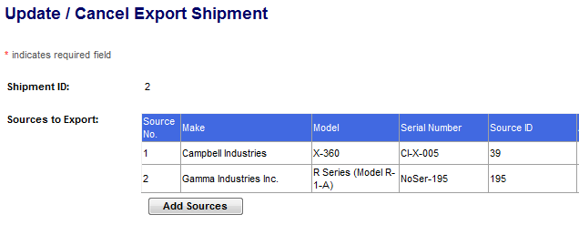
Figure 4-129: Update / Cancel Export Shipment with Added Source

The following fields are available to update export shipment information:
Field Name | Req. Value | Description/Comments | Acceptable Values | Example Value
Export License Number | Y | Export license number assigned by the NRC. | Alphanumeric | 0398392110
Foreign Company Name | Y | Name of the foreign recipient. | Free-form text | British Company
Foreign Company Contact Name |  | Name of the contact person at the foreign company. | Free-form text | John Bright
Foreign Company Phone Number |  | Telephone number at the foreign company | Numeric value | 011-2321-3222
Ship-to-Address: Line 1 | Y | Receiving Licensee’s foreign street address. | Free-form text | 123 lamp road
Ship-to-Address: Line 2 |  | Receiving Licensee’s additional mailing address | Free-form text | Room 3C
City | Y | Name of the foreign City | Free-form text | Montreal
State |  | Name of the State in the foreign country (Same as Province.) | Free-form text | Quebec
Foreign Province |  | Province of the foreign country | Free-form text | Quebec
Foreign Zip | Y | Zip code of the foreign country | Alphanumeric | 234 Y3K
Foreign Country | Y | Where the Licensee is importing from or being exported. | Drop-down list | Canton
Shipping Date | Y | Date the Sources were shipped. Defaults to the current date. | mm/dd/yyyy | 04/04/2006
Carrier |  | Sending company that delivers the shipment. | Drop-down list | FedEx
Tracking Number |  | Number provided by the Shipping or Sending company. | Alphanumeric | 666M32JS666
Estimated Arrival Date |  | Date when the transfer/export is estimated to be received by the Receiving Licensee. | mm/dd/yyyy  (Must be on or after the sending date.) | 04/04/2006
Alternate Shipment ID |  | Shipment ID generated in another system such as the DOE RSRT or a Sending Licensee’s system. | Numeric value | 2309478598
Comment |  | Information regarding the export | Free-form text (up to 2000 characters). | This shipment is complete.

- To cancel a source from the Export shipment, click on the Cancel check box for the particular source. To remove a newly added Source from the shipment, click the Remove link for the source. To cancel a shipment, click Cancel Entire Shipment.
- To update the information, make changes, and then click Save. To exit the window without saving the changes, click Cancel.
- When the confirmation window appears, click Back to Menu to return to the NSTS Main Menu.

Review Transfer History
User – NRC Staff, Agreement State Staff, DOE Staff, NSTS Analysts, and Licensees.

Use – To view a Licensee’s Source transfer history. This includes NSTS trackable sources that have been received /imported and those that have been shipped/exported.

- From the NSTS Main Menu, under Transfer Management, click the Review Transfer History link.
  - Licensee
    - For licensees, a list of shipments in which the licensee is either the Sender or Receiver will be automatically displayed.

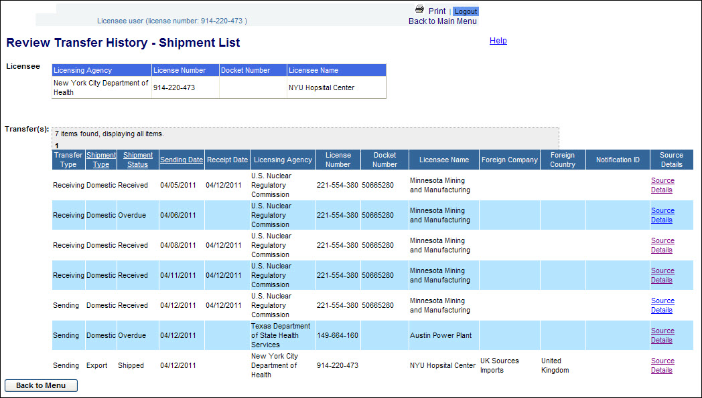
Figure 4-130: Review Transfer History (Shipment List of Licensee NYC 914-220-473)

    - For domestic shipments of Transfer Type ‘Sending,’ the licensee to whom the shipment was sent is displayed. For shipments of Transfer Type ‘Receiving,’ the licensee by whom the shipment was sent is displayed.
    - An export shipment will display the sending licensee’s agency, number, and name. An import shipment will display the receiving licensee’s agency, number, and name.

  - An NRC or Licensing Agency staff user will be presented with the Review Transfer History search screen. The search will return a list of licenses for which a shipment list can be displayed.

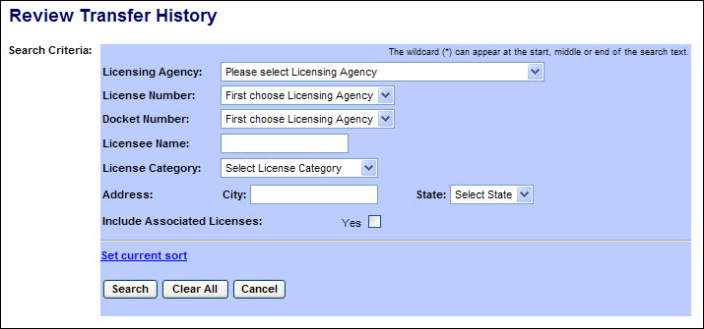
Figure 4-131: Review Transfer History (Search Criteria)

The following fields are available to specify the criteria to search for Licenses:
Field Name | Description/Comments | Acceptable Values | Example Value
Licensing Agency | The Agency that has regulatory authority over the Licensee. An NRC user or NSTS Analyst can select any Licensing Agency. A DOE user or State Agency user can select only their agency. | Drop-down list | Ohio Department of Health
License Number | Number assigned when a license is issued. | Drop-down list | 45-27764-01
Docket Number | License identifier used by NRC. NRC Licensees only. | Drop-down list | 05000313
Licensee Name | Name of the organization to which the license was issued. | Free-form text | ABC Company
License Category | Category of the License | Drop-down list | Power Reactor
Address: City | Name of the U. S. City. | Free-form text | Cleveland
Address: State | Name of the U. S. State. | Drop-down list | OH
Include Associated Licenses: Yes | If a search returns a license that has licenses associated with it, the associated licenses will be included in the search results. | Check mark

- Enter search criteria and click the Search button.
A list of licenses meeting the search criteria will be displayed. (If no criteria are entered, all licenses accessible to the user will be listed.)

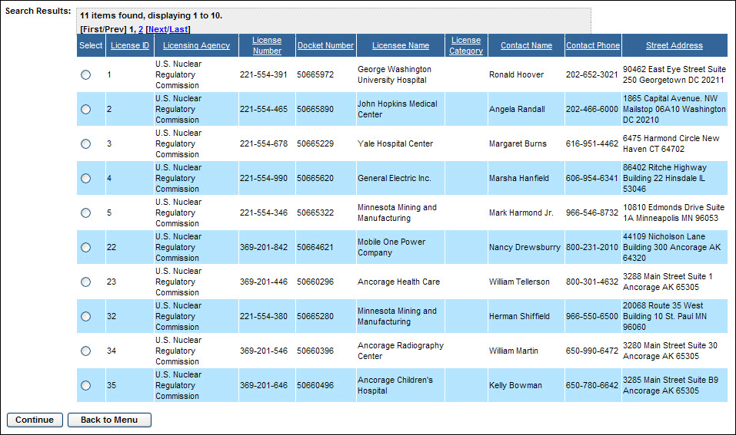
Figure 4-132: Review Transfer History (Search Results)

- From the search results, select the radio button () for the desired license. Then select the Continue button. The Shipment List for the selected license will be displayed.

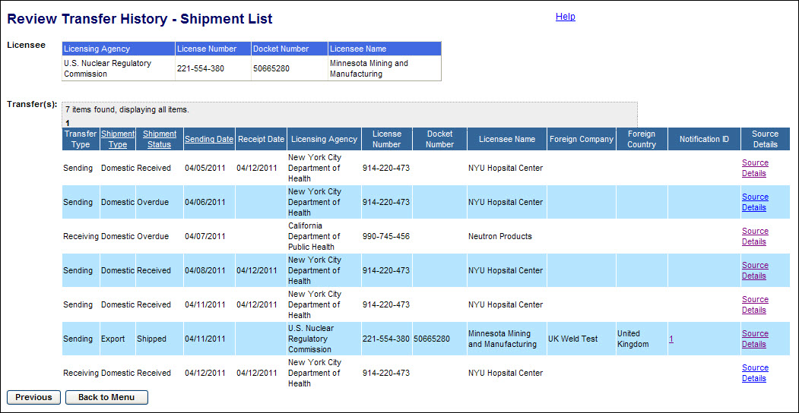
Figure 4-133: Review Transfer History (Shipment List)

Note: Click the Previous button to return to the Review Transfer History (Search Results) window.

- Review the information provided. To view additional information, select the links on the right portion of the screen.

- Notification ID will display the Import or Export notification associated with a shipment

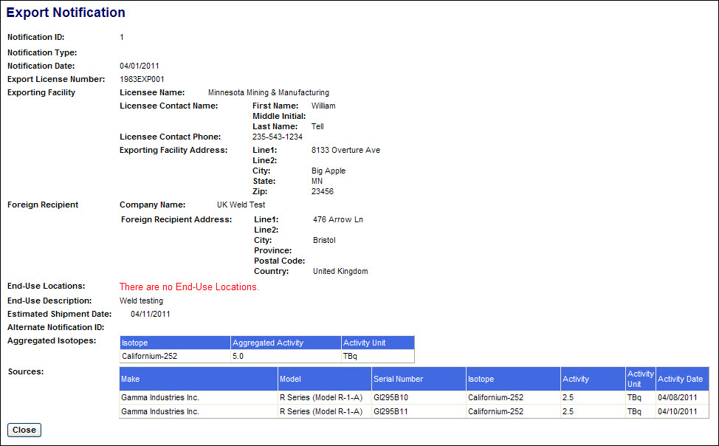
Figure 4-134: Review Transfer History (Export Notification)

- Source Details will display the sources in a shipment

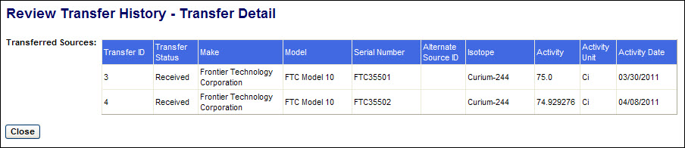
Figure 4-135: Review Transfer History (Source Details)

After viewing the information provided, click the Close button to return to the Review Transfer History – Shipment List window.

- From the Review Transfer History – Shipment List window, click the Back to Menu button to return to the NSTS Main Menu.

View Transfer Progress
User – Sending and Receiving Licensees, Agency Staff, and NSTS Analyst.

Use – To view the status of open source transfers reported to the NSTS. The Transfer Progress report provides a single view of all data entered by the parties involved in the transfer of a source.

- From the NSTS Main Menu, under Transfer Management, click the View Transfer Progress link.

  - If the user is a licensee, a list of any open shipments in which the licensee is either the Sender or Receiver will be automatically displayed.

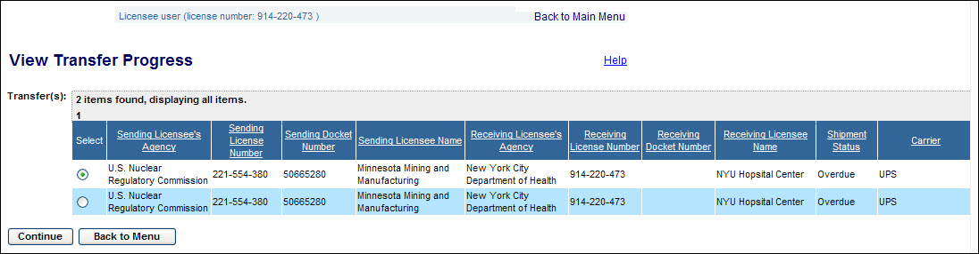
Figure 4-136: View Transfer Progress (Open Shipments for NYC 914-220-473)

  - An NRC or Licensing Agency staff user will be presented with the Search and Choose Shipment and Associated Sources search criteria window. The search will return a list of open shipments meeting the criteria entered.
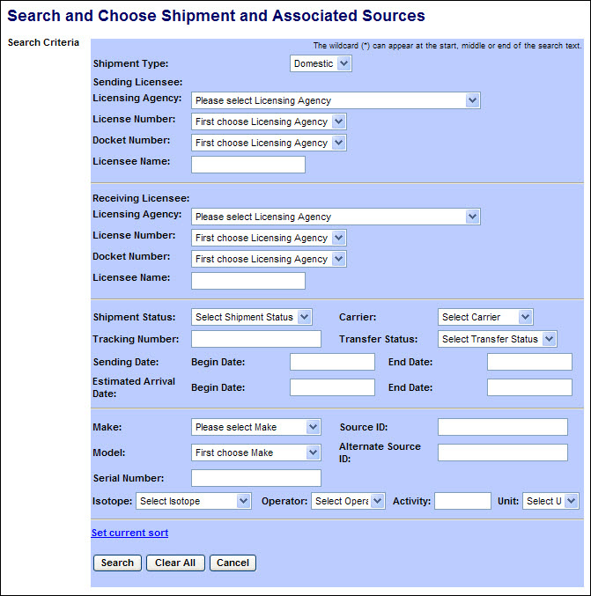
Figure 4-137: View Transfer Progress (Search criteria)

The following fields are available to specify the search criteria:

Field Name | Description/Comments | Acceptable Values | Example Value
Shipment Type | Select type of shipment | Drop-down list | Export
Sending Licensee: Licensing Agency | The Agency that has regulatory authority over the Sending Licensees. Defaults to the user’s Agency. Only an NRC user or NSTS Analyst can change the value of the Licensing Agency. | Drop-down list | Illinois Emergency Management Agency
License Number | Number assigned when a license is issued. | Drop-down list | 45-27764-01
Docket Number | License identifier used by NRC. Required for NRC Licensees only. Optional for search criteria. | Drop-down list | 05000313
Licensee Name | Name of the organization to which the license was issued. | Free-form text | ABC Company
Receiving Licensee: Licensing Agency | The Agency that has regulatory authority over the Receiving Licensees. Defaults to the user’s Agency. Only an NRC user or NSTS Analyst can change the value of the Licensing Agency. | Drop-down list | Illinois Emergency Management Agency
License Number | Number assigned when a license is issued. | Drop-down list | 45-27764-01
Docket Number | License identifier used by NRC. Required for NRC Licensees only. Optional for search criteria. | Drop-down list | 05000313
Licensee Name | Name of the organization to which the license was issued. | Free-form text | ABC Company
Shipment Status | Current status of the Shipment | Drop-down list | Overdue
Carrier | Company transporting the shipment. | Drop-down list | FedEx
Tracking Number | Shipment ID used by the carrier. | Free-form text | 34P487
Transfer Status | Status of the Transfer (Shipped or Not Received) | Drop-down list | Shipped
Sending Date: Begin Date | Beginning date of sending date range | mm/dd/yyyy | 02/01/2011
Sending Date: End Date | End date of sending date range | mm/dd/yyyy | 02/08/2011
Estimated Arrival Date: Begin Date | Beginning date of estimated arrival date range | mm/dd/yyyy | 02/20/2011
Estimated Arrival Date: End Date | End date of estimated arrival date range | mm/dd/yyyy | 02/21/2011
Make | Represents the manufacturer. Each Make has one or more models associated with it. | Drop-down | Delta
Model | Item that is manufactured. Represents a Model associated with a Make. | Drop-down | A424-19
Serial Number | Identification number assigned to a Source by the manufacturer. | Alphanumeric | TK12345
Source ID | A unique system-generated identifier for each manufactured source. | Numeric value | 23456
Alternate Source ID | Additional Source ID that is designated by the Licensee. | Alphanumeric | 456781B
Isotope | Identification of the isotope in a Source | Drop-down list | Cobalt-60
Operator | A filter for searching by the level (greater than, less than, etc.) of the current activity. | Drop-down list | = (equal)
Activity | Current activity level for isotope. | Numeric value | 223
Unit | Unit in which the activity level of the Source is measured. | Drop-down list | Ci

- Enter the search criteria and click the Search button. The search results will be displayed below the search criteria box.

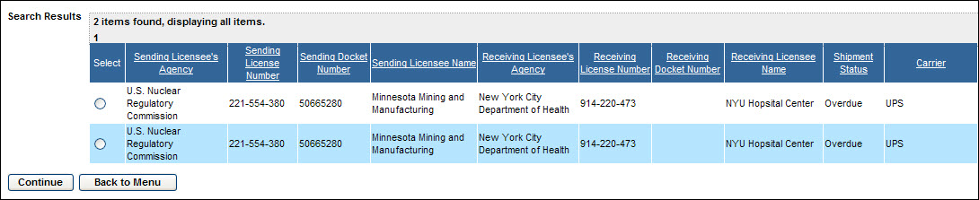
Figure 4-138: View Transfer Progress (Search Results)

3. From the shipment list, select the radio button () for the desired shipment to be viewed and click the Continue button. The View Transfer Progress window will be displayed.

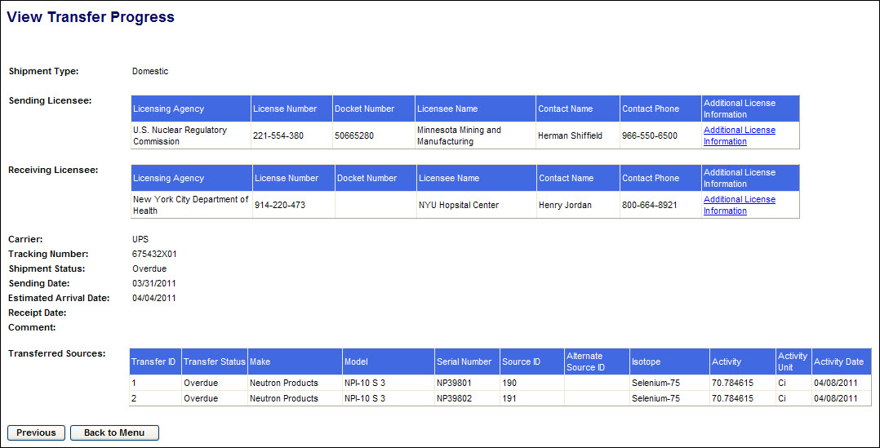
Figure 4-139: View Transfer Progress (Transfer Details)

Note: Click the Previous button to return to the Search and Choose Shipment and Associated Sources (Search Results) window.

4. Review the information provided. For more details on either the Sending Licensee or the Receiving Licensee, click the applicable Additional License Information link on the right side of the window.

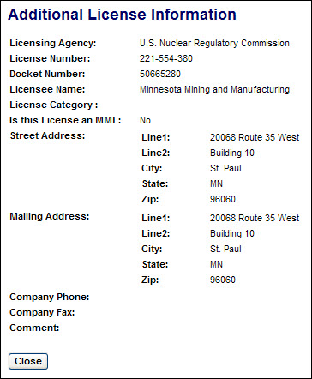
Figure 4-140: View Transfer Progress (Additional License Information)

5. Click the Close button to return to the View Transfer Progress window.

6. From the View Transfer Progress window, click the Back to Menu button to return to the NSTS Main Menu.

Query Transfers/Receipts
User – NRC Staff, Agreement State Staff, DOE Staff, and NSTS Analyst

Use – To retrieve a list of import, export, or domestic transfers.

1. From the NSTS Main Menu, under Transfer Management, click the Query Transfer/Receipts link. The Query Transfers and Receipts search criteria window appears:

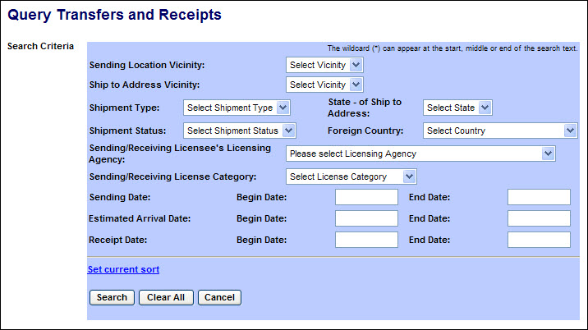
Figure 4-141: Query Transfers and Receipts (Search Criteria)

The following fields are available to narrow the search:

Field Name | Description/Comments | Acceptable Values | Example Value
Sending Location Vicinity | Geographic regions defined by a set of zip codes of source location addresses | Drop-down list | Baltimore
Ship to Address Vicinity | Geographic regions defined by a set of zip codes of source location addresses | Drop-down list | Baltimore
Shipment Type | Select type of shipment | Drop-down list | Export
State – of Ship to Address | State in which the Ship to Address is located. | Drop-down list | MD
Shipment Status | Status of the Shipment | Drop-down list | Overdue
Foreign Country | Country to which the Shipment was sent | Drop-down list | Bolivia
Sending/Receiving Licensee’s Agency | The Agency that has regulatory authority over the Licensee. An NRC user or NSTS Analyst can select a Licensing Agency. A DOE user or State Agency user can select only their own agency. | Drop-down list | Illinois Emergency Management Agency
Sending/Receiving License Category | License Category for the Sending/Receiving Licensee | Drop-down list | Medical
Sending Date: Begin Date | Beginning date of sending date range | mm/dd/yyyy | 02/01/2011
Sending Date: End Date | End date of sending date range | mm/dd/yyyy | 02/08/2011
Estimated Arrival Date: Begin Date | Beginning date of estimated arrival date range | mm/dd/yyyy | 02/20/2011
Estimated Arrival Date: End Date | End date of estimated arrival date range | mm/dd/yyyy | 02/21/2011
Receipt Date: Begin Date | Beginning date of receipt date range | mm/dd/yyyy | 02/01/2011
Receipt Date: End Date | End date of receipt date range | mm/dd/yyyy | 02/08/2011

2. After entering the search criteria, select the Search button. (If no criteria are selected, all shipments which the user is authorized to view will be displayed.)

Scroll to the right to display additional source information.

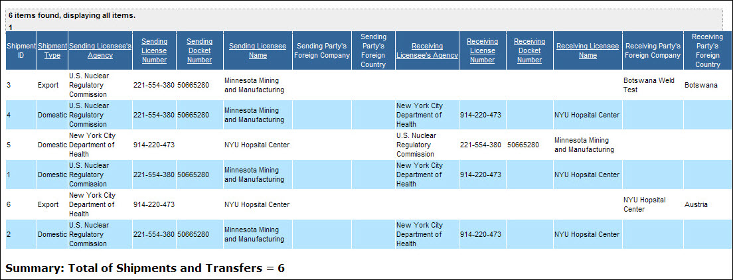
Figure 4-142: Query Transfers and Receipts (Search Results)

To view the Sources in a shipment, click on the Source link (in the far right column).

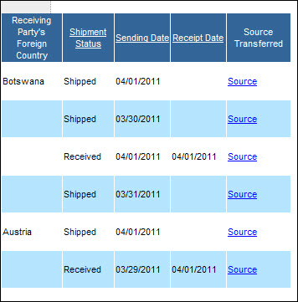
Figure 4-143: Query Transfers and Receipts (Search Results- Right Columns)
The Query Transfers and Receipts – Source Detail window will appear.

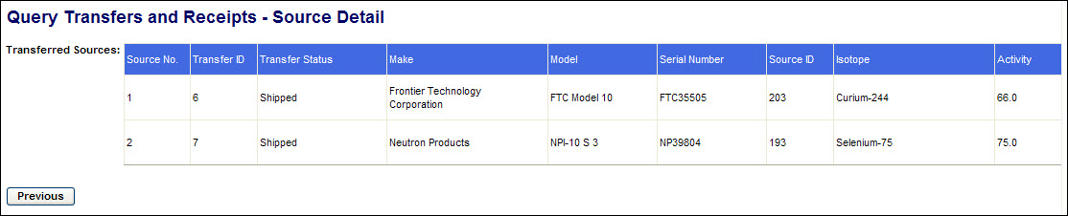
Figure 4-144: Query Transfers and Receipts (Source Detail)

3. After reviewing the source information, click the Previous button to return to the Search Results screen.

4. After reviewing the Search Results, click the Back to Menu button to return to the NSTS Main Menu.

Review Pending/Overdue Transfers
User – NRC Staff, Agreement State Staff, DOE Staff, and NSTS Analyst

Use – To retrieve a list of pending and overdue transfers.

1. From the NSTS Main Menu, under Transfer Management, click the Review Pending Transfers link. The Review Pending/Overdue Transfers search criteria window appears:

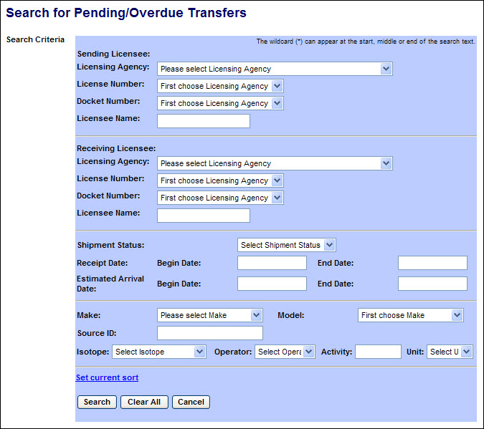
Figure 4-145: Review Pending/Overdue Transfers (Search Criteria)

The following fields are available to narrow the search:

Field Name | Description/Comments | Acceptable Values | Example Value
Licensing Agency | The Agency that has regulatory authority over the Licensee. An NRC user or NSTS Analyst can select a Licensing Agency. A DOE user or State Agency user can select only their agency. | Drop-down list | Illinois Emergency Management Agency
License Number | Number assigned when a license is issued. | Drop-down list | 45-27764-01
Docket Number | License identifier used by NRC. NRC Licensees only. | Alphanumeric | 05000313
Licensee Name | Name of the organization to which the license was issued. | Free-form text | ABC Company
Shipment Status | Status of the Shipment | Drop-down list | Overdue
Receipt Date: Begin Date | Beginning date of receipt date range | Free-form text | 02/01/2011
Receipt Date: End Date | End date of receipt date range | Free-form text | 02/08/2011
Estimated Arrival Date: Begin Date | Beginning date of estimated arrival date range | Free-form text | 02/20/2011
Estimated Arrival Date: End Date | End date of estimated arrival date range | Free-form text | 02/21/2011
Make | Represents the manufacturer. Each Make has one or more models associated with it. | Drop-down | Delta
Model | Item that is manufactured. Represents a Model associated with a Make. | Drop-down | A424-19
Source ID | A unique system-generated identifier for each manufactured source. | Numeric value | 23456
Isotope | Identification of the isotope in a Source | Drop-down list | Cobalt-60
Operator | A filter for searching by the level (greater than, less than, etc.) of the current activity. | Drop-down list | = (equal)
Activity | Current activity level for isotope. | Numeric value | 223
Unit | Unit in which the activity level of the Source is measured. | Drop-down list | Ci

2. After entering the search criteria, select the Search button. (If no criteria are selected, all shipments which the user is authorized to view will be displayed.)

Scroll to the right to display additional source information.

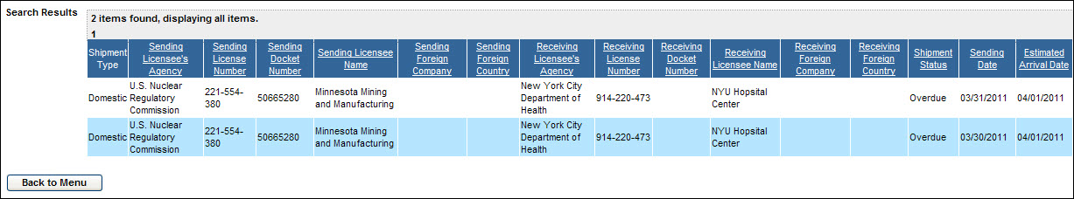
Figure 4-146: Review Pending/Overdue Transfers (Search Results)

To view the Sources in a shipment, click the Source Details link.

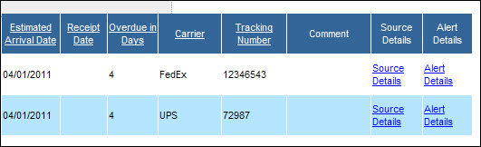
Figure 4-147: Review Pending/Overdue Transfers (Search Results- Right Columns)

The Review Pending/Overdue Transfers – Source Detail window will appear.

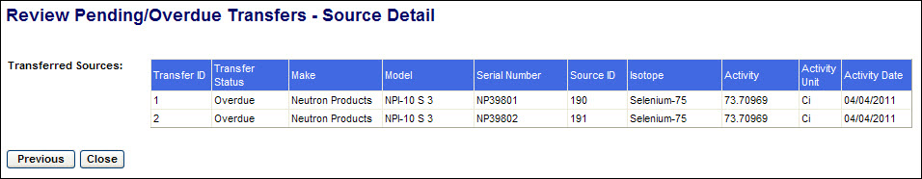
Figure 4-148: Query Transfers and Receipts (Source Detail)

3. After reviewing the source information, click the Previous button to return to the Search Results screen.

4. If an alert has been generated for a shipment, the details may be viewed by clicking on Alert Details (in the far right column). After reviewing the alert details, click the Previous button to return to the Search Results screen.

5. After reviewing the Search Results, click the Back to Menu button to return to the NSTS Main Menu.

Record Import Notifications
According to the IAEA Code of Conduct, exporting companies shall notify the importing country prior to shipment of Category 1 and Category 2 Sources. The NRC receives and records Import Notifications of sources sent to US licensees.

User – NRC Staff

Use – To record import notifications received from foreign exporting companies of source shipments to US licensees.

- From the NSTS Main Menu, under Transfer Management, click the Record Import Notifications link. The Record Import Notifications input form will be displayed.

Enter the information from the import notification received from the exporting company. Required fields are marked with a red asterisk.

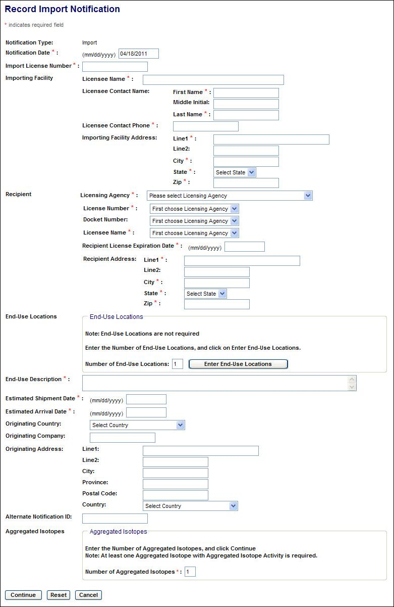
Figure 4-149: Record Import Notifications (Import Notification Form)

The following fields are available to enter the notification:

Field Name | Req’d Field | Description/Comments | Acceptable Values | Example Value
Notification Date | X | Date the Import Notification was received | mm/dd/yyyy | 03/15/2011
Import License Number | X | The domestic license number of the importer (i.e. Part 110 License Number) | Free-form text | 235256
Importing Facility |  | The organization to which the Import License was issued.
Licensee Name | X | The company name of the importer | Free-form text | Source Imports, Inc
Licensee Contact Name | X | First Name, MI, Last Name of the importing licensee contact (Free-form text)
Licensee Contact Phone | X | Phone number of the importing licensee contact | xxx-xxx-xxxx | 123-234-3456
Address | X | Street, City, State, Zip Code of the importer (Free-form text & Drop-down fields)
Recipient |  | The Radioactive Materials License holder that will receive the imported source(s).
Licensing Agency | X | Licensing Agency that issued the 'possession' license of the recipient. This may be the NRC or an Agreement State agency | Drop-down list | Ohio Department of Health
License Number | X | The possession license number of the ultimate recipient of this import | Drop-down list | 45-27764-01
Docket Number |  | License identifier used by NRC. NRC Licensees only. | Alphanumeric | 05000313
Licensee Name | X | The company name of the ultimate recipient of this import | Drop-down list | ABC Company
License Expiration Date | X | The date the ‘possession’ license expires | mm/dd/yyyy | 12/31/2013
Address | X | Street, City, State, Zip Code of the recipient (Free-form text & Drop-down fields)
End-Use Locations |  | Street, City, State, & Zip Code of locations where the imported source(s) will be used (Free-form text & Drop-down fields)
End-Use Description | X | Description how the imported sources will be used | Free-form text | Blood irradiation
Estimated Shipment Date | X | The estimated date when the import shipment departs from the originating country | mm/dd/yyyy | 04/18/2011
Estimated Arrival Date | X | The estimated date when the import shipment will arrive at the end-use location. | mm/dd/yyyy | 04/23/2011
Originating Country |  | Country from which the source(s) were imported | Drop-down list | United Kingdom
Originating Company |  | Company which exported the source(s) | Free-form text | UK Nuclear, LTD
Originating Address |  | Street, City, State/Province, Postal Code, Country where the shipment originated  Free-form text (Free-form text & Drop-down fields)
Alternate Notification ID |  | An NRC notification ID generated outside of NSTS. | Free-form text | 245697

Field Name | Req’d Field | Description/Comments | Acceptable Values | Example Value
Sources and Activity |  | The sources or aggregated activity of the sources being imported.
Aggregated Isotopes | X | The total current activity level in TBq of each isotope in the sources being imported.
Source Details |  | The Make, Model, Serial Number, Isotope, and Activity/Activity Date of Sources being imported

2. If the end-use locations are included in the notification, enter the number of locations to be described and click the Enter End-Use Location link.

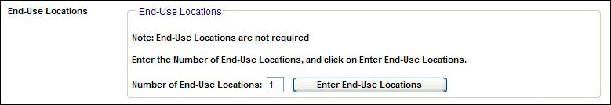
Figure 4-150: Record Import Notifications (Number of End-Use Locations)

The Location Address form will be displayed.

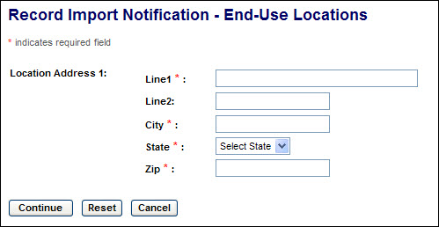
Figure 4-151: Record Import Notifications (End-Use Locations Address Form)

After entering the address information, click Continue to save the addresses and return to the Import Notification screen. To clear the form and remain on the End-Use Location screen, click Reset. To return to the Import Notification screen without saving address information, click Cancel.

- After entries have been made in all of the required fields (marked with a red asterisk), enter the number of isotopes in the shipment for which an aggregated total activity will be reported.

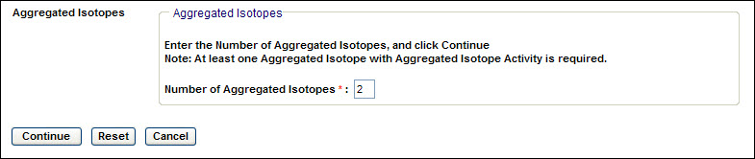
Figure 4-152: Record Import Notifications (Aggregated Isotopes-1)

- Click Continue. The Record Import Notification – Aggregated Isotopes screen will be displayed.

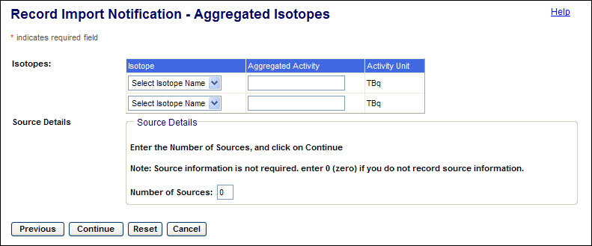
Figure 4-153: Record Import Notifications (Aggregated Isotopes-2)

- Select the isotope(s) in the sources to be imported, and for each isotope enter the total activity of all sources. Then enter the number of sources to be imported.

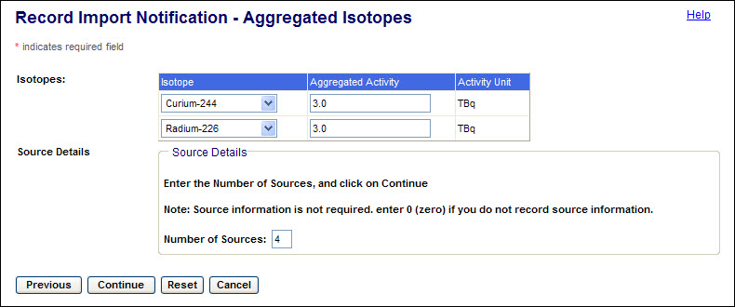
Figure 4-154: Record Import Notifications (Aggregated Isotopes-3)

- Click Continue. The source description form will be displayed.

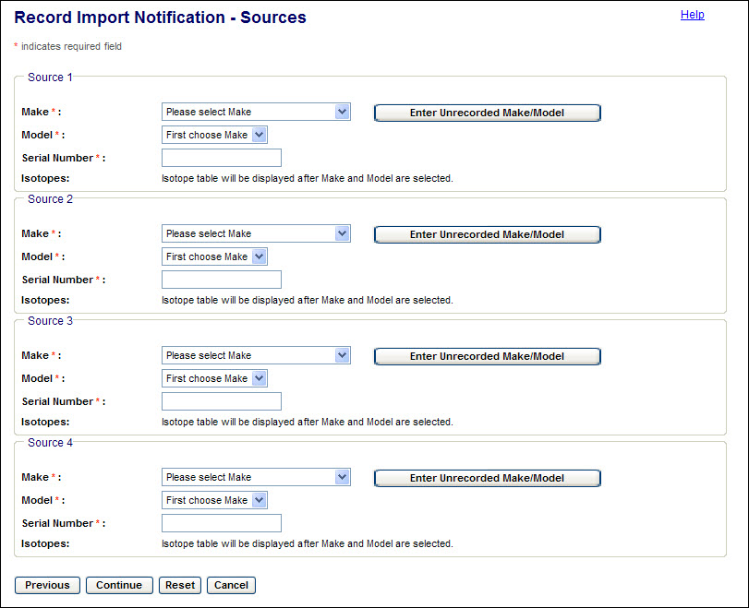
Figure 4-155: Record Import Notifications (Source Details- Blank)

- Select the Make, Model, and Serial Number of each source. The isotope and activity fields will be displayed.

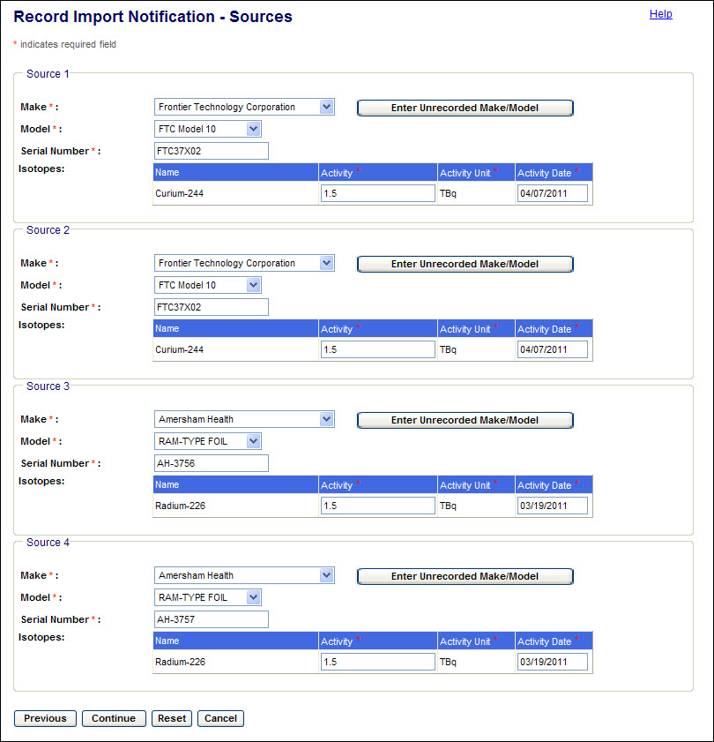
Figure 4-156: Record Import Notifications (Source Details – Isotope/Activity)

- Enter the Activity (TBq) and Activity Date. Click Continue to save the entries and return to the Import Notification screen.

Note: If the source Make or Model is not found in the dropdown list, click the Enter Unrecorded Make/Model button and record the sources as described in the notification received from the exporting company. (See Section 4.4.5 of the NSTS User Guide.) After recording the Make and Model, complete the entry of source data for the Import Notification.

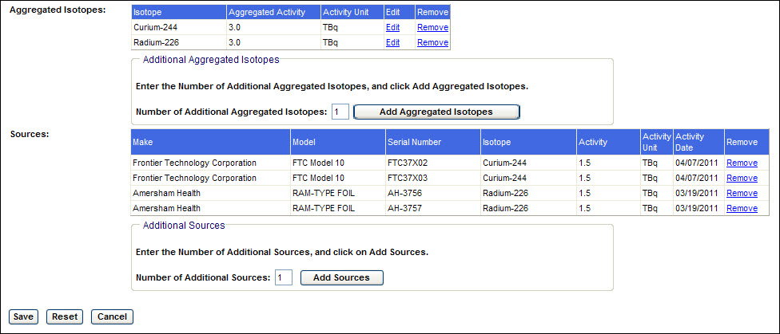
Figure 4-157: Record Import Notifications (Import Notification Form – Isotopes/Sources)

- Click the Save button to create the notification. The Record Import Notification Confirmation will be displayed. When saved, a unique Notification ID is assigned to each notification by the system.

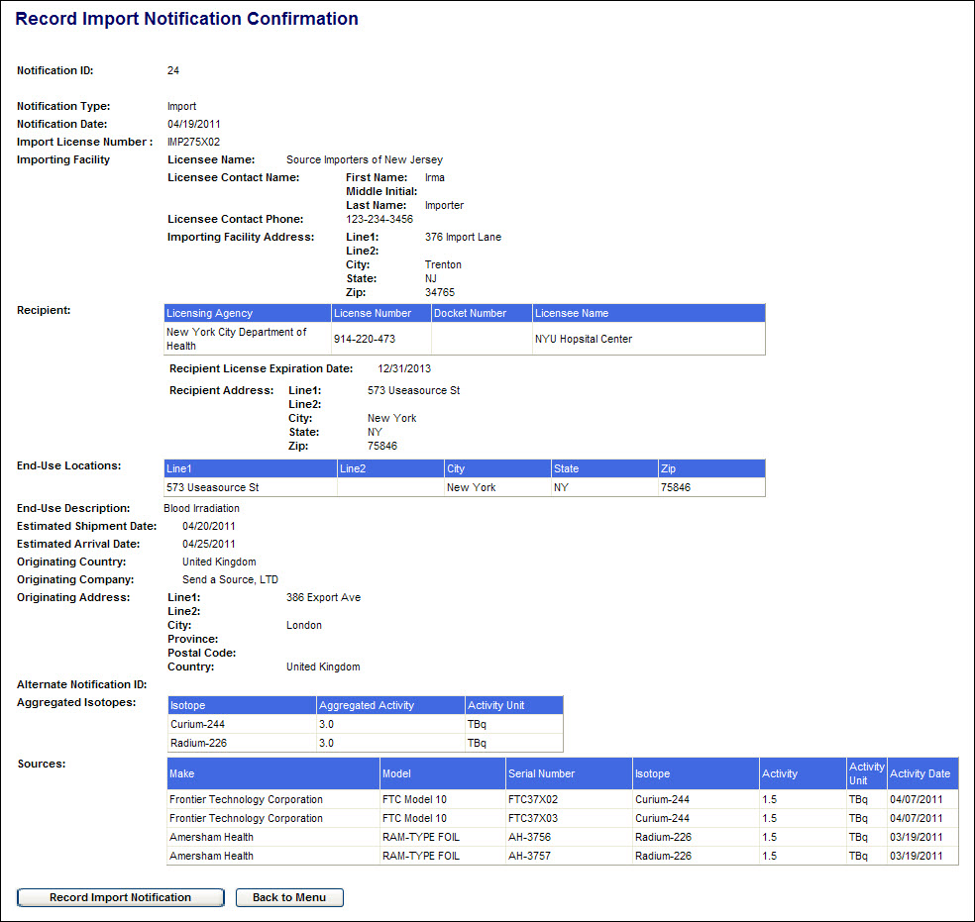
Figure 4-158: Record Import Notifications (Import Notification Confirmation)

- On the confirmation screen, click the Back to Menu button to return to the NSTS Main Menu, or click the Record Import Notification button to record another Import Notification.

Update Import Notifications
User – NRC Staff

Use – To retrieve a list of import notifications and update or delete selected import notifications.

1. From the NSTS Main Menu, under Transfer Management, click the Update Import Notifications link. The Update Import Notifications search criteria window will be displayed.

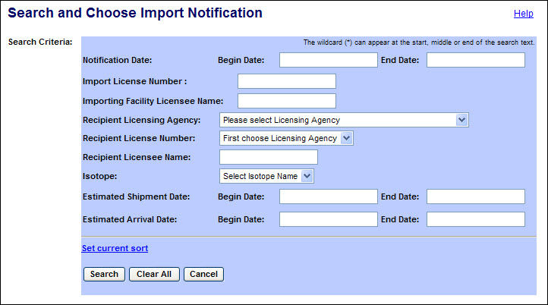
Figure 4-159: Update Import Notifications (Search Criteria)

The following fields are available to narrow the search:

Field Name | Description/Comments | Acceptable Values | Example Value
Notification Date: Begin Date | Beginning date of notification date range | mm/dd/yyyy | 02/20/2011
Notification Date: End Date | End date of notification date range | mm/dd/yyyy | 02/23/2011
Import License Number | The domestic license number of the importer (i.e. Part 110 License Number) | Free-form text | 235256
Importing Facility Licensee Name | The company name of the importer | Free-form text | Source Imports, Inc
Recipient  Licensing Agency | Licensing Agency that issued the 'possession' license of the recipient. This may be the NRC or an Agreement State agency | Drop-down list | Ohio Department of Health
Recipient License Number | The possession license number of the ultimate recipient of this import | Drop-down list | 45-27764-01
Recipient Licensee Name | The company name of the ultimate recipient of this import | Free-form text | ABC Company
Isotope | Identification of the isotope in a Source | Drop-down list | Cobalt-60
Estimated Shipment Date: Begin Date | Beginning date of estimated shipment date range | mm/dd/yyyy | 02/20/2011
Estimated Shipment Date: End Date | End date of estimated shipment date range | mm/dd/yyyy | 02/21/2011
Estimated Arrival Date: Begin Date | Beginning date of estimated arrival date range | mm/dd/yyyy | 02/20/2011
Estimated Arrival Date: End Date | End date of estimated arrival date range | mm/dd/yyyy | 02/21/2011

2. After entering the search criteria, select the Search button. (If no criteria are selected, all import notifications which the user is authorized to view will be displayed.)

Scroll to the right to display additional notification information.

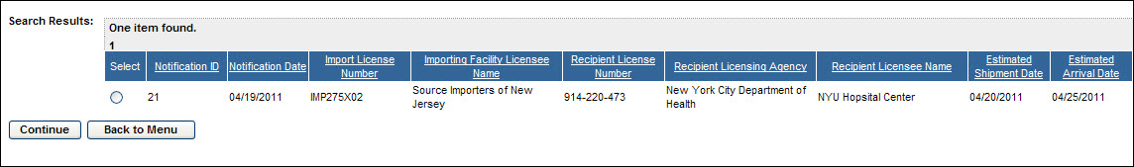
Figure 4-160: Update Import Notifications (Search Results)

- Select a notification to update or delete by clicking the radio button in the Select column and then the Continue button. The Update Import Notification screen will be displayed.

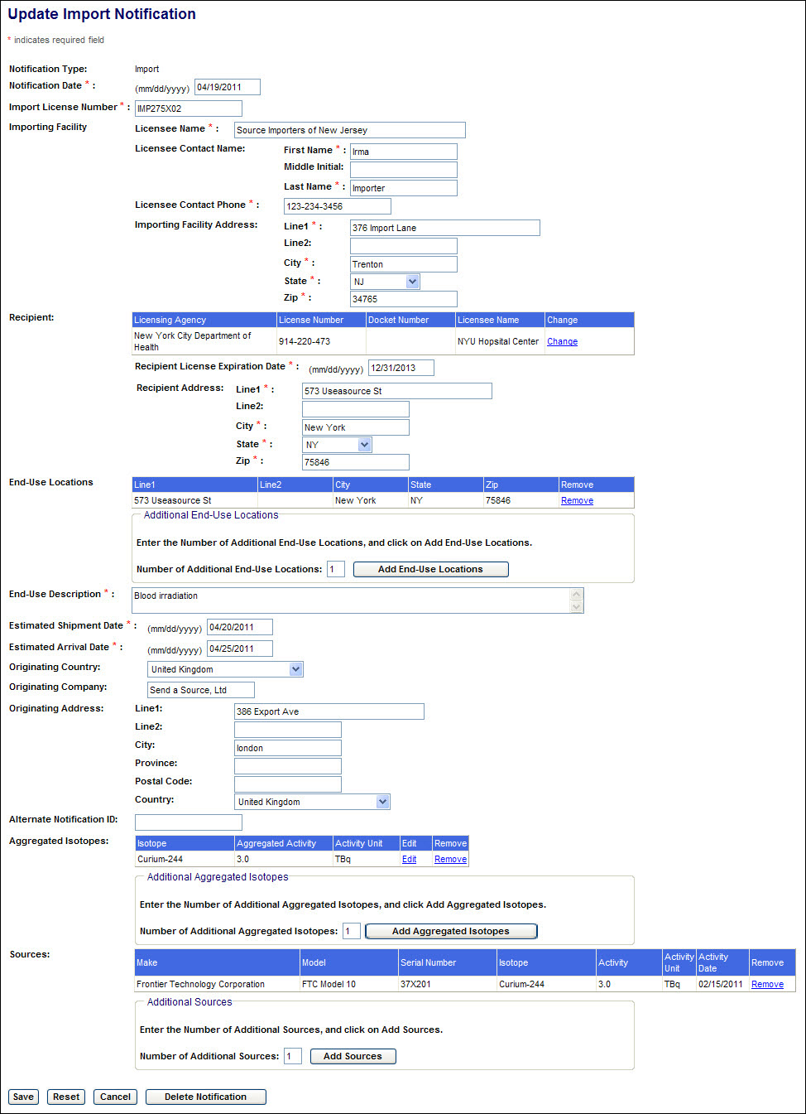
Figure 4-161: Update Import Notifications (Edit Screen)

- Update the details of the Import Notification and click the Save button. The revised notification will be displayed in an Update Import Notification confirmation screen.

The Reset button will return the notification fields to their saved values and leave the Update Import Notification edit screen displayed.

Note: Only fields editable on this screen will be reset. Changes to the notification made using the Change or Remove links in the form; and the addition of End-Use Locations, Aggregated Isotopes, and Sources will not be undone by the Reset button. Instead, use the Cancel button to prevent such changes from being saved.

The Cancel button will return the user to the Main Menu without saving any changes to the Import Notification.

To delete the Import Notification from NSTS, click the Delete Notification button.

- On the Update Import Notification confirmation screen, click the Update Import Notification button to search for and update another Import Notification.

Click the Back to Menu button to return to the NSTS Main Menu.

Record Export Notifications
According to the IAEA Code of Conduct, exporting companies shall notify their own regulatory authority and that of the importing country prior to shipment of Category 1 and Category 2 Sources. The NRC receives and records Export Notifications of sources sent by U.S. licensees to foreign companies.

User – NRC Staff

Use – To record export notifications received from U.S. licensees of source shipments to foreign companies.

1. From the NSTS Main Menu, under Transfer Management, click the Record Export Notifications link. The Record Export Notification window will be displayed.

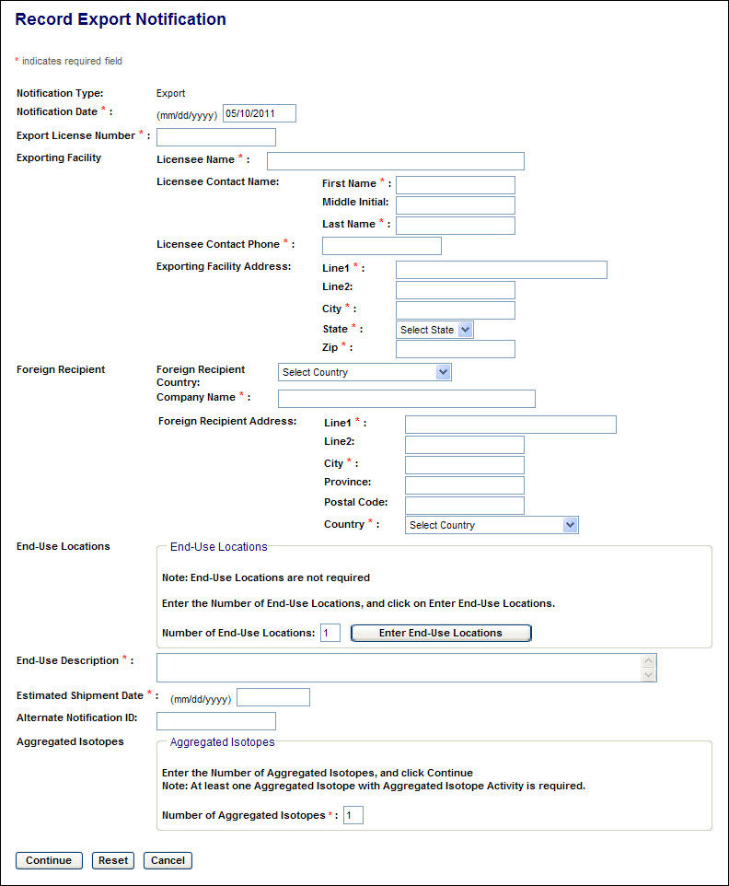
Figure 4-162: Record Export Notification (Export Notification Form)

The following fields are available to enter the notification:

Field Name | Req’d Field | Description/Comments | Acceptable Values | Example Value
Notification Date | X | Date the Export Notification was received | mm/dd/yyyy | 03/15/2011
Export License Number | X | The domestic license number of the exporter (i.e. Part 110 License Number) | Free-form text | 235256
Exporting Facility |  | The organization to which the Export License was issued.
Licensee Name | X | The company name of the exporter | Free-form text | Source Imports, Inc
Licensee Contact Name | X | First Name, MI, Last Name of the exporting licensee contact (Free-form text)
Licensee Contact Phone | X | Phone number of the exporting licensee contact | xxx-xxx-xxxx | 123-234-3456
Exporting Facility Address | X | Street, City, State, Zip Code of the exporter (Free-form text & Drop-down fields)
Foreign Recipient |  | The foreign company to which the source(s) will be sent..
Foreign Recipient Country | X | Country to which the source(s) will be exported | Drop-down list | United Kingdom
Company Name | X | Company that will receive the exported source(s) | Free-form text | UK Nuclear, LTD
Foreign Recipient Address | X | Street, City, Province, Postal Code, and Country of the recipient (Free-form text & Drop-down fields)
End-Use Locations |  | Street, City, State, & Zip Code of locations where the exported source(s) will be used (Free-form text & Drop-down fields)
End-Use Description | X | Description how the exported sources will be used | Free-form text | Blood irradiation
Estimated Shipment Date | X | The estimated date when the export shipment departs from the U.S. | mm/dd/yyyy | 04/18/2011
Alternate Notification ID |  | An NRC notification ID generated outside of NSTS. | Free-form text | 245697
Sources and Activity |  | The sources or aggregated activity of the sources being exported.
Aggregated Isotopes | X | The total current activity level in TBq of each isotope in the sources being exported.
Source Details |  | The Make, Model, Serial Number, Isotope, and Activity/Activity Date of Sources being exported

2. If the end-use locations are included in the notification, enter the number of locations to be described and click the Enter End-Use Location link.

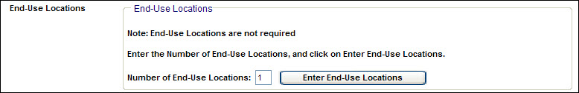
Figure 4-163: Record Export Notifications (Number of End-Use Locations)

The Location Address form will be displayed.

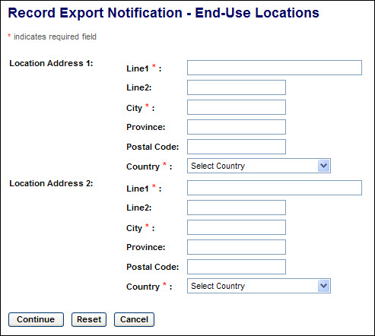
Figure 4-164: Record Export Notifications (End-Use Locations Address Form)

- After entering the address information, click Continue to save the addresses and return to the Import Notification screen. To clear the form and remain on the End-Use Location screen, click Reset. To return to the Export Notification screen without saving address information, click Cancel.

Note: The End-Use Location addresses entered will not be displayed on the Record Export Notification screen until after the exported source information has been entered.

- After entries have been made in all of the required fields (marked with a red asterisk), enter the number of Aggregated Isotopes in the notification and click Continue.

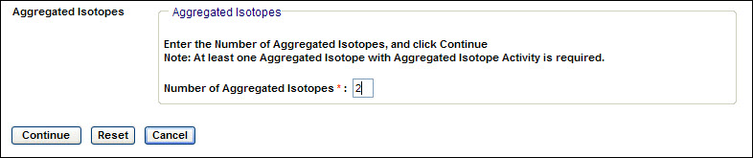
Figure 4-165: Record Export Notifications (Number of Aggregated Isotopes)

The Aggregated Isotopes form will be displayed.

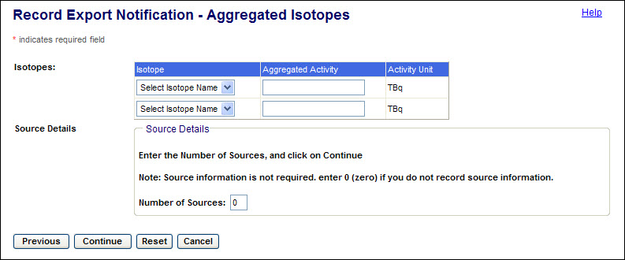
Figure 4-166: Record Export Notifications (Aggregated Isotopes Activity Form)

- Select the isotope(s) in the sources to be exported, and for each isotope enter the total activity of all sources.

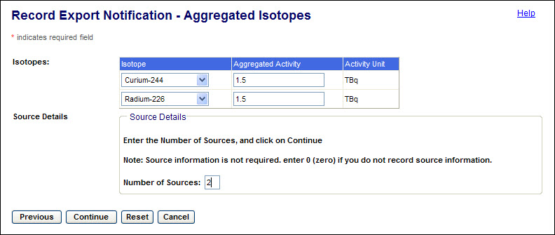
Figure 4-167: Record Export Notifications (Aggregated Sources / # of Sources)

Then enter the number of sources to be exported and click Continue. The source description form will be displayed.

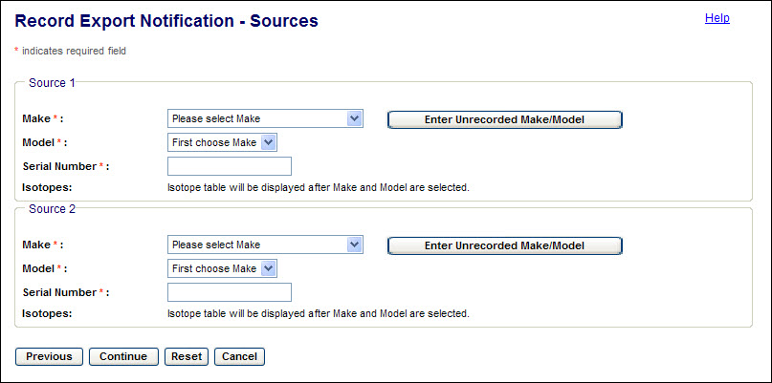
Figure 4-168: Record Export Notifications (Source Details)

- For each source, select the Make and Model, and enter the Serial Number. The isotope in the selected Make/Model will be displayed.

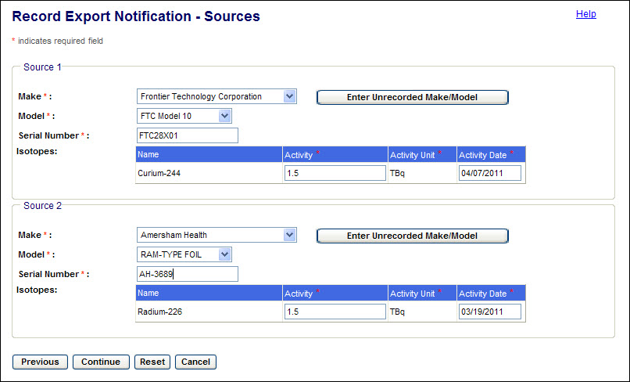
Figure 4-169: Record Export Notifications (Source Details – Isotope/Activity)

- Enter the Activity (TBq) and Activity Date. Click Continue to save the entries and return to the Import Notification screen.
Note: If the source Make or Model is not found in the dropdown list, click the Enter Unrecorded Make/Model button and record the sources as described in the notification received from the exporting company. (See Section 4.4.5 of the NSTS User Guide.) After recording the Make and Model, complete the entry of source data for the Export Notification.
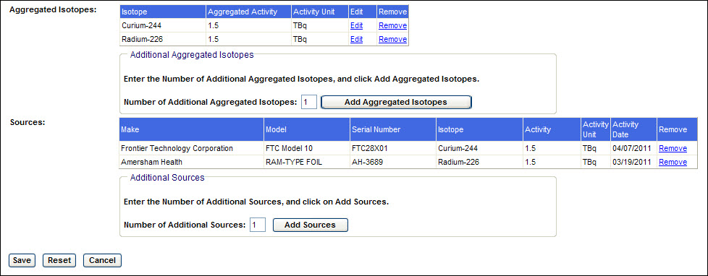
Figure 4-170: Record Export Notifications (Export Notification Form - Sources)

- Click the Save button to complete creation of the notification. The Record Export Notification Confirmation will be displayed. When saved, a unique Notification ID is assigned to each notification by the system.

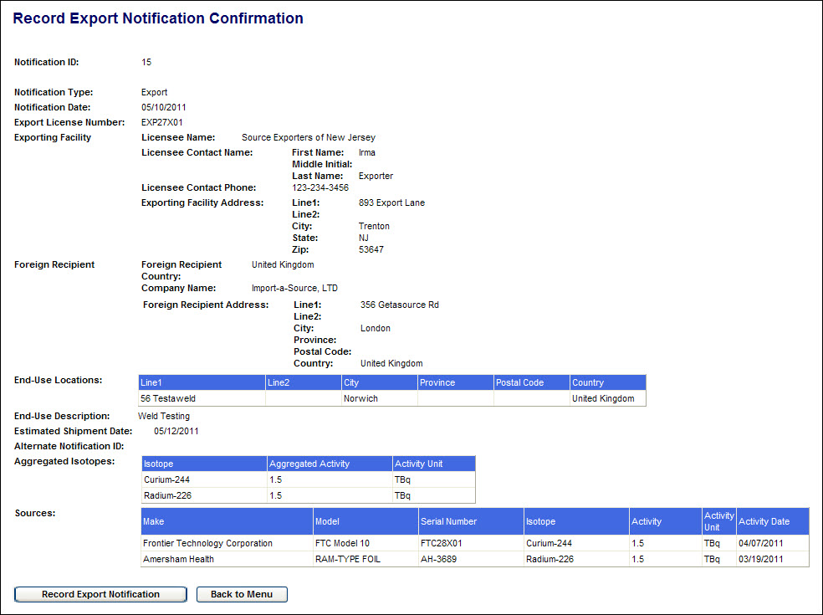
Figure 4-171: Record Export Notifications (Export Notification Confirmation)

- On the confirmation screen, click the Back to Menu button to return to the NSTS Main Menu, or click the Record Export Notification button to record another Export Notification.

Update Export Notifications
User – NRC Staff

Use – To retrieve a list of export notifications and update or delete selected export notifications.

1. From the NSTS Main Menu, under Transfer Management, click the Update Export Notifications link. The Update Export Notifications search criteria window will be displayed.

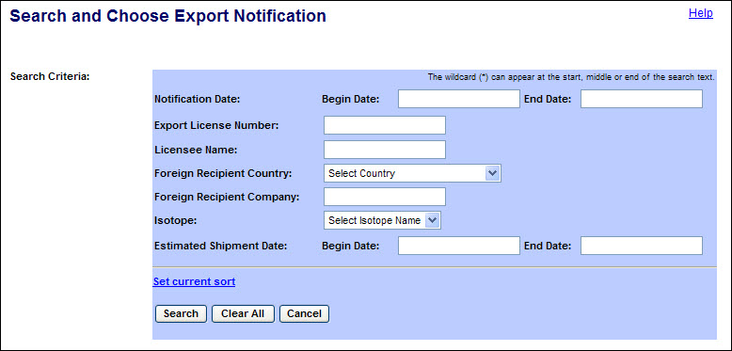
Figure 4-172: Update Export Notifications (Search Criteria)

The following fields are available to narrow the search:

Field Name | Description/Comments | Acceptable Values | Example Value
Notification Date: Begin Date | Beginning date of notification date range | mm/dd/yyyy | 02/20/2011
Notification Date: End Date | End date of notification date range | mm/dd/yyyy | 02/23/2011
Export License Number | The domestic license number of the exporter (i.e. Part 110 License Number) | Free-form text | 235256
Licensee Name | The company name of the exporting licensee | Free-form text | Source Exports, Inc
Foreign Recipient Country | Country to which the source(s) will be exported | Drop-down list | United Kingdom
Foreign Recipient Company | The company name of the ultimate recipient of this export | Free-form text | Source Importers, Ltd
Isotope | Identification of the isotope in a Source | Drop-down list | Cobalt-60
Estimated Shipment Date: Begin Date | Beginning date of estimated shipment date range | mm/dd/yyyy | 02/20/2011
Estimated Shipment Date: End Date | End date of estimated shipment date range | mm/dd/yyyy | 02/21/2011

2. After entering the search criteria, select the Search button. (If no criteria are selected, all export notifications which the user is authorized to view will be displayed.)

Scroll to the right to display additional notification information.

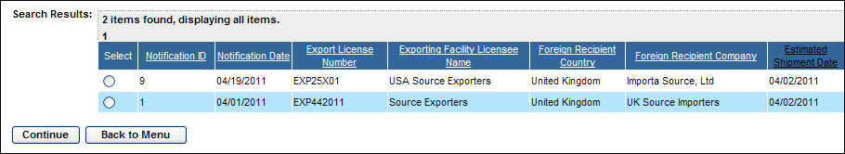
Figure 4-173: Update Export Notifications (Search Results)

- Select a notification to update or delete by clicking the radio button in the Select column and then the Continue button. The Update Export Notification screen will be displayed.

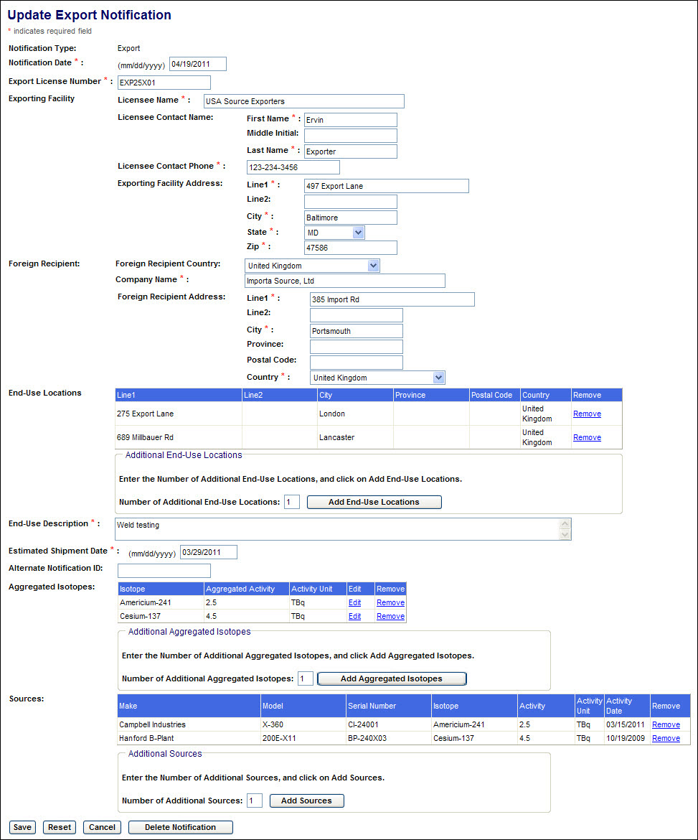
Figure 4-174: Update Export Notifications (Edit Screen)

- Update the details of the Export Notification and click the Save button. The revised notification will be displayed in an Update Export Notification Confirmation screen.

The Reset button will return the notification fields to their saved values and leave the Update Export Notification edit screen displayed.

Note: Only fields editable on this screen will be reset. Changes to the notification made using the Remove links in the form; and the addition of End-Use Locations, Aggregated Isotopes, and Sources will not be undone by the Reset button. Instead, use the Cancel button to prevent such changes from being saved.

The Cancel button will return the user to the Main Menu without saving any changes to the Export Notification.

To delete the Export Notification from NSTS, click the Delete Notification button.

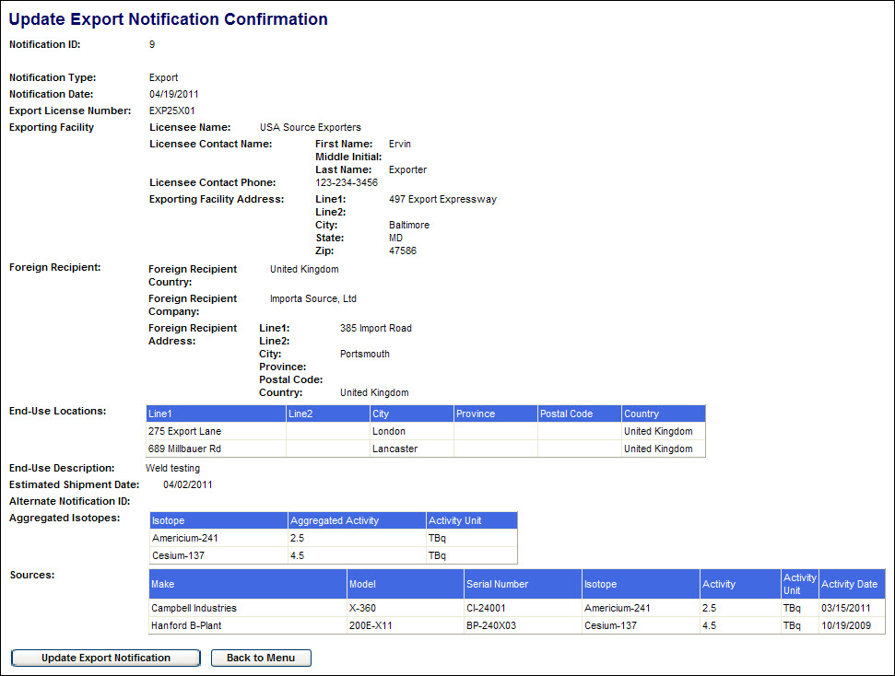
Figure 4-175: Update Export Notifications (Confirmation)

- On the Update Export Notification confirmation screen, click the Update Export Notification button to search for and update another Export Notification.

Click the Back to Menu button to return to the NSTS Main Menu.

Review Import Notifications
User – NRC Staff, Agreement State Staff, DOE Staff, and NSTS Analyst

Use – To retrieve a list of import notifications and review the notifications

1. From the NSTS Main Menu, under Transfer Management, click the Review Import Notifications link. The Review Import Notifications search criteria window appears:

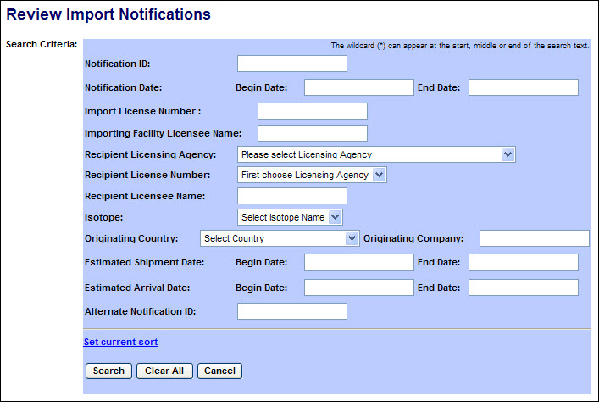
Figure 4-176: Review Import Notifications (Search Criteria)

The following fields are available to narrow the search:

Field Name | Description/Comments | Acceptable Values | Example Value
Notification ID | A unique system-generated identifier for each notification source. | Numeric value | 234
Notification Date: Begin Date | Beginning date of notification date range | mm/dd/yyyy | 02/01/2011
Notification Date: End Date | End date of notification date range | mm/dd/yyyy | 02/08/2011
Import License Number | Number of import license assigned by NRC | Free-form text | 235256
Importing Facility Licensee Name | Name of licensed importer | Free-form text | Source Imports, Inc
Recipient Licensing Agency | The Agency that has regulatory authority over the source recipient. An NRC user or NSTS Analyst can select a Licensing Agency. A State Agency user can select only their agency. | Drop-down list | Ohio Department of Health
Recipient License Number | License number of source recipient | Drop-down list | 45-27764-01
Recipient License Name | License name of source recipient | Free-form text | ABC Company
Isotope | Identification of the isotope in a Source | Drop-down list | Cobalt-60
Originating Country | Foreign country the licensee is importing from | Free-form text | United Kingdom
Originating Company | Company name of the foreign supplier | Free-form text | UK Nuclear, LTD
Estimated Shipment Date: Begin Date | Beginning date of estimated shipment date range | mm/dd/yyyy | 02/20/2011
Estimated Shipment Date: End Date | End date of estimated shipment date range | mm/dd/yyyy | 02/21/2011
Estimated Arrival Date: Begin Date | Beginning date of estimated arrival date range | mm/dd/yyyy | 02/20/2011
Estimated Arrival Date: End Date | End date of estimated arrival date range | mm/dd/yyyy | 02/21/2011
Alternate Notification ID | An identifier supplied by the notification creator. | Free-form text | ABC #1

2. After entering the search criteria, select the Search button. (If no criteria are selected, all shipments which the user is authorized to view will be displayed.)

Scroll to the right to display additional source information.

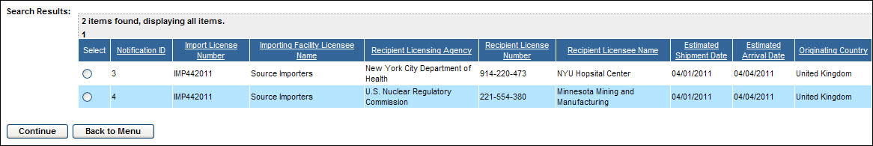
Figure 4-177: Review Import Notifications (Search Results)

3. To view the details of a notification, select the radio button in the Select column and click on Continue.

The Review Import Notification Detail window will appear.

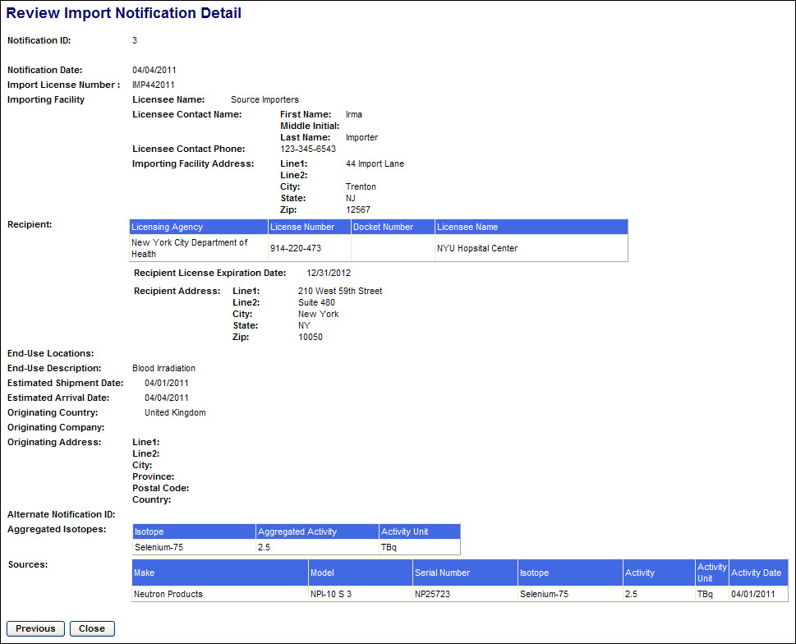
Figure 4-178: Review Import Notifications (Detail)

4. After reviewing the notification information, click the Previous button to return to the Search Results screen.

5. After reviewing the Search Results, click the Back to Menu button to return to the NSTS Main Menu.

Review Export Notifications
User – NRC Staff, Agreement State Staff, DOE Staff, and NSTS Analyst

Use – To retrieve a list of export notifications and review the notifications

1. From the NSTS Main Menu, under Transfer Management, click the Review Export Notifications link. The Review Export Notifications search criteria window appears:
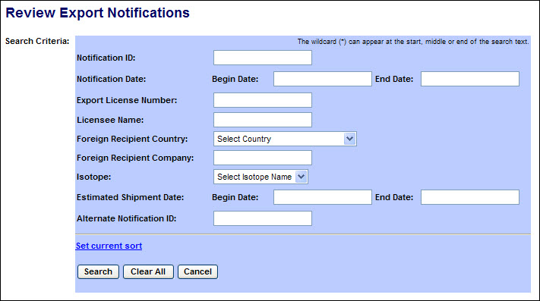
Figure 4-179: Review Export Notifications (Search Criteria)

The following fields are available to narrow the search:

Field Name | Description/Comments | Acceptable Values | Example Value
Notification ID | A unique system-generated identifier for each notification. | Numeric value | 234
Notification Date: Begin Date | Beginning date of notification date range | mm/dd/yyyy | 02/01/2011
Notification Date: End Date | End date of notification date range | mm/dd/yyyy | 02/08/2011
Export License Number | Number of export license assigned by NRC | Alphanumeric | 235256
Foreign Recipient Country | Country of the foreign recipient | Drop-down list | United Kingdom
Foreign Recipient Company | Company name of the foreign recipient | Free-form text | UK Nuclear, LTD
Isotope | Identification of the isotope in a Source | Drop-down list | Cobalt-60
Estimated Shipment Date: Begin Date | Beginning date of estimated shipment date range | mm/dd/yyyy | 02/20/2011
Estimated Shipment Date: End Date | End date of estimated shipment date range | mm/dd/yyyy | 02/21/2011
Alternate Notification ID | An identifier supplied by the notification creator. | Free-form text | ABC #1

2. After entering the search criteria, select the Search button. (If no criteria are selected, all shipments which the user is authorized to view will be displayed.)

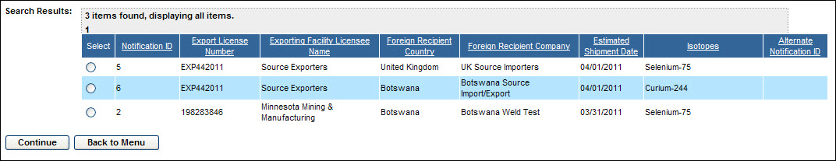
Figure 4-180: Review Export Notifications (Search Results)

3. To view the details of a notification, select the radio button in the Select column and click on Continue.

The Review Export Notification Detail window will appear.

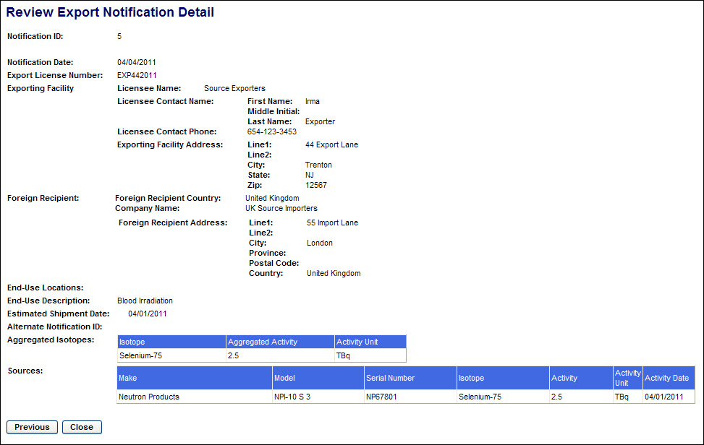
Figure 4-181: Review Export Notifications (Detail)

4. After reviewing the notification information, click the Previous button to return to the Search Results screen.

5. After reviewing the Search Results, click the Back to Menu button to return to the NSTS Main Menu.

Unrecorded Information

Enter Unrecorded Source
User – Licensees, and Licensing Agencies and NSTS Analyst.

Use – Licensee enters unrecorded Source information into NSTS.

- From the NSTS Main Menu, under Unrecorded Information, click Enter Unrecorded Source.

2. The Enter Unrecorded Source window appears.
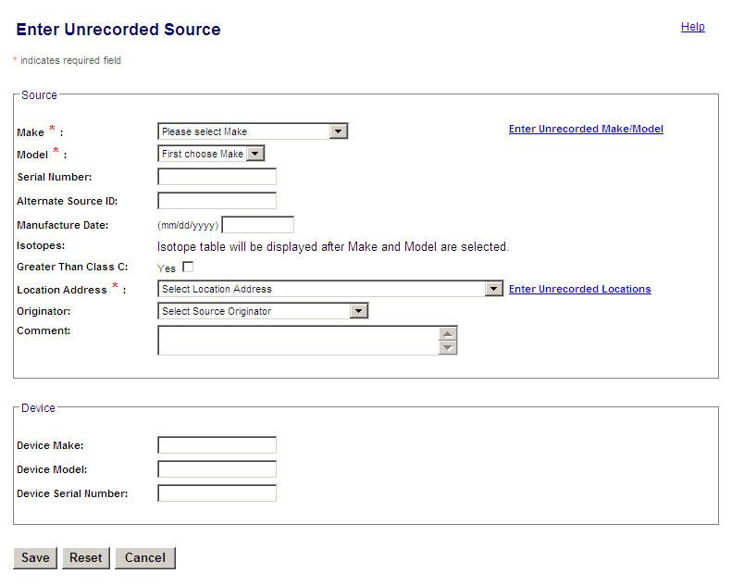
Figure 4-182: Enter Unrecorded Source

The following fields are available to enter Source information:
Field Name | Req. Value | Description/Comments | Acceptable Values | Example Value
Make | Y | Represents the manufacturer. Each Make will have one or more models associated with it. | Drop-down list | 800 Delta
Model | Y | Item that is manufactured. Represents a Model associated with a Make. | Drop-down list | A424-19
Serial Number |  | Identification number assigned to a Source by the manufacturer. | Alphanumeric | TK12345
Isotope: Name |  | Identification of the isotope in a Source | Drop-down list | Cobalt-60
Isotope: Activity | Y | Activity level for isotope | Numeric value | 223
Isotope: Activity Date | Y | Date the activity level of the Source is measured. Defaults to the entered Manufactured Date. | mm/dd/yyyy | 01/02/2006
Isotope: Activity Unit | Y | Unit in which the activity level of the Source is measured. | Drop-down list | Ci
Greater-Than-Class-C |  | Indicates a Source’s radioactivity exceeds the concentration limits established for Class C.  If the checkbox is not checked, the source will be recorded as Not GTCC. | Check mark
Alternate Source ID |  | Additional Source ID that is designated by the Licensee. | Alphanumeric | 456781B
Originator |  | The entity that manufactured or regenerated a Source. This can be a Licensee or the DOE. | Drop-down list | University of Texas
Location Address | Y | Physical location of the Source. | Drop-down list | 415 Oak Road  Town, LA 70360
Comment |  | Details entered as free-form text by the user. | Free-form text | A shipment contains a transfer.
Device Make |  | Make of the device containing a trackable nuclear source. | Alphanumeric | Acme
Device Model |  | Model of the device containing a trackable nuclear Source. | Alphanumeric | Acme xx
Device Serial Number |  | Device serial number assigned by the manufacturer. | Alphanumeric | L98X777

  - Select a Make and Model from the drop-down list. The Isotope table will display, populated with the isotopes associated with the selected Make and Model. If the Make or Model is not available in the drop-down list, click the link for Enter Unrecorded Make/Model to enter it.

  - Enter the Source Serial Number designated by the manufacturer.
Note: Duplicate Entry – The system will check to see if a duplicate source exists that has the same Make/Model/Serial Number. If a duplicate exists, the system will display an error message and not allow entry of the new Source.

  - Enter Isotope information (Activity, Activity Unit, and Activity Date) in the Isotopes table. The displayed isotopes are those Isotopes already associated with the entered Make/Model. The user does not have to enter values for each isotope row. If no value is entered on a row, that isotope is not saved with the source.

Note: Maximum Activity – If the Activity entered is greater than the Maximum Activity of the Source’s Make/Model, the system will display a WARNING to the user. This is a warning, but not a restriction; the system will still accept the entered Activity if the user chooses to ignore the warning.

- If applicable, enter an Alternate Source ID.

- If the source manufactured is Greater Than Class C, check the GTCC check box. If the GTCC check box is not checked, the system will set the GTCC to NO.

- Select a Location Address from the drop-down list, which is populated with all locations on file for this particular Licensee. If the drop-down list does not contain the appropriate Location Address, click on the link “Enter Unrecorded Location” to enter the desired location.

- Select an Originator (if known) from the Originator drop-down list.

- Any applicable comments may be entered in the Comment field. Up to 2,000 characters may be entered.

- Enter Device Make, Device Model, and Device Serial Number, if applicable.

- If all entered information is correct, click Save. To discard all changes and exit the Enter Unrecorded Source window, click Cancel. To erase all entered data on the screen, click Reset and new data can be entered.

- When the confirmation window appears, to return to the NSTS Main Menu, click Back to Menu.

- The system will process entered Sources as follows:
  - Found / Not Exported – If the Source is found in the system and its status is not Exported, the system rejects the entry and prompts the user to verify and re-enter the correct Make, Model, and Serial Number. If the Source cannot be entered, the Licensee should contact the NSTS Help Desk at 1-877-671-NSTS (6787) to solve the problem.
  - Found / Exported – If the Source is found in the system and its status is Exported, the system keeps the Source’s existing unique identifier and will not update the ‘Source Entered By’ value but will perform all other processing listed under the ‘Not Found’ section below.
  - Not Found – if the Source is not found in the system, the system:
- Generates a unique identifier for each Source.
- Sets the Source Status to Above Threshold.
- Sets the Status Date and Entry Date to the current date.
- Uses the entered Activity and Activity Unit values to calculate and internally store a Standard Activity value using a Standard Unit (e.g., Curies). This common unit simplifies system calculations and comparisons.
- Sets the Source Category by comparing the calculated Activity to the category threshold (e.g., 1, 2, or blank).
- Adds each Source to the Licensee’s inventory, and carries the Source’s entered Alternate Source ID to the Alternate Source ID of the Licensee’s Inventory record to preserve the Alternate Source ID history.
- Sets the Source Entered By to ‘Through Unrecorded Sources.’

Enter Unrecorded Transfer
User – Licensees, and Licensing Agencies and NSTS Analyst (acting as a Licensee surrogate).
Use – Receiving Licensee enters unrecorded Transfer information into NSTS.

- From the NSTS Main Menu, under Transfer Management, click Receive Sources (Domestic). The View and Choose Open Shipments (Domestic) window appears.

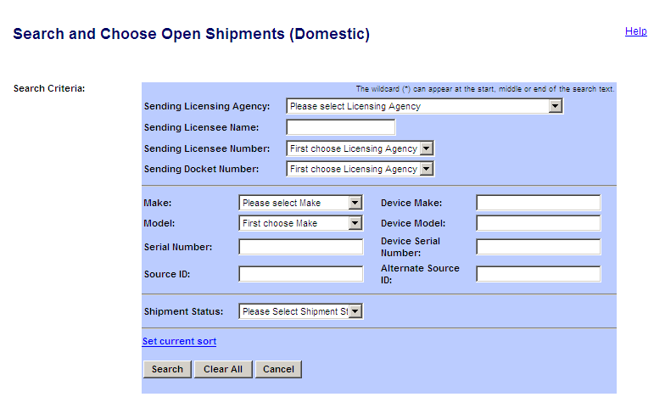
Figure 4-183: Search and Choose Open Shipments (Domestic)
Enter search criteria and click on Search, a list of shipment displays in the Search Result area.
Note: The default Shipment Status is Shipped.
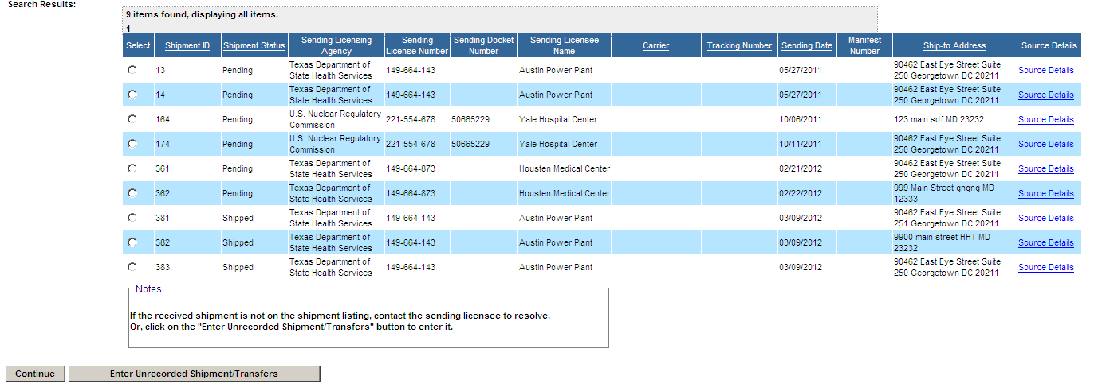
Figure 4-184: Search and Choose Open Shipments (Domestic)

Note: If the shipment you would like to record as received is not on the Open Shipments listing, click Enter Unrecorded Shipment/transfers to enter the information.

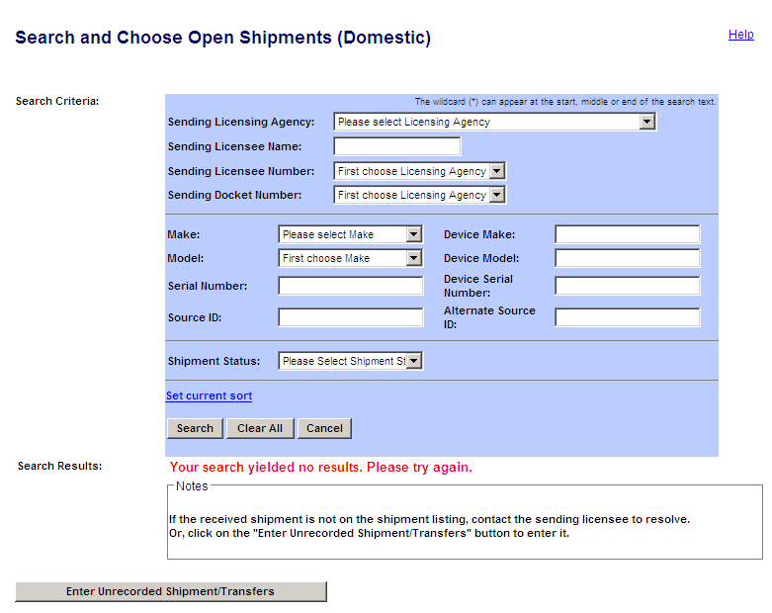
Figure 4-185: Search and Choose Open Shipments (Domestic) (No Open Shipment/Transfers)
Note: If the shipment you would like to record as received is not on the Open Shipments listing, click Enter Unrecorded Shipment/transfers to enter the information.

Figure 4-186: Search and Choose Open Shipments (Domestic) (No Open Shipment/Transfers)
- The Search and Choose Sending Licensee window appears.

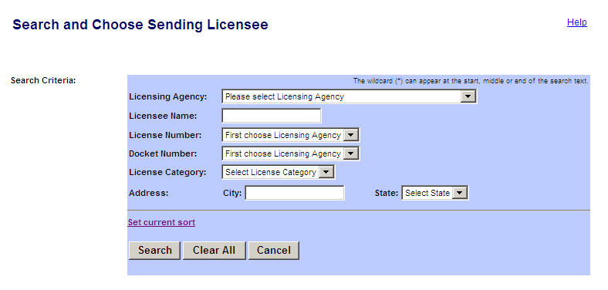
Figure 4-187: Search and Choose Sending Licensee

The following fields are available to search for a Licensee:
Field Name | Req. Value | Description/Comments | Acceptable Values | Example Value
Licensing Agency |  | Agency that has regulatory authority over the Licensees. Defaults to the user’s Agency. Only the NSTS Analyst can change the value of the Licensing Agency. | Drop-down list | NRC
Licensee  Name |  | Name of the licensee. | Free-form text | ABC Company
License Number |  | Number assigned when a license is issued. | Drop-down list | 945AL733WP9990
Docket Number |  | License identifier used by NRC. Required for NRC Licensees only. | Drop-down list | 05000313
License Category |  | The category of the License | Drop-down list | Manufacturer
City |  | Name of the U.S. City | Free-form text | Dallas
State |  | Name of the U.S. State | Drop-down list | TX

- Enter search criteria, and then click Search.

Note: To see all Licensees, leave search criteria fields blank, then click Search.
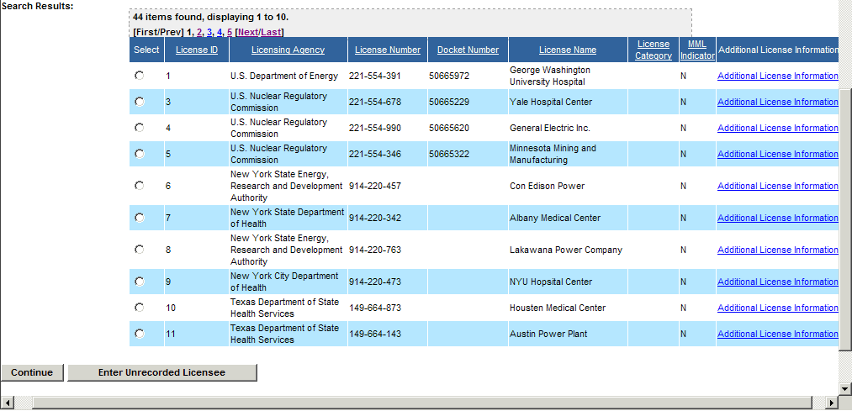
Figure 4-188: Search and Choose Sending Licensee (Search Results)

Note: To view additional license information (Street Address, Mailing Address, Company Phone Number, and Company Fax Number), click the Additional License Information link. The Additional License Information window appears. To close the window and return to the Search and Choose Licensee window, click Close.

Figure 4-189: Additional License Information

- In the Search and Choose Licensee window, select the licensee by clicking the Select radio
Button (), and then click Continue.

Note: If the licensee is not in the system, click Enter Unrecorded Licensee.
- The Enter Unrecorded Shipment/Transfers window appears. Select the location address of the Receiving Licensee in the Location Address drop-down list.
- If the selected location address of the receiving licensee is the same as the Ship-to-Address, select Yes. The selected location address will be populated in the Ship-to-Address fields (Line 1, Line 2, City, State, and Zip).
- Enter the date that the shipment/transfer was received in the Date Received box.

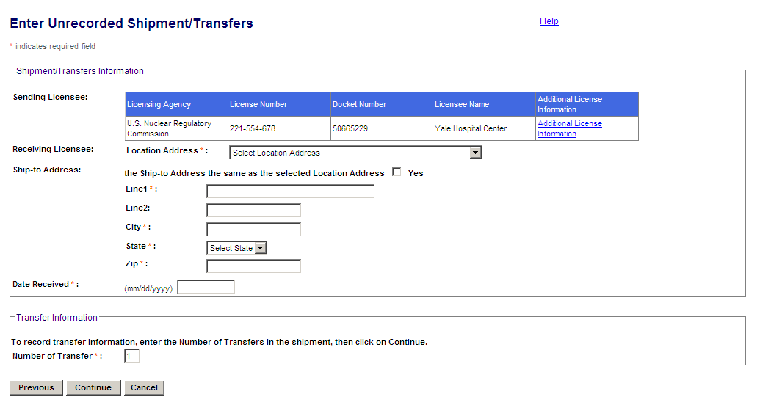
Figure 4-190: Enter Unrecorded Shipment/Transfers

- Enter the number of transferred sources received in the Number of Transfers box, and then click Continue.
- The Transfer records for the number of transfers entered will be displayed and enabled for entry. The Enter Unrecorded Shipment/Transfers window appears with details of the transfer.

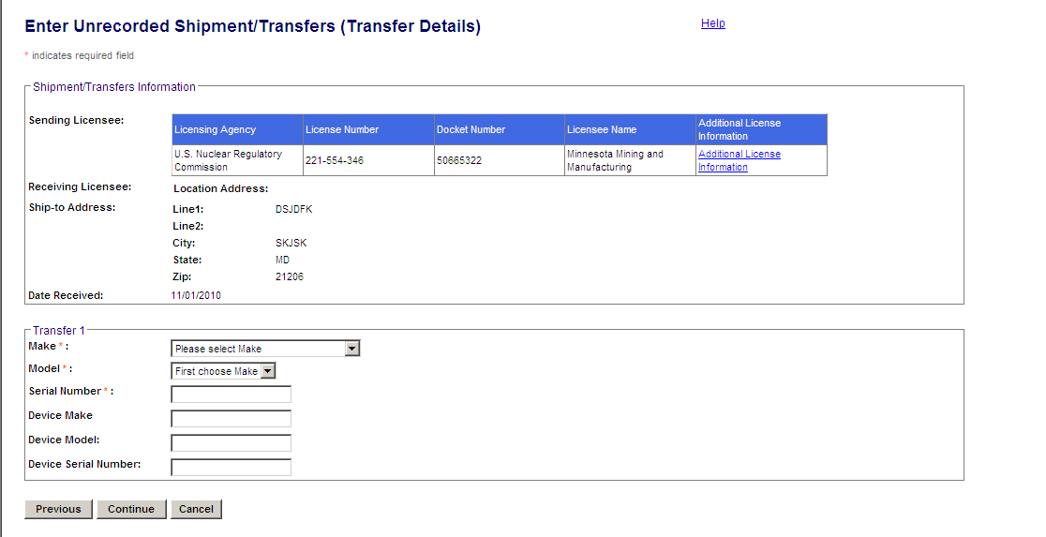
Figure 4-191: Enter Unrecorded Shipment/Transfers (Transfer Details)

The following fields are available to enter source transfer information:
Field Name | Req. Value | Description/Comments | Acceptable Values | Example Value
Make | Y | Represents the manufacturer. Each Make will have one or more models associated with it. | Drop-down list | 800 Delta
Model | Y | Item that is manufactured. Represents a Model associated with a Make. | Drop-down list | A424-19
Serial Number | Y | Identification number assigned to a Source by the manufacturer. | Alphanumeric | TK12345
Device Make |  | Make of the device containing a trackable nuclear source. | Alphanumeric | Acme
Device Model |  | Model of the device containing a trackable nuclear Source. | Alphanumeric | Acme xx
Device Serial Number |  | Device serial number assigned by the manufacturer. | Alphanumeric | L98X777

- When all required data is entered in the window, click Continue.

- The Review Unrecorded Shipment/Transfers window will appear. To edit the entered Make, Model, Serial Number, or Device information, click Edit, and the Edit Unrecorded Shipment/Transfers (Edit Transfers) window will appear. When you are done making edits, click Save to return to the Review Unrecorded Shipment/Transfers window.

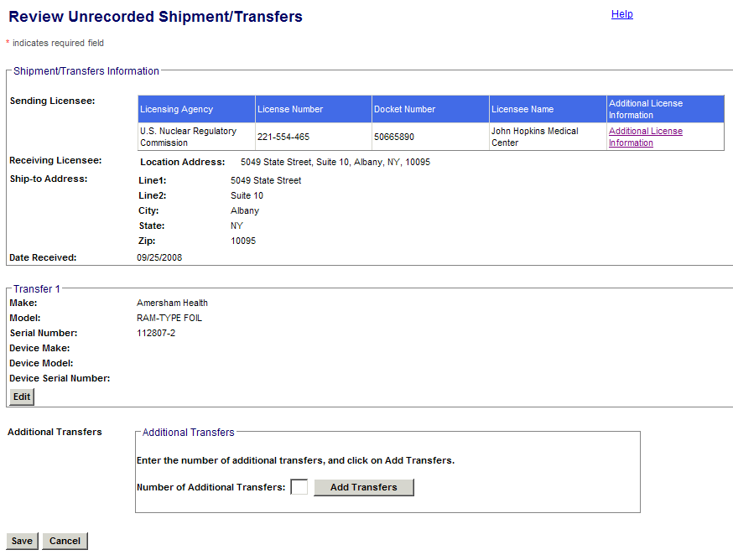
Figure 4-192: Review Unrecorded Shipment/Transfers

- Verify all entered information in the Review Unrecorded Shipment/Transfers window, and then click Save. This completes the Enter Unrecorded Transfer tranasaction and it is not mandatory to explicitly ‘Receive’ the Shipment.

- The View and Choose Open Domestic Shipments window will appear.. To see the newly entered shipment, select Pending or All for Shipment Status and click Search.

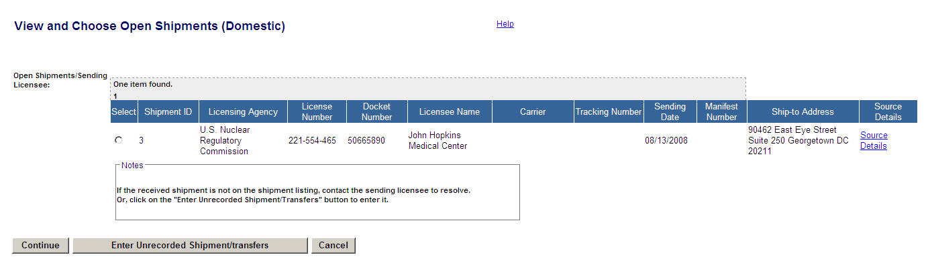
Figure 4-193: View and Choose Open Shipments (Domestic)

- Click the Select radio button for the entered shipment, and then click Continue.

- The Enter Receipt Shipment/Transfers Information (Domestic) window will appear. To see other fields in the window, use the horizontal scroll bar to scroll to the right.

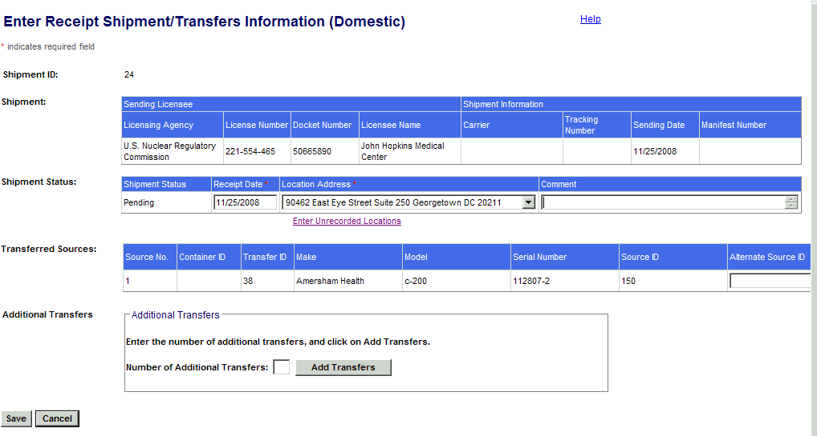
Figure 4-194: Enter Receipt Shipment/Transfers Information (Domestic)

Figure 4-195: Enter Receipt Shipment/Transfers Information (Domestic)(Right-hand columns)

- Enter a Receipt Date. It will default to the current date.

- Select a location address from the Location Address drop-down list. If the location is not available in the list, click the Enter Unrecorded Locations link to enter it.

- The Transfer Status of the sources in the shipment will be set to Pending.

- If an additional Source ID is designated, enter it in the Alternate Source ID field.
- Enter additional details about the transfer in the Comments field.

- Click Save. To return to the NSTS Main Menu, click Cancel.

- If you click Save, the Receive Sources Confirmation window will appear.

Note: To view other fields in the confirmation window, use the hortizontal scroll bar to scroll to the right.

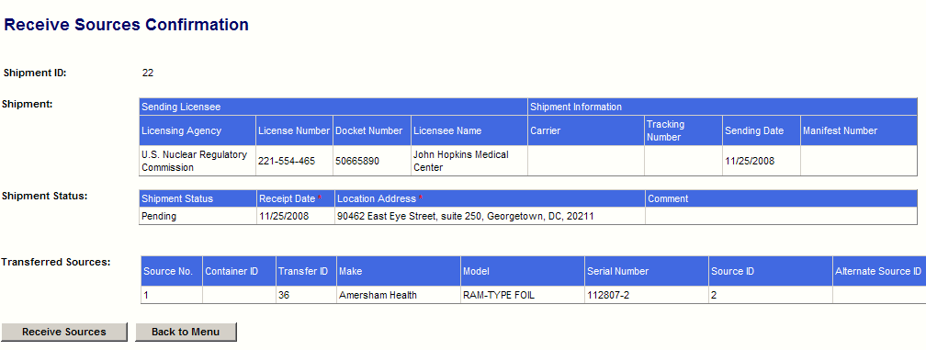
Figure 4-196: Receive Sources Confirmation

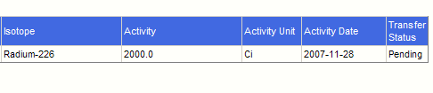
Figure 4-197: Receive Sources Confirmation (Right-hand columns)

- Click Receive Sources to return to the View and Choose Open Shipments (Domestic) window. To return to the NSTS Main Menu, click Back to Menu.
The system processes Shipment/Transfer information as follows:

  - Generate Pending Shipment/Transfers – If the entered Sources are found in the Sending Licensee’s inventory, the system generates a pending Shipment record and the associated Transfer records.

Shipment elements: | Set to:
Receiving Licensee’s Licensing Agency, License Number, Docket Number (NRC Licensees only), and Licensee name. | Those of the Licensee entering the transaction.
Sending Licensee’s Licensing Agency, License Number, Docket Number (NRC Licensees only), Licensee Name | As entered by the user
Shipment Status | Pending
Shipment Type | Domestic
Sending Date | Current Date
Estimated Arrival Date | Current Date
Status Date | Current Date
Entered By | Through Unrecorded Transfers
Transfer elements (one for each entered Source) | Set to:
Source ID | Retrieved by the system based on entered Source.
Transfer Status | Pending
Status Date | Current Date
Entered By | Through Unrecorded Transfers

  - Incorrect Sending Licensee – If Source is found, but not in the Sending Licensee’s inventory, the system rejects the entry.

  - Source Not Found – If the Source is not found in the system, the system prompts the user to verify that the Make, Model, and Serial Number are entered correctly. If the problem remains, the user will be prompted to contact the Sending Licensee to resolve the problem. The user may enter the Sources using the ‘Enter Unrecorded Sources’ link and continue with the remaining steps. The system will create the Sources, with the following exceptions:
- The entered Source will be associated to the named Sending Licensee’s inventory, not the Receiving Licensee’s inventory.
- The Source Entered By will be set to ‘Through Unrecorded Transfers.’

Enter Unrecorded Location – Licensee – Manufacturer Landing Page
User – Licensees, and Licensing Agencies and NSTS Analyst.

Use – Licensee enters unrecorded Location address information into NSTS.

- From the NSTS Main Menu, under Unrecorded Information, click Enter Unrecorded Location. The Enter An Unrecorded Location window appears.

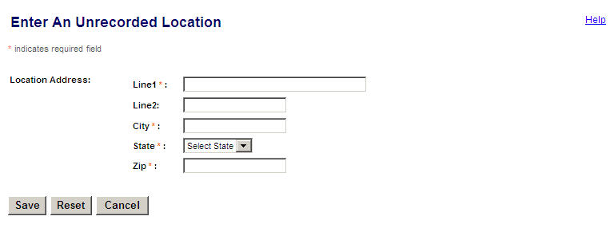
Figure 4-198: Enter an Unrecorded Location

The following fields are available to enter unrecorded location information:
Field Name | Req. Value | Description/Comments | Acceptable Values | Example Value
Address:  Line 1 | Y | Physical street address | Free-form text | 375 Bernard Lane
Address Line 2 |  | Additional address information, e.g., Room, Building, Suite, etc. | Free-form text | Suite 546
City | Y | City of the unrecorded location | Free-form text | Anytown
State | Y | State of the unrecorded location | Drop-down list | VA
Zip | Y | Zip code of the unrecorded location | 5 or 9 digit ZipCode | 22193-0000

- Enter Address location information, and then click Save.

- To return to the Main Menu without saving changes, click Cancel. To clear the fields in the window, click Reset.
- When the confirmation window appears, click Enter Unrecorded Location to return to the Enter an Unrecorded Location window to enter information for another unrecorded location. To return to the NSTS Main Menu, click Back to Menu.
- When the entered Location information has been processed, several updates automatically occur, including:
  - One Location record with a unique system-generated identifier (Location ID) is created.
  - Location Entry Status is set to Pending.
  - Entry Date is set to the current date.
  - Entered By is set to the user that is entering the Location.
  - Entered Location will be associated with the chosen Licensee record.

Enter Unrecorded Location – Licensing Agency – NRC Landing page
User – Licensing Agencies and NSTS Analyst.

Use – Licensing Agency or NSTS Analyst enters unrecorded Location address information into NSTS.

- From the NSTS Main Menu, under Unrecorded Information, click the Enter Unrecorded Location link.

- The Search and Choose Licensee window appears.

The following fields are available to search Licensee information:
Field Name | Req. Value | Description/Comments | Acceptable Values | Example Value
Licensing Agency |  | Agency that has regulatory authority over the Licensees. Defaults to the user’s Agency. Only the NSTS Analyst can change the value of the Licensing Agency. | Drop-down list | NRC
Licensee  Name |  | Name of the licensee. | Free-form text | ABC Company
License Number |  | Number assigned when a license is issued. | Drop-down list | 945AL733WP9990
Docket Number |  | License identifier used by NRC. Required for NRC Licensees only. | Drop-down list | 05000313
License Category |  | The category of the License | Drop-down list | Manufacturer
City |  | City of the unrecorded location | Free-form text | Richmond
State |  | State of the unrecorded location | Drop-down list | VA
- To search for the Licensee (owner of the pending location), enter search criteria, and then click Search.

Note: To see all Licensees available to that user, leave search criteria fields blank, then click Search.
4. The search results appear below the search criteria.

- Select the Licensee by clicking the Select radio button, and then click Continue. The Enter an Unrecorded Location window appears.

Figure 4-199: Enter an Unrecorded Location

- Enter location information (Address Line 1, Address Line 2 [optional], City, and Zip. Select the State).
- Click Save.
- To return to the Main Menu without saving changes, click Cancel. To clear the fields on the screen, click Reset.
- When the confirmation window appears, click Enter Unrecorded Location to return to the Enter Unrecorded Location window and enter information for another unrecorded location. To return to the NSTS Main Menu, click Back to Menu.
- When the entered Location information has processed, several updates automatically occur, including:
  - One Location record with a unique system-generated identifier (Location ID) is created.
  - Location Entry Status is set to Pending.
  - Entry Date is set to the current date.
  - Entered By is set to the user that is entering the Location.
  - Entered Location will be associated with the chosen Licensee record.

Enter Unrecorded Make/Model
User – Licensees, and Licensing Agencies and NSTS Analyst.

Use – Licensee enters unrecorded Make/Model information into NSTS.

- From the NSTS Main Menu, under Unrecorded Information, click Enter Unrecorded Make/Model. The Enter an Unrecorded Make/Model window appears.

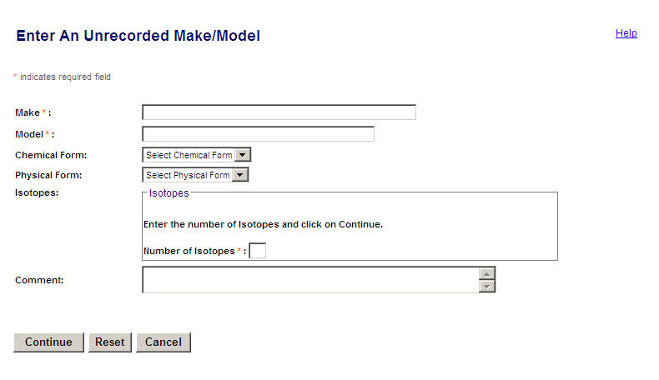
Figure 4-200: Enter an Unrecorded Make/Model

The following fields are available to enter Make and Model information:
Field Name | Req. Value | Description/Comments | Acceptable Values | Example Value
Make | Y | Represents the manufacturer. Each Make will have one or more models associated with it. | Free-form text | 800 Delta
Model | Y | Item that is manufactured. Represents a Model associated with a Make. | Free-form text | A424-19
Chemical Form |  | Chemical composition of a Source. | Drop-down list | Common forms of uranium oxide are U₃O₈ and UO₂
Physical Form |  | Physical composition of a Source. | Drop-down list | Solid
Number of Isotopes | Y | Quantity of isotopes associated to a particular Make and Model. | Numeric value | 3
Comment |  | Details entered as free-form text by the user. | Free-form text (up to 2000 characters). | The Model was not recorded.

- Enter the Make and Model.
- Select a Chemical Form and a Physical Form from the drop-down list.
- To add isotopes, enter the number of isotopes in the Number of Isotopes box.
- Enter additional Comments, if any.
- Click Continue.
- The Enter Isotope Information window is displayed, with the Number of Isotopes entered previously enabled for entry
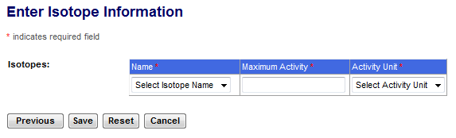
Figure 4-201: Enter Isotope Information

Note: Click the Previous button to return to the Enter An Unrecorded Make/Model window.

The following fields are available to enter Isotope information:
Field Name | Req. Value | Description/Comments | Acceptable Values | Example Value
Isotope: Name | Y | Identification of the isotope in a Source | Drop-down list | Cobalt-60
Maximum Activity |  | Highest recommended activity level for a particular isotope. | Numeric value | 222.0
Activity Unit | Y | Unit of measure | Drop-down list | Ci

- Select the Isotope Name and Activity Unit. Enter the Maximum Activity. Click Save.
- The Enter an Unrecorded Make/Model Review window will be displayed. Review the information, and then click Save.
- When the confirmation window appears, click Enter Unrecorded Make/Model to return to the Enter Unrecorded Make/Model window to enter information for another unrecorded make/model. To return to the NSTS Main Menu, click Back to Menu.
- When the entered Make and Model information has been processed, several updates automatically occur, including:
  - Make/Model’s Entry Status is set to Pending.
  - Entry Date is set to the current date.
  - Entered By is set to the user that is entering the Make/Model.

Enter Unrecorded Licensee
User – Licensees, and Licensing Agencies and NSTS Analyst.

Use – Sending Licensee enters unrecorded Licensee into NSTS.

      - From the NSTS Main Menu, under Unrecorded Information, click Enter Unrecorded Licensee. The Enter An Unrecorded Licensee window appears.

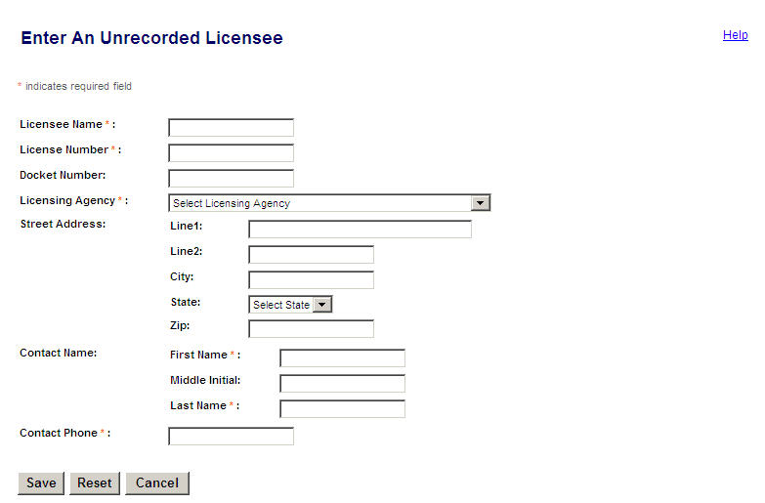
Figure 4-202: Enter an Unrecorded Licensee

The following fields are available to enter Licensee information:
Field Name | Req. Value | Description/Comments | Acceptable Values | Example Value
Licensee  Name | Y | Name of the licensee. | Free-form text | ABC Company
License Number | Y | Number assigned when a license is issued. | Alphanumeric | 945AL733WP9990
Docket Number |  | License identifier used by NRC. Required for NRC Licensees only. | Drop-down list | 05000313
Licensing Agency | Y | Agency that has regulatory authority over the Licensees. Defaults to the user’s Agency. | Drop-down list | NRC
Address Line 1 |  | Physical street address. | Free-form text | 123 Lamp Road
Address Line 2 |  | Additional address information, e.g., Room, Building, Suite, Floor, etc. | Free-form text | 29th Floor
City |  | City of the unrecorded licensee | Free-form text | Billings
State |  | State of the unrecorded licensee | Drop-down list | MT
Zip |  | Zip code of the unrecorded licensee | 5 or 9 digit ZipCode | 59101-0000
Contact First Name | Y | First name of the contact person | Free-form text | Mary
Contact Middle Initial |  | Middle initial of the contact person | Free-form text | K
Contact Last Name | Y | Last name of the contact person | Free-form text | Doe
Contact Phone Number | Y | Telephone number of the contact person | xxx-xxx-xxxx | 555-221-1212

      - Enter the licensee’s name and number in the Licensee Name and License Number fields, respectively.
      - Enter the Docket Number if the Licensee is an NRC Licensee.
      - Select the licensing agency in the Licensing Agency drop-down list.
      - Enter address information in Address Line 1, Line 2, City, and Zip fields. Select the State from the drop-down list.
      - Enter the contact name and phone number in the Contact Name and Contact Phone Number fields, respectively.
      - Click Save.
      - When the confirmation window appears, click Enter Unrecorded License to return to the Enter Unrecorded Licensee window to enter information for another unrecorded license. To return to the NSTS Main Menu, click Back to Menu.
      - When the entered Licensee information has been processed, several updates automatically occur, including:
  - System generates a unique identifier for the entered License.
  - Licensee’s Entry Status is set to Pending.
  - Entry Date is set to the system date.
  - Entered By is set to Through Unrecorded Licensee.
  - Location record for the Licensee is generated with the entered Location address.
  - Location’s Entry Status is set to Pending.

Verifications

Verify Pending Transfers
User – Licensees, and Licensing Agencies and NSTS Analyst (acting as a Licensee surrogate).

Use – Sending Licensee reviews pending transfers and confirms or rejects the transfer.

1. From the NSTS Main Menu, under Verifications, click Verify Pending Transfers. The Search and Choose Pending Shipment/Transfers window displays.
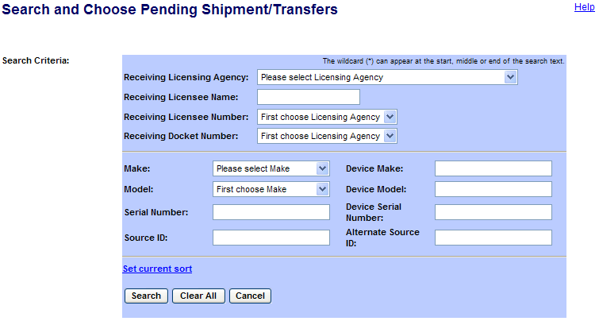
Figure 4-203: Search and Choose Pending Shipment/Transfers

- Enter search criteria and click Search button. A list of pending shipments/transfers is displayed in the Search Result table.
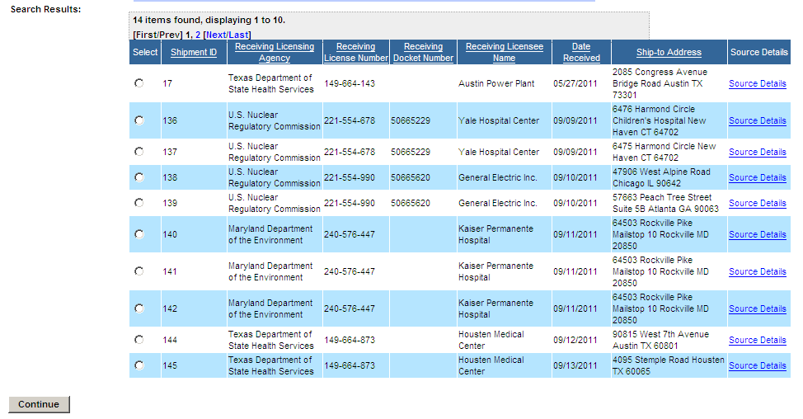
Figure 4-204: Search and Choose Pending Shipment/Transfers

- To view the source information, click the Source Details link.
3. Click the Select radio button to select a pending Shipment/Transfer to confirm or reject. If there are multiple Pending Shipment/Transfers you can use the sort capability by clicking the column headings for ascending and descending sorts.
4. Click Continue. The Verify Pending Shipment/Transfers window will appear.

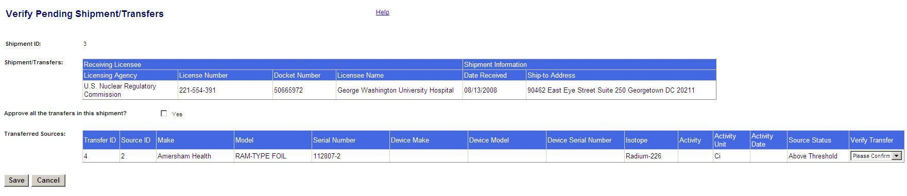
Figure 4-205: Verify Pending Shipment/Transfers

- To verify a pending transfer in the shipment, select Approve from the Verify Transfer drop-down list. To reject a pending transfer, select Rejected.

The following fields are available to enter Shipment/Transfer information:
Field Name | Req. Value | Description/Comments | Acceptable Values | Example Value
Approve all the transfers in this shipment? |  | Allows the user to approve Transfers (sources) as a group. | Check mark
Verify Transfer | Y | Allows the user to approve or reject the pending transfer (individual sources)as a group. | Drop-down list | Approve

- To Approve all the transfers in the shipment, select the Yes check box for “Approve all of the transfers in this shipment?”
- Click Save to commit the entry. Click Cancel to close the window without saving.
- When the confirmation window appears, click Verify Pending Transfers to return to the Search and Choose Shipment/Transfer window to search and select another pending shipment/transfers to verify. To return to the NSTS Main Menu, click Back to Menu.
- When the confirmed Shipment/Transfers have been processed, several updates automatically occur, including:
Confirm Transfers:
Inventory Adjustment – For each Source, the system removes the Source from the Sending Licensee’s inventory and finds the Source in the Receiving Licensee’s inventory, and removes the inventory status of Pending. The system will carry the Source’s Current Alternate Source ID to the Alternate Source ID of the Receiving Licensee’s inventory record.
Transfer Status – For each Source, the system sets the Transfer Status to Received.
Shipment Status – Set to Received.
Reject Transfers:
Transfer Status – For each Source, the system sets the Transfer Status to Investigate.
Shipment Status – Set to Investigate.

Verify Pending Make/Model
User – Licensing Agencies (DOE and NRC Staff) and NSTS Analyst.

Use – NRC or DOE staff reviews and verifies make/model information entered into the system.

1. From the NSTS Main Menu, under Verifications, click Verify Pending Make/Model.
2. The View and Choose Pending Make/Model window appears.
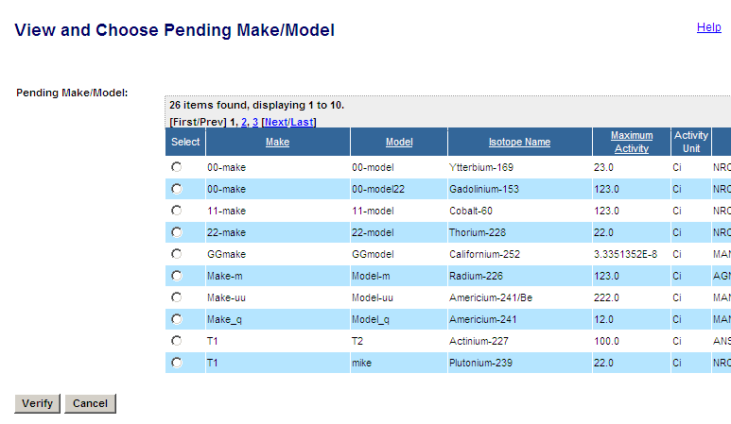
Figure 4-206: View and Choose Pending Make/Model

Note: Sort capabilities are available by clicking the column headings for ascending and descending sorts.
3. Click the Select radio button () to the left of the Model column to select a pending make/model.
4. Click the Verify button.

5. The Verify Pending Make/Model Information window appears.
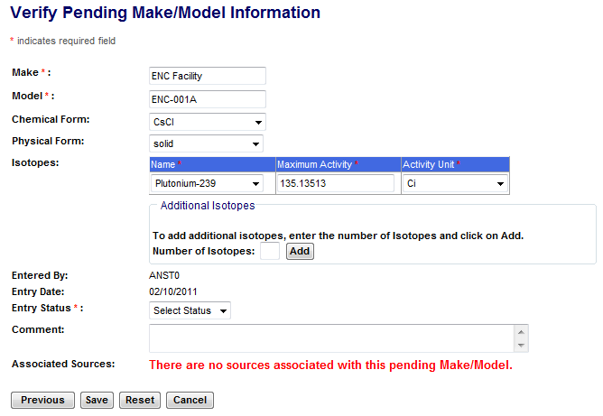
Figure 4-207: Verify Pending Make/Model Information

Note: Click the Previous button to return to the View and Choose Pending Make/Model window.

The following fields are available to enter pending make/model information:
Field Name | Req. Value | Description/Comments | Acceptable Values | Example Value
Make |  | Represents the manufacturer. Each Make will have one or more Models associated with it. | Drop-down list | 800 Delta
Model |  | Item that is manufactured. Represents a Model associated with a Make. | Drop-down list | A424-19
Chemical Form |  | Chemical composition of a Source. | Drop-down list | TH02
Physical Form |  | Physical composition of a Source. | Drop-down list | Solid
Isotope: Name |  | Identification of the isotope in a Source. | Drop-down list | Cobalt-60
Isotope: Maximum Activity |  | Highest recommended activity level for a particular isotope. This information may need to be entered. | Numeric value | 222.0
Isotope: Activity Unit |  | Unit in which the activity level of the Source is measured. | Drop-down list | Ci
Number of Isotopes |  | The number of additional isotopes to be added during the verify process. This information may need to be entered. | Numeric value | 3
Entry Status | Y | Status of an entry. | Drop-down list | Approved
Comment |  | Details entered as free-form text by the user. If a model is rejected, a comment must be provided. | Free-form text (up to 2000 characters). | The Model was not recorded.

- If an edit to the pending Make/Model is required prior to approval, make the correction. In the Isotope table, enter the Maximum Activity, if it has not already been entered.
- To verify the pending make and model, select Approved in the Entry Status drop-down list.
- To reject the pending make and model, select Rejected, and enter a comment in the Comment box.
Note: A pending Make and Model can not be rejected if any Source is associated with the Model. If there is such an association, the user is notified by the system and instructed to resolve the issue (i.e., change the Source’s Model).
- To add isotopes, enter the Number of Isotopes in the box, and then click Add.
- Enter additional Comments, if any.
- Click Save to commit the entry. Click Cancel to close the window without saving.
- When the confirmation window appears, click Verify Pending Make/Model to return to the View and Choose Pending Make/Model window to select another pending make/model to verify. To return to the NSTS Main Menu, click Back to Menu.
- When the information has been verified by the system, several updates automatically occur, including:
    - Approved Model - Entry Status is set to Approved.
    - Rejected Make/Model – If no existing Source is associated with the model, the Make/Model’s Entry Status is set to Rejected.
    - Prohibit Access – Once rejected, the system prohibits user access to the rejected Make/Model.

Verify Pending Licenses
User – Licensing Agencies (DOE, A/S Staff, and NRC Staff), and NSTS Analyst.

Use – NRC staff reviews and verifies pending licensee information entered into the system.

1. From the NSTS Main Menu, under Verifications, click Verify Pending Licenses.
2. The View and Choose Pending Licensee window appears.
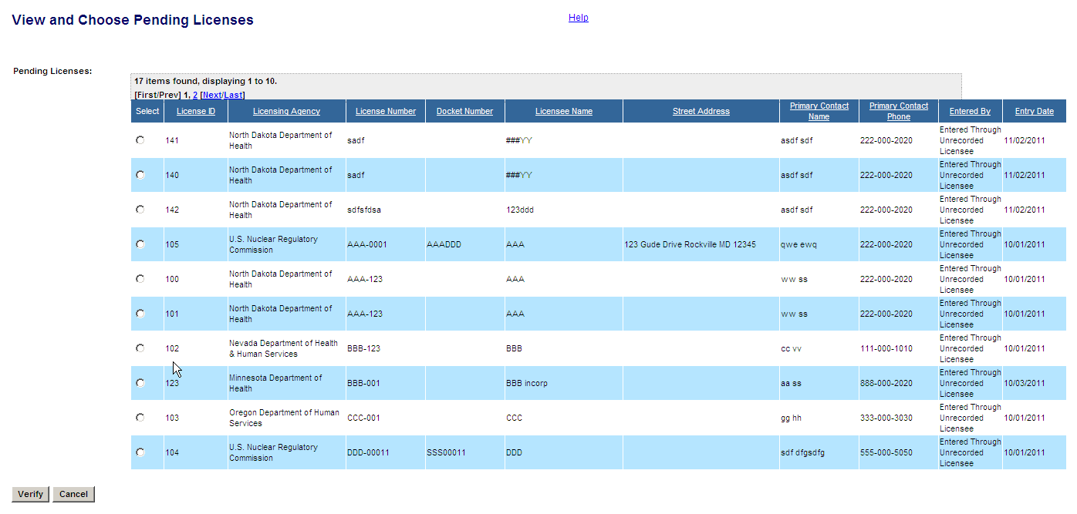
Figure 4-208: View and Choose Pending Licensee
Note: Sort capabilities are available by clicking the column headings for ascending and descending sorts.
3. Click the Select radio button () to select a pending licensee.
4. Click the Verify button.
- The Verify and Complete Pending License Information window will be displayed.
- In the License Information section, click on the link for Complete License Information.

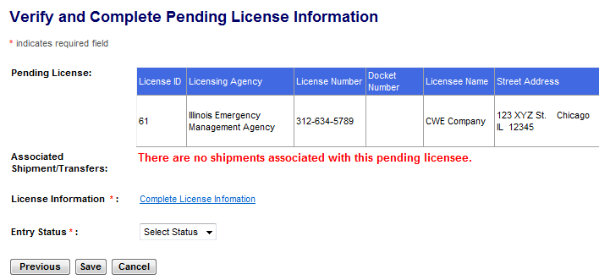
Figure 4-209: Verify and Complete Pending License Information

Note: Click the Previous button to return to the View and Choose Pending Licensee window.

- The Enter Pending License Information window will appear.

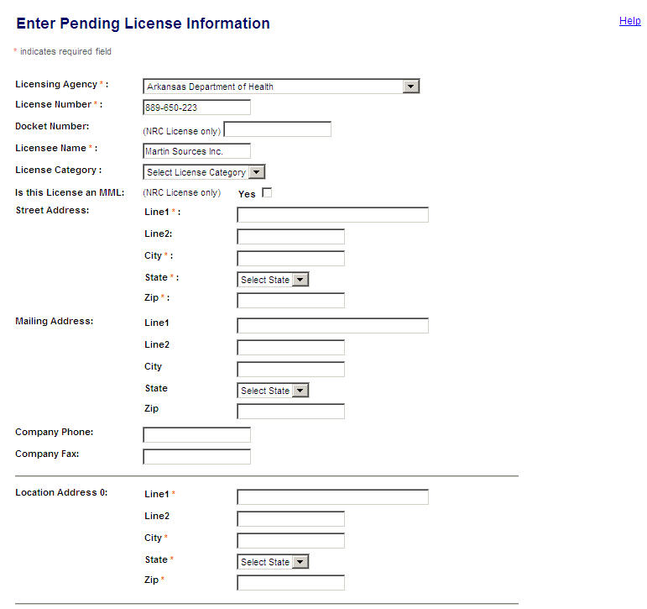
Figure 4-210: Enter Pending License Information

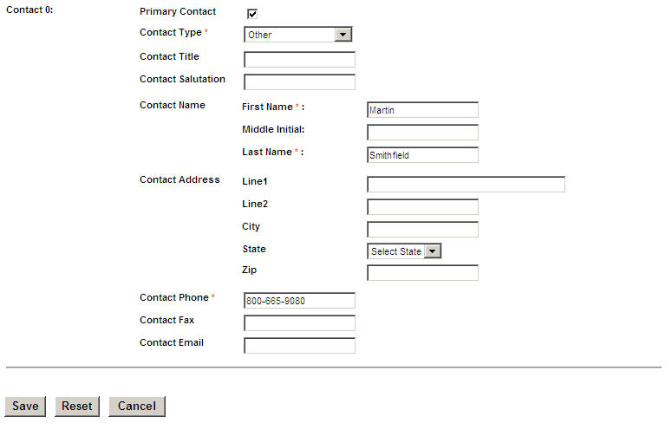
Figure 4-211: Enter Pending License Information (continued)

The following fields are available to enter Licensee/License information:

Field Name | Req. Value | Description/Comments | Acceptable Values | Example Value
Licensing Agency | Y | Agency that has regulatory authority over the Licensees. Defaults to the user’s Agency. Only an NRC user or the NSTS Analyst can change the value of the Licensing Agency. | Drop-down list | NRC
License Number | Y | Number assigned when a license is issued. | Free-form text | 945AL733WP9990
Docket Number |  | License identifier used by NRC. Required for NRC Licensees only. | Alphanumeric | 05000313
Licensee Name | Y | Name of the organization or individual to whom the license is issued. | Free-form text | ABC Company
License Category |  | Category assigned by a Licensing Agency. | Drop-down list | Gamma Knifes
Is this Licensee an MML |  | Indicates if the Licensee is a Master Materials Licensee. (NRC User only). | True or False (check box).
Address Line 1 | Y | Physical street address | Free-form text | 375 Oak Street
Address Line 2 |  | Additional address information, e.g., Room, Building, Suite, Floor, etc. | Free-form text | Suite 546
Address: City | Y | Name of the U. S. City | Free-form text | Houston
Address: State | Y | Name of the U. S. State | Drop-down list | TX
Address: Zip | Y | U. S. Zip Code | 5 or 9 digit ZipCode | 77019-0000
Mailing Address:  Line 1  Line 2  City  State  Zip |  | Mailing address of the Licensee | Free-form text.  State – drop-down list.  Zip – 5 or 9 digit ZipCode. | PO Box 2010  Rockville  MD  20852-0000
Location Address:  Line 1 | Y | Physical location of the Source. | Free-form text | 300 Frederick Rd
Location Address: Line 2 |  | Additional address information, e.g., Room, Building, Suite, Floor, etc. | Free-form text | Room 202
Location Address: City | Y | Name of the U. S. City | Free-form text | Rockville
Location Address: State | Y | Name of the U. S. State | Drop-down list | MD
Location Address: Zip | Y | U. S. Zip Code | 5 or 9 digit ZipCode | 20854-0000

- Complete the License information by populating the Street Address and the Location Address, Populate the optional fields Mailing Address, Company Phone, Company Fax, Contact Title, Contact Salutation, Contact Address, Contact Fax, and Contact Email. When complete, click Save.
Note: Click the Previous button to return to the View and Choose Pending Licensee window.
- The Verify and Complete License Information window will be displayed, with data entered on the previous screen populated.
- To verify the pending Licensee, select Approved from the Entry Status drop-down list. To reject the pending Licensee, select Rejected.
- Click Save. Click Cancel to close the window without saving.
- When the confirmation window appears, click Back to Menu to return to the NSTS Main Menu.
The system will process the Licensee information according to the following rules:
Approve Licensees
- Entry Status is set to Approved.
Reject Licensees
- Disallows rejecting the Licensee if any Shipment/Transfer is still associated with the Licensee, and instructs the user to resolve the issue first (e.g., by changing the Receiving Licensee to the appropriate one).
      - Entry Status – if no existing Shipment/Transfer is associated with the Licensee, the system sets the Licensee’s Entry Status to Rejected.
      - Prohibit Access – Once rejected, the system prohibits user access to the rejected Licensee.

Verify Pending Locations
User – Licensing Agencies (DOE, A/S Staff, and NRC Staff), and NSTS Analyst.

Use – Licensing Agency verifies pending location information entered into the system.

1. From the NSTS Main Menu, under Verifications, click Verify Pending Locations.
2. The View and Choose Pending Locations window appears.
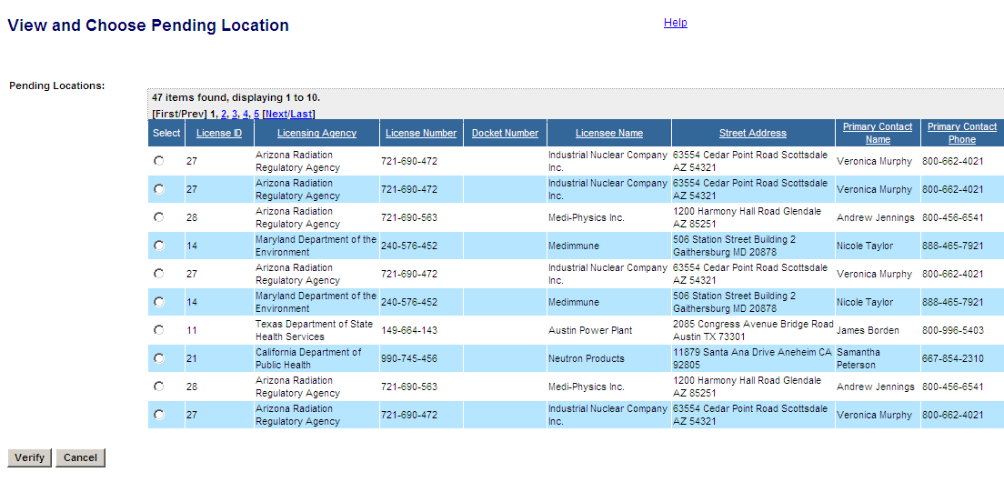
Figure 4-212: Verify and Choose Pending Locations

Note: Sort capabilities are available by clicking the column headings for ascending and descending sorts.

3. To select a pending location, click the Select radio button.
4. Click Verify.

5. In the Verify Pending Location Information window, review the pending location information.

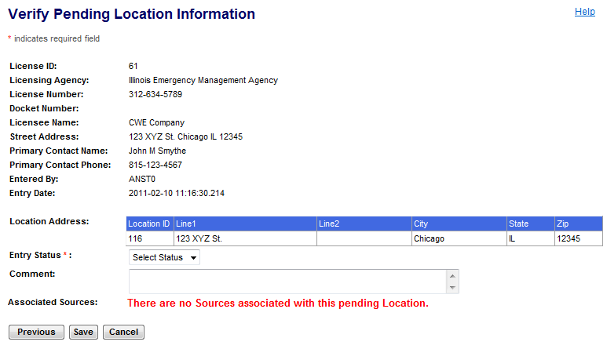
Figure 4-213: View Pending Location Information

Note: Click the Previous button to return to the Verify and Choose Pending Locations window.

The following fields are available to enter Status information:

Field Name | Req. Value | Description/Comments | Acceptable Values | Example Value
Entry Status | Y | Status of an entry. | Drop-down list | Approved
Comment |  | Details entered as free-form text by the user. | Free-form text (up to 2000 characters). | The location is pending.

6. To verify the pending location, select Approved from the Entry Status drop-down list. To
reject the pending location, select Rejected.
Note: You cannot reject the Location if there are sources associated with the Location.
- If the status is Rejected, enter additional detail information in the Comment field (up to 2,000 characters).
- Click Save.
- To close without saving and return to the Main Menu, click Cancel.
- When the confirmation window appears, click Verify Pending Location to return to the View and Choose Pending Location window to view and select another pending location to verify. To return to the NSTS Main Menu, click Back to Menu.
When the system has verified the location information, it will be processed according to the following rules:
Approve Location
- Entry Status is set to Approved.

Reject Location
- The system will disallow rejecting the location if any Source or Source Transfer is still associated with the Location, and instructs the user to resolve the issue first (e.g., by changing the Source’s Location to an appropriate one).
- If no existing Source or Source Transfer is associated with the location, the system sets the Location’s Entry Status to Rejected.
- Once rejected, the system prohibits user access to the rejected Location.

Upload/Download Information
The Upload/Download function allows the DOE or Licensee user to send the NSTS required
information in computer readable files that can be batch loaded into the system. This allows the NSTS to accept data from another system and to eliminate the need to have data entered manually in both the users’ system and in the NSTS.

For details on XML file content, refer to the NSTS File Upload Guide.

File Upload
User – Department of Energy (DOE), Licensing Agency, and Licensees.

Use – The DOE sends NSTS required information in computer readable files that can
be uploaded into the system. The NSTS accepts the data, which eliminates the need
for entering data manually in both the users' system and in the NSTS.

From the NSTS Main Menu, under Upload/Download Information, click Upload Information. The File Upload window appears.

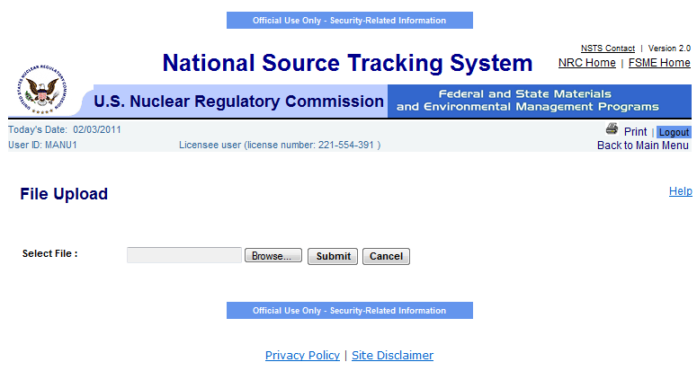
Figure 4-214: File Upload

- Click Browse to choose the file to upload. The Choose File box appears.
- Select the file, which will be populated into the File Name box, and then click Open.

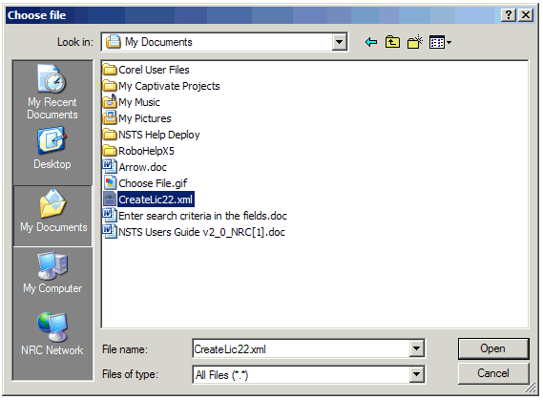
Figure 4-215: Choose File

- The file will appear in the Select File box. Click Submit.

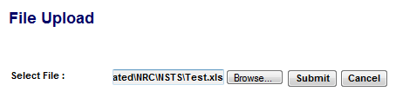
Figure 4-216: Select File

- The file will be uploaded. If there is a problem with the file, an error message will be displayed, and the file will be rejected. To return to the NSTS Main Menu without uploading the file, click Cancel.

Alert Management
Certain business or system events require the attention of the NRC staff, Agreement State Staff, DOE Staff, and/or Licensees. When such events occur, the system generates an alert, presents it to the user when they login to the system, emails it to the designated alert recipients, and logs the alert. Alerts are generated in response to rules maintained by the system administrator.

Alerts will be generated for such events as the report of a lost or stolen source; an overdue report of transfer or receipt of a source; report of an incomplete shipment by the recipient of a transfer; and the entry of unrecorded sources, makes/models, and locations.

Current Alerts
User – NRC Staff, Agreement State Staff, DOE Staff, NSTS Analysts, and Licensees.

Use – To review the history of Alerts generated by the NSTS.

- At the top of the Main Menu, a notice of new Alerts in which the user is a recipient will be displayed. Click the link to display the details of the Alert(s).

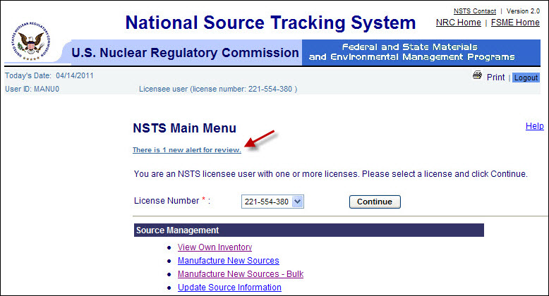
Figure 4-217: Display Current Alerts (Notice of New Alerts)

- From the NSTS Main Menu, under Alert Management, click the Current Alerts link. Details of all current Alerts in which the user is a recipient will be displayed.

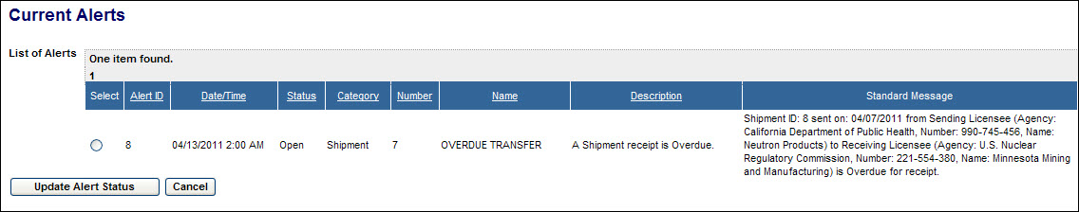
Figure 4-218: Display Current Alerts (Current Alerts)

Scroll to the right to view additional information on an Alert.

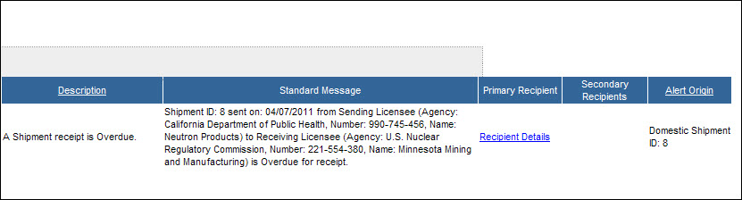
Figure 4-219: Display Current Alerts (Current Alerts – Right-hand columns)

- Click the Recipient Details link under either Primary Recipient or Secondary Recipient to display the name and information about the recipient of the Alert.

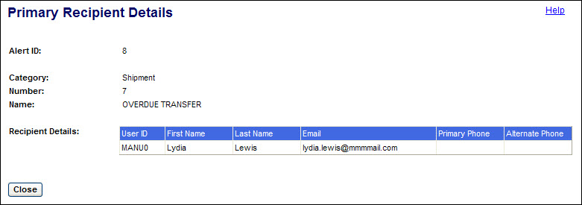
Figure 4-220: Display Current Alerts (Recipient Details)

Click the Close button to return to the list of Alerts.

- To update the status of an Alert, in the list of Alerts select the radio button () of the Alert to be updated. Then click the Update Alert Status button. The Update Alert Status window will be displayed.

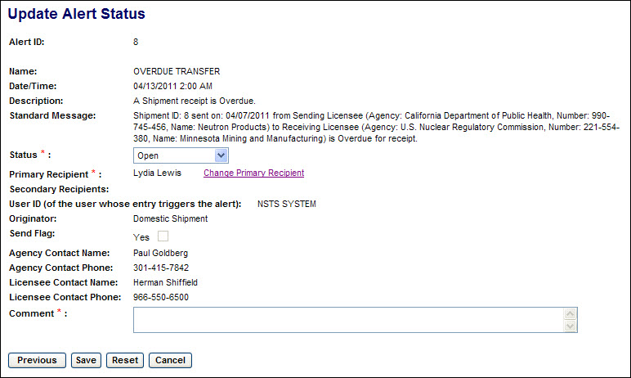
Figure 4-221: Display Current Alerts (Update Alert Status)

After reviewing the Alert Status History, click the Previous button to return to the list of Alerts or click the Cancel button to return to the NSTS Main Menu.

(See 6. below regarding the Save and Reset buttons.)

- A user named as the Primary Recipient and whose role includes Alert Manager for the associated license can update the Alert Status or change the Primary Recipient. Both Primary and Secondary Recipients can add Comments.

To change the Primary Recipient, click the Change Primary Recipient link. A list of users associated with the license which is the subject of the Alert will be displayed.

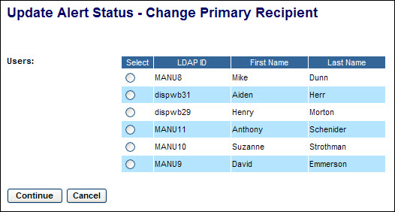
Figure 4-222: Display Current Alerts (Change Primary Recipient)

To select a new Primary Recipient, click the radio button () for that user. Then click the Continue button. The Update Alert Status window will be displayed. (Click the Cancel button to return to the Update Alert Status window without making any change.)

- Review the changes and add a comment. Then click the Save button. The Update Alert Status Confirmation window will be displayed.

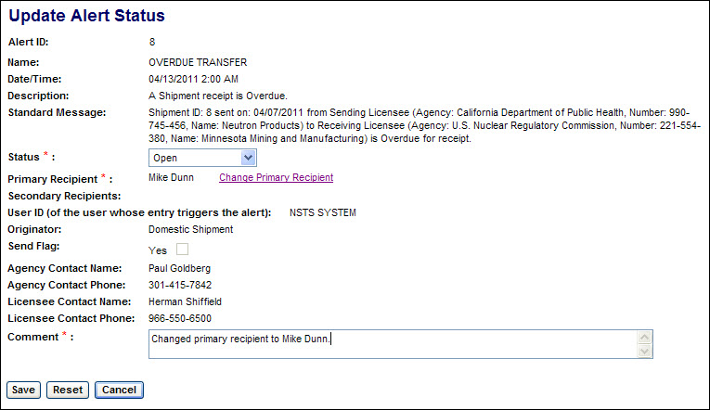
Figure 4-223: Display Current Alerts (Update Alert Status)

If the Primary Recipient is changed, the new recipient will be sent a copy of the Alert.

(Prior to saving, you may click the Reset button to undo any changes to the Alert Status or Comments and remain in the Update Alert Status Window. The Reset button will not undo a change of the Primary Recipient.

Click the Cancel button to return to the list of current Alerts without saving any changes (including a change of the Primary Recipient.))

- Review the confirmation of changes to the Alert Status.

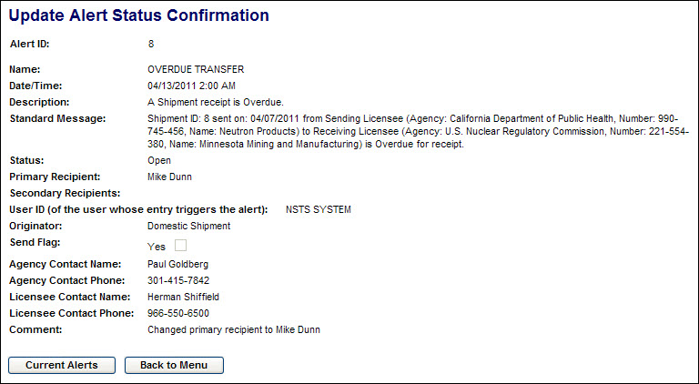
Figure 4-224: Display Current Alerts (Update Alert Status Confirmation)

- Click the Current Alerts button to return to the list of current Alerts. To return to the Main Menu, click the Back to Menu button.

Update Alert Status
User – NRC Staff, Agreement State Staff, DOE Staff, and NSTS Analysts.

Use – To monitor and update the status of Alerts generated by the NSTS.

- From the NSTS Main Menu, under Alert Management, click the Update Alert Status link. The Search Alerts for Update search criteria window will be displayed.

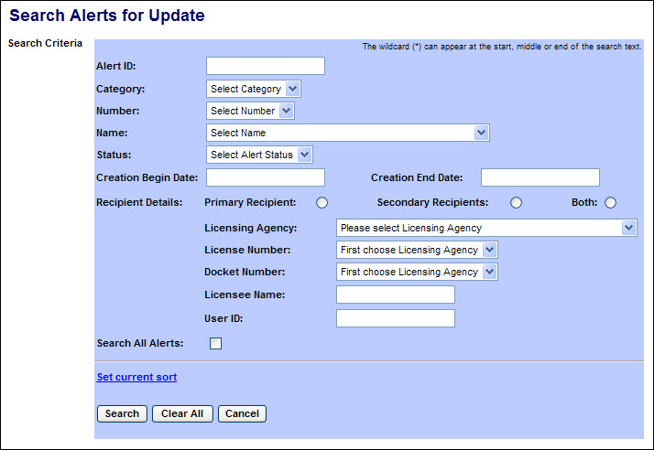
Figure 4-225: Update Alert Status (Search Criteria)

The following fields are available to populate in aiding the search for alerts ot update:
Field Name | Description/Comments | Acceptable Values | Example Value
Alert ID | The unique, system-generated ID number of an Alert | Numeric | 137
Category | Groupings of related alerts as reflected by the Category title | Drop-down list | Shipment
Number | The ID number of the rule which generated the Alert | Drop-down list | 3
Name | The named event which triggered the Alert | Drop-down list | Overdue Transfer
Status | Open or Closed | Drop-down list | Open
Creation Begin Date | Beginning date of alert creation date range | mm/dd/yyyy | 02/12/2010
Creation End Date | End date of alert creation date range | mm/dd/yyyy | 02/23/2010
Recipient Details:
Primary Recipient | Limit search results to only alerts sent to primary recipients. | Radio button
Secondary Recipients | Limit search results to only alerts sent to secondary recipients. | Radio button
Both | Limit search results to only alerts sent to primary or secondary recipients. | Radio button
Licensing Agency | The Agency that has regulatory authority over the Licensee. An NRC user or NSTS Analyst can select a Licensing Agency. A DOE user or State Agency user can select only their agency. | Drop-down list | Ohio Department of Health
License Number | Number assigned when a license is issued. | Drop-down list | 45-27764-01
Docket Number | License identifier used by NRC. NRC Licensees only. | Drop-down list | 05000313
Licensee Name | Name of the organization to which the license was issued. | Free-form text | ABC Company
User ID | NSTS user account ID | Free-form text | WCD003
Search All Alerts | Expand the search to include Alerts in which the user is not the Primary or Secondary Recipient’s alert manager. | Check mark

- Enter the search criteria, then click the Search button. The Search Results will display.

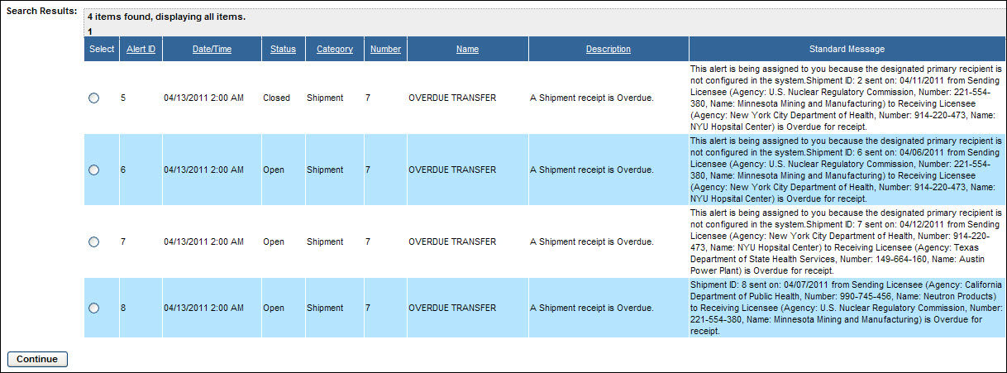
Figure 4-226: Update Alert Status (Search Results)

Scroll to the right to view additional Alert information.

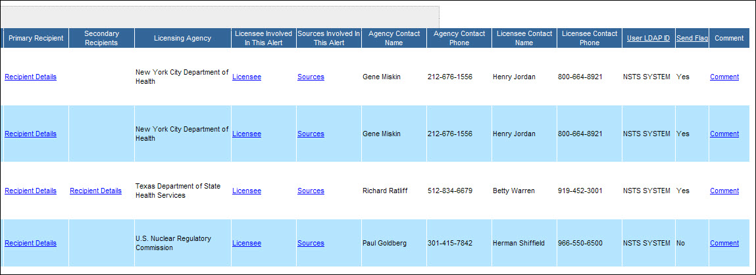
Figure 4-227: Update Alert Status (Search Results – Right-hand columns)

- Click the Recipient Details link under either Primary Recipient or Secondary Recipient to display the name and information about the recipients of the Alert.

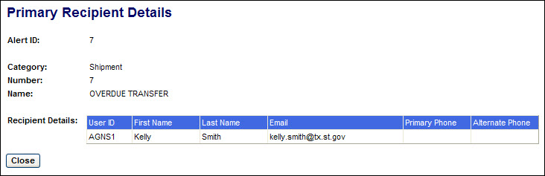
Figure 4-228: Update Alert Status (Recipient Details)

(Click the Close button to return to the list of Alerts.)

- Click the Licensee link to display the license information associated with the Alert

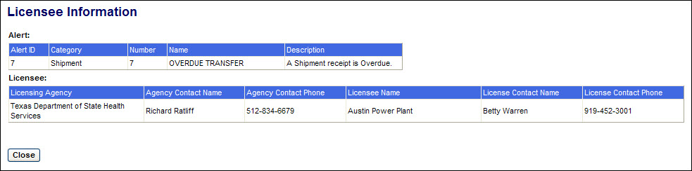
Figure 4-229: Update Alert Status (Licensee Details)

(Click the Close button to return to the list of Alerts.)

- Click the Sources link to display the source information associated with the Alert.

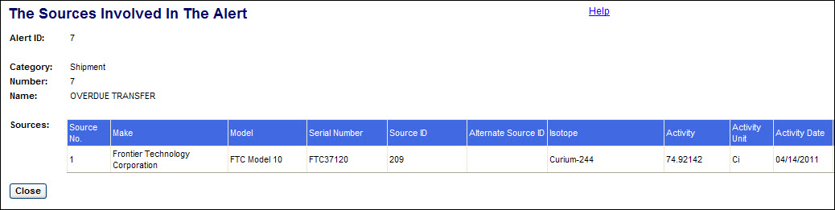
Figure 4-230: Update Alert Status (Source Details)

(Click the Close button to return to the list of Alerts.)

- Click the Comments link to display any comments associated with the Alert.

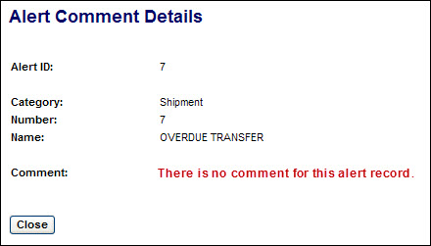
Figure 4-231: Update Alert Status (Comments)

(Click the Close button to return to the list of Alerts.)

- From the list of Alerts, select the radio button () of the Alert to be updated, then select the Continue button. The Update Alert Status window will be displayed.

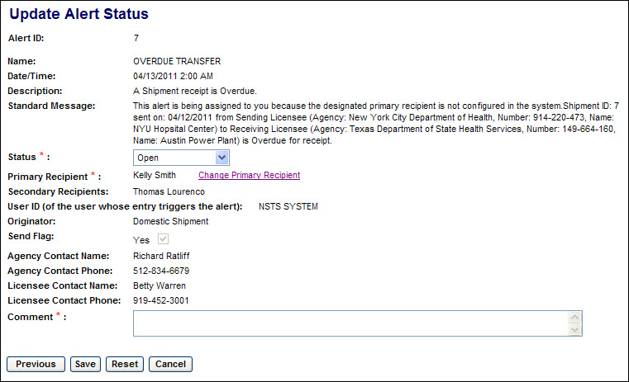
Figure 4-232: Update Alert Status (Update Screen)

If no updates will be made, click the Previous button to return to the list of Alerts or click the Cancel button to return to the NSTS Main Menu.

(See 9. below regarding the Save and Reset buttons.)

- A user named as the Primary Recipient and whose role includes Alert Manager for the associated license can update the Alert Status or change the Primary Recipient. Both Primary and Secondary Recipients can add Comments. (Agency Staff can add comments to all Alerts to which they have access.)

To change the Primary Recipient, click the Change Primary Recipient link. A list of users associated with the license which is the subject of the Alert will be displayed.

Figure 4-233: Update Alert Status (Change Primary Recipient)

To select a new Primary Recipient, click the radio button () for that user. Then click the Continue button. The Update Alert Status window will be displayed.

(Click the Cancel button to return to the Update Alert Status window without making any change.)

- If either the Alert Status or primary Recipient have been changed, a Comment is also required.

(Prior to saving, you may click the Reset button to undo any changes to the Alert Status or Comments and remain in the Update Alert Status Window. The Reset button will not undo a change of the Primary Recipient.

Click the Cancel button to return to the list of current Alerts without saving any changes (including a change of the Primary Recipient.))

To save the updated Alert, click the Save button. The Update Alert Status Confirmation window will be displayed.

(If the Primary Recipient is changed, the new recipient will be sent a copy of the Alert.)

- Review the confirmation of changes to the Alert Status.

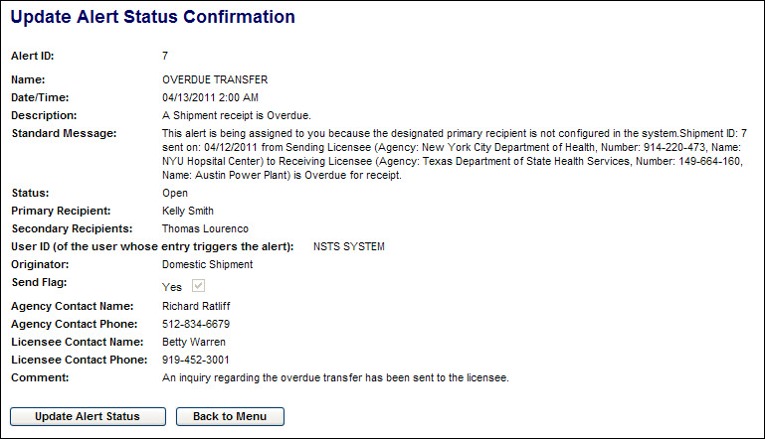
Figure 4-234: Update Alert Status (Update Confirmation)

- Click the Update Alert Status button to return to the Search Alerts for Update search criteria window. To return to the Main Menu, click the Back to Menu button.

Review Alert History
User – NRC Staff, Agreement State Staff, DOE Staff, and NSTS Analysts.

Use – To review the history of Alerts generated by the NSTS.

- From the NSTS Main Menu, under Alert Management, click the Review Alert History link. The Search Alerts for Reviewing History search criteria window will be displayed.

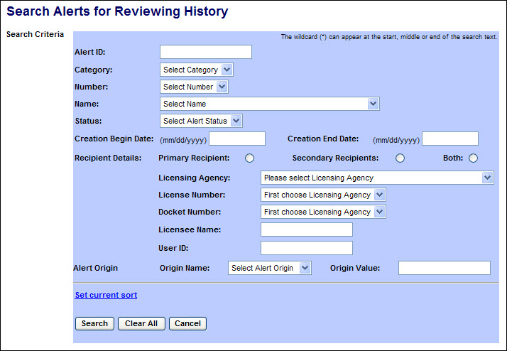
Figure 4-235: Review Alert History (Search Criteria)

The following fields are available to populate in aiding the search for alerts ot update:
Field Name | Description/Comments | Acceptable Values | Example Value
Alert ID | The unique, system-generated ID number of an Alert | Numeric | 137
Category | Groupings of related alerts as reflected by the Category title | Drop-down list | Shipment
Number | The ID number of the rule which generated the Alert | Drop-down list | 3
Name | The named event which triggered the Alert | Drop-down list | Overdue Transfer
Status | Open or Closed | Drop-down list | Open
Creation Begin Date | Beginning date of alert creation date range | mm/dd/yyyy | 02/12/2010
Creation End Date | End date of alert creation date range | mm/dd/yyyy | 02/23/2010
Recipient Details:
Primary Recipient | Limit search results to only alerts sent to primary recipients. | Radio button
Secondary Recipients | Limit search results to only alerts sent to secondary recipients. | Radio button
Both | Limit search results to only alerts sent to primary or secondary recipients. | Radio button
Licensing Agency | The Agency that has regulatory authority over the Licensee. An NRC user or NSTS Analyst can select a Licensing Agency. A DOE user or State Agency user can select only their agency. | Drop-down list | Ohio Department of Health
License Number | Number assigned when a license is issued. | Drop-down list | 45-27764-01
Docket Number | License identifier used by NRC. NRC Licensees only. | Drop-down list | 05000313
Licensee Name | Name of the organization to which the license was issued. | Free-form text | ABC Company
User ID | NSTS user account ID | Free-form text | WCD003
Alert Origin: Origin Name | The domain entity that is the “source” of the Alert | Drop-down list | Domestic Shipment
Alert Origin: Origin Value | The system-assigned ID of the Alert Origin | Free-form text | ID: 3

- Enter the search criteria and click the Search button. The Search Results will display. (If no criteria are entered, all alerts accessible to the user will be listed.)

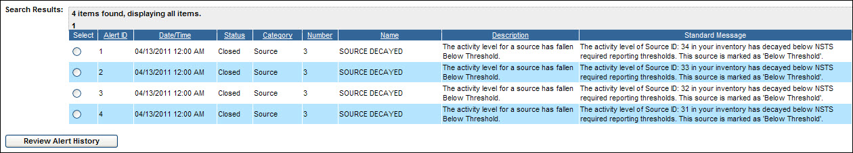
Figure 4-236: Review Alert History (Search Results)

Scroll to the right to view additional Alert information.

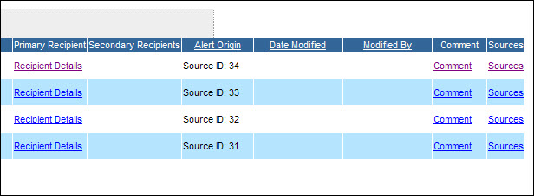
Figure 4-237: Review Alert History (Search Results – Right-hand columns)

- Click the Recipient Details link under either Primary Recipient or Secondary Recipient to display the name and information about the recipients of the Alert.

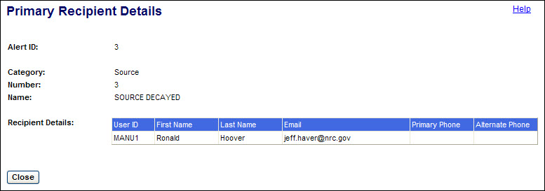
Figure 4-238: Review Alert History (Recipient Details)

(Click the Close button to return to the Search Results window.)

- Click the Comments link to display any comments associated with the Alert.

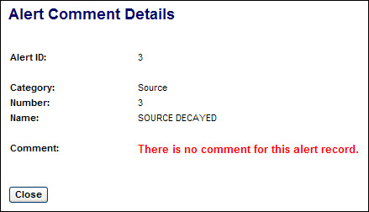
Figure 4-239: Review Alert History (Comments)

(Click the Close button to return to the Search Results window.)

- Click the Sources link to display the source information associated with the Alert.

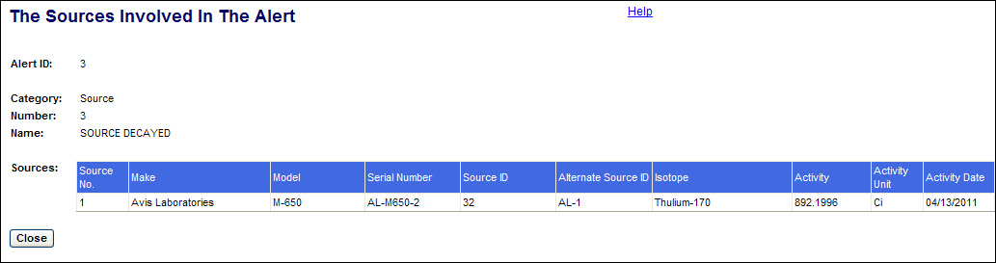
Figure 4-240: Review Alert History (Sources)

(Click the Close button to return to the Search Results window.)

- In the search results window, select the radio button () for the Alert to be reviewed, then click the Review Alert History button. The Review Alert Status History window appears:

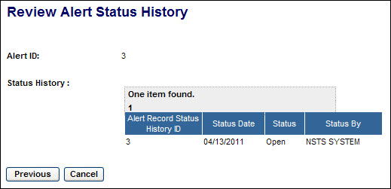
Figure 4-241: Review Alert History (Alert Status)

After reviewing the Alert Status History, click the Previous button to return to the Search Results window or click the Cancel button to return to the NSTS Main Menu.

Send Message to NSTS Mailbox
User – NSTS Users

Use – To send a message to an NSTS internal mailbox which is managed by designated program members.

- From the NSTS Main Menu, under Alert Management, click the Send Message to NSTS Mailbox link. The Send Message to NSTS Mailbox window will be displayed.

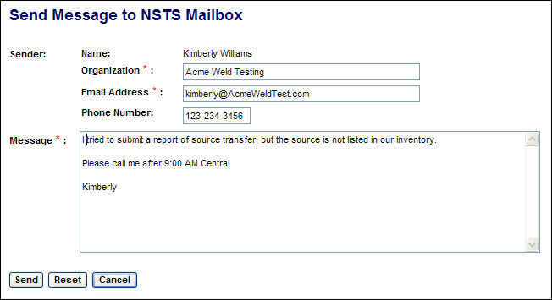
Figure 4-242: Send Message to NSTS Mailbox (Message Form)

- Based on the digital certificate used to log on to NSTS and the user account information in NSTS, the form will be auto-populated with the Name, Organization, and Email Address of the user. Review and correct the Organization and Email Address if needed. (These are required fields.)

- Enter a Phone Number for the user, including the area code. (This field is not required.)

- Type a Message describing the comment, request, or problem encountered. (This is a required field.)

- Click the Send button. The Send Message Confirmation screen will be displayed.

(The Reset button will return the auto-populated entries in the Organization and Email Address fields and delete any entries in the Phone Number and Message fields. The Cancel button will close the form without sending the message and return to the Main Menu.)

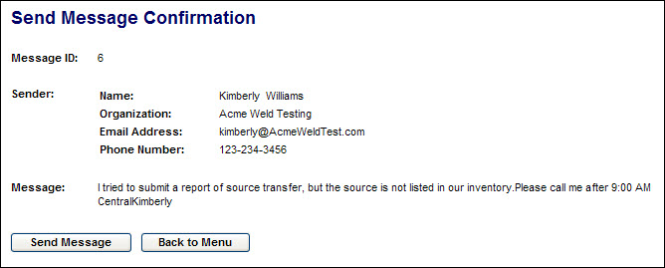
Figure 4-243: Send Message to NSTS Mailbox (Confirmation)

- To send another message, click the Send Message button. To return to the NSTS Main Menu, click the Back to Menu button.

Update Message in NSTS Mailbox
User – NSTS Analysts and NSTS Administrators

Use – To retrieve a list of open messages in the NSTS internal mailbox and to close selected messages.

- From the NSTS Main Menu, under Alert Management, click the Update Message in NSTS Mailbox link. The View and Choose Open Messages window will be displayed.

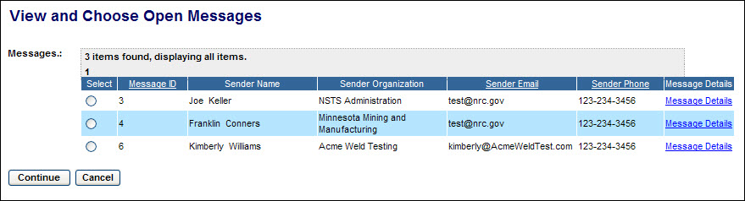
Figure 4-244: Update Message in NSTS Mailbox (Open Message List)

      - The details of a message can be displayed by clicking the Message Details link.

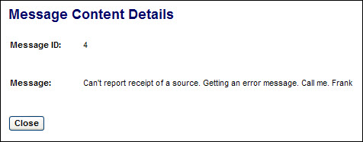
Figure 4-245: Update Message in NSTS Mailbox (Message Details)

Click the Close button to return to the message list.

      - Select the radio button () in the Select column of the Message to be updated, then click the Continue button. The Update Message Status window will be displayed.

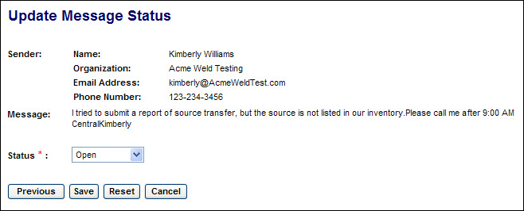
Figure 4-246: Update Message in NSTS Mailbox (Update Message Status window)

      - If this message can be closed, click the drop-down arrow for the Status field and select Closed.

      - Click the Save button to accept the changes made. The Update Message Status Confirmation window will be displayed.

Note: Click the Previous button to return to the message list. Click the Reset button to undo a change to the Status field. Click the Cancel button to return to the NSTS Main Menu.

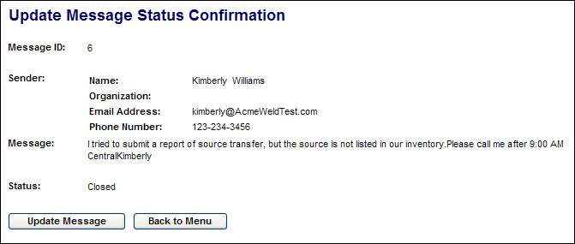
Figure 4-247: Update Message in NSTS Mailbox (Confirmation)

      - Click the Update Message button to return to the View and Choose Open Messages window. Click the Back to Menu button to return to the NSTS Main Menu.

Reporting
Agency Staff (NRC, DOE, and State Agency) and NSTS Analysts are able to retrieve reports of NSTS data. The report data presented to agency staff will be filtered to include only data pertinent to their agency.

Users select a report from a list of preformatted report templates. Depending upon the report template selected, the requestor will be prompted to enter specific search criteria to define the data to be included in the report. For example, a report of source data may allow the requestor to limit the report to one, several, or all licensees of a selected agency. (Reports requested by DOE and State Agency staff will automatically be limited to data from the agency’s licensees, but may allow the requestor to select one, several, or all licensees.)

A report may be run and viewed or downloaded immediately, or it can be scheduled to run either at a specified date and time (including ‘Now’) or periodically on a frequency set by the requestor (daily, weekly, etc.). If the ‘Schedule’ option is used, a date/time stamped ‘Report Instance’ is saved by NSTS and can retrieved and viewed or downloaded from the report’s history list. (The Schedule option is not available to Read-Only users.)

Using the “Schedule’ option to run a report also allows other NSTS users of the requestor’s agency to retrieve saved instances of the report. As part of scheduling the report, the requestor can chose to have an email notification of the availability of a new report instance sent to selected users each time the report is run with instructions on how to retrieve it.

Reports can be viewed on-screen and can be downloaded in several file formats, including PDF, MS Excel, MS Word, .RTF, .TXT, .CSV, and .XML.

Manage Reports
User – NRC Staff, Agreement State Staff, DOE Staff, and NSTS Analysts

Use – To generate, view, and download reports of NSTS data

- From the NSTS Main Menu, under Report Management, click the Manage Reports link. The Report Search criteria screen will be displayed.

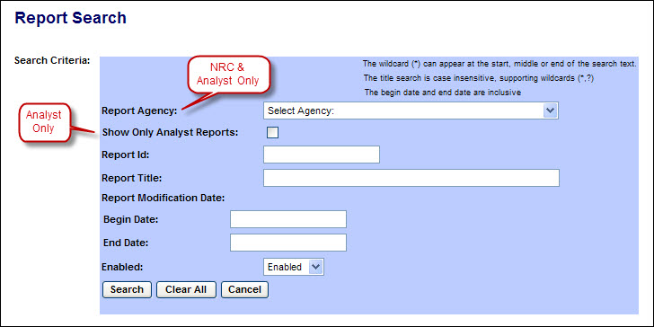
Figure 4-248: Manage Reports (Report Search Criteria)

The following fields are available to narrow the search:

Field Name | Description/Comments | Acceptable Values | Example Value
Report Agency (Displayed only to NRC Staff & NSTS Analysts) | Limit search results to only those reports the selected agency is authorized to run. | Drop-down list | Ohio Department of Health
Show Only Analyst Reports (Displayed only to NSTS Analysts) | Limit search results to those reports which only NSTS Analysts are authorized to run.. | Check mark
Report ID | A unique system-generated identifier assigned to each report. | Numeric value | 6698
Report Title | Title of the report | Free-form text | Source Information by Isotope
Report Modification Date: Begin Date | Beginning date of report modification date range | mm/dd/yyyy | 02/20/2011
Report Modification Date: End Date | End date of report modification date range | mm/dd/yyyy | 02/21/2011
Enabled | Display only reports which are enabled, disabled, or both | Drop-down list | Enabled

To search for reports with a specific word or text string in the title, enter an asterisk (*), then the word or text string, followed by an asterisk (*). For example, *isotope* Also, a question mark (?) may be used as a wildcard for individual letters in a word or text string. Searches of the title field are case-insensitive.

- After entering the search criteria, click the Search button. (If no criteria are selected, all reports which the user is authorized to run will be displayed.) The search results will be displayed below the search criteria form.

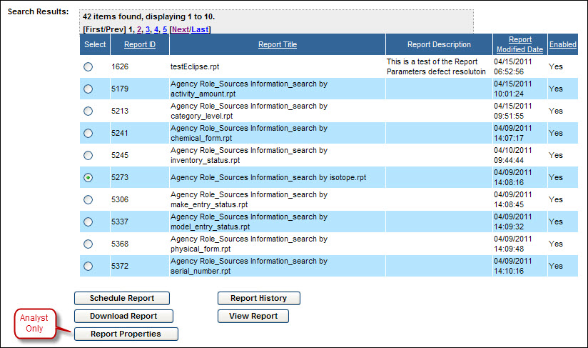
Figure 4-249: Manage Reports (Report Search Results)

From the search results, select the radio button () for the desired report. Then click one of the action buttons below the list:
- View Report will display the report results on-screen.
- Download Report will download the report results in one of several file formats.
- Schedule Report will enable the user to set a date & time for the report to run, either once or repeatedly at a set interval, e.g., daily, weekly, etc. Schedule Report is not available to Read-Only users.
- Report History will display a list of previously run scheduled-reports (Report Instances) and the scheduled run date of the next report instance. An existing report instance can be selected from the history list and viewed or downloaded. Only instances of previously run reports will be displayed to Read-Only users.
- Report Properties will display and allow modification of the properties of the report. This option is available only to NSTS Analysts with write permission.

- Selecting View Report will display the Parameters for View Report screen. The parameter selection options available will vary depending on the selected report.

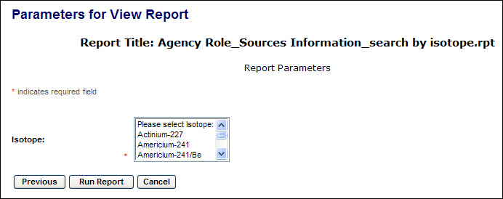
Figure 4-250: Manage Reports (View Report Parameters)

Select the parameters for the report. (In most drop-down lists, multiple selections can be made by depressing the Ctrl key when selecting each additional item.)

- After selecting the desired parameters of the report, click the Run Report button. The report results will be displayed on a new screen.

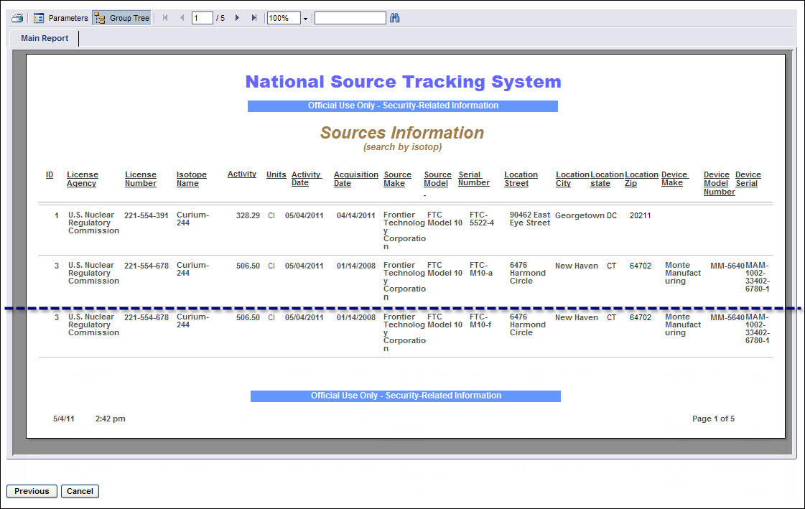
Figure 4-251: Manage Reports (View Report)

Use the tools at the top of the report to print the report, go to other pages of the report, and search for text within the report.

Click the Previous button to return to the report parameters selection screen. Click Cancel to go to the Main Menu.

- From the Report Search results list, click Download Report to download the report results in one of several file formats. The Parameters for Report screen will be displayed.

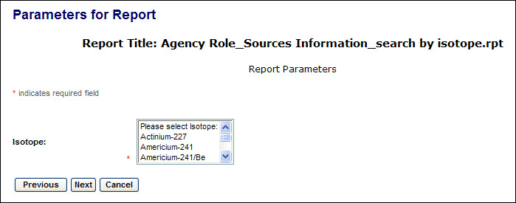
Figure 4-252: Manage Reports (Download Report Parameters)

Select the parameters for the report. (In most drop-down lists, multiple selections can be made by depressing the Ctrl key when selecting each additional item.)

- After selecting the desired parameters of the report, click the Next button. The File Format for Report screen will be displayed.

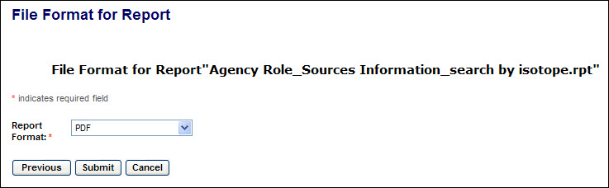
Figure 4-253: Manage Reports (Download Report File Format)

Reports can be downloaded in several file formats, including PDF, MS Excel, MS Word, .RTF, .TXT, .CSV, and .XML.

- Select the desired file format for the download and click the Submit button. The report will be displayed either in the application associated with the file type or in an Internet Explorer screen.
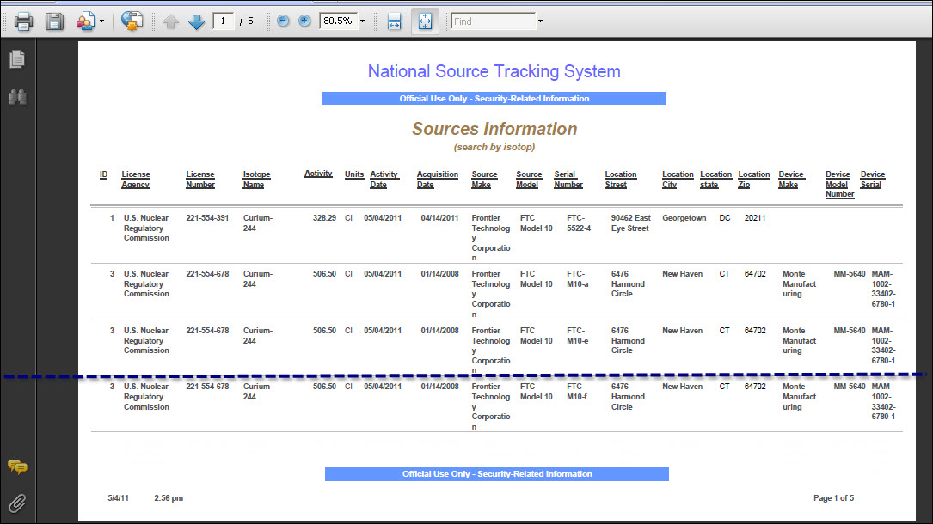
Figure 4-254: Manage Reports (Download Report - PDF)

If the report results are displayed in an Internet Explorer window, it will be necessary to click the browser back button to return to NSTS. Do not close the browser window or your session will be closed without having logged off and you will need to wait at least 10 minutes for your session to timeout before logging on again.

Use the application’s or Internet Explorer’s tools to save, print, and navigate in the report results.

- From the Report Search results list, click Schedule Report to set a date & time for the report to run, either once or repeatedly at a set interval, e.g., daily, weekly, etc. The Parameters for Run/Schedule Report screen will be displayed. Schedule Report is not available to Read-Only users.

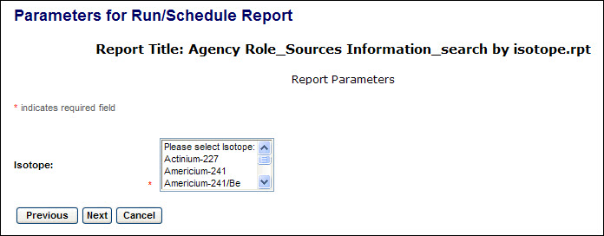
Figure 4-255: Manage Reports (Run/Schedule Parameters)

Select the parameters for the report. (In most drop-down lists, multiple selections can be made by depressing the Ctrl key when selecting each additional item.)

- After selecting the desired parameters of the report, click the Next button. The Report Instance Values screen will be displayed.

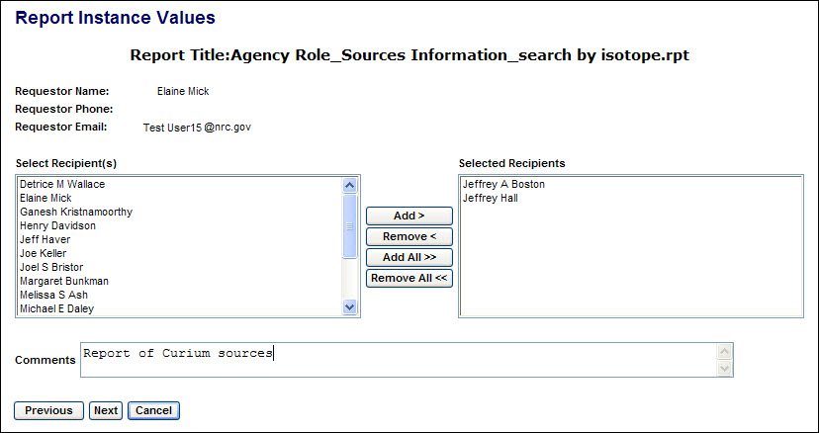
Figure 4-256: Manage Reports (Report Instance Values)

Use this screen to select additional NSTS users to be sent an email notification of availability of a new report instance and instructions for retrieving it after the report has been run. The list of possible recipients comprises those users with permission to view the data in the report results.

- After entry of the Report Instance Values is complete, click the Next button. The Report Schedule Settings screen will be displayed.

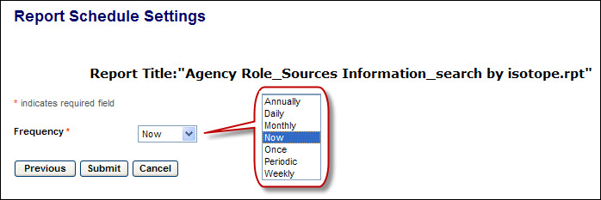
Figure 4-257: Manage Reports (Report Schedule Settings)

Reports can be scheduled to run either once at a specified date and time (including ‘Now’) or periodically on a schedule set by the requestor. Several frequency intervals are available.

- Select the desired frequency and click the Submit button. On the Report Schedule Settings screen, the date and time options associated with the selected frequency will be displayed.

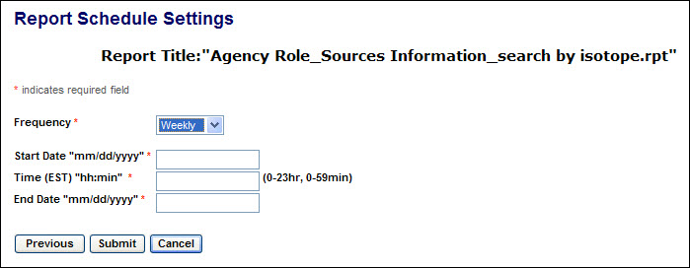
Figure 4-258: Manage Reports (Report Schedule Settings – Weekly)

Using the required format, enter the date and time at which the report should first be run, and enter an end date for a series of reports.

- After entry of the report schedule settings are complete, click the Submit button. The Run/Schedule Report Confirmation screen will be displayed.

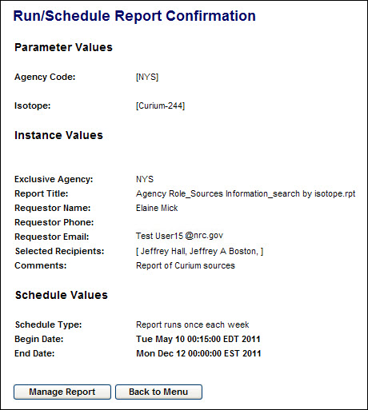
Figure 4-259: Manage Reports (Report Schedule Confirmation)

To view, download, or schedule another report, click on the Manage Report button to return to the Report Search screen. Click on Back to Menu to go to the main menu.

- Each time a scheduled report is run, including ‘Now,” an email notification of availability of a new report instance and instructions for retrieving it will be sent to the report recipients.

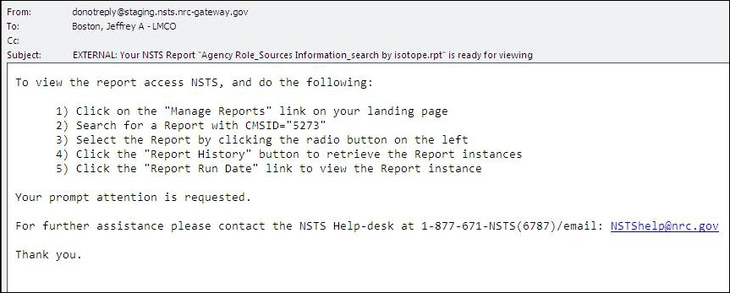
Figure 4-260: Manage Reports (Report Notification Email)

- In NSTS, follow the notification instructions to search for the specified report.

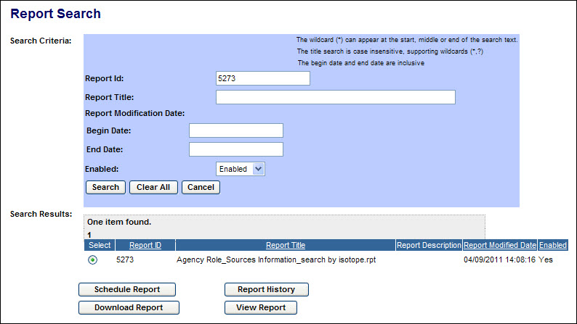
Figure 4-261: Manage Reports (Report Search – Retrieve Report Instance - 1)

- Select the report in the search results list and click the Report History button. The list of report instances will be displayed. Read-Only users will see only report instances with a Status of Success.

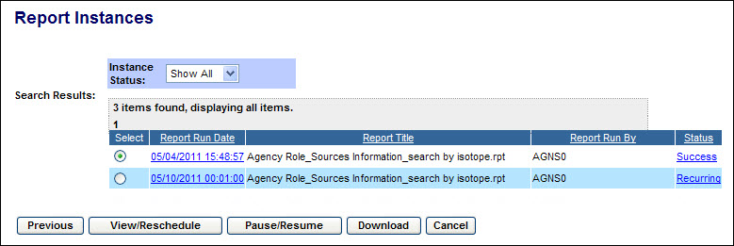
Figure 4-262: Manage Reports (Report History - 1)

- Report instances that are available to view will have a Status of “Success.” To see the report parameters and execution date/time & frequency information, click the Success link. The Instance Status screen will be displayed.

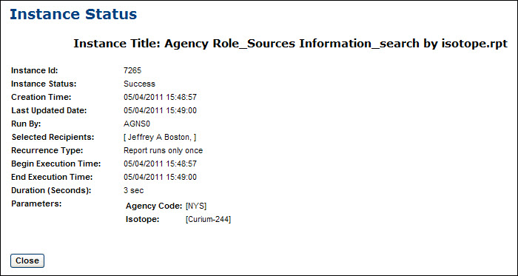
Figure 4-263: Manage Reports (Report Instance – Success Link)

To return to the list of report instances, click the Close button.

- The next instance of a report to be run will have a Status of “Pending” if it is set to run once, or “Recurring” if it is set to run multiple times at a set interval. To see the report parameters and execution date/time & frequency information, click the Pending/Recurring link. The Instance Status screen will be displayed.

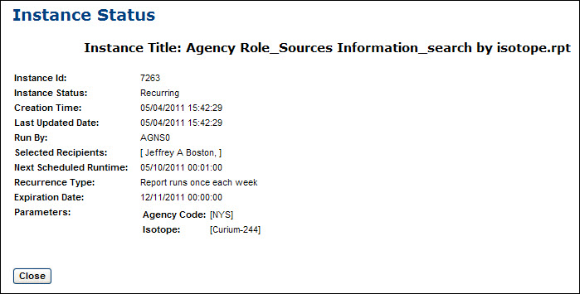
Figure 4-264: Manage Reports (Report Instance – Recurring Link)

To return to the list of report instances, click the Close button.

Figure 4-265: Manage Reports (Report History - 2)

- The buttons on the Report Instances screen have the following functions:
- For an instance with the status of Success, the View/Reschedule button (or the Report Run Date link) will display the report results. For Read-Only users, the button will be titled View.
- For an instance with the status of Pending or Recurring, the View/Reschedule button (or the Report Run Date link) will restart the sequence of report scheduling screens for entry of report parameters, notification recipients, and schedule settings. (Described below in paragraphs #8-12)
- The Pause/Resume button will suspend the running of a report in Pending or Recurring status and will reset a Paused report to Pending or Recurring according to its properties. Pause/Resume is not available to Read-Only users.
- For an instance with a status of Success, the Download button will allow downloading of the report results. The File Format for Report screen will be displayed. (Described below in paragraph #6)
- For an instance with the status of Recurring, the Download button will return an NSTS Recoverable Error because no report results are yet available for the selected instance.

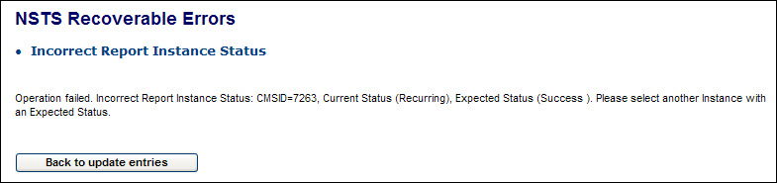
Figure 4-266: Manage Reports (Download of Recurring Report Instance)

- From the Report Search results list, click Report Properties to review and update the properties of a report. (Available only to NSTS Analysts with write permission.) The Report Properties screen will be displayed.

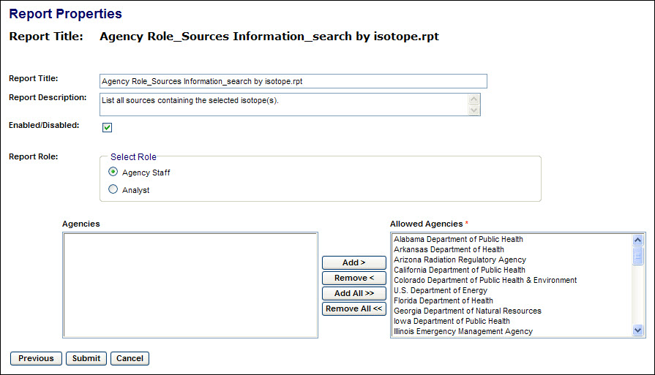
Figure 4-267: Manage Reports (Report Properties)

A report can be enabled or disabled, and can be made available to agency staff users or only to NSTS analysts.

If available to agency staff users, it can be available to one, several, or all agencies. Select an agency (or multiple agencies by depressing the Ctrl key while selecting the additional agencies), and click the Add button. Click the Add All button to add all agencies to the Allowed Agencies list.

To delete agencies from the Allowed Agencies list, select an agency (or multiple agencies by depressing the Ctrl key while selecting the additional agencies), and click the Remove< button. Click the Remove All<< button to delete all agencies from the Allowed Agencies list.

- After reviewing or updating the report settings, click Submit, and the Update Report Properties Confirmation screen will be displayed.

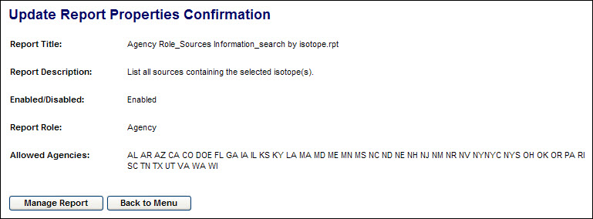
Figure 4-268: Manage Reports (Update Report Properties Confirmation)

To view, download, or schedule another report click on the Manage Report button to return to the Report Search screen. Click on Back to Menu to go to the main menu.

Maintain Report Schedules
User – NRC Staff, Agreement State Staff, DOE Staff, and NSTS Analysts

Use – To view and download the report results of successful report instances, and update the parameters of scheduled report instances. (Updating of scheduled report instances is not available to Read-Only users.)

- From the NSTS Main Menu, under Report Management, click the Maintain Report Schedules link. The Report Instance Search criteria screen will be displayed.

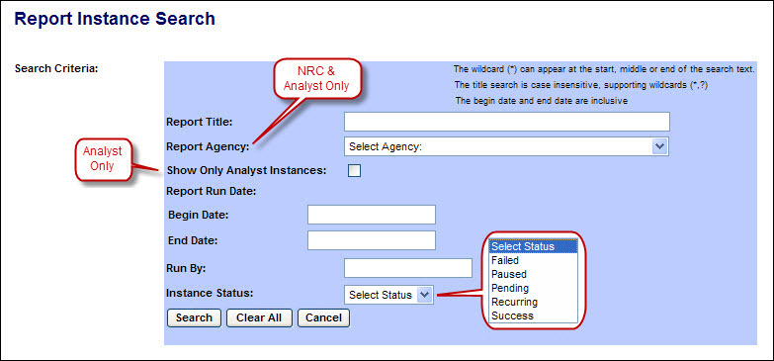
Figure 4-269: Maintain Report Schedules (Report Instance Search Criteria)

The following fields are available to narrow the search:

Field Name | Description/Comments | Acceptable Values | Example Value
Report Title | Title of the report | Free-form text | Source Information by Isotope
Report Agency (Displayed only to NRC Staff & NSTS Analysts) | Limit search results to those instances in which the selected agency is named in the instance parameters | Drop-down list | Ohio Department of Health
Show Only Analyst Instances (Displayed only to NSTS Analysts) | Limit search results to those instances which were requested by NSTS Analysts | Check mark
Report Run Date: Begin Date | Beginning date of report run date range | mm/dd/yyyy | 02/20/2011
Report Run Date: End Date | End date of report run date range | mm/dd/yyyy | 02/21/2011
Run By | NSTS User ID of the person who requested the report | Free-form text | jwb003
Instance Status | Limit search results to instances with selected status. (Only the status of Success is available to Read-Only users.) | Drop-down list | Success

To search for reports with a specific word or text string in the title, enter an asterisk (*), then the word or text string, followed by an asterisk (*). For example, *isotope* Also, a question mark (?) may be used as a wildcard for individual letters in a word or text string. Searches of the title field are case-insensitive.

- After entering the search criteria, click the Search button. (If no criteria are selected, all instances which the user is authorized to view will be displayed.) The search results will be displayed below the search criteria form.

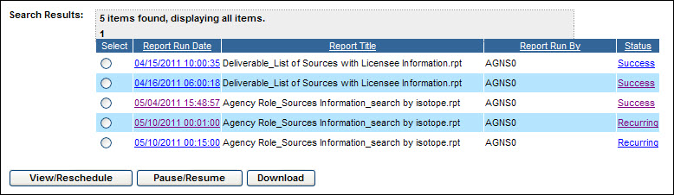
Figure 4-270: Maintain Report Schedules (Report Instance Search Results - 1)

Read-Only users will see only report instances with a Status of Success, and only View and Download buttons will be available below the search results.

- Report instances that are available to view will have a Status of “Success.” To see the report parameters and execution date/time & frequency information, click the Success link. The Instance Status screen will be displayed.

Figure 4-271: Maintain Report Schedules (Report Instance – Success Link)

To return to the list of report instances, click the Close button.

- The next instance of a report to be run will have a Status of “Pending” if it is set to run once, or “Recurring” if it is set to run multiple times at a set interval. To see the report parameters and execution date/time & frequency information, click the Pending/Recurring link. The Instance Status screen will be displayed.

Figure 4-272: Maintain Report Schedules (Report Instance – Recurring Link)

To return to the list of report instances, click the Close button.

Figure 4-273: Maintain Report Schedules (Report Instance Search Results - 2)

- From the Report Instance Search results list, the report results of a successful instance can be viewed or downloaded, the parameters and schedule of a pending or recurring instance can be reviewed and modified, and the execution of a pending or recurring instance can be paused.
First select the radio button () for the desired instance. Then click one of the action buttons below the list:
- For an instance with the status of Success, the View/Reschedule button (or the Report Run Date link) will display the report results. (Described below in paragraph #6) For Read-Only users, the button will be titled View.
- For an instance with the status of Pending or Recurring, the View/Reschedule button (or the Report Run Date link) will restart the sequence of report scheduling screens for entry of report parameters, notification recipients, and schedule settings. (Described below in paragraph #7)
- The Pause/Resume button will suspend the running of a report in Pending or Recurring status and will reset a Paused report to Pending or Recurring according to its properties. Pause/Resume is not available to Read-Only users.
- For an instance with a status of Success, the Download button will allow downloading of the report results. The File Format for Report screen will be displayed. (Described below in paragraph #12)
- For an instance with the status of Pending or Recurring, the Download button will return an NSTS Recoverable Error because no report results are yet available for the selected instance. (Described below in paragraph #14)

- To view the results of an instance with the Status of Success, click the View/Reschedule button (or the Report Run Date link). The report results will be displayed on a new screen.

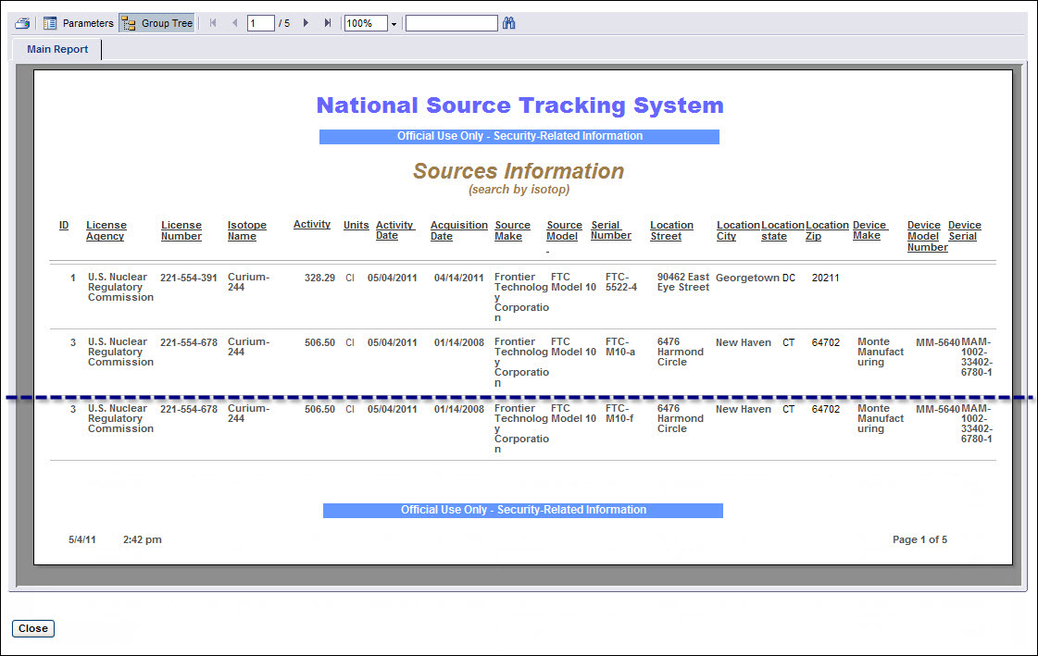
Figure 4-274: Maintain Report Schedules (View Report)

Use the tools at the top of the report to print the report, go to other pages of the report, and search for text within the report.

Click the Close button to return to the list of report instances.

- To review and modify the parameters of an instance with the Status of Pending or Recurring, click the View/Reschedule button (or the Report Run Date link). The Parameters for Run/Schedule Report screen will be displayed. Changing the parameters or schedule of a report is not available to Read-Only users.

Figure 4-275: Maintain Report Schedules (Run/Schedule Parameters)

Select the parameters for the report. (In most drop-down lists, multiple selections can be made by depressing the Ctrl key when selecting each additional item.)

- After selecting the desired parameters of the report, click the Next button. The Report Instance Values screen will be displayed.

Figure 4-276: Maintain Report Schedules (Report Instance Values)

Use this screen to select additional NSTS users to be sent an email notification of availability of a new report instance and instructions for retrieving it after the report has been run. The list of possible recipients comprises those users with permission to view the data in the report results.

- After entry of the Report Instance Values is complete, click the Next button. The Report Schedule Settings screen will be displayed.

Figure 4-277: Maintain Report Schedules (Report Schedule Settings)

Reports can be scheduled to run either once at a specified date and time (including ‘Now’) or periodically on a schedule set by the requestor. Several frequency intervals are available.

- Select the desired frequency and click the Submit button. On the Report Schedule Settings screen, the date and time options associated with the selected frequency will be displayed.

Figure 4-278: Maintain Report Schedules (Report Schedule Settings – Weekly)

Using the required format, enter the date and time at which the report should first be run, and enter an end date for a series of reports.

- After entry of the report schedule settings are complete, click the Submit button. The Run/Schedule Report Confirmation screen will be displayed.

Figure 4-279: Maintain Report Schedules (Report Schedule Confirmation)

To view, download, or schedule another report click on the Manage Report button to return to the Report Search screen. Click on Back to Menu to go to the main menu.

- From the Report Instance Search results list, to download the report results of an instance with the Status of Success, select the instance and click the Download Report button. The File Format for Report screen will be displayed.

Figure 4-280: Maintain Report Schedules (Download Report File Format)

Reports can be downloaded in several file formats, including PDF, MS Excel, MS Word, .RTF, .TXT, .CSV, and .XML.

- Select the desired file format for the download and click the Submit button. The report will be displayed either in the application associated with the file type or in an Internet Explorer screen.

Figure 4-281: Maintain Report Schedules (Download Report - PDF)

If the report results are displayed in an Internet Explorer window, it will be necessary to click the browser back button to return to NSTS. Do not close the browser window or your session will be closed without having logged off and you will need to wait at least 10 minutes for your session to timeout before logging on again.

Use the application’s or Internet Explorer’s tools to save, print, and navigate in the report results.

- From the Report Instance Search results list, clicking the Download button for an instance with the status of Pending or Recurring will return an NSTS Recoverable Error because no report results are yet available for the selected instance.

Figure 4-282: Maintain Report Schedules (Download of Recurring Report Instance)

Click the Back to update entries button to return to the list of report instances.

Upload Report
Based on a request from the NRC for a specific report, a system developer will create a report template using Crystal Reports and save the file in .RPT format. (The tools, steps, and validation of report design are described in the NSTS Report Designer Guide.)

The file is then uploaded by an NSTS Analyst to the NSTS application server and “published.” Publishing pairs the report template with the report properties set by the analyst so that the report is available to the appropriate user group(s).

User – NSTS Analysts

Use – To upload a report template file and set the initial properties of a new report.

- From the NSTS Main Menu, under Report Management, click the Upload Report link. The Publish Report screen will be displayed.

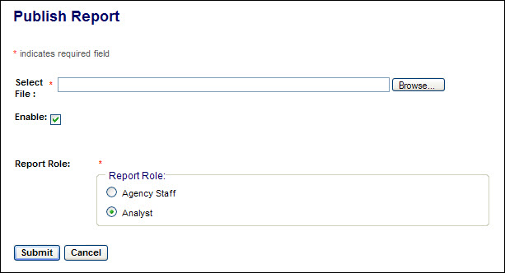
Figure 4-283: Upload Report (Publish Report - 1)

- Click the Browse button and select the file to be uploaded.

- If the report is to be available for use, click the Enable checkbox ().

- Chose the Report Role for which this report will be available by clicking the corresponding radio button ().

If Agency Staff is selected, the Agency selection tool will be displayed.

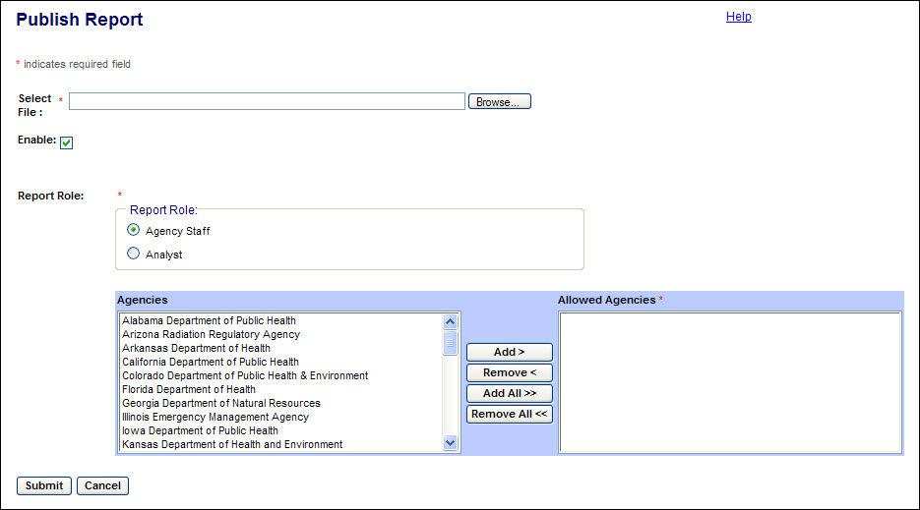
Figure 4-284: Upload Report (Publish Report - 2)
Use the tool to add one, several, or all agencies to the list allowed to run the report.
Select an agency (or multiple agencies by depressing the Ctrl key while selecting the additional agencies), and click the Add button. Click the Add All button to add all agencies to the Allowed Agencies list.
- After selecting the file to be uploaded and setting the properties of the report, click the Submit button. The Publish Report Confirmation screen will be displayed.

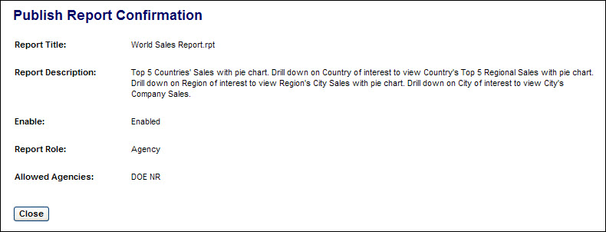
Figure 4-285: Upload Report (Publish Report Confirmation)
Click the Close button to return to the main menu.

NSTS Security-Related Requirements
This section describes security-related requirements for the NSTS. The NSTS design is based on a rigorous set of security regulations to ensure the safety of system data. These regulations (listed in Section 1.4) comply with Federal guidance and provide a means of standardization across the NSTS. Security considerations and responsibilities for using the system are provided in the NSTS security documentation.

Classification
The security classification for the NSTS is ‘Sensitive Unclassified – Official Use Only (also known as ‘OUO’). There is no Personally Identifiable Information (PII) required or retained by the system.

Sensitivity of Information
The Sensitivity of Information for the NSTS is based on the guidance in the National Institute of Standards and Technology Special Publications (NIST SP) 800-60, Guide for Mapping Types of Information and Information Systems to Security Categories. This publication identifies information types and information systems, and assigns impact levels for confidentiality, integrity, and availability.

Security Controls
The NSTS meets the assurance requirements and protective measures specified in NIST SP 800-53, Recommended Security Controls for Federal Information Systems, for a system with “high” sensitivity of information.

Digital Certification
Digital certificates are employed to ensure that only authorized users of the NSTS have access to the system. The NRC and Agreement State Staff users are required to obtain digital certificates, according to procedures, to use the NSTS.

Role Driven Permissions
The NSTS provides the capability to support role driven permissions for determining access to objects (e.g., menu options, screens, specific functions, data groupings by region, etc.) in the system. Role-based access control also applies to data records sent in upload files that are received by the system.

Single Sign-on (SSO)
The NSTS provides an authentication process that collects user security credentials (e.g., user ID and password) that can be used to access multiple applications. Note: The highest level security policy will be applied to all SSO applications.

Receive Security Credentials
The NSTS securely accepts user security credentials that have been authenticated by an external authentication system (e.g., a Lightweight Directory Access Protocol (LDAP) repository, an Oracle SSO server, etc.).

Send Security Credentials
The NSTS securely captures, authenticates, and passes user security credentials to other systems.

Security Auditing
The NSTS performs audit tracking on modifications to the security permissions for users and roles.

Encryption
The NSTS is capable of encrypting data in transit according to Federal Information Processing Standard (FIPS) Publication140-2, Security Requirements for Cryptographic Modules, or prevailing standards to prevent unauthorized access and other attacks.

External Data Transmission
The NSTS is capable of encrypting non-public data for transmission over various media, locally and remotely. Encryption should be assignable based on the contents of the record.

Encryption Algorithms
The NSTS will give the System Administrator the ability to designate what FIPS 140 validated algorithm (as shown on the product’s FIPS 140 certificate) should be used to encrypt data for transmission. In essence, if cryptography is required, the product and algorithm must be validated.

Smart Card

Using the Smart Card
- Insert the USB end of the card reader into your USB port on your Personal Computer (PC).
- Insert the Smart Card, with the gold metal tab up, into the card reader.
- The light on the card reader will flicker as it reads the card (usually about 10 second).
- After the card has been read, launch your Internet Explorer browser.
Note: Do not remove the card from the reader.
- Once the browser starts, go to the NSTS Website.
- You will be prompted to enter a PIN (see Section 2.5, NSTS Authentication).

Safeguarding your Smart Card
Do not give your card to someone else. Do not leave your card unattended.

NSTS User Responsibilities
It is critical that users of the NSTS fulfill their responsibilities in protecting NSTS’ vital information. The people who access Source information have a special responsibility to protect if from unauthorized use and disclosure. Understanding information security responsibilities and how to fulfill them will help to mitigate risks to the NSTS.

The goal of this section is to provide simple everyday tools to protect the NSTS’ information while using its resources. End user roles and responsibilities for using the NSTS are as follows:

Protection Controls
Protect NSTS resources by applying system-wide protection controls. If your token or ID information is stolen, lost, or forgotten, immediately report it to the NSTS Help Desk at 1-877-671-NSTS (6787).

Workstation Security Controls
Protect data by implementing security controls at your workstation as follows:

- Protect your computer from unauthorized access by keeping it physically secure. Your NSTS workstation is equipped with a password-protected screen saver. Anytime you leave your desk, be sure to invoke the screen saver or shut down your computer.

- Log on securely to the system.

- Preserve your PIN and keep it safe so that no one can access it.

- Identify and report NSTS-related security incidents to the NSTS Help Desk at 1-877-671-NSTS (6787).

Handling Sensitive Information
Federal guidance for sensitive but unclassified information security can be found on the NIST Website at http://csrc.nist.gov/index.html.

Training

Computer Based Training

Purpose
The goal of the NSTS Computer Based Training (CBT) is to enable users to effectively learn the various NSTS procedures required of their role as well as provide access to those various process training modules as quick reference resources.

Scope
The NSTS CBT training will provide:

- An intuitive interface providing simple navigation tools.
- Background and key concepts of the NSTS.
- A “big picture” overview of the NSTS software including main systems function and features.
- Guided practice and interactive exercises using real-life scenarios.
- A detailed look at the NSTS functionality and tasks required for each function.
- Post-lesson self-assessment testing to reinforce learning, with questions linked to specific learning objectives.
All tasks included in the NSTS CBT modules will include steps in the classic instructional sequence: “hear, see, do.” Users listen to or read an explanation of a concept or task, observe a demonstration, and then complete the task independently. Users will not be required to complete the modules in any particular order. Access to any given module is not dependent on the completion or score of any other module within the user’s track.

Interface and Navigation
The typical user will:

- Log on to the NSTS web application
- Access the CBT “Main Menu” page from links on the NSTS site.
- Select Role-Based Track – Once on the CBT page, the user selects among the Training Tracks from the NSTS Main Menu based on their role.
- Select Module- The user selects the module that they wish to complete.
- View the Module- Once in a specific module, the CBT interface will allow the user to move forward or backward through the individual screens of instruction.
- Practice - Each module guides the user through an interactive multimedia experience to learn the information and will provide guided practice where appropriate.

Accessing the NSTS Computer Based Training Menu
From the NSTS Main Menu, scroll down to the Training module, and then select Computer Based Training.
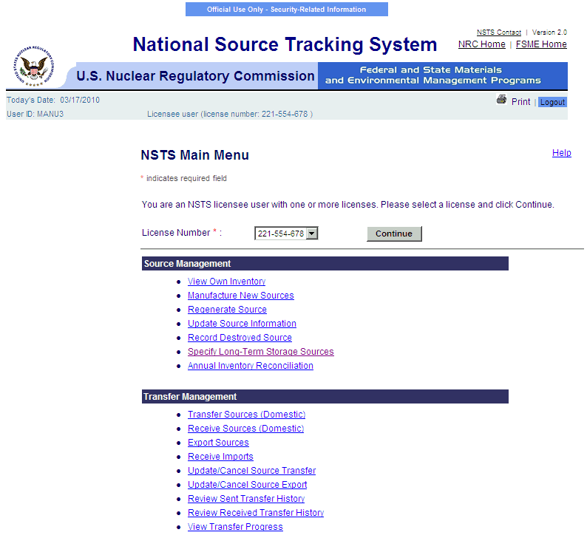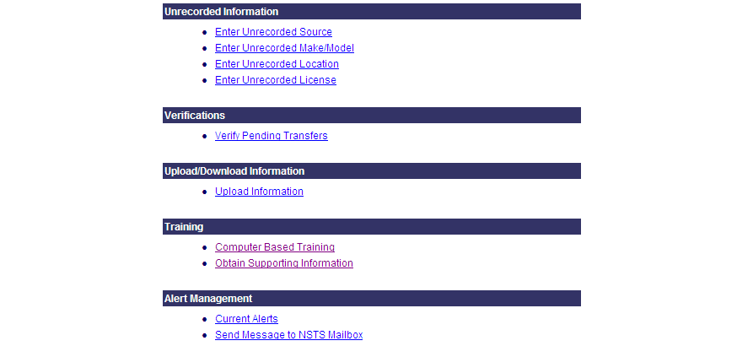

Figure 6-1: NSTS Main Menu – Computer Based Training

Depending on your logon user role, the NSTS Computer Based Training menu will appear. For example, the training menu for the Licensee is shown in Figure 6-2.

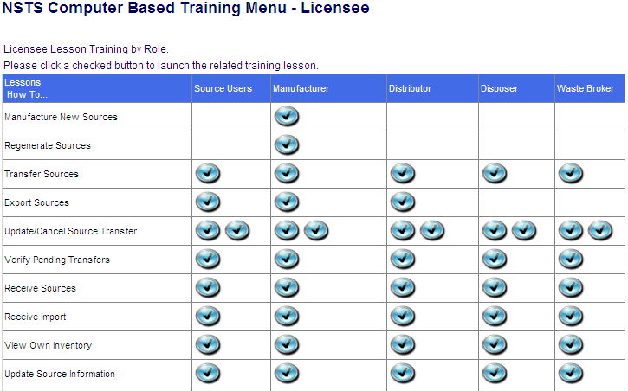
Figure 6-2: NSTS CBT Menu – Licensee

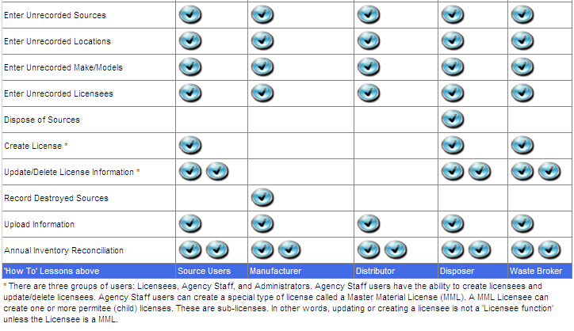
Figure 6-3: NSTS CBT Menu – Licensee (continued)

NSTS Rules of Behavior
You will not be able to access the NSTS application until you have complied with the NSTS Security Policy (see Figure 6-4) and acknowledged the NSTS Rules of Behavior.
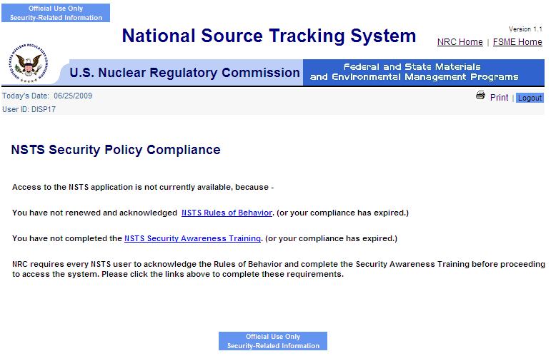
Figure 6-4: NSTS Security Policy Compliance

The NRC requires every NSTS user to read and accept the NSTS Rules of Behavior before proceeding. Click the NSTS Rules of Behavior link to read and accept the rules.
When you are done reading the rules, click I Accept (see Figures 6-5, 6-6, and 6-7). You will
be returned to the NSTS Security Policy Compliance window.

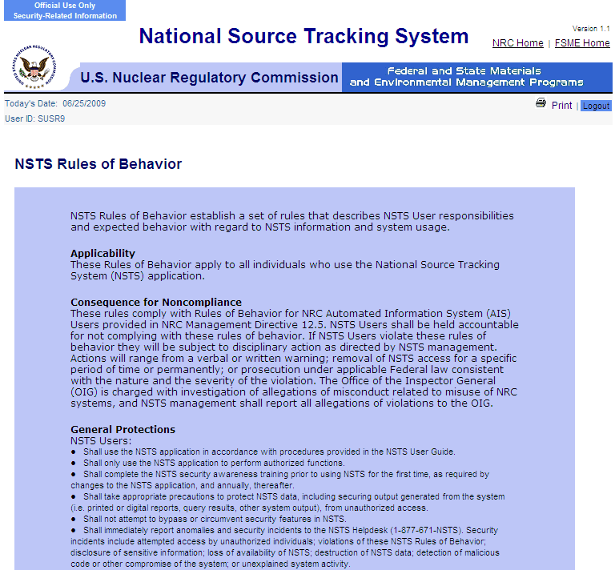

Figure 6-5: NSTS Rules of Behavior

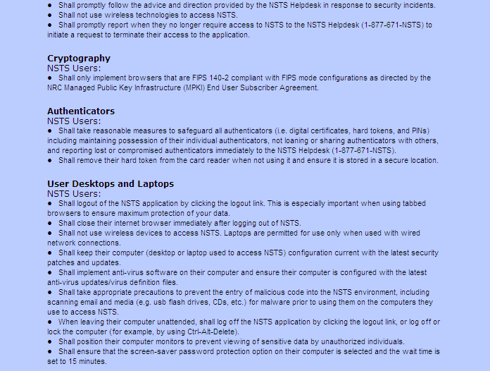
Figure 6-6: NSTS Rules of Behavior (continued)
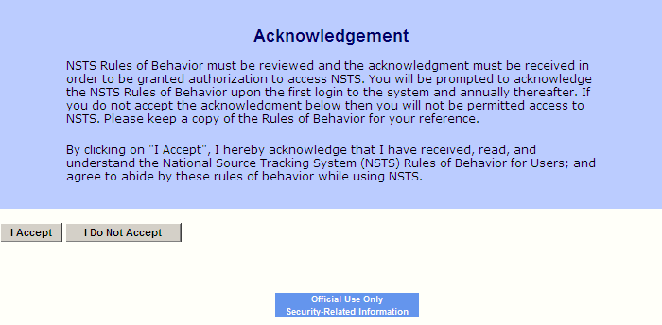

Figure 6-7: NSTS Rules of Behavior (end)

If you do not accept the rules of behavior, click I Do Not Accept. A dialog box will appear: ‘Are you sure you do not want to accept the NSTS Rules of Behavior?’

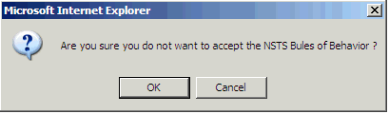
Figure 6-8: NSTS Rules of Behavior (Do Not Accept confirmation)

If you click OK, a second dialog box will appear: ‘Since you did not accept the NSTS Rules of Behavior, your session is closed.’ To confirm your decision, click OK, and your session will be closed (see Figure 6-9). You will have to wait 15 minutes before logging on to the NSTS application.

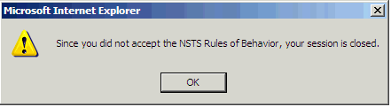
Figure 6-9: NSTS Rules of Behavior (Do Not Accept second confirmation)

NSTS Security Awareness Training

The NRC requires every NSTS user to complete the NSTS Security Awareness Training before proceeding. Click the NSTS Security Awareness Training link (see Figure 6-4).

The NSTS Security Training window appears (see Figure 6-10).

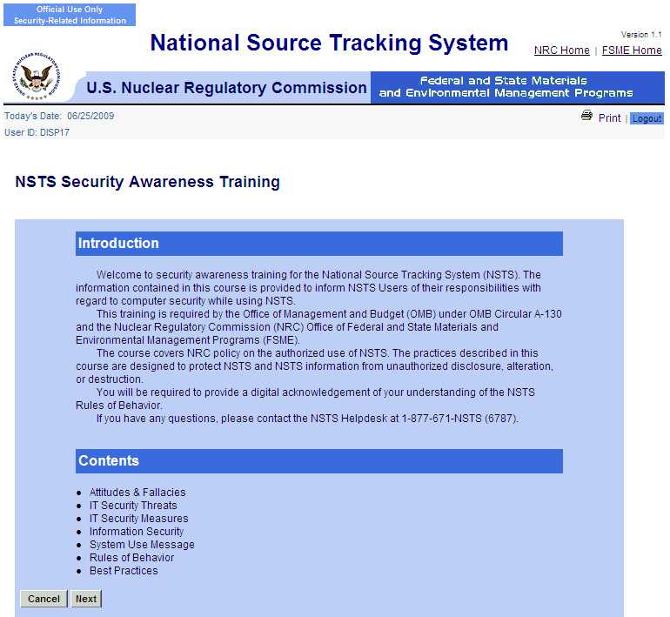

Figure 6-10: NSTS Security Awareness Training (Introduction and Contents)

Read the training information, and then click Next to proceed to the next window (see Figures 6-11 through 6-21). To return to the NSTS Security Policy Compliance window, click Cancel.
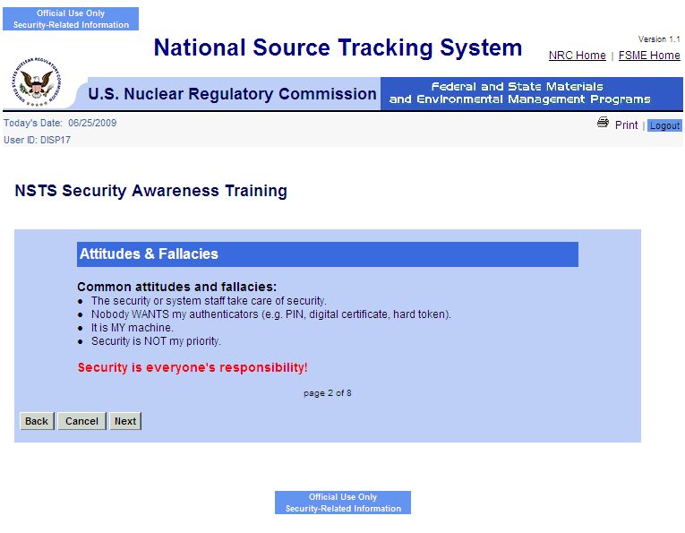
Figure 6-11: NSTS Security Awareness Training (Attitudes and Fallacies)
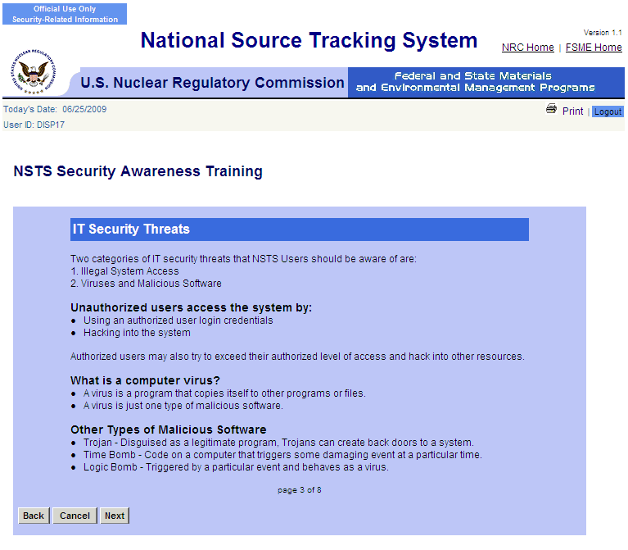
Figure 6-12: NSTS Security Awareness Training (IT Security Threats)

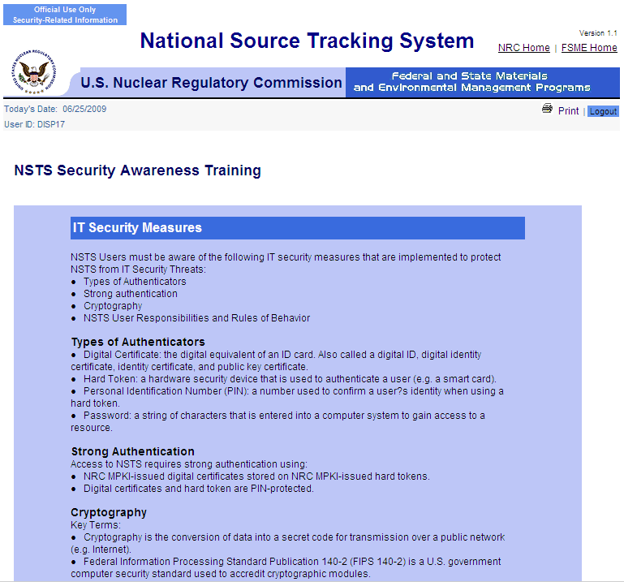

Figure 6-13: NSTS Security Awareness Training (IT Security Measures)

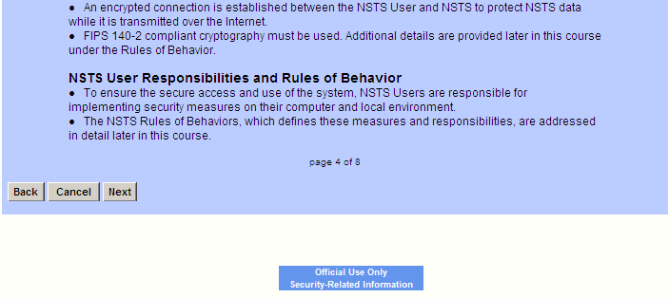

Figure 6-14: NSTS Security Awareness Training (IT Security Measures)(continued)

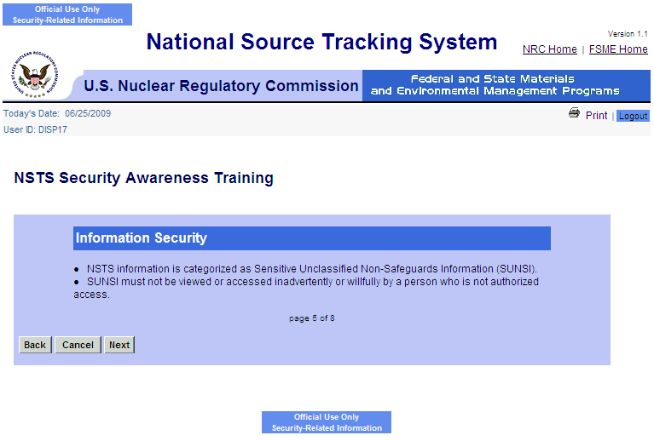

Figure 6-15: NSTS Security Awareness Training (Information Security)

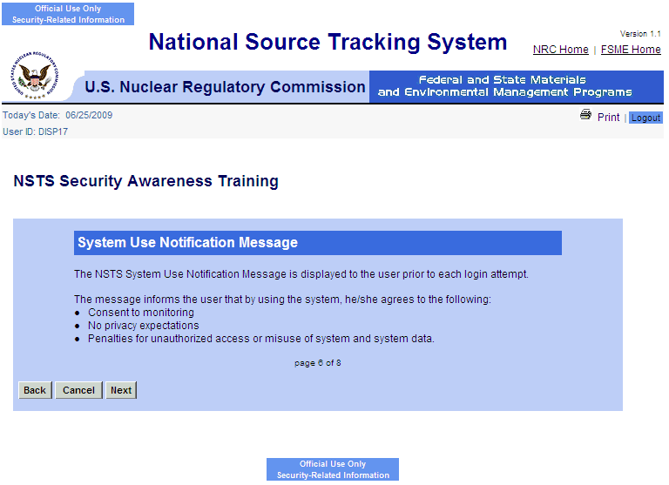

Figure 6-16: NSTS Security Awareness Training (System Use Notification Message)

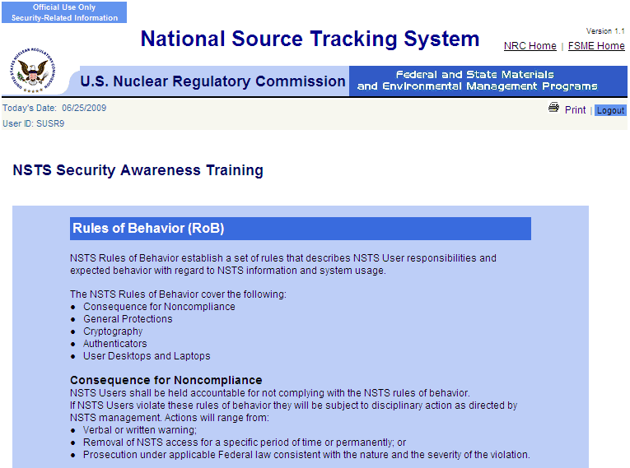
Figure 6-17: NSTS Security Awareness Training (Rules of Behavior)

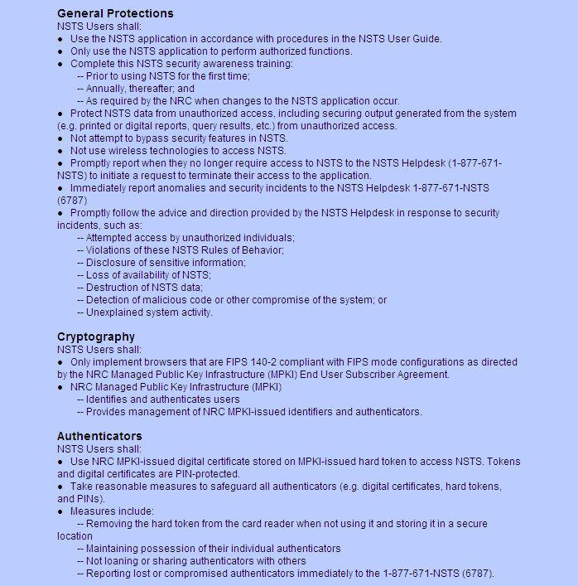
Figure 6-18: NSTS Security Awareness Training (Rules of Behavior)(continued)

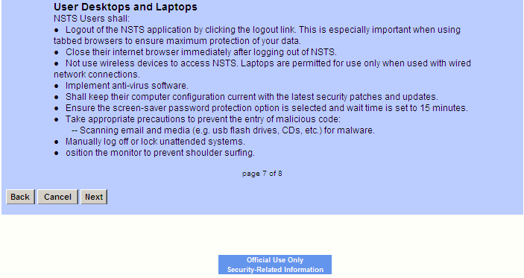

Figure 6-19: NSTS Security Awareness Training (Rules of Behavior)(end)

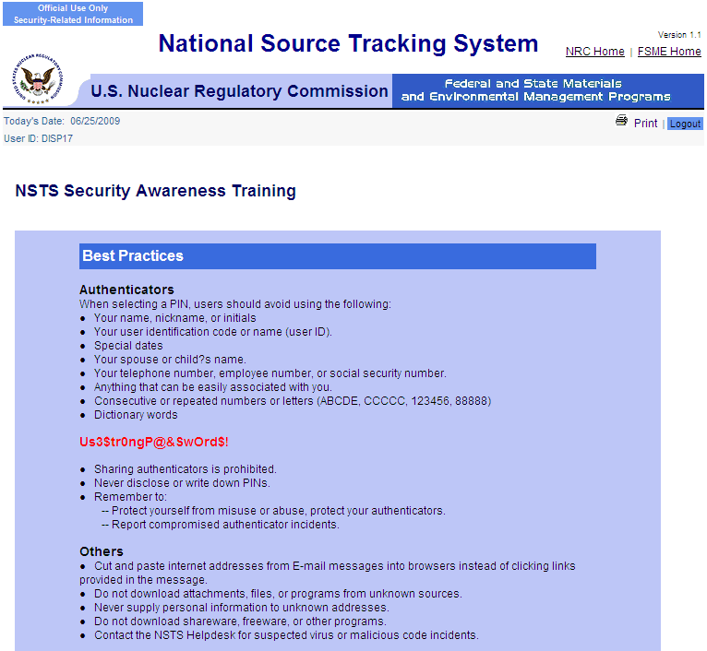
Figure 6-20: NSTS Security Awareness Training (Best Practices)
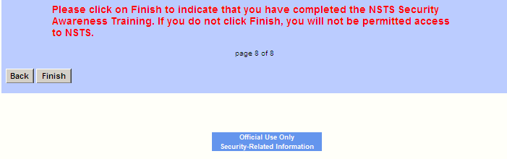
Figure 6-21: NSTS Security Awareness Training (Best Practices)(continued)

When you are done reading all of the training information, click Finish to indicate that you have completed the NSTS Security Awareness Training. You will be returned to the NSTS Main Menu. To go back to the previous window, click Back.

Roles and User Groups
The NSTS computer-based training is intended for three primary roles, or user groups: Licensees, Licensing Agencies, and the NSTS Analyst.

Licensee
Licensees represent the company or person authorized to use radioactive materials under a license issued by the NRC or an Agreement State. Generally speaking, Licensees will use NSTS to record manufacture, use, distribution, transportation, storage, and disposal activities.
- Source User
A Licensee who is authorized to use Sources and permitted to manage Sources and transfers.
- Manufacturer
A Licensee who is authorized to manufacture Sources.
- Distributor
A Licensee who is authorized to distribute Sources.
- Waste Disposer
A Licensee who is authorized to dispose of Sources.
- Waste Broker
A Licensee who is authorized to temporarily store Sources.

The NSTS CBT Menu for Licensees is shown in Figures 6-22 and 6-23.

Figure 6-22: NSTS CBT Menu – Licensee

Figure 6-23: NSTS CBT Menu – Licensee (continued)

Licensing Agencies
Generally speaking, Licensing Agencies will use the NSTS to track, monitor and control Sources and Licensee activity.
- NRC Staff
NRC Licensing Agency staff manages licenses and Sources.
- Department of Energy (DOE)
Considered a pseudo-licensee, the DOE is responsible for tracking radioactive material assigned to it. They act as a licensing agency, managing licenses and Sources.
- Agreement State (A/S) Staff
Agreement States Staff manage licenses and Sources.

The NSTS CBT Menu for Licensing Agencies is shown in Figure 6-24 and 6-25.

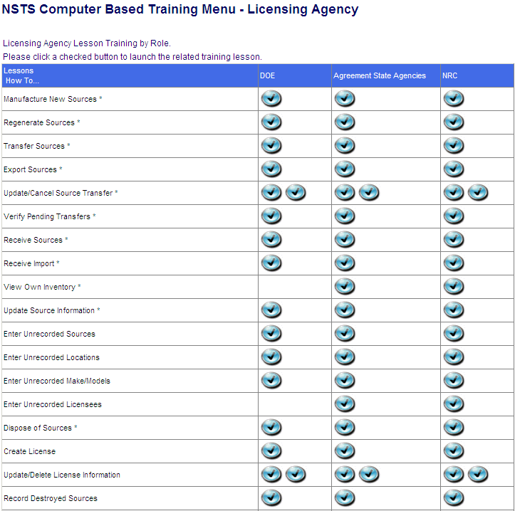
Figure 6-24: NSTS CBT Menu – Licensing Agency

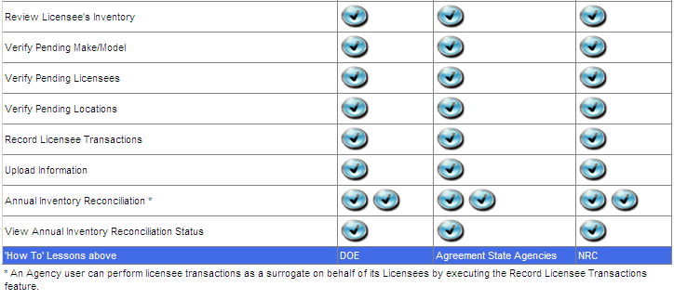
Figure 6-25: NSTS CBT Menu – Licensing Agency (continued)

NSTS Analyst
The NSTS Analyst is the NRC staff member who views and enters license and source information regardless of Licensing Agency jurisdiction. The NSTS CBT Menu for the NSTS Analyst is shown in Figures 6-26 and 6-27.

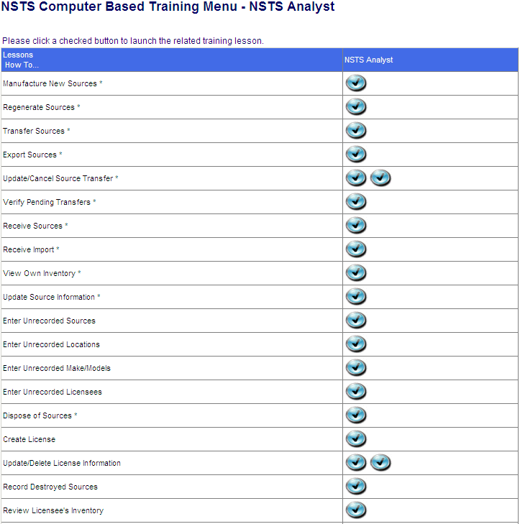
Figure 6-26: NSTS CBT Menu – NSTS Analyst

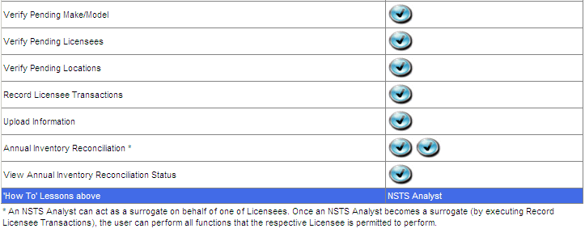
Figure 6-27: NSTS CBT Menu – NSTS Analyst (Continued)

Obtain Supporting Information
User – NSTS Users

Use – To access a list of (and links to) reference documents (including other Websites) that are related to the National Source Tracking System (NSTS).

- From the NSTS Main Menu, under Training, click the Obtaining Supporting Information link. The NSTS Supporting Information screen will be displayed.

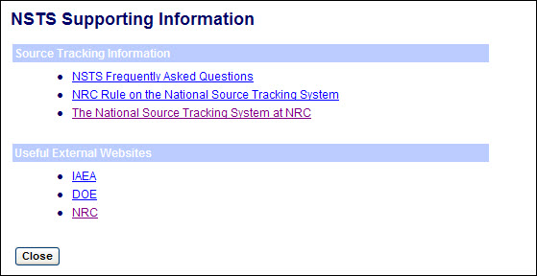
Figure 6-28: NSTS Supporting Information

- The links presented on the NSTS Supporting Information screen will take the user to the associated Website, as follows:

Link: | Website URL:
NSTS Frequently Asked Questions | http://www.nrc.gov/security/byproduct/nsts/faqs.html
NRC Rule on the NSTS | http://www.nrc.gov/security/byproduct/nsts/nsts-rule.html
The NSTS on the NRC website | http://www.nrc.gov/security/byproduct/nsts.html
IAEA (International Atomic Energy Agency) | http://www.iaea.org/
DOE (Department of Energy) | http://www.energy.gov/
NRC (Nuclear Regulatory Commission) | http://www.nrc.gov/

Appendix A: Abbreviations and Acronyms

A/S Agreement State
CBP Customs and Border Patrol
CBT Computer-Based Training
DHS Department of Homeland Security
DOC Department of Commerce
DOD Department of Defense
DOE Department of Energy
DOT Department of Transportation
EPA Environmental Protection Agency
FIPS Federal Information Processing Standard
GUI Graphical User Interface
HTTP HyperText Transfer Protocol
HTTPS HyperText Transfer Protocol Secure
LDAP Lightweight Directory Access Protocol
MDI Multiple Document Interface
MML Master Material License
NIST National Institute of Standards and Technology
NMSS Nuclear Material Safety and Safeguards
NRC Nuclear Regulatory Commission
NSS&DR National Sealed Source and Device Registry
NSTS National source Tracking System
OAO Orbital Astronomical Observatory
OUO Official Use Only
PII Personally Identifiable Information
PIN Personal Identification Number
RIS Reporting Identification Symbol (Identifier for Department of Energy sites)
RSRT Radiological Source Registry and Tracking System
SSO Single Sign-On
SOW Statement of Work
SUNSI Sensitive Unclassified Non-Safeguards Information
URL Uniform Resource Locator
WBL/LTS Web-Based Licensing/Licensing Tracking System
XML Extensible Markup Language
Appendix B: NSTS Windows, Functions, Alternatives, and Scenarios

The following table provides a general description of the NSTS windows and their functions, and typical usage scenarios that show how various user types might perform the functional processes. Also included are alternative flows that show other ways that a user might interact with the system to perform the functional processes. The sections numbers correspond to the section numbers in the document.

Section | Window | Function |  |  | Alternative |  | Scenario
4.1.1  View Own Inventory | Search and View Own Inventory | Allows Licensee to view a list of Sources that the Licensee possesses.  Allows Licensee to retrieve a list of Sources that are considered to be in the possession of the Licensee according to the information in the system.  Allows Licensee to perform periodic inventory and to cross-check its inventory against what NSTS recorded.  Allows Licensee to complete search criteria and initiate a search. |  |  | None |  | Licensee performs its periodic inventory and would like to cross-check its inventory against what NSTS recorded.
4.1.2  Manufacture New Source | Manufacture a New Source  Review New Sources  Edit Source  Manufacture Additional Sources  Confirm Source Creation | Allows Manufacturer Licensee to record in NSTS, new NSTS trackable Sources that are manufactured.  Allows Licensees to correct any discrepancies, to supply required additional information, and re-submit the form. |  |  | Location Not Found:  If the Licensee cannot find the address of the Location in the system, the Licensee must first enter the Location by using “Enter Unrecorded Locations” (see 4.4.3).  Make/Model Not Found:  lf the Licensee cannot find the Model in the system, the Licensee must first enter the Make/Model by using “Enter Unrecorded Make/Model” (see 4.4.4). |  | Manufacturer manufactures a new NSTS trackable Source from bulk material.  Manufacturer manufactures a new NSTS trackable Source from re-manufactured material.  Manufacturer uploads a file containing information about multiple Sources that were manufactured during the manufacturing process.
4.1.3  Regenerate Sources | Search Sources for Regeneration  Regenerate Source | Allows Manufacturer Licensee to record in NSTS that an NSTS trackable Source has been regenerated and has a new activity amount.  Allows the Licensee to view a list of Sources that the Licensee possesses, and select Sources to update.  Allows Licensees to correct any discrepancies, supply required additional information, and re-submit the form. |  |  | Source Not Found:  If the Licensee cannot find the Sources to be reported, the Licensee must first enter the Sources by using “Enter Unrecorded Sources” (see 4.4.1). |  | Manufacturer regenerated a Source so that its activity is increased
4.1.4  Update Source Information | Search Sources for Update  Update Source Information | Allows Licensee to initiate a request to update a Source’s information.  Allows user to enter search criteria and initiate the search.  Allows Licensee to choose a Source to update or delete.  Allows Licensee to enter and submit information. |  |  | Source Not Found:  If the Licensee cannot find the Sources in the system, the Licensee must first enter the Sources in NSTS by using “Enter Unrecorded Sources” (see 4.4.1).  Location Not Found:  If the Licensee cannot find the Location in the system, the Licensee must first enter the Location in the system by using “Enter Unrecorded Locations” (see 4.4.3).  Model Not Found:  If the Licensee cannot find the Model in the system, the Licensee must first enter the Model in the system by using “Enter Unrecorded Make/Model” (see 4.4.4). |  | Source user measures the Source Activity, and enters that information into the system.  NRC Staff received the serial number of a Found Source that was recorded a few days ago and now wants to put in the serial number information.  A Source is removed from the Device before it is shipped back to the Manufacture for regeneration and wants to blank out the Device Make/Model/Serial Number.
4.1.5  Record Destroyed Sources | Search Sources for Recording Destroyed  Record Destroyed Sources | Allows user to initiate a request to record that a Source has been destroyed.  Allows user to enter search criteria and initiate the search.  Allows user to view a list from which to choose the Licensee to record information for.  Allows user to choose the Source to update.  Allows user to complete and submit the form.  Allows user to correct any discrepancies, to supply required additional information, and re-submit the form. |  |  | None |  | Fire at a Licensee’s site destroys a Source; the Licensee reports the incident to its Licensing Agency. The Licensing Agency staff records the information in the system.  Manufacturer disassembles a Source to produce several new Sources.  Manufacturer disassembles several Sources to produce one new Source.
4.1.6  Record Destroyed Sources – NRC Staff | Search and Choose Licensee  View and Choose Sources  Record Destroyed Source | Allows NRC user to search and choose Licensee.  Allows user to initiate a request to record that a Source has been destroyed.  Allows user to enter search criteria and initiate the search.  Allows user to view a list from which to choose the Licensee to record information for.  Allows user to choose the Source to update.  Allows user to complete and submit the form.  Allows user to correct any discrepancies, to supply required additional information, and re-submit the form. |  |  | None |  | Fire at a Licensee’s site destroys a Source; the Licensee reports the incident to its Licensing Agency. The Licensing Agency staff records the information in the system.  Manufacturer disassembles a Source to produce several new Sources.  Manufacturer disassembles several Sources to produce one new Source.
4.1.7  Dispose Source | Search Sources for Dispose  Dispose Source | Allows Disposer Licensee to initiate a request to record disposal of a container of Sources.  Allows Licensee to select the Container(s) to be disposed of.  Allows the Licensee to complete and submit the form.  Allows user to correct any discrepancies, to supply required additional information, and re-submit the form. |  |  | None |  | Disposer buries a container of Sources at its facility.
4.1.8  Record Lost or Stolen Sources | Search and Choose Licensee  Search Sources for Record Lost or Stolen  Record Lost or Stolen Source  Record Lost or Stolen Source Confirmation | Allows Licensee to record in the NSTS when trackable Sources have been lost or stolen. |  |  | If Source cannot be found for reporting, Licensee enters the Source by using ‘Enter Unrecorded Source.’ |  | Manufacturer discovers that some NSTS trackable Sources are stolen. The Manufacturer reports the incident to the Agreement State, who provides the information to the NRC, The NRC Staff records the information reported by the Manufacturer.
4.1.14  Annual Inventory Reconciliation | Verify, Print, Export  Pre-Existing Inventory Reconciliation Record | Verify Annual Inventory Reconciliation Report.  Print Annual Inventory Reconciliation Report.  Export Annual Inventory Reconciliation data in Microsoft Excel or Portable Document Format (PDF).  Licensee or Agency user acts as a surrogate for the Licensee. |  |  | None |  | See ‘Annual Inventory Reconciliation User Guide,’ version 0.3, dated November 2009.
4.1.15  View Annual Inventory Reconciliation Status (Agency User) | View Agency Status  View Licensee Details | Agency User can view the status of the annual inventory.  Agency User can view detailed inventory reconciliation information for each Licensee in an agency. |  |  | None |  | See ‘Annual Inventory Reconciliation User Guide,’ version 0.3, dated November 2009.
4.1.10
Manufacture New Source – Bulk
4.2.1  View Licensee Inventory | Search and Choose Licensee  View Licensee’s Inventory Information | Allows Agency Staff to initiate a request to view a Licensee’s inventory.  Allows Agency Staff to enter search criteria and initiate a search.  Allows Agency Staff to select the Licensee.  Allows Agency Staff to view a list of Sources that a particular Licensee possesses. |  |  | None |  | To prepare for an inspection, a NRC inspector prints out a list of Sources that a Licensee is supposed to have.
4.2.2  Create License | Create License  Enter License Location Address Information  Enter License Contact Information | Allows Agency Staff to initiate a request to enter a new License record.  Allows Agency Staff to complete and submit the license.  Allows Agency Staff to correct any discrepancies, to supply required additional information, and re-submit the form. |  |  | Special Permission: Only NRC Staff and the NSTS Analyst are allowed to create a License for another Licensing Agency. The MML Indicator can only be set by the NRC. |  | An Agreement State recently licensed a new Source user; the Agreement State Staff needs to enter the new License into the program.
4.2.3  Update/Delete License Management | Search and Choose License  Update / Delete License  Enter License Location Address Information  Enter License Contact Information | Update License:  Allows Agency or MML Staff to initiate a request to update License information.  Allows Agency or MML Staff to enter criteria and initiate a search.  Allows Agency or MML Staff to select a License.  Allows Agency or MML Staff to complete and submit the form.  Allows Agency Staff or MML Staff to correct any discrepancies, to supply required additional information, and re-submit the form. |  |  | Delete License:  Agency or MML Staff request to delete a License. The system presents a search entry form.  Agency or MML Staff enters the search criteria and initiates the search. The system provides a list of Licenses that meet the criteria.  Agency or MML Staff chooses License from the list. The system performs deletion of the License and displays a confirmation message. |  | An Agreement State Staff adds a new contact name to an existing License.
4.2.4
Inventory Report
4.3.1  Transfer Sources (Domestic) | Search and Choose Sources for Transfer (Domestic)  Search and Choose Receiving Licensee  Enter Transfer Information (Domestic) | Allows Licensee to initiate a request to record a transfer of Sources.  Allows the Licensee to complete and submit the form.  Allows Licensee to correct any discrepancies, to supply required additional information, and re-submit the form. |  |  | Source Not Found:  If the Licensee cannot find the Sources to be reported, the Licensee must first enter the Sources by using “Enter Unrecorded Sources” (see 4.4.1).  Receiving Licensee Not Found:  If the Receiving Licensee does not exist in the system, the Sending Licensee must enter the Receiving Licensee using “Enter Unrecorded Licensees” (see 4.4.5). |  | Manufacturer ships manufactured Sources to a U.S. Distributor.  Distributor ships manufactured Sources to a U.S. Source User.  Source User ships manufactured Sources back to a Manufacturer.  Source User ships Sources in a container to a Disposer.  Source user ships manufactured sources to another Source User.  Disposer ships manufactured Sources back to the Sending Licensee because of improper packaging or because it is not an acceptable type of Source for that Disposer.
4.3.2  Receive Sources (Domestic) | View and Choose Open Shipments (Domestic)  Enter Receipt Shipment/  Transfers Information (Domestic) | Allows Licensee to request to record the receipt of one or more Sources.  Allows Licensees to choose one or more Source transfers from the list.  Allows Licensee to complete and submit the form.  Allows Licensee to correct any discrepancies, to supply required additional information, and re-submit the form. |  |  | Missing Items:  When one or more Sources are missing from a shipment, and some or all of the Source serial numbers cannot be identified immediately, the Receiving Licensee marks the shipment as received with missing items, (i.e., shipment status of “Incomplete” with missing Sources given a transfer status of “Not Received”).  Shipment/Transfer Not Found:  When the search for a particular Source transfer is not found in the system (e.g., the Sending Licensee failed to report the shipment/transfer to the system), follow these steps:  1. The Licensee requests to record the receipt of one or more Sources.  2. The Licensee indicates that the received shipment/transfers are not among the displayed.  3. The Receiving Licensee may alternatively enter the shipment/transfer using “Enter Unrecorded Transfers” (see 4.4.2).  Location Not Found:  If the Licensee cannot find the address of the receiving Location in the system, the Licensee must enter the Location in the system by using the “Enter Unrecorded Locations” (see 4.4.3). |  | Distributor receives manufactured Sources from a U.S. supplier.  Source User receives manufactured Sources from a U.S. Distributor.  Disposer receives spent Sources from a U.S. Source User, Distributor, or Manufacturer.  Receiving Licensee previously marked the transfers as “Not Received’ since part of the shipment was incomplete and serial numbers could not be identified at the time. Since then, the serial numbers of the received transfers have been identified so the Licensee now has to complete the receiving process.
4.3.3  Export Sources (Domestic) | Search and Choose Sources for Export  Enter Export Information | Allows Licensee to initiate a request to record the export of Sources.  Allows Licensee to select the Sources to be exported.  Allows Licensee to complete and submit the form.  Allows Licensee to correct any discrepancies, to supply required additional information, and re-submit the form. |  |  | Source Not Found:  If the Licensee cannot find the Sources to be exported in the system, the Licensee must first enter the Sources by using “Enter Unrecorded Sources” (see 4.4.1). |  | Manufacturer exports manufactured Sources to a foreign entity.  Distributor exports manufactured Sources to a foreign entity.  Source User exports manufactured Sources to a foreign entity.
4.3.4  Receive Imports | Enter Receipt Information (Foreign)  Enter Receipt Sources Information (Foreign) | Allows Licensee to record the receipt of one or more imported Sources.  Allows Licensee to complete and submit the form.  Allows Licensee to correct any discrepancies, to supply required additional information, and re-submit the form. |  |  | Location Not Found:  If the Licensee cannot find the address of the receiving Location in the system, the Licensee must enter the Location in the system by using the “Enter Unrecorded Locations” (see 4.4.3).  Make/Model Not Found:  lf the Licensee cannot find the received Model in the system, the Licensee must first enter the Make/Model by using “Enter Unrecorded Make/Model” (see 4.4.4). |  | Manufacturer receives Sources from a foreign supplier.  Distributor receives manufactured sources from a foreign supplier.  Source User receives manufactured Sources directly from a foreign supplier.
4.3.5  Update /Cancel Source Transfer | View and Choose Open Domestic Shipments  Update /Cancel Domestic Shipment  Search and Choose Sources for Transfer (Domestic)  Search and Choose Receiving Licensee | Allows Licensee to initiate a request to record the export of Sources.  Allows Licensee to select the Sources to be exported.  Allows Licensee to complete and submit the form.  Allows Licensee to correct any discrepancies, to supply required additional information, and re-submit the form. |  |  | Source Not Found:  If the Licensee cannot find the Sources to be exported in the system, the Licensee must first enter the Sources by using “Enter Unrecorded Sources” (see 4.4.1). |  | Manufacturer exports manufactured sources to a foreign entity.  Distributor exports manufactured Sources to a foreign entity.  Source User exports manufactured Sources to a foreign entity.
4.3.6  Update/  Cancel Source Export | View and Choose Open Export Shipments  Update/  Cancel Export Shipment  Search and Choose Sources for Export | Allows Licensee to initiate a request to record the export of Sources.  Allows Licensee to select the Sources to be exported.  Allows Licensee to complete and submit the form.  Allows Licensee to correct any discrepancies, to supply required additional information, and re-submit the form. |  |  | Source Not Found:  If the Licensee cannot find the Sources to be exported in the system, the Licensee must first enter the Sources by using “Enter Unrecorded Sources” (see 4.4.1). |  | Sending Licensee updates existing export information or cancels an export.
4.4.1  Enter Unrecorded Sources | Enter Unrecorded Source | Allows Licensee to initiate a request to enter an unrecorded Source.  Allows Licensee to complete and submit the form.  Prompts the Licensee to contact its Licensing Agency to resolve problem if a Source exists in the system that is possessed by another Licensee. |  |  | Model Not Found:  If the Licensee cannot find the Model in the system, the Licensee must first enter the Model in the system by using “Enter Unrecorded Make/Model” (see 4.4.4). |  | Manufacturer searches for a Source to record a transfer for, but cannot find the Source in the system because the Manufacturer neglected to enter the Source into NSTS when it was manufactured. The system generates an alert to be sent to the designated agency staff to notify the staff that a source has been entered.  A Source User wants to specify a Source as Long-Term Storage, but cannot find the Source in the system because the Source was not loaded into NSTS during the initial load. The system will generate an alert to be sent to the designated agency staff to notify the staff that a source has been entered.
4.4.2  Enter Unrecorded Transfer | Search and Choose License  Enter Unrecorded Shipment/  Transfers  Enter Unrecorded Shipment/  Transfers (Transfer Details) | Allows Licensee to initiate a request to enter an Unrecorded Transfer.  Allows Licensee to complete and submit the form.  Allows Licensee to correct any discrepancies, to supply required additional information, and re-submit the form. |  |  | Source Not Found:  If the Licensee cannot find the Sources in the system, the Licensee must enter the Sources in the system by using “Enter Unrecorded Sources” (see 4.4.1).  Model Not Found:  If the Source entered by the Licensee as part of the Transfer cannot be found in the system, the Licensee must first enter the Source by using “Enter Unrecorded Make/Model” (see 4.4.4).  Sending Licensee Not Found:  If the Sending Licensee does not exist in the system, the Receiving Licensee must enter the Sending Licensee using “Enter Unrecorded Licensees” (see 4.4.5). |  | Receiving Licensee attempts to receive sources, but cannot find the associated shipment/transfer in the system. The Receiving Licensee enters the transfers into the system. Once the Transfers are entered, they are considered ‘pending transfers.’ The system generates and sends an alert to the Sending Licensee. The Sending Licensee validates the transfers (see ‘Verify Pending Transfers,’ section 4.5.1).
4.4.3  Enter Unrecorded Location –  Licensee –  Manufacturing Landing Page | Enter an Unrecorded Location | Allows user to enter unrecorded location information.  Allows user to complete and submit the form.  Allows user to correct any discrepancies, to supply required additional information, and re-submit the form. |  |  | None |  | Licensee moves a Source to another location and needs to record it, but the Location does not exist in the system. Once the location is entered, it is considered a ‘pending location.’ The system generates and sends an alert to the designated Agency Staff. The Agency Staff is required to validate the entered location (see ‘Verify Pending Locations,’ section 4.5.4).
4.4.4  Enter Unrecorded Location -  Licensing  Agency – NRC  Landing Page | Search and Choose Licensee  Enter an Unrecorded Location | Allows Agency Staff to search and choose a Licensee.  Allows user to enter unrecorded location information.  Allows user to complete and submit the form.  Allows user to correct any discrepancies, to supply required additional information, and re-submit the form. |  |  | None |  | Licensee moves a Source to another location and needs to record it, but the Location does not exist in the system. Once the location is entered, it is considered a ‘pending location.’ The system generates and sends an alert to the designated Agency Staff. The Agency Staff is required to validate the entered location (see ‘Verify Pending Locations,’ section 4.5.4).
4.4.5  Enter Unrecorded Make/Model | Enter an Unrecorded Make/Model | Allows user to enter unrecorded make/model information.  Allows user to complete and submit the form.  Allows user to correct any discrepancies, to supply required additional information, and re-submit the form. |  |  | None |  | Licensee receives a Source manufactured by a foreign country. The Source’s make and model is not currently in the system. The Licensee enters the unrecorded make/model into the system. Once the make/model is entered, it is considered a pending make/model. The system will generate and send an alert to the designated Agency Staff. The Agency Staff is required to validate the pending make/model (see ‘Verify Unrecorded Make/Model,’ section 4.5.2).
4.4.5  Enter Unrecorded Licensee | Enter an Unrecorded Licensee | Allows Licensee to initiate a request to enter a Licensee.  Allows Licensee to complete and submit the form.  Allows Licensee to correct any discrepancies, to supply required additional information, and re-submit the form. |  |  | None |  | Manufacturer Licensee transfers a Source to a Source User, but the Source User does not exist in the system; therefore, the Manufacture must enter the Source User as an Unrecorded Licensee to complete the Transfer. Once the unrecorded licensee is entered, it is considered a ‘pending licensee.’ The system will generate and send an alert to the designated Agency Staff. The Agency Staff is required to validate the pending licensee (see ‘Verify Pending Licensees,’ section 4.5.3).
4.5.1  Verify Pending Transfers | View and Choose Pending Shipment/  Transfers  Verify Pending Shipment/  Transfers | Allows Licensee to verify pending Source Transfers.  Allows Licensee to choose and confirm a Shipment from the list. |  |  | Reject Transfers:  When the Sending Licensee reviews the pending shipment/transfers and determines that it did not send that shipment to the Receiving Licensee, the Sending Licensee:  - Requests to verify pending Source Transfers.  - Chooses a Shipment from the list and rejects that Shipment. |  | Manufacturer confirms a Pending Shipment that it sent to a Source User.  Source User confirms that it has shipped a Source to the Disposer.
4.5.2  Verify Pending Make/Model | View and Choose Pending Make/Model  Verify Pending Make/Model Information | Allows NRC Staff to verify pending Make/Model.  Allows NRC Staff to select a Make/Model to verify.  Allows NRC Staff to complete and submit the form. |  |  | None |  | Source User receives a foreign model and enters the make and model into the system. The designated NRC staff verifies the entered information.  A pending Make/Model was created because a model sent in by the DOE batch file did not exist in the system. The DOE staff needs to review and verify the model.
4.5.3  Verify Pending Licensees | View and Choose Pending Licensee  Verify and Complete Pending Licensee Information  Enter Pending Licensee/  License Information  Enter License Location Address Information  Enter License Contact Information | Allows NRC Staff to initiate a request to verify a pending Licensee.  Allows NRC Staff to choose a pending Licensee.  Allows NRC Staff to complete and submit the form.  Allows NRC Staff to correct any discrepancies, to supply required additional information, and re-submit the form. |  |  | None |  | Sending Licensee enters a new Licensee as the receiving party; the NRC Staff verifies the Licensee information that was entered by the Sending Licensee.
4.5.4  Verify Pending Locations | View and Choose Pending Locations  View Pending Location Information | Allows Agency Staff to initiate a request to verify a pending Location.  Allows Agency Staff to choose a pending Location.  Allows Agency Staff to complete and submit the form.  Allows Agency Staff to correct any discrepancies, to supply required additional information, and re-submit the form. |  |  | None |  | Licensee enters a new Source Location; the Licensing Agency verifies the Location that was entered by the Licensee.
4.7.1  Computer-Based Training | See Section 6.0 | Allows NSTS user to learn the various NSTS functions required for their role and to access the various training modules as quick reference resources. |  |  | None |  | NSTS user accesses radioactive material packaging information through the link provided by the NSTS.
4.7.2  Obtain Supporting Information | NSTS Supporting Information | Allows NSTS user to access a list of reference documents (including other Web sites) that are related to the NSTS. |  |  | None
6.4  Accessing the NSTS Computer-Based Training Menu | NSTS Main Menu – CBT  NSTS CBT Menu – Licensee  NSTS Rules of Behavior  NSTS Rules of Behavior Confirmation  NSTS Security Awareness Training | Enables the NSTS users to effectively learn various NSTS procedures required to use the system.  Provides acces to training modules.  Serves as a quick reference resource for training and learning the NSTS.  Provides access to a set of rules that describe NSTS User responsibilities and expected behavior on system usage. |  |  | None |  | A user wants to learn how to enter an unrecorded source in the system.  A user wants to know the rules of behavior for using NSTS computers (desktops and laptops).
6.5  Roles and User Groups | NSTS CBT Menu – Licensee  NSTS CBT Menu – Licensing Agency  NSTS CBT Menu – NSTS Analyst

Appendix C: Data Field Descriptions

Descriptions for each data field and data item in the NSTS are listed below.

Field Name | Description | Acceptable Values | Example Value
Account Status | Status of the user’s account (Active, Inactive, Deleted, etc.). | Drop-down list | Active
Acquisition Date | Date when the Source is added to a Licensee’s inventory. | mm/dd/yyyy | 03/12/2005
Activity | Current activity level for isotope. | Numeric value | 223
Additional License Contacts: Number of Contacts | Number of contacts associated with a particular license. | Numeric value | 5
Additional Location Addresses: Number of Location Addresses | Total number of additional addresses associated with a particular license. | Numeric value | 2
Address City | Name of the U. S. City | Free-form text | Dallas
Address Line 1 | Physical street address | Free-form text | 375 Oak Street
Address Line 2 | Additional address information, e.g., Room, Building, Suite, Floor, etc. | Free-form text | Suite 546
Address State | Name of the U. S. State | Drop-down list | TX
Address: City | City in which the license address is located. | Free-form text | Hanover
Address: State | State in which the license address is located. | Drop-down list | OH
Alert ID | The unique, system-generated ID number of an Alert | Numeric | 137
Alert Manager | User identified to receive Alert notifications. | Free-form text | Alert message.
Alert Origin: Origin Name | The domain entity that is the “source” of the Alert | Drop-down list | Domestic Shipment
Alert Origin: Origin Value | The system-assigned ID of the Alert Origin | Free-form text | ID: 3
Alternate Notification ID | An identifier supplied by the notification creator. | Free-form text | ABC #1
Alternate Shipment ID | Shipment ID generated in another system such as the DOE RSRT or a Sending Licensee’s system. | Free-form text | 2309478598
Alternate Source ID | Additional Source ID that is designated by the Licensee. | Alphanumeric | 456781B
Approve all the Sources in this shipment | Allows the user to approve Sources as a group. | Check mark
Carrier | Company transporting the shipment. | Drop-down list | FedEx
Category | Groupings of related alerts as reflected by the Category title | Drop-down list | Shipment
Cc: Email Address | Optional, if listed. Addressee will receive alert e-mail notifications. Separate multiple addresses with semicolons. | Valid e-mail format | xax@nrc.gov
Chemical Form | The chemical form of the Source | Drop-down list | THO2
City | Name of the U.S. City. | Free-form text | Dallas
Code Description | Describes an entry in the Code Table. | Free-form text | Becquerel (1/37e9 ci)
Comment | Details entered as free-form text by the user. | Free-form text (up to 2000 characters). | A shipment contains one or more transfers.
Company Fax Number | Fax number of the Licensee. | xxx xxx-xxxx | 555-333-2222
Company Phone Number | Phone number of the Licensee. | xxx xxx-xxxx | 555-333-1111
Confirm Password | Additional password entry to ensure accuracy on new or changed passwords. | Free-form text | Allows numbers and special characters.
Contact Address Line 1 | U. S. street address | Free-form text | 30 W. Gude Drive
Contact Address Line 2 | U. S. optional mailing address. | Free-form text | P.O. Box 400
Contact Address: City | U. S. City | Free-form text | Rockville
Contact Address: Same as Street Address? | Allows user to select existing address | Check mark
Contact Address: State | U. S. State abbreviations | Drop-down list | MD, VA, FL, NY
Contact Address: Zip | Five-digit number, optionally followed by four digits. | 5 or 9 digit ZipCode | 20850-0000
Contact Email | E-mail address of the contact person. | Valid e-mail format | source@nrc.com
Contact Fax | Fax number of the contact person. | xxx xxx-xxxx | 555-222-1212
Contact Name: First Name | First name of the contact person. | Free-form text | John
Contact name: Last Name | Last name of contact person. | Free-form text | Goode
Contact Name: Middle Name | Middle name of contact person. | Free-form text | Edward
Contact Phone | Telephone number of the contact person. | xxx xxx-xxxx | 555-440-1000
Contact Salutation | Greeting for a contact | Mr., Mrs., Miss, Ms., Dr. | Mr., Mrs., Dr.
Contact Title | Title of the contact person | Free-form text | Director of Regulation
Primary Contact | Each license must have one, but only one, primary contact. | Check mark
Contact Type | Type of contact. | Drop-down list | RSO
Container ID | ID of the container to be disposed. | Numeric value | 02349294
Copy Street Address to Location Address | Allows the user to select the address used previously. | Check mark
Country | A country which a shipment can be exported to or imported from. | Drop-down list | Canada
Created Date | Audit information | mm/dd/yyyy | 11/16/2006
Creation Begin Date | Beginning date of alert creation date range | mm/dd/yyyy | 04/22/2011
Creation End Date | End date of alert creation date range | mm/dd/yyyy | 04/28/2011
Current Activity: Maximum | Upper limit of current source activity search criteria | Free-Text field | 300
Current Activity: Minimum | Lower limit of current source activity search criteria | Free-Text field | 25
Current Activity: Unit | Unit in which the current activity level of the Source is measured. | Drop-down list | Ci
Destroyed Date | Date the Source was destroyed, i.e., no longer physically intact. | mm/dd/yyyy  (Must be on or before current date. Default is the current date.) | 02/05/2002
Destroyed Details | Comment field | Free-form text | Destroyed for remanufacturing
Destroyed Type | Indicates how Source was destroyed, i.e., type of destruction that occurred. | Drop-down list | Accidental
Device Make | Make of the device containing a trackable nuclear Source. | Alphanumeric | Acme
Device Model | Model of the device containing a trackable nuclear Source. | Alphanumeric | Acme123
Device Serial Number | Device serial number assigned by the manufacturer. | Free-form text | L98X777
Discovery Date | Date the Source was found (a.k.a. Status Date). Defaults to the current date. Should be on or before the current date. | mm/dd/yyyy | 03/11/2010
Disposal Date | Date a Source was disposed. | mm/dd/yyyy | 04/04/2006
Docket Number | License identifier used by NRC. NRC Licensees only. | Drop-down list | 5000313
Email Address | Used for Alert notification | Valid e-mail format | johndoe@xml.com
Enabled | Display only reports which are enabled, disabled, or both | Drop-down list | Enabled
End Date | Last date in a date range search. | mm/dd/yyyy | 10/10/2006
Entered By | Audit information | Free-form text | George Doe
Entry Date | Audit information | mm/dd/yyyy | 10/25/2006
Entry Status | Status of an entry | Drop-down list | Approved
Estimated Arrival Date | Date when the transfer/export is estimated to be received by the Receiving Licensee. | mm/dd/yyyy  (Must be on or after the sending date.) | 04/04/2006
Estimated Arrival Date: End Date | End date of estimated arrival date range | mm/dd/yyyy | 04/25/2011
Estimated Shipment Date: Begin Date | Beginning date of estimated shipment date range | mm/dd/yyyy | 04/22/2011
Export Date | Date the Sources were exported. Defaults to the current date. | mm/dd/yyyy | 04/04/2006
Export License Number | The domestic license number of the exporter (i.e. Part 110 License Number) | Free-form text | 235256
Foreign Company Contact Name | Name of the contact person at the foreign company. | Free-form text | John Bright
Foreign Company Name | Name of the foreign recipient. | Free-form text | UBS Company
Foreign Company Phone Number | Telephone number at the foreign company. | Free-form text | 011-2321-3222
Foreign Country | Country the Licensee is importing from or exporting to. | Drop-down list | England
Foreign Province | Province of the foreign country. | Free-form text | Quebec
Foreign Recipient Company | Company name of the foreign recipient | Free-form text | UK Nuclear, LTD
Foreign Recipient Country | Country to which the source(s) will be exported | Drop-down list | United Kingdom
Foreign Zip | Zip code of the foreign country. | Free-form text | 234 Y3K
Full Name | First, Middle, and Last name of the user. | Free-form text | John Henry Doe
Greater-Than-Class-C | Indicates a Source’s radioactivity exceeds the concentration limits established for Class C. | Drop-down list | No
Greater-Than-Class-C | Indicates a Source’s radioactivity exceeds the concentration limits established for Class C. | Check mark
Import License Number | The domestic license number of the importer (i.e. Part 110 License Number) | Free-form text | 235256
Import Notification ID | Used by exporting companies to notify importing countries for Category 1 and Category 2 Sources. | Numeric value | 2311124567
Imported Sources: Number of Sources | Number of Sources received in a particular import shipment. | Numeric value | 10
Importing Facility Licensee Name | Name of licensed importer | Free-form text | Source Imports, Inc
Incident Report Number | Associated incident report number, if any. | Alphanumeric | ADWE123456
Include All Sources | Include in search results all sources meeting the search criteria rather than just those sources reported as lost or stolen. | Check mark
Include Associated Licenses: Yes | If a search returns a license that has licenses associated with it, the associated licenses will be included in the search results. | Check mark
Include Sources Below Threshold | Indicates whether to include Sources Below Threshold in the search. | Check mark
Initial Activity: Maximum | Upper limit of initial source activity search criteria | Free-Text field | 300
Initial Activity: Minimum | Lower limit of initial source activity search criteria | Free-Text field | 25
Instance Status | Limit search results to instances with selected status. (Only the status of Success is available to Read-Only users.) | Drop-down list | Success
Irretrievable Date | Date the Source could not be retrieved. Date should be on or befor the current date. Defaults to the current date. | mm/dd/yyyy | 03/11/2010
Is Long-Term Storage | Indicates a Source is in long-term storage. | Check mark
Is this Licensee an MML | Indicates if the Licensee is a Master Material License Licensee. | Check mark | True
Is User an Alert Manager | User can receive Alert notifications. | Check mark
Isotope Name | Identification of the isotope in a Source. | Entry from a Code Table; populated based on Make and Model. | Cobalt-60
Isotope: Activity | Activity level for isotope | Numeric value | 223
Isotope: Activity Date | Date the activity level of the Source is measured. Defaults to the entered Manufacture Date. | mm/dd/yyyy | 01/02/2006
Isotope: Activity Unit | Unit in which the activity level of the Source is measured. | Drop-down list | Ci
Isotope: Select Operator | A filter for search criteria. | Drop-down list | = (equal)
Last Updated By | Name of person who last made updates (or Audit information). | Free-form text | Mary Smith
Last Updated Date | Date last updated (or Audit information). | mm/dd/yyyy | 12/29/2006
License Category | Category of the License | Drop-down list | Power Reactor
License ID | Unique identifier for the entered License. | System-generated | 1256896543
License Number | Number assigned when a license is issued. | Drop-down list | 45-27764-01
Licensee Name | Name of the organization to which the license was issued. | Free-form text | ABC Company
Export Licensee Name | The company name of the exporting licensee | Free-form text | Source Exports, Inc
Licensing Agency | Agency that has authority to license and inspect source materials used or possessed within their jurisdiction. | Drop-down list | Ohio Department of Health
Location Address:  Line 1  Line 2  City  State  Zip | Physical location of the Source. A location cannot exist without an address. | Line 1, 2, & City - free-form text  State – drop-down list  Zip – 5 or 9 digit ZipCode | 415 Oak Road  Suite 101  Town, LA  70360-0000
Long-Term Storage Date | Date the Source will be or was placed in long-term storage. | mm/dd/yyyy | 03/24/2006
Long-Term Storage Date: End Date | Ending date range when the Source was placed in Long-Term Storage (Status Date). | mm/dd/yyyy | 02/19/2010
Long-Term Storage Date: Begin Date | Beginning date range when the Source was placed in Long-Term Storage (Status Date). | mm/dd/yyyy | 02/12/2010
Long-Term Storage Indicator | Indicates a Source is in long-term storage. | Check mark
Long-Term Storage Reason | Reason the Source will be placed in long-term storage. | Free-form text | Available for reuse.
Lost and Stolen: Begin Date | Beginning date range of Lost or Stolen (Status Date). | mm/dd/yyyy | 02/12/2010
Lost and Stolen: End Date | Ending date range of Lost or Stolen (Status Date). | mm/dd/yyyy | 02/19/2010
Mailing Address:  Line 1  Line 2  City, State Zip | Location at which mail can be received, sometimes different from a street address. | Free-form text. State – drop-down list.  Zip – 5 or 9 digit ZipCode. | 375 Bernard Lane  Third Floor  Anytown, VA 22193-0000
Make | Represents the manufacturer. Each Make will have one or more models associated with it. | Drop-down list | Delta
Manifest Number | Number used in a shipping record. | Alphanumeric | 4094420999999
Manufacture Date | Date the Source is manufactured. | mm/dd/yyyy | 02/05/2003
Maximum Activity | Highest recommended activity level for a particular isotope. | Numeric value | 222.0
Model | Item that is manufactured. Represents a Model associated with a Make. | Drop-down list | A424-19
Name (Alert) | The named event which triggered the Alert | Drop-down list | Overdue Transfer
Not Received (Transfer Status) | Status of a transfer in which the Source is missing from the received Shipment. | Drop-down list | No Received
Notification Date: Begin Date | Beginning date of notification date range | mm/dd/yyyy | 04/22/2011
Notification Date: End Date | End date of notification date range | mm/dd/yyyy | 04/25/2011
Notification ID | A unique system-generated identifier for each notification source. | Numeric value | 234
Rule ID Number | The ID number of the rule which generated the Alert | Drop-down list | 3
Number of Contacts | Total number of contacts for this license. (At least one contact is required.) | Numeric value | 2
Number of Isotopes | Quantity of isotopes associated to a particular Make and Model. | Numeric value | 3
Number of Location Addresses | Total number of Location Addresses associated with a particular license. | Numeric value | 5
Number of Sources | Number of Sources in an import. | Numeric value | 4
Number of Transfers | Number of transfers in a shipment. | Numeric value | 3
Operator | A filter for searching by the level (greater than, less than, etc.) of the current activity. | Drop-down list | = (equal)
Organization ID | Indicator of user’s organization. For Agency Staff, this will be a single Agency ID; for a Licensee user, this is a list of one or more License IDs with which the user is associated. | Drop-down list | 40F51
Organization Type | A kind of organization. | Drop-down list | Agency
Originating Company | Company name of the foreign supplier | Free-form text | UK Nuclear, LTD
Originating Country | Foreign country the licensee is importing from | Free-form text | United Kingdom
Originator | The entity that manufactured or regenerated a Source. This can be a Licensee or DOE. | Free-form text | Neutron Products
Password | Secure password for each user – needed for system authentication. | Alphanumeric | Sunshine1
Physical Form | The Physical Form of the Source | Drop-down | Solid
Physical Location of Abandonment | Physical location where the source was found abandoned. | Free-form text | ABC Labs, Inc., Cleaning Room, Baltimore, MD
Primary Recipient | Limit search results to only alerts sent to primary recipients as defined below. | Radio button
Receipt Date | Date a Source is received. | mm/dd/yyyy | 11/30/2006
Receipt Date: Begin Date | Beginning date of receipt date range | mm/dd/yyyy | 04/22/2011
Receipt Date: End Date | End date of receipt date range | mm/dd/yyyy | 04/28/2011
Received (Transfer Status) | Status of a transfer in which the Source has been received by the Receiving Licensee. | Drop-down list | Received
Receiving Licensee | Name of the Licensee receiving the transfer/import. | Free-form text | Mercy Hospital
Receiving Licensee Location Address:  Line 1  Line 2  City, State | Physical address of the receiving licensee. Address Line 1, City, State, and Zip are required. If the Receiving Licensee only has one Location associated with it, the Location Address defaults to that location. | Line 1, 2, & City - free-form text  State – drop-down list  Zip – 5 or 9 digit ZipCode | 375 Bernard Lane  Third Floor  Anytown, VA 22193-0000
Recipient License Name | License name of source recipient | Free-form text | ABC Company
Recipient License Number | License number of source recipient | Drop-down list | 45-27764-01
Recipient Licensee Name | The company name of the ultimate recipient of this import | Free-form text | ABC Company
Recipient Licensing Agency | Licensing Agency that issued the 'possession' license of the recipient. This may be the NRC or an Agreement State agency | Drop-down list | Ohio Department of Health
Regenerated Date | Date the Source is regenerated. | mm/dd/yyyy | 11/21/2006
Report Agency (Displayed only to NRC Staff & NSTS Analysts) | Manage Reports: Limit search results to only those reports the selected agency is authorized to run. | Drop-down list | Ohio Department of Health
Report Agency (Displayed only to NRC Staff & NSTS Analysts) | Maintain Report Schedules: Limit search results to those instances in which the selected agency is named in the instance parameters | Drop-down list | Ohio Department of Health
Report ID | A unique system-generated identifier assigned to each report. | Numeric value | 6698
Report Modification Date: Begin Date | Beginning date of report modification date range | mm/dd/yyyy | 04/22/2011
Report Modification Date: End Date | End date of report modification date range | mm/dd/yyyy | 04/25/2011
Report Run Date: Begin Date | Beginning date of report run date range | mm/dd/yyyy | 04/22/2011
Report Run Date: End Date | End date of report run date range | mm/dd/yyyy | 04/28/2011
Report Title | Title of the report | Free-form text | Source Information by Isotope
Role | Position identifying privileges (such as Licensing Agency, Licensee, NSTS Analyst, NSTS Administrator, etc.) for the user. Multiple roles should be separated by semicolons. | Free-form text | NSTS Analyst
Run By | NSTS User ID of the person who requested the report | Free-form text | jwb003
Search All Alerts | Expand the search to include Alerts in which the user is not the Primary or Secondary Recipient’s alert manager. | Check mark
Secondary Recipients | Limit search results to only alerts sent to secondary recipients as defined below. | Radio button
Sending Date | Shipping date for transfers. (Defaults to the current date.) | mm/dd/yyyy | 11/12/2006
Sending Date: Begin Date | Beginning date of sending date range | mm/dd/yyyy | 04/22/2011
Sending Date: End Date | End date of sending date range | mm/dd/yyyy | 04/28/2011
Sending Licensee | Name of the Licensee sending the Source. | Free-form text | ABC Manufacturer
Sending Location Vicinity | Geographic regions defined by a set of zip codes of source location addresses | Drop-down list | Baltimore
Sending/Receiving License Category | License Category for the Sending/Receiving Licensee | Drop-down list | Medical
Sending/Receiving Licensee’s Agency | The Agency that has regulatory authority over the Licensee. An NRC user or NSTS Analyst can select a Licensing Agency. A DOE user or State Agency user can select only their own agency. | Drop-down list | Illinois Emergency Management Agency
Serial Number | Identification number assigned to a Source by the manufacturer. | Alphanumeric | TK12345
Ship to Address Vicinity | Geographic regions defined by a set of zip codes of source location addresses | Drop-down list | Baltimore
Shipment Status | Status of the Shipment | Drop-down list | Overdue
Shipment Type | Select type of shipment | Drop-down list | Export
Ship-to Address: (domestic)  Line 1  Line 2  City, State Zip | Receiving Licensee’s U.S. street address. | Line 1, 2, & City - free-form text  State – drop-down list.  Zip – 5 or 9 digit ZipCode | 30 Gude Drive  Room 3C  Rockville, MD 20850-0000
Ship-to-Address (foreign)  Line 1  Line 2  City, State  Province  Zip  Country | Receiving Licensee’s foreign address. Country is a required field. | Free-form text | 123 lamp Road  29th Floor  Toronto, Ontario  D15 4EK  Canada
Show Only Analyst Instances (Displayed only to NSTS Analysts) | Limit search results to those instances which were requested by NSTS Analysts | Check mark
Show Only Analyst Reports (Displayed only to NSTS Analysts) | Limit search results to those reports which only NSTS Analysts are authorized to run. | Check mark
Source Acquisition Begin Date | The beginning date a Source is added to a Licensee’s inventory. | mm/dd/yyyy | 03/02/2006
Source Acquisition End Date | The ending date a Source is removed from a Licensee’s inventory. | mm/dd/yyyy | 05/05/2007
Source Category | Category of the Source | Drop-down list | 2
Source Comment | Details entered as free-form text by the user. | Free-form text | The Source status is inactive.
Source ID | A unique system-generated identifier for each manufactured source. | Numeric value | 23456
Source Originator | The entity that manufactured or regenerated a source. | Drop-down list | Neutron Products
Source Removed Begin Date | The beginning date a Source was removed from a Licensee’s inventory. | mm/dd/yyyy | 09/24/2005
Source Removed End Date | The ending date a Source was removed from a Licensee’s inventory. | mm/dd/yyyy | 09/30/2005
Source Status | Status of trackable Sources. | Drop-down list | Above Threshold
State | Name of the U.S. state. | Drop-down list | TX
State – of License Location Address | State in which the license address is located. | Drop-down list | OH
State – of License Street Address | State in which the license street address is located. | Drop-down list | OH
State – of Ship to Address | State in which the Ship to Address is located. | Drop-down list | MD
Status (Source) | Status of the Source (Active, Inactive, Deleted, etc.). | Drop-down list | Inactive
Status (Alert) | Open or Closed | Drop-down list | Open
Street Address | Physical location of the Licensee. | Alphanumeric | 30 W. Gude Drive  Rockville, MD 20852
Unit | Unit in which the activity level of the Source is measured. | Drop-down list | Ci
Unknown (Transfer Status) | Status of a transfer in which the Source may be missing from the received Shipment, but it is unclear since the serial number of the missing Source has not been ascertained. | Drop-down list | Unknown
User ID | NSTS user account ID | Free-form text | WCD003
User’s First Name | First name of the user. | Free-form text | Mary
User’s Full Name | First, Middle, and Last name of the user. | Free-form text | Mary Jean Doe
User’s Last Name | Last name of the user. | Free-form text | Doe
Vicinity | Geographic regions defined by a set of zip codes of source location addresses | Drop-down list | Baltimore
Zip | Zip Code | 5 or 9 digit ZipCode | 19191-0000

